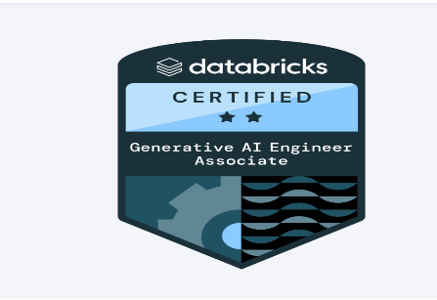
PRUDHVIRAJ MUDDANGULA
📧 m.prudhviraj@outlook.com | 📱 +1 2074644520
🔗 LinkedIn | Detroit, MI

PROFESSIONAL SUMMARY
Generative AI Engineer with 4+ years of experience designing intelligent AI agents and scalable NLP applications using LLMs. Proven expertise in prompt engineering, LangChain, OpenAI APIs, and Retrieval-Augmented Generation (RAG) pipelines. Strong programming foundation in Python with a deep understanding of machine learning, vector search, and embedding-based systems. Adept at collaborating with cross-functional teams to deliver AI-driven solutions aligned with business objectives.

CORE TECHNICAL SKILLS
- Programming: Python, SQL, Java, Scala, C/C++
- Frameworks & Tools: LangChain, Streamlit, Flask, Django REST, Hugging Face, OpenAI APIs
- AI/ML & LLMs: RAG, LLM Fine-tuning, Prompt Engineering, Embeddings, FAISS, Pinecone
- Big Data & Cloud: Apache Spark, Hive, Hadoop, AWS (S3, Lambda, EC2, Glue), Microsoft Azure
- ETL & Workflow: Airflow, AWS Glue, Informatica, Azure Data Factory
- Databases: MySQL, Oracle, SQL Server, NoSQL
- DevOps & CI/CD: Git, GitHub Actions, Jenkins, Docker

PROFESSIONAL EXPERIENCE
Senior Generative AI Engineer
Turing – Remote, USA | Oct 2024 – Present
- Designed and deployed GenAI-powered assistants using LangChain and OpenAI APIs.
- Built RAG systems leveraging FAISS and Pinecone for real-time document search and semantic querying.
- Created intelligent agents grounded in enterprise data repositories for contextual accuracy.
- Integrated Streamlit-based UIs for interactive user experiences.
- Collaborated with cross-functional teams to align AI product development with business goals.
Tech Stack: Python, LangChain, OpenAI, Hugging Face, FAISS, Streamlit, Flask, Pinecone
Data Engineer
Wipro Technologies (Client: Telstra) – Hyderabad, India | Oct 2020 – Apr 2023
- Built scalable data pipelines using Apache Spark and Hive for telecom data analytics.
- Automated ingestion processes with Python, reducing data latency by 70%.
- Implemented job scheduling and monitoring using Apache Airflow.
- Delivered actionable insights through optimized Spark transformations and SQL tuning.
- Mentored junior developers in Spark and big data workflows.
Tech Stack: Python, Apache Spark, Hive, Airflow, YARN, AWS S3, Glue

PROJECTS
RAG-Based Knowledge Assistant
- Developed a chatbot using LangChain and OpenAI's GPT-4 for a simulated enterprise environment.
- Embedded unstructured text corpora into FAISS vector database and implemented real-time retrieval pipeline.
- Integrated Streamlit frontend for interactive querying with LLM responses.
AI-Powered SQL Query Generator
- Created a GenAI application to translate natural language prompts into SQL queries using OpenAI and prompt templates.
- Enabled integration with structured databases for contextual grounding.

EDUCATION
Master of Science (M.S.) – Computer and Information Systems
University of Detroit Mercy – Detroit, MI | Apr 2023 – Dec 2024
GPA: 3.91 / 4.00
Bachelor of Technology – Computer Science Engineering
Jawaharlal Nehru Technological University – Hyderabad, India | Jul 2018 – Jul 2022
GPA: 3.19 / 4.00

CERTIFICATIONS
- Generative AI Engineer Associate – Databricks | May 2025
- Web Development using Advanced JAVA/J2EE | Jan 2020
- 36-Hour State Level Hackathon on Game Development | Mar 2020
- Cyber Security Management Systems (CYBE 5800/5760) | Apr 2023 – Jul 2023

