Sailohith Dodda
Senior Data Analyst

+1 332-203-5666
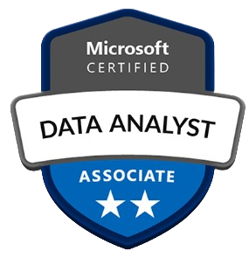
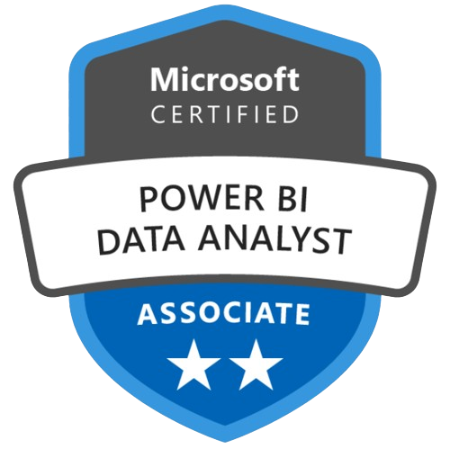
 sailohithdodda1@gmail.com

PROFILE SUMMARY
- Senior Data Analyst with 6+ years of experience delivering data-driven insights across financial services, insurance, healthcare, and manufacturing using SQL, Python, Power BI, Tableau, and Excel.
- Improved business performance by building KPI dashboards, automated reports, and analytical data models adopted by leadership and cross-functional teams.
- Accelerated analytics workflows through ETL development (SSIS, Informatica, Talend, NiFi) and scalable data integration across cloud and on-prem systems.
- Strong hands-on expertise with Snowflake, Redshift, BigQuery, Azure Synapse, and ADF, including data modeling, query optimization, and warehousing best practices.
- Proficient in statistical analysis and forecasting (A/B testing, regression, ARIMA, Prophet) with a proven ability to translate complex datasets into insights that support executive decision-making and operational improvements.
TECHNICAL SKILLS
Programming & Analysis: SQL, Python (Pandas, NumPy), R, DAX, Power Query.
Business Intelligence: Power BI, Tableau, Excel (Power Query, Pivot Tables), Looker Studio.
ETL & Data Integration: SSIS, Informatica, Talend, Apache NiFi, Data Quality, API Integration.
Cloud Data Platforms: Snowflake, AWS Redshift, Google BigQuery, Azure Synapse, Azure Data Factory, AWS Glue, S3.
Statistics & Forecasting: Regression, A/B Testing, Time Series (ARIMA, Prophet), Hypothesis Testing.
Tools & Automation: CRM, Git, GitHub, Jupyter Notebook, Alteryx, Power Automate, Advanced Excel.
WORK EXPERIENCE
Wintrust Financial Rosemont, Illinois, USA
Senior Data Analyst March 2024 – Present
- Identified inconsistencies in revenue, loan, and customer datasets and resolved root causes, resulting in a 30% increase in financial reporting accuracy.
- Accelerated monthly and quarterly reporting cycles by standardizing financial data integration using SSIS, Informatica, Talend, and AWS Glue.
- Built executive dashboards in Power BI/Tableau that delivered real-time visibility into loan health, deposit growth, fee income, and credit risk metrics.
- Reduced reconciliation defects by 40% by implementing data validation rules, quality controls, and audit-ready logic across Finance and Risk datasets.
- Delivered executive-ready reporting packages summarizing portfolio performance and customer insights to support strategic planning.
- Partnered with Finance, Risk, and FP&A teams to standardize KPI definitions and ensure insights aligned with regulatory and operational requirements.
ENVIRONMENT: SQL, Python, Power BI, Tableau, Excel, SSIS, Informatica, Talend, AWS Glue, Snowflake, Redshift, S3, Git.
Allstate Northfield Township, Illinois, USA
Senior Data Analyst Dec 2022 – Feb 2024
- Analyzed claim severity, reopen rates, and cycle-time variation to pinpoint bottlenecks, enabling operations teams to improve throughput and reduce processing delays.
- Developed leadership dashboards that highlighted SLA compliance, adjuster performance, customer outcomes, and regional claim trends.
- Improved data consistency across Claims, Underwriting, and Policy teams by engineering integrated datasets using SSIS and Azure Data Factory.
- Enhanced operational planning through forecasting models for claim volume, staffing needs, and seasonal utilization patterns.
- Strengthened regulatory and compliance reporting by creating standardized KPI frameworks and automated reporting logic.
- Collaborated with Claims, Product, and Compliance leaders to address process inefficiencies and improve claimant experience.
ENVIRONMENT: SQL, Python, Power BI, Tableau, SSIS, Azure Data Factory, Snowflake, Alteryx, Git.
Cigna Bangalore, India
Data Analyst Apr 2021 – Aug 2022
- Elevated healthcare analytics quality by uncovering denial trends, utilization inefficiencies, and provider performance gaps.
- Developed dashboards that visualized claims aging, denial rates, provider quality metrics, and care management KPIs for operational leadership.
- Increased data reliability by building scalable ETL processes with SSIS, Talend, Redshift, and BigQuery to unify claims and operational datasets.
- Reduced reporting errors through validation rules, anomaly detection, and QA workflows applied across clinical and claims data.
- Supported actuarial, care coordination, and compliance teams with insights on high-cost cases, fraud identifiers, and utilization gaps.
- Accelerated recurring reporting by automating SQL-driven processes and standardizing dataset preparation.
ENVIRONMENT: SQL, Python, Power BI, Tableau, SSIS, Talend, Redshift, BigQuery, Excel, Git.
Cummins Inc. Pune, India
Data Analyst Jun 2019 – Mar 2021
- Expanded production visibility by analyzing throughput, scrap rate, downtime, and cycle-time metrics across shop-floor systems.
- Built Power BI/Tableau dashboards that enabled plant managers to monitor OEE, equipment utilization, material flow, and inventory KPIs.
- Ensured consistent operational reporting by developing ETL workflows using SSIS and Informatica for production and supply chain datasets.
- Supported inventory and supply planning through forecasting models that predicted demand variability and part consumption patterns.
- Reduced manual reporting workload by 30% through automation using Python and advanced Excel.
- Strengthened data accuracy by implementing cleansing, transformation, and validation standards across shop-floor and logistics data sources.
ENVIRONMENT: SQL, Python, Power BI, Tableau, SSIS, Informatica, Snowflake, Databricks, Excel, Git.

EDUCATION
Master of Science in Computer Science
Bradley University, Peoria, IL, 2022 – 2024

