 |  |  | 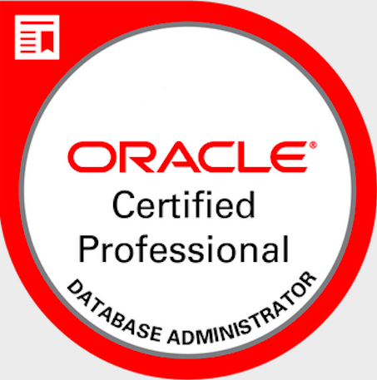

Summary
Accomplished process-oriented Data Analyst with two years of track record of analyzing business intelligence and detailed reports to increase sales revenue. Seeking opportunity to leverage my analytical, methodical skills and experience to guide business decisions in a friendly and fast-growing environment. Add value in achieving the company’s missions and goals.

Skills
- Oracle SQL and PL/SQL (ODBMS, stored procedures, function, DDL and DML), SQL Server, MySQL
- Excel (Formulas, Pivot tables, V-Lookups, Advanced tools such as Power Pivot, Power Query)
- Tableau (Bar Chart, Scatter Plot for Correlations, Maps for Demographic Data, KPIs, Calculated fields, Dashboards and Story points)
- Power BI (Interactive Data Visualization, connecting tables, creating measurements, filters, DAX)
- Cognos (Business Intelligence and Performance Management)
- Python (Pandas, NumPy, Sea born, Matplotlib)
- Java Core Programming
- Microsoft Access
- Microsoft Power Point
- Microsoft Office
- HANA

Career and Achievements

Illumina – Business Data Analyst July 2023- Sep 2025
Illumina is one of the largest growing Biotechnology Company. They specialize in studying human genome and DNA and provide information to its customers regarding their health and enable them to investigate the illness before it becomes aggressive. As a Business Analyst, I worked under the Facility Department with other analysts, project managers and developers. My responsibility is to ensure our Enterprise Assist Management data is accurate and there are no gaps and inaccuracy, provide visibility to leaders and team members for any data related issues through reporting and data investigation.

- Investigate and verify data according to business needs and get insights for accuracy and business-related decisions.
- Use SQL for retrieving and pulling data from HANA views into Tableau for data extraction and writing queries to join different tables/objects together from same/different sources.
- Perform data optimization when reports are working slow and showing performance issues either on Server level or desktop by improving the SQL or by report improvement through Tableau.
- Investigate data errors and inaccuracy in Excel using V-lookup, functions, pivot tables etc and match the data with the reports of other reports created by different analysts and developers.
- Leveraging different kind of reports (exception, data validation, analysis) using Tableau for business related demands and provide better understanding to employees and leaders.
- Use calculations to make different types of analysis as per report requirements.
- Use project management tools such as Asana, Confluence to manage/prioritize tasks and track progress.
- Participate in meetings to collaborate with the team and discuss business related issues/demands/announcements.

Realade Inc. Junior Data Analyst Aug 2020-March 2023
Responsibilities
Realade is social commerce platform. The platform is designed to engage locals and travellers with the city through innovative storytelling and experience. As a Junior Data Analyst at Realade Inc, my responsibilities include assisting Data Analyst working with business and marketing teams, attend and participate in meetings to understand the requirements, provide guidance, research for solution, generate weekly, monthly, quarterly reports, handle data collection, analysis, interpretation and presentation to management and other team members gathered via a wide range of available means and methods from users and business partners.

Key achievements
- Expertise in gathering data from various sources including databases, web-based tools, internal reports and other team members using SQL and Access.
- Creating stored procedures, views and functions for the automation of tasks in PL/SQL.
- Experience in cleaning data using Excel and Access by removing or updating null values, removing or managing duplicates, conditional formatting and using Pivot Tables to reports and customize data to the needs.
- Treating data with statistical analysis such as mean, median, mode and standard deviation.
- Performing different statistical analysis such as predictive, prescriptive, descriptive etc.
- Creating forms and reports using Microsoft Access.
- Automation of tasks and daily activities using macros and Power Query in Excel.
- Working knowledge of Power Query, Power Pivot and Power BI for relational database and working with M and DAX language to edit the code as needed.
- Expertise in SQL to import data and ran queries for data mining purposes. Created CTE, temporary tables and views to store the required data for later visualizations.
- Worked with Python Data Frames (Pandas) to convert and read different files formats (including csv, json, excel) and manipulate and clean the data as per needs.
- Have created automation functions/code to easily reuse the code in efficient manner.
- Visualization tools such as Tableau has been extensively used for importing data, storytelling the numeric data into meaningful and easy to understand visuals.

Education

Bachelor’s degree in business administration – Computer Information Systems
Cal Poly Pomona (2025)

Associate Degree in Computer Information System (Database Management),
Mount San Antonio College, Walnut, CA (2019)

Professional Certifications
- Oracle Database Administration Certified Professional (OCP) -2011
- IBM Professional Data Analyst Certification-2021
- Data Visualization with Tableau (Specialization)-2021
- Google Analytics Certification - 2022

Certificate Courses
- Statistics for Data Science and Business Analysis-2021
- Excel Power Tools for Data Analysis (Power Query, Power Pivot and Power BI)-2022
- Microcomputer Productivity-2019
- Java Programming Core-2011

Portfolio
https://sanaq1.github.io/sanatheanalyst.github.io/

References
- Available on request

