NAGESWARA RAO
+1 3125886392

Data Analyst
pnr87083@gmail.com

Chicago, IL, USA
Objective
Experienced data analyst with 5+ years in transforming data into strategic insights, Skilled in leading cross-functional teams and implementing data-driven solutions to enhance profitability and streamline operations, seeking to bring expertise to a leadership role within a forward-thinking organization.
Education:
Lewis University - Illinois, USA (2021 – 2023)
- Masters In Business Analytics
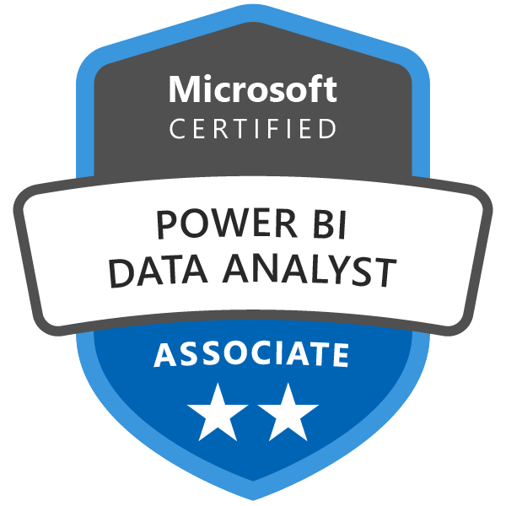
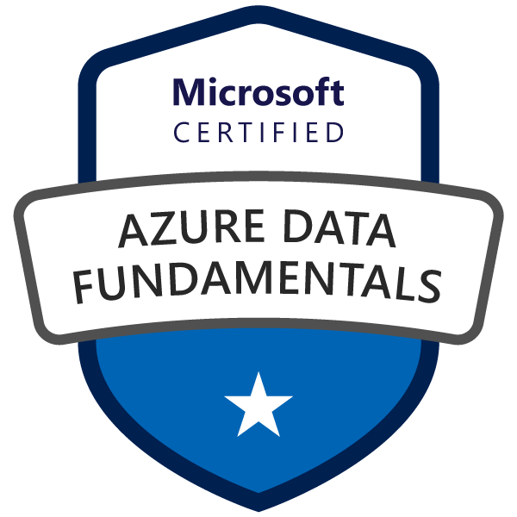

Profile Summary
      - 5+ years of Industry experience as a Data Analyst with solid understanding of Data Modelling Evaluating Data Sources ETL Development and strong understanding of Data Warehouse/Data Mart Design ETL Bl OLAP Client/Server applications, Strong skills for preparing adhoc reports in Tableau, Proficient in data warehousing, data modeling, and SQL queries within Snowflake for scalable and efficient analytics
- Experience in big data technologies like Hadoop, Apache Spark, and Kafka. Skilled in designing scalable data pipelines, processing large datasets, and deriving actionable insights.
- Extensive Experience in Teradata Utilities like Fast load Multi load, BTEQ, T Pump. Fast Export and Teradata Parallel Transporter (TPT) on UNIX environments
- Experienced working with Excel Pivot and VBA macros for various business scenarios.
- Design, develop, and implement machine learning models (e.g., regression, classification, clustering, and recommendation systems) to solve business problems.
- Proficient in leveraging libraries such as pandas, NumPy, Matplotlib, sea born, and scipy for data manipulation, visualization, and statistical modeling.
- Strong experience in Data Analysis. Data Migration, Data Cleansing. Transformation, Integration. Data Import. Data Export and writing SQL and PUSQL statements - Stored Procedures, Functions. Triggers and packages.
- Experience in automating and scheduling the ETL jobs using UNIX shell scripting in Autosysy, Experience in leveraging cloud platforms such as AWS (S3, Redshift), Google BigQuery, and Azure Data Lake to process and analyze large datasets.
- Experience in testing Business Intelligence reports generated by various Bl Tools like Tableau Experience leveraging Tableau, Power BI, and Looker to transform raw data into actionable business insights.
- Proficient in coordination of defect management and monitoring the status using Bugzilla, JIRA, Quality Center, ServiceNow,
- Experience with query optimization and ETL loading on Teradata, Vertical DB performance tuning.
- Experience in Python and UNIX shell scripting for processing large volumes of data.
- Experienced in creating Use Case Models, Process Flows, Workflow Analysis and Unified Modeling Language (UML) Diagrams like Class, Use Case, Activity, Swim Lanes and ER Diagrams using popular designing tools.
Technical Skills
- Operating Systems: Windows. Linux, Solaris
- Databases: MS Access, MS SQL Server, Oracle, Sybase. Teradata
- Design and Tools: MS Office. MS Project. ZEN, JIRA. Rally, MSVISIO Enterprise Architect Toad Gliffy
- Data warehouse tools: Informatica, Lava storm
- Quality Management Tools: Quality Center/ALM, Rational Clear Quest, ZEN
- Programming/Scripting Languages: Unix/Perl scripting Python, e, VB Script R, snowflake, machine learning
- Document/ Content Management Tools: Documentum MS SharePoint
- Knowledge Management: Share point, Twiki sites
- Applications / Tools: Tableau, MS Office Suite, Toad, Perforce
- Big Data & Cloud Technologies: Hadoop, Apache Spark, Kafka, AWS, Azure Data Lake
Work Experience:
Senior Data Analyst | Bankers Life

Dec 2023 - Present
Chicago, Illinois, USA
Description: Bankers Life is a U.S.-based insurance company specializing in life insurance; I am developing and maintaining dashboards, reports, and visualizations to present data insights. Deploy the machine learning models into production environments using tools like Tableau, Power BI, or Excel.
Environment: Tableau, Power BI, Looker, KPIs, Apache Spark, Hadoop, Kafka, Redshift, Tableau, Apache Spark, VLOOKUP, INDEX MATCH, Google Big Query, pandas, NumPy, Matplotlib, sea born, Snowflake, python scripts
Responsibilities:
- Built and optimized machine learning models, including regression, classification, clustering, and time series forecasting, Extracted and integrated data from multiple sources into Snowflake using ETL tools like Talend, Informatica, and Matillion, Created and maintained over interactive dashboards in Tableau, Power BI, Excel and Looker to track KPIs, operational metrics, and financial performance, enhancing executive decision-making.
- Scraping data from diverse platform's and applying business logics and loading data to Snowflake(Cloud) database
- Responding for incoming requests from the Business users and understanding business requirement.
- Built and optimized distributed data pipelines using Apache Spark and Hadoop for processing datasets of up to X TB.
- Implemented Kafka-based streaming solutions for real-time data ingestion and processing, reducing system latency, Created Python programs to analyze complex data structures from varied sources.
- Employed INDEX MATCH to perform complex, multi-criteria lookups for detailed analysis, enabling cross-referencing between multiple data sources and improving decision-making.
- Developed ETL pipelines in Google Big Query to automate data ingestion from multiple sources, reducing manual workload, Help business users by providing the forecasting report for revenue to monetize the traffic.
- Implemented cost-effective data storage strategies in Azure Data Lake, optimizing query performance and reducing expenses by 20, Attending turnover meetings (tools: Gitlab TCM) Regular interaction with the Business Users.
- Prepared Logical Data Models that contain a set of diagrams and supporting documents containing the essential business elements, detailed definitions, and descriptions of the relationships between the data elements to analyze and document business data requirements, Handle the analytical request from business users using Tableau.
- Analyzed large datasets using pandas and NumPy, uncovering insights that increased operational efficiency
- Designed and deployed interactive visualizations using Matplotlib and sea born, enabling stakeholders to track KPIs effectively, Attending audit meetings with project leader and higher management people.
- Helped design scope document and to coordinate with top management for the approval process.
- Extract large datasets from PADB (Paracceldb) and load it in Snowflake cloud database via s3.
- Involved in extensive DATA validation by writing several complex SQL queries and Involved in back-end testing and worked with data quality issues, Wrote SQL code to help the business users.
- Upload daily feeds from external server on s3 using multipart upload feature of Azure and then load this data into Snowflake cloud database, Wrote python scripts to automate the load and the job failure alerting.

Senior Data Analyst | Medline Industries
Chicago, Illinois, USA

Apr 2022 - Nov 2023


Description: Medline Industries, LP is a privately held American healthcare company, I collaborated and developed Excel-based tools to monitor product demand with other teams to understand their data needs and provided actionable insights, using tools like MapReduce, Spark, pandas, Teradata, Oracle
Environment: pandas, MapReduce, Hadoop, Spark, Power BI, BTEQ scripts, scipy stats, diagrams, OLAP, OLTP, ER diagrams, SQL queries, Oracle database, Excel Pivot tables, Perl, Toad, MS Access. Excel and SQL, AWS
Responsibilities:
- Conducted data cleaning and transformation using pandas, ensuring data integrity for reporting and analysis, Acted as a liaison between IT department and the business client for collection, analysis, review, documentation, and communication of business needs and requirements.
- In-depth interaction with SME's from various business units for requirement gathering, managing Change Control Process, updating existing use case specification, Automated data pipelines to load and transform large datasets from on-premises systems into Snowflake using Snowflake's native tools and SQL.
- Designed and executed MapReduce jobs on Hadoop to extract and aggregate data for marketing analytics.
- Worked on business requirements involving Corporate General Ledger Reconciliation involving Financial Strategic Reporting departments interact with SME's and prepare the metadata for future references.
- Prepared Logical Data Models that contain a set of diagrams and supporting documents containing the essential business elements, detailed definitions, and descriptions of the relationships between the data elements to analyze and document business data requirements.
- Analyzed and visualized over 1 TB of data stored in AWS S3 using Redshift and Tableau to improve operational efficiency by 25%, Generated regular performance reports Apache Spark using VLOOKUP to pull data from different systems, ensuring that key metrics and KPIs were accurately represented in executive dashboards,
- Extensively worked on the ETL mappings analysis and documentation of OLAP and OLTP reports requirements.
- Created class diagrams, Data mapping, logical data modeling, and ER diagrams and used SQL queries to filter data within the Oracle database, build a python wrapper to handle the ETL load in Teradata.
- Worked in importing and cleansing of data from various sources like Teradata, Oracle, flat files, SQL Server with high volume data, Worked with Excel Pivot tables.
- Helped implement Source-to-target mapping (STM) to migrate existing historical data from legacy system to new schema, Worked on design to normalizing the tables for simplification of the Data Model.
- Performing data management projects and fulfilling ad-hoc requests according to user specifications by utilizing data management software programs and tools like Perl, Toad, MS Access. Excel and SQL
- Create regular reports for the stakeholders and SME's - Project Schedule reports. Revenue forecasting report and ad-hoc query using Tableau, Wrote python script for alerting and sending out an email.
- Verified and got approval for final requirement specifications for correctness completeness unambiguousness, consistency and traceability, Extract large datasets from Teradata using utilities like fast export, BTEQ and Load into Verticas, Written complex SQL queries for validating the data against different kinds of reports.
- Worked closely with the project team in planning, coordinating and implemented QA methodology on various phases of UAT, Provided post-production support during the Go-live phase of the project and working on production issues.
- Provided assistance and training to the technical support staff and end users for any problems in running the application, errors and questions with the application.

Data Analyst | Canara Bank
May 2020 - Nov 2021

Bangalore, India
Description: Canara Bank is one of India's largest and oldest public sector banks, I worked with database management systems (DBMS) like SQL Server, MySQL, PostgreSQL, or Oracle to extract and manipulate data, and Created Power BI dashboards to track logistics performance and delivery timelines.
Environment: Google BigQuery, Azure Data Lake, EDA, pandas, sea born, UNIX and SQL, UNIX. Shell/Perl scripts, SQL queries, Teradata, python scripts, shell script, machine learning.

Responsibilities:
- Prepared Business Requirement Documents (BRD's) based on the Client requirement meetings and extracted Functional requirements, Extracted and processed large datasets from Google BigQuery to identify market trends and forecast sales patterns, improving forecasting accuracy by 15%.
- Migrated legacy on-premises data to Azure Data Lake, ensuring compliance with data governance standards.
- Performed EDA with pandas and sea born, identifying key factors influencing churn.
- Writing scripts and automating the support activities to reduce man power (tools: UNIX. Shell/Perl scripts)
- Design and analyze A/B tests to measure the impact of machine learning-driven decisions on business outcomes.
- Being at on shore I was involved in interaction with client, understanding there issues and single handily resolve all the issues and given adhoc reports and automate also using UNIX and SQL, Managed and optimized large-scale data warehouses in Snowflake, ensuring high performance, scalability, and cost-efficiency for querying massive datasets.
- created class diagrams, Data mapping, logical data modeling, and ER diagrams and used SQL queries to filter data within database, Performing backend testing for the databases and applications
- Designed and maintained SQL queries, stored procedures, and views for MySQL and Oracle databases to analyze supply chain performance and reduce
- Conducted data cleansing and ETL operations using SSIS and PL/p SQL, ensuring data integrity across platforms.
- Wrote SQL queries and validated back end data used by Edge for storing and retrieving data for Data Analysis.
- Conducted JAD sessions for Requirement analysis and Risk analysis studies with the developers, QAs. and the management staff to identify business critical and high-risk areas of the application
- Using the UML techniques created use case Process flows, Activity Diagrams to illustrate different scenarios for the requirements and interacted with the development team to impart knowledge of the new requirements
- Supported development and QA post requirements phase for question and concerns.
- Developed test Environment Application for testing swap trade booking and maintain test data by overnight auto sys batch job, Attending audit meetings with project leader and higher management people
- Frequently used Teradata Utilities such as BTEQ. Fast load and Multi load accordingly to load small and large amounts of the data into the tables, Wrote python scripts which sends out an email with the load stats to the reporting team, wrote a shell script to manage the batch process load.

Programmer Analyst | Decathlon

Bangalore, India
Mar 2019 - Apr 2020

Description: Decathlon is a leading global sports retailer known for offering a wide range of high-quality and affordable sports equipment, apparel, and accessories, I integrated the software applications with existing systems and databases, ensuring compatibility and seamless data flow. Using tools like SQL PL-SQL scripts, functions, Power BI, Python
Environment: UNIX, script, Diagrams, Data Flow Diagrams, SQL PL-SQL scripts, functions, Hadoop, ETL pipeline, Power BI, Python, SDLC, work flow, UAT, SIT.
Responsibilities:
- The solution designing, implementing and developing for the client requirements using UNIX and Perl script implement the unit testing for the application, Led the design team in implementing Unified Modeling Language (UML) methodologies to design Use Case Diagrams, Data Flow Diagrams and Activity Diagrams.
- Creation and maintenance of SQL PL-SQL scripts, functions, procedures, developed and maintained project related relevant documents, working on numerous small enhancements programming project, Created and maintained Snowflake schemas (Star and Snowflake) for organizing data efficiently for reporting and analysis.
- Built a Hadoop-based ETL pipeline to consolidate customer data, enabling faster analytics and reporting.
- Helped design scope document and to coordinate with top management for the approval process.
- Interviewed various personnel including broker dealers and traders to understand the current process and the future requirements, Acted as a liaison between the project group and the operations group.
- Designed an interactive dashboard in Power BI integrating Python visualizations for advanced forecasting.
- Responsible for physical/logical data modelling metadata documentation user documentation and production specs, Manage Scope and change throughout the SDLC process of the product.
- Developed Business rules for the equity trading system based on technical chart analysis and fundamental analysis and trends, Prepared Use Case Models, Domain Models, System Mapping, and Source-Target Data Mapping.
- Established trace ability matrix using Rational Requisite Pro to trace completeness of requirements in different SDLC stages, Used rational Rose to create use cases for different scenarios and cases.
- Developed Business specification diagram so as to understand the whole work flow.

