ANEESH REDDY MEKALA
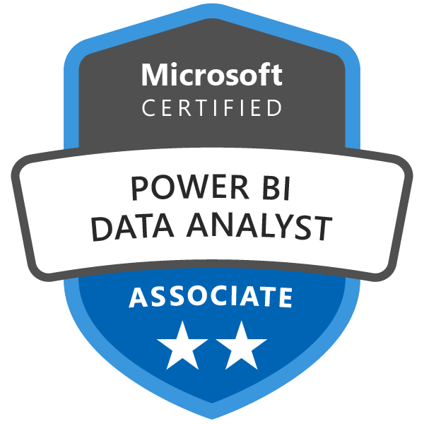
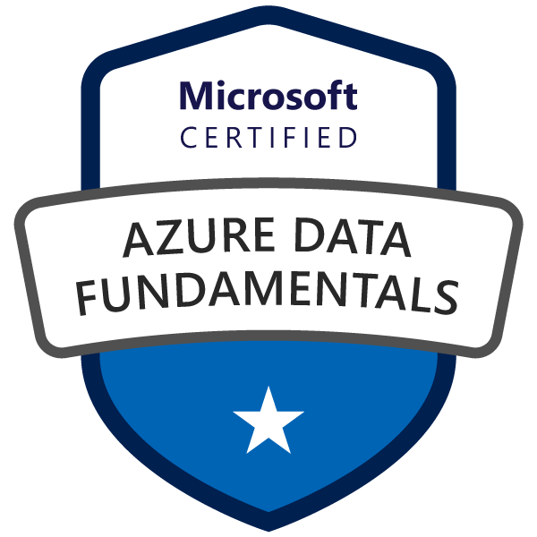
aneeshreddymekala30@gmail.com
513-428 9459

Data Analyst
Detail-oriented and analytical professional with 5+ years of experience in interpreting and analyzing complex data sets to drive actionable business insights Proficient in data visualization tools (such as Tableau and Power BI), SQL, Excel, and statistical analysis.
Technical Skills
Professional Experience
- 5+ years of Industry experience as a Data Analyst with solid understanding of Data Modeling, Evaluating Data Sources and strong understanding of Data Warehouse/Data Mart Design, ETL, BI, OLAP, Client/Server applications.
  - Expert in writing SQL queries and optimizing the queries in Oracle, SQL Server 2008 and Teradata
  - Excellent experience in analysis huge volumes of data in industries such as Finance, Healthcare & Retail.
  - I have honed my skills in business analytics by analyzing complex datasets, identifying key trends, and creating actionable reports and dashboards. I specialize in leveraging tools like SQL, Python, Tableau, and Excel to streamline operations, enhance performance, and support strategic decision-making
  - . My work often involves collaborating with cross-functional teams to understand business needs, design data solutions, and drive measurable outcomes that align with organizational goals.
  - Excellent Software Development Life Cycle (SDLC) with good working knowledge of testing methodologies, disciplines, tasks, resources and scheduling
  - Excellent knowledge in Data Analysis, Data Validation, Data Cleansing, Data Variation and identifying data mismatch.
  - Performed data analysis and data poling using complex SQL on various sources systems including Oracle and Teradata.
  - Proficient in Google Looker is responsible for transforming raw data into actionable insights using Looker's data visualization and business intelligence (BI) capabilities.
  - Experience in DOMO is responsible for leveraging this business intelligence tool to collect, analyses, and visualizes data to support decision-making processes.
  - Experienced working with Excel Pivot and VBA macros for various business scenarios.
  - Familiarity in Power BI is specifically skilled in using this business analytics tool to visualize data and share insights across the organization.
  - Excellent knowledge in preparing required project documentation and tracking and reporting regularly on the status of projects to all project stakeholders
  - Extensive knowledge and experience in producing tables, reports, graphs and listings using various procedures and handling large databases to perform complex data manipulations.
  - Using Power BI is responsible for transforming raw data into actionable insights through the creation of interactive and intuitive dashboards and reports.
  - Specializing in Azure Data Factory (ADF) leverages this cloud-based ETL (Extract, Transform, and Load) service to design, orchestrate, and automate data pipelines.
  - Excellent knowledge on creating DML statements for underlying statements.
  - An excellent team player & technically strong person who has capability to work with business users, project managers, team leads, architects and peers, thus maintaining healthy environment in the project.
  - Understanding of lookup functions is responsible for managing and analyzing complex datasets to support business decision-making. They utilize advanced Excel functions, such as VLOOKUP, INDEX MATCH, and other data analysis tools, to efficiently retrieve and manipulate data.
  - Proficiency in SQL (both DDL & DML queries) is adept at using SQL to define, manipulate, and query data stored in relational databases.

- Data Warehousing: Informatica 9.1/8.6/71.2 (Repository Manager Designer, Workflow Manager and Workflow Monitor), SSIS. Data Stage 8.x
- Reporting Tools: Business Objects6.5 XIR3, Cognos 8 Suite
- Data Modeling: Star-Schema Modeling Snowflake-Schema Modeling, FACT and dimension tables, Pivot Tables, Erwin
- Testing Tools: Win Runner Load Runner Test Director, Mercury Quality Center, Rational Clear Quest
- RDBMS: Oracle 1Og/9i/8i/7.x, MS SQL Server UDB DB2 9.x. Teradata, MS Access 7.0
- Programming: SQL PL/SQL UNIX Shell Scripting, VB Script
- Environment: Windows (95. 98,2000,NT.XP), UNIX
- Other Tools: TOAD, MS-Office suite (Word, Excel, Project and Outlook), BTEQ, Teradata SQL Assistant
- Operating Systems: Windows NT, 2000 & XP, Vista, UNIX And Linux
- Data base: ORACLE, MS Access, SQL Server, Teradata
- Languages: PL/SQL, SQL,HTML
- BI Tools: Power BI (2.x), Tableau, Python, ADF, Looker
Education
- Masters in Data Science from Wichita State University, Wichita, KS, USA


OBJECTIVE
Work Experience
Client: Fifth Third Bank, Ohio, USA Nov 2023 – present
Role: Senior Data Analyst
Description: Fifth Third Bank is a regional banking corporation it’s providing a wide range of financial services, including personal banking, business banking, wealth management, and commercial banking. Developed comprehensive business requirements and reporting solutions by analyzing data trends, collaborating with functional teams, and conducting predictive modeling to drive data-driven decision-making.
Responsibilities:
- Analyzed the historical documentation supporting documentation, screen prints, e-mail conversations, presented business and wrote the business requirements document and got it electronically signed off from the stake holder
- Wrote the test cases and technical requirements and got them electronically signed off Created new reports based on requirements
- Collaborated with cross-functional teams, including marketing, finance, and operations, to define key performance indicators (KPIs) and develop data-driven strategies. Use Power BI to analyze complex datasets and visualize data trends, patterns, and outliers to aid in decision-making processes
- Experienced Data Analyst with a strong background in data visualization and business intelligence using Power BI Created a multi-page report dashboard in Google Looker (Data Studio) using Google Big Query data.
- Utilized simple methods like PowerPoint presentations while conducting walkthroughs with the stakeholders.
- Conducted GAP analysis so as to analyze the variance between the system capabilities and business requirements Interacted with teams in AFS ACBS and info lease to extract the information for the reports.
- Involved in defining the source to target data mappings, business rules business and data definitions created Report-Models for ad-hoc reporting and analysis Built Big Query SQL queries and views for Google Looker
- Created Logical/physical Data Model in ER win and have worked on loading the tables in the Data Warehouse worked extensively with the ER win Model Mart for version control
- Extensively designed Data mapping and filtering consolidation, cleansing, Integration, ETL and customization of data mart Built Big Query SQL queries and views for Google Looker
- Guided end users of Clients in using Power BI, Tableau and developing and publishing dashboards, sharing them with other colleagues and how to embed them on their websites.
- Provide 24 x 7 problem management supports to the development team Document various Data Quality mapping document. Worked on daily basis with the main frame team and lead data warehouse developers to evaluate impact on current implementation
- Conducted predictive modeling and regression analysis using Python and R to forecast sales trends and customer behavior,
- Written several shell scripts using UNIX Korn shell for file transfers error logging, data archiving, checking the log files and clean-up process
- Developed and maintained data extraction processes using APIs to gather data from external services, ensuring timely and accurate data retrieval Managed Business Objects user account administration and maintenance.
- Solution Design and Implementation of Business Intelligence reports and OLAP cubes using Cognos Reporting Services, Tableau and Power Pivot & Performance Test Design and Development of Data Analytics solution leveraging Tableau and Cognos Conducted User Acceptance testing (UAT) and worked with users and vendor who build the system.
- Analyzed API data to identify trends, patterns, and insights, generating reports and visualizations to support business decisions Knowledge of transactions like HIPAA 5010, 270/271 for Medical id and Medicare members.
- Worked according to the software development life cycle Creating pipelines with GUI in Azure data Factory(ADF)
- Gathered requirements from remotely based business users and defined and elaborated the requirements by holding meetings with the users (who are also Fifth-third employees) Communicated with the third party vendor to do the programming Upgraded the present application by adding new functionalities and adding new reports.
- Wrote regression test cases, did smoke testing with users Coordinated (with business users, data base administrator, mainframe team and testing team) in mirror to production testing.
Environment: Power BI, decision-making, KPIs, data-driven, Google Looker, Google Big Query data, Big Query SQL, Power BI, Tableau, Python and R, OLAP, APIs, HIPAA, GUI, Cognos, Azure data Factory (ADF)
Client: Great American Insurance Company, Ohio, USA Nov 2022 - Oct 2023
Role: Senior Data Analyst
Description: Great American Insurance Company, its provider offering a wide range of specialty commercial and property/casualty insurance products. Managed the design and implementation of data models and dashboards to enhance data integration, reporting, and predictive analytics for business performance and operational insights.
Responsibilities:
- Designed and implemented robust data models within Power BI to ensure efficient data integration and reporting processes integrated data from multiple sources into DOMO for comprehensive analysis and reporting.
- Develop and implement predictive models and algorithms to forecast business performance, risk assessments, and pricing strategies Built Big Query SQL queries and views for Google Looker
- Analyze large volumes of data related to underwriting, claims, and other business operations to identify trends, patterns, and insights Prepare and present reports to management and stakeholders.
- Ensure data integrity, accuracy, and consistency work with data engineering teams to manage data pipelines and ETL processes, ensuring data is easily accessible and usable.
- Involved in Planning, Defining and Designing database using Erwin on business requirement and provided documentation.
- Designed the WellPoint Facets domains Member Provider, Claim, Product Billing Group conceptual and logical model for categorizing and mapping automated business processes jobs, user reports and application processes to the appropriate doma in entities using Erwin.
- Monitor network and Mainframe/Tandem systems and other applications Published reports to Azure - based Power Bl services (Pro) and schedule subscription and various sharing options (workspace, content pack and Apps) Design and implement dashboards and reports in DOMO to provide actionable insights.
- Worked closely with underwriting, claims, finance, and other business units to understand their data needs and provide analytical support utilize tools like SQL, Python, R, Power BI, Tableau, and other advanced analytics and visualization tools to analyze and interpret data.
- Used SQL on the new AWS Databases like Redshift and Relation Data Services and worked with various RDBMS like Oracle 11g SQL Server Worked with PivotTables working with up to 140 million-record multi-table, data sets in SQL (MS SQL Server, SAS Proc SQL, etc.)
- Published reports to Azure - based Power Bl services (Pro) and schedule subscription and various sharing options (workspace, content pack and Apps) Design and implement dashboards and reports in DOMO to provide actionable insights Experience in data analysis, preferably in the insurance or reinsurance industry.
- Use Data Definition Language (DDL) queries to create, alter, and manage database schemas, tables, indexes, and other database objects Utilize Data Manipulation Language (DML) queries to insert, update, delete, and select data from databases.
- An API can be used to collect data from a variety of sources and then analyze that data more efficiently and accurately
- Create dynamic and interactive reports and dashboards using Power Query and Excel Develop custom Excel reports that utilize VBA for automation and enhanced functionality.
- Performed data lookups (VLOOKUP, HLOOKUP, and INDEX-MATCH) to efficiently merge and cross-reference data from different sources developed and maintained Looker dashboards and reports to provide actionable insights
- Identify opportunities for process improvements through data analysis, driving more efficient and effective business operations ensure all data analytics and reporting activities comply with internal and external regulatory requirements.
- Strong analytical and problem-solving skills with a deep understanding of statistical methods and techniques.
- Excellent communication and presentation skills to convey complex data findings to non-technical stakeholders.
Environment: SQL, Python, R, Power BI, Tableau ETL processes, ADF, DOMO, API, Power Query, Excel Reports, VLOOKUP, HLOOKUP, INDEX- MATCH, ETL

Client: Indian Overseas Bank, Chennai, India Feb 2021 - Jul 2022
Role: Data Analyst
Description: Indian Overseas Bank (IOB) is a major public sector bank in India it’s offering services like retail banking, corporate banking, and international banking. Contributed to data design and modeling by gathering business requirements, developing ETL processes, and creating interactive dashboards to enhance data analysis and decision-making.
Responsibilities:
- Consulted with application development business analysts to translate business requirements into data design requirements used for driving innovative data designs that meet business objectives.
- Involved in information-gathering meetings and JAD sessions to gather business requirements, deliver business requirements document and preliminary logical data model Responsible in designing new FACT or Dimension Tables to existing Models Took ownership of Source to Target Mapping and tracked and maintained changes.
- Performed requirements gathering and design analysis for customer contact history for customer relationship management Performed Extraction, Transformation and Loading (ETL) using Informatica power center.
- Worked as business requirements analysts with subject matter experts to identify and understand requirements.
- Supported data warehouse projects with logical and physical data modeling in Oracle environment and assured accurate delivery of DDL to the development teams Structure and organize data models in Power BI.
- Documented the data requirements and system changes into detailed functional specifications.
- Designed and implemented data profiling and data quality improvement solution to analyze match cleanse, and consolidate data before loading into data warehouse.
- Preparing reports extracts and integration of existing data as needed to support analysis Visualizations, and statistical models. Worked with Azure Data Factory (ADF) since it’s a great SaaS solution to compose and orchestrate Azure data services Integrate data from multiple databases and systems into Power BI for comprehensive analysis
- Designing Developing and providing technical solutions through Tableau reports based on user requirements.
- Creating PivotTables to summarize, analyze, and explore large data sets, allowing analysts to quickly view data trends and patterns designing and developing interactive dashboards and reports using tools like Tableau, Power BI, or Looker write SQL queries to clean data, handle missing values, remove duplicates, and standardize formats.
- Extensively used ER Win to design Logical Physical Data Models, and Relational database and to perform forward/reverse engineering Develop interactive and visually appealing dashboards and reports in Power BI.
- Implemented stored procedures, functions, views, triggers, packages in PL/SQL.
Environment: Erwin, T-SQL, OLTP, PL/SQL, OLAP, Teradata, SQL Ell. SAS, SSRS, ADF, Power BI, Tableau
Client: Bafna Pharmaceuticals Ltd, Chennai, India Mar 2020 - Jan 2021
Role: Programmer Analyst
Description: Bafna Pharmaceuticals Ltd is an Indian pharmaceutical company is engaged in the development, manufacturing, and marketing of a wide range of pharmaceutical formulations. Involved in designing and optimizing data models and ETL processes, conducting data analysis, and creating interactive dashboards to support business insights and decision-making.
Responsibilities:
- Participated in Business Analysis, talking to business Users and determining the entities and attributes for Data Model.
- Identified and determined physical attributes and their relationships through cross-analysis of functional areas.
- Identified and analyzed source data coming from Oracle SQL server and flat files.
- Extensively used ERWIN to design and restructure Logical and Physical Data Models.
- Evaluated and enhanced current data model as per the requirements
- Performed forward and reverse engineering applying DDLs to database in restructuring the existing data Model using ERWIN Involved in Data migration and Data distribution testing.
- Designed ETL specification documents to load the data in target using various transformations according to the business requirements Used Informatica- Power center for extracting, transforming and loading
- Performed Data profiling Validation and Integration Identified and analyze stakeholders and subject areas.
- Worked with Data Warehouse team in developing Dimensional Model and analyzing the ER-Diagrams
- Created materialized views to improve performance and tuned the database design.
- Leverage advanced features of Tableau, Looker, or other visualization tools to enhance data representation.
- Design and build interactive dashboards in DOMO to visualize key metrics and performance indicators.
- Performed testing, knowledge transfer and mentored other team members.
Environment: Oracle SQL, ERWIN, SAS, SQL Queries and MS Excel, MS Access, PowerPoint Tableau VB Scripting, Macros. DDLs, Tableau, Looker, DOMO

