Veera Venkata Ramarao Bikkina
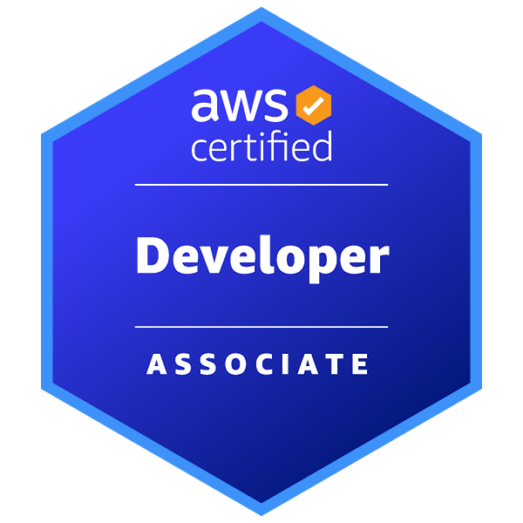
AWS Python Developer | AWS Developer Associate Certified
219.699.1621 |rambikkina@yahoo.com | McKinney, TX - 75071
Professional Summary:
- Results-oriented software engineer with over 1.7 years of hands-on experience in developing and deploying Python applications for Backend and Data Processing.
- Proficient in using libraries such as pandas, NumPy, and scikit-learn, I have consistently delivered high-quality solutions to complex data challenges.
- I've applied my expertise in AWS services, including EC2 for scalable compute, S3 for data storage, Lambda for serverless computing, and Glue for ETL processes.
- In addition to my Python prowess, I possess substantial experience in database systems, having designed and implemented solutions using MySQL and PostgreSQL.
- My skills extend to schema design, query optimization, and data indexing, with over 1.5 years of experience in this domain.
- I've made significant contributions to data warehousing by utilizing AWS Redshift for complex analytics and reporting requirements.
- I've also enabled interactive ad-hoc analysis by integrating AWS Athena for serverless querying of data stored in S3.
- My proficiency extends to structured and NoSQL data management through the integration of AWS RDS (Relational Database Service) and DynamoDB.
- Designed and implemented Snowflake stages to efficiently load data from various sources into Snowflake tables.
- I'm well-versed in system performance monitoring, utilizing AWS CloudWatch for setting up alarms and automating remediation tasks.
- Throughout my career, I've embraced modern software engineering practices, including version control with Git, hosting repositories on platforms like GitHub and Bitbucket.
- Implementing CI/CD pipelines using Jenkins and AWS CodePipeline for automated testing, building, and deployment of applications.
- With a strong foundation in project management, I've successfully overseen end-to-end project life cycles using Jira, from requirement gathering and planning to execution and delivery.
- My proficiency extends to creating and maintaining project boards, backlogs, and sprints, ensuring efficient task tracking and progress monitoring.
- I've effectively communicated complex technical concepts and collaborated with cross-functional teams in Agile methodologies like Scrum and Kanban.
- My problem-solving skills, analytical thinking, and dedication to delivering high-quality software solutions consistently contribute to project success.

Skillset Table:
Programming Languages | Python (advanced), SQL, JavaScript
AWS Services | EC2, S3, Lambda, Glue, Redshift, EMR, RDS, DynamoDB, CloudWatch
Database Systems | Oracle, MySQL, PostgreSQL, MongoDB
Web Frameworks | Django, Flask, ReactJS
Version Control Systems | Git, GitHub, Bitbucket
Deployment and CI/CD | Docker, AWS CodePipeline
Data Visualization | Power BI, matplotlib
Agile Methodologies | Scrum, Kanban
Testing | PyTest, UnitTest

Education:
- Bachelor of Technology in Electronics and Communication Engineering from Aditya College of Engineering, India (May 2016 -Oct 2020).
- Master of Science in Computer Information technology from Purdue University with 3.7/4.0 GPA (Jan 2022 - May 2023).

Certifications:
- Microsoft Certified in Python and JavaScript in Advanced Level.
- VMware IT Academy Certified on Virtualization and Data Center Design
- AWS Certified Developer Associate on AWS Tools and Services.
- HackerRank Certified on SQL and Database Management and Query Optimizations.

Professional Experience:

AWS Python Developer |Jukshio Innovation and Technology PVT LTD
Hyderabad, India | Aug 2020 – Sept 2021

- Designed, developed, and maintained secure and high-quality Python applications hosted on the AWS cloud platform.
- Implemented an efficient serverless architecture using AWS Lambda functions to optimize resource utilization and reduce operational costs.
- Leveraged AWS services, including EC2, S3, DynamoDB, and RDS, for storage, compute, and database management, ensuring system scalability and reliability.
- Orchestrated data processing pipelines using AWS Glue enabling efficient data ingestion, transformation, and analysis.
- Utilized AWS Redshift for data warehousing, including schema design and query optimization for complex analytical requirements.
- Leveraged Snowflake's Time Travel feature to perform temporal data analysis, allowing for the retrieval of historical data at various points in time.
- Developed RESTful APIs using Python frameworks such as Flask and Django to facilitate seamless communication between backend and frontend systems.
- Integrated front-end components with backend APIs using AJAX, Fetch API, or other data-fetching techniques, enabling dynamic content rendering.
- Implemented database schemas using SQL and NoSQL databases like PostgreSQL, MySQL, and MongoDB to support various data storage needs.
- Established continuous integration and continuous deployment (CI/CD) pipelines using Jenkins and AWS CodePipeline for automated testing, building, and deployment of applications.
- Wrote reusable and scalable scripts to automate repetitive tasks, significantly reducing manual effort and resource consumption.
- Collaborated closely with cross-functional teams, including data scientists and analysts, to gather requirements and deliver data-driven solutions.
- Developed and maintained modern front-end applications using JavaScript frameworks and libraries like React, Angular and jQuery.
- Created and managed different types of tables in Snowflake, such as transient, temporary, and persistent tables.
- Implemented monitoring and alerting systems using AWS CloudWatch, ensuring system availability, and proactively addressing issues.
- Stayed updated with the latest AWS services, Python frameworks, and industry trends, actively exploring new tools and techniques to enhance development processes.
Python & Oracle DB Developer Intern | Oracle Corporation
Hyderabad, India | Jan 2019 – July 2019

- Developed and maintained Python applications using libraries such as NumPy, Django, Flask, UnitTest, and PyTest, ensuring code quality and reliability.
- Designed, developed, and maintained automated test scripts using Python and the selected automation framework for web and/or mobile applications.
- Integrated external systems and databases, including Oracle DB, for data retrieval and storage, enhancing application functionality.
- Implemented database schemas, crafted complex SQL queries, and optimized database performance for efficient data management.
- Conducted comprehensive unit testing using frameworks like UnitTest and PyTest, ensuring code correctness and reliability.
- Utilized version control systems such as Git and hosted repositories on platforms like GitHub and Bitbucket for efficient code management and collaboration.
- Collaborated with QA teams to identify and address software defects and actively participated in code reviews to maintain code quality standards.
- Worked within an Agile development environment, participating in daily stand-ups, sprint planning, and retrospectives.
- Engaged actively in the software development lifecycle, from requirements gathering and design to implementation and maintenance.
- Contributed to continuous improvement initiatives, sharing knowledge, and exploring new technologies and best practices to enhance team productivity and project efficiency.

Projects:
- Different Versions of my personal portfolio’s using HTML, CSS, JS, Firebase and More.
- Designed and developed a RSVP for a personal event with Firebase, HTML, Django.
- Worked on Couple of Data Analysis projects using Amazon, Netflix, and Uber Data.
- Hands-on experience with ML Projects with PyTorch, Sci-kit learn and NLP.
- Working on Single page application using ReactJS and Exploring More soon.

References:
Available up on request.

