 | Kiranmai Pajjuri  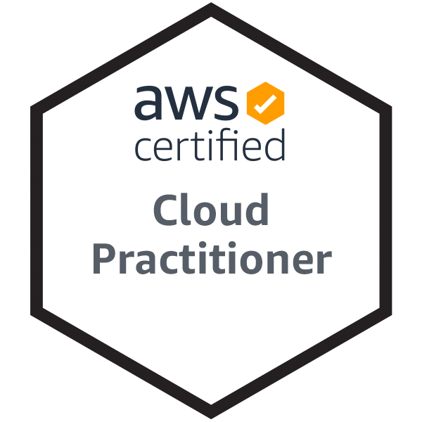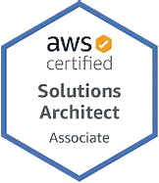  - Business Analyst  Email kiran.gariki@gmail.com  Reach me at 860-374-3979 |  |  |  |  | Hartford, Connecticut
 | EDUCATION |  |  |  | EDUCATION  Completed the Highest Degree Of Education, Masters Of Computer Applications in Computer Science, Math and Statistics
 | Professional experience | Nov 2022 - Mar 2025 |  |  | Business Analyst, CT-WiZ, State Of Connecticut (Dept. Of Public Health)  - Built strong relationships with healthcare providers to drive quality improvement initiatives.  - Collaborated with physician offices to enhance EHR utilization for better care management.  - Led provider consultations and onboarded 50 providers, identifying challenges and implementing strategic solutions.  - Empowered providers with tailored guidance to improve pay-for-performance outcomes.  EHR System Assessment & Optimization  - Evaluated EHR systems, pinpointing barriers to effective quality measure reporting.  - Optimized electronic workflows, ensuring seamless data capture and compliance tracking.  - Implemented targeted interventions to enhance documentation and reporting accuracy.  - Provided hands-on training in EHR navigation and performance analysis.  - Applied problem-solving techniques to streamline provider workflows and reduce inefficiencies.  - Designed and executed DQA strategies, aligning processes with national quality benchmarks.  facilitated process reengineering, ensuring better tracking of key performance indicators.  - Developed best practices for EHR utilization to support continuous quality enhancement.  - Maintained detailed documentation of interventions using SharePoint and CRM tools.  - Generated comprehensive reports, capturing key metrics and progress benchmarks.  - Translated complex data insights into actionable strategies for provider success.  - Leveraged analytics to inform decision-making and improve reporting precision.
 |  | Feb 2022 - Nov 2022 |  |  | Business Analyst, Cognizant, Guidewire Insurance  - Acted as a project liaison, converting business requirements into functional solutions for Auto and Workers’ Compensation lines.  - Participated in Agile development cycles, collaborating with cross-functional teams to implement process improvements.  - Conducted business meetings, analyzed system customizations, and provided actionable insights for UI enhancements.
 |  | Feb 2022 - Mar 2022 |  |  | Business Analyst Training, Pyramid Consulting  - Guidewire Functional BA Development  - E2E Requirements Management, including establishing, planning, eliciting, analyzing  - Basics of Insurance Domain Terminologies  - UI Architecture, Policy Transactions/Policy Jobs  - Configuration Policy Job Lifecycle  - Claim center
 |  | Apr 2016 - Aug 2021  Dec 2014 – Mar 2015  Mar 2007- Feb 2008 |  |  | Personal Projects, Volunteer Experience  - Created multiple web pages using HTML, CSS and JavaScript., Successful completion of course in Code Academy on Web Designing., Launching Amazon EC2 Cloud Instances using AWS., Experience in monitoring and deployment of EC2 instances.  - Vice president of PTO, Rocky Hill Elementary School, 2019-2020, Organizing kick-off activities., Raised donations for the school. English Teacher, eVidyaloka, 2018-2019, Taught English in a government school in India., Designed the syllabus and conducted assessments.  Dev-ops Trainee, Unisys India Pvt. Ltd, Bangalore  - Performed package & deployment integration testing: Analyze, review, and assess application packaging requirements, specifications, and application packages for testability  - Generation of weekly reports and metrics for IT management  - Provides analysis of problems while working toward solutions to technical issues.  - Environment: InstallShield Adminstudio, Rational ClearCase.  Java Developer, TCS Bangalore, India  - Worked as a Java developer for Bank Of America Project.  - Technologies are Java Webservices and IBM Web logic server.
 | Skills & Abilities |  | - Data Analysis & Reporting: Excel, Basic SQL, Google sheets, MS- Access, Health IT EHR Systems, Interoperability  - Project Management & Collaboration: Agile, Scrum and Waterfall  - Data Security & Compliance: HIPAA
 | Accomplishments |  |  |  | - Master’s in Computer Applications, Computer Science  - AWS Certified Cloud Practitioner  - Microsoft Azure Fundamentals Certified  - AIRA Certified in Interoperability & HL7

