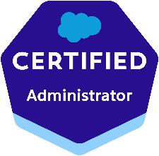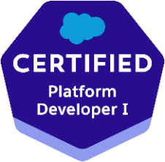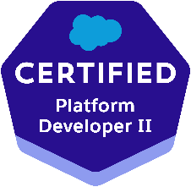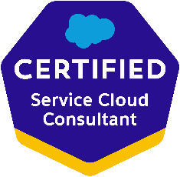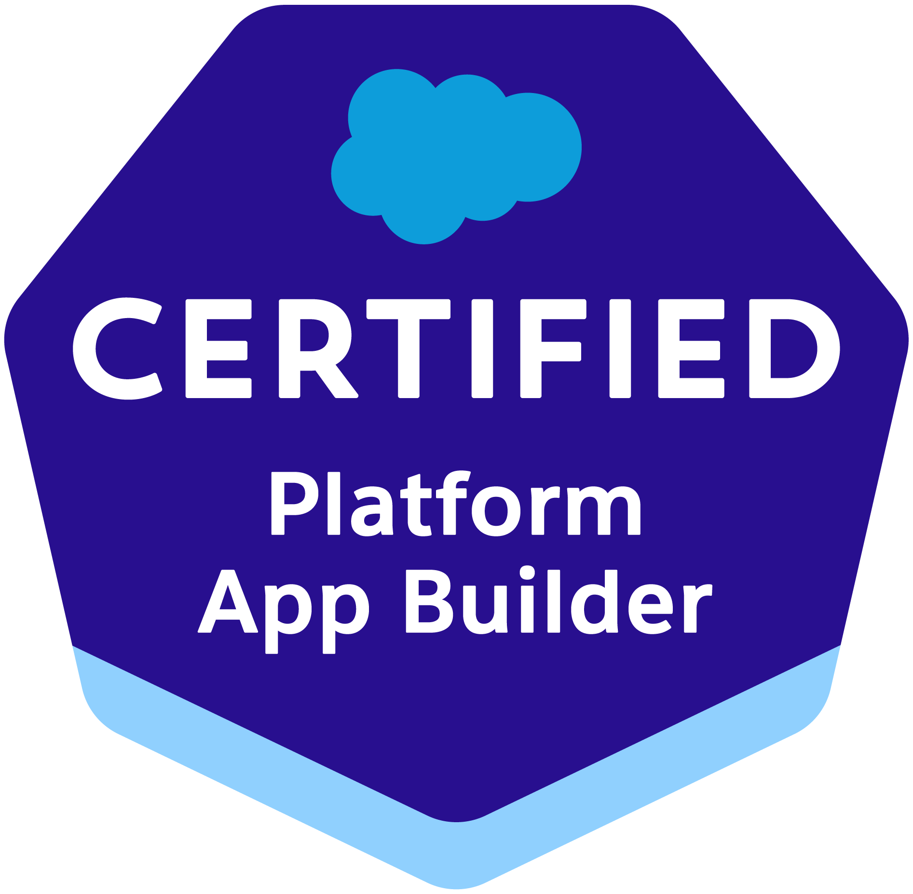

Name : SHODAK PATTURU
LinkedIn : https://www.linkedin.com/in/shodak-patturu-83a654136?utm_source=share&utm_campaign=share_via&utm_content=profile&utm_medium=ios_app
Salesforce Developer
Phone No.: (214)506-8451| patturushodak2610@gmail.com
OBJECTIVE
To obtain a challenging Salesforce Developer position where I can utilize my expertise in configuration, customization, integration, and lightning migration, as well as my strong understanding of Apex, Visualforce, and Lightning Web Components development to drive success and growth for the organization. With 5 years of Salesforce experience and 5 years of JAVA/J2EE experience, I am confident in my ability to design and develop innovative solutions that meet business needs while adhering to best practices and industry standards.

PROFILE SUMMARY
- Experienced in all phases of Software Development Life Cycle (SDLC) and project life cycle processes.
- Highly skilled in Salesforce.com (SFDC) development and implementation.
- Good development experience with Apex Language, Apex Trigger, Apex Scheduler, Batch Apex, Apex Class & Apex Web Services using Partner WSDL & Enterprise WSDL, Visual Force (Page, Component & Controllers) and S-Control.
- Experience in Customization, Administration, Configuration, Implementation, and Support of Salesforce CRM and Salesforce SFA applications based on Apex Language and leveraging Force.com.
- Experienced customizing standard objects Accounts, Contacts, opportunities, Products, Price books, Cases, Leads, Campaigns, Reports and Dashboards.
- Have expertise in Administration and Configuration of Salesforce.com CRM.
- Proficient in security and sharing rules at object, field, and record level for different users at different levels of organization.
- Built Customized Lightning components replacing the existing ones, using JavaScript on the client side and Apex on the server side.
- Enabled Aura Framework, by adding Aura Attributes and Aura Handlers for Events to focus on Logic and Interactions in Lightning Applications.
- Involved in building Lightning Web Components Apps to provide better and more interactive interfaces to end-users, which helps in Sales enhancements.
- Created multiple Lightning Web Components, added CSS and Design Parameters from LDS (Lightning Design System) that makes the Lightning component look and feel better.
- Worked in developing various lightning web components, events and Applications.
- Experience in Force.com Apex Classes, Apex triggers Integration, Visual force and Force.com API. Development using custom lightning web components (Aura and LWC).
- Extensively worked on the lightning web components (LWC).
- Developed multiple number of Lightning web components (LWC) regarding service case console page.
- Worked on advanced JavaScript and HTML elements for developing the LWC components.
- Migrating aura components to Lightning Web Components.
- Developed single lightning page Lightning Web Components using publish-subscribe pattern to communicate between components.
- Created Lightning components of the Case Record Page (Email templates, Case close templates, Compact Views).
- Involved in end-to-end QA and UAT testing and validation of CPQ including Products, Pricing, Quoting etc.
- Experience on Sales cloud, Service cloud.
- Experience in working with Marketing Tools Apttus, DocuSign and Draw loop.
- Have performed page layout customization, page layout assignment based on profiles and created custom links based on user requirement.
- Extensive experience in developing enterprise applications using Java and J2EE technologies such as JSP, Servlets, Tiles, Struts, Spring, XML, XSL, HTML, JavaScript, JDBC and CSS.
- Good Experience on project management tools like JIRA and Rally. Ability to meet deadlines and handle pressure in coordinating multiple tasks in a work/project environment.
- Highly skilled in Salesforce.com (SFDC) development and implementation, with experience in all phases of Software Development Life Cycle (SDLC) and project life cycle processes.
- Experienced in Customization, Administration, Configuration, Implementation, and Support of Salesforce CRM and Salesforce SFA applications based on Apex Language and leveraging Force.com.
- Experienced customizing standard objects Accounts, Contacts, opportunities, Products, Price books, Cases, Leads, Campaigns, Reports, and Dashboards.
- Developed multiple Lightning web components (LWC) regarding service case console page, using advanced JavaScript and HTML elements.
- Extensively worked on the Lightning Web Components (LWC), and also worked on migrating aura components to Lightning Web Components.
- Built Customized Lightning components to replace existing ones, enabled Aura Framework, added Aura Attributes and Aura Handlers for Events, and developed various lightning web components, events, and applications.
- Developed single lightning page Lightning Web Components using publish-subscribe pattern to communicate between components and created Lightning components of the Case Record Page (Email templates, Case close templates, Compact Views).
- Involved in building Lightning Web Components Apps to provide better and more interactive interfaces to end-users, which helps in Sales enhancements.
- Created multiple Lightning Web Components, added CSS and Design Parameters from LDS (Lightning Design System) that makes the Lightning component look and feel better.
- Experience on Sales cloud, Service cloud, and working with Marketing Tools Apttus, DocuSign, and Draw loop.
- Have performed page layout customization, page layout assignment based on profiles, and created custom links based on user requirement.
- Proficient in developing enterprise applications using Java and J2EE technologies such as JSP, Servlets, Tiles, Struts, Spring, XML, XSL, HTML, JavaScript, JDBC, and CSS.
- Experience in working with Agile/Scrum environment, Iterative, Waterfall software development methodologies.
- Good experience on project management tools like JIRA and Rally, with the ability to meet deadlines and handle pressure in coordinating multiple tasks in a work/project environment.

EDUCATION:
- Bachelor’s from JNTU Hyderabad, India.

CERTIFICATIONS:
- Certified Salesforce Platform Developer-I
- Certified Salesforce Platform Developer-II
- Certified Salesforce Sales Cloud
- Certified Salesforce Service Cloud
- Certified Salesforce Administrator
- Certified Salesforce Platform App builders

SKILLS
Salesforce Technologies | Apex Language, Apex Trigger, Apex Scheduler, Batch Apex, Apex Class & Apex Web Service, Partner WSDL & Enterprise WSDL and Visualforce (Page, Component & Controllers)
Custom Integration | Outbound Messages, Workflow & Approvals, Field updates, Reports, Custom Objects ,Custom settings, Custom labels and Tabs, Email Services, Role Hierarchy, Dashboards, Security Controls, AppExchange Package & Custom Application and Sandbox data loading
Force.com tools | Apex Data loader, Force.com Apex Explorer, AJAX tool kit, Force.com Migration Tool, Force.com Excel connector and Force.com Eclipse IDE Plug-in
Programming Languages | Java, C, C++, VB, APEX and UML
Database | MS SQL Server and MySQL
IDE | Eclipse, My Eclipse and Force.com Eclipse IDE plug-in
Tools | MS Visual Source Safe, HTML Dream weaver, Microsoft Project, Sub Version and MS Visio
Platforms | UNIX and Windows (NT/2000/XP/Vista/7)

EXPERIENCE:
LinkedIn, Sunnyvale, CA| Salesforce Lighting Developer | April 2022 - Current
Responsibilities:
- Developed various Visualforce Pages, Apex Triggers to include extra functionality and wrote Apex Classes and Controller to provide functionality to the visual pages.
- Developed Asynchronous process such as Batch Apex and Future methods to handle volume and governor limits.
- Implemented Batch Apex job, scheduling the Batch apex, invoking batch jobs.
- Creating the Batch Apex and Schedule Apex.
- Worked with Integration and web services. Integrated Sales force with legacy systems using Apex Web services and outbound messaging.
- Integrated Salesforce.com with external systems like Oracle and SAP using SOAP API and REST API.
- Undertake development of SFDC reporting tools, systems documentation and technical process flows.
- Designed and developed workflows and Process Builders to automate the business processes.
- Created workflow rules, defined related tasks, email alerts, and field updates.
- Designed, and developed the custom objects, record types, formula fields, validation rules, page layouts, workflow rules, tasks, emails and alerts to track customer related tasks and activities.
- Experience with data migration and updates through App Exchange data loader in Salesforce.com
- Imported data from excel sheets in to Leads, Accounts, Contacts and Opportunities using Data Loader and Import Wizard.
- Involved in the enhancement and development of different LWC components.
- Developed multiple LWC components.
- Experienced in working on LWC Events built on DOM Events, collection of APIs and objects available in browser.
- Defining LWC in creating Maintenance Plans based Service Resource, Service Territory, Timeslot objects.
- Created UI pages as per business requirement using Lightning web components (LWC).
- Designed and developed Visual Force pages with FSL using Lightning web components (LWC) to invoke methods.
- Created and invoked apex methods to read data from custom objects in LWC.
- Customized and used the external Java Scripts in a Lightning web components (LWC).
- Experienced in integration of Salesforce.com with external applications by using Web Services (API, Metadata API, XML, JSON, WSDL, SOAP, and REST).
- TEMP Effectively handled Meta Data Migrations in Salesforce using Sandboxes Worked with Restful web services along with SOAP and WSDL for third party Integrations.
- Implemented Salesforce Development Cycle covering extensively in Sales Cloud, Service Cloud and Call Center.
- Developed a SOAPUI based framework to enable testing of legacy SOAP/REST API implementations and Salesforce Service cloud integration with CI/CD Automation.
- Experience in using Copado for deploying the code from sandbox to production with continuous integration and delivery (CI/CD) technologies1.
- Developing Copado credentials and environment snapshots best practices for streamlining commits, user story credential updates and promotions/deployments2.
- Proficient in designing and building scalable and performant CPQ platform using Copado3.
- Familiar with Copado functionalities such as value stream management, automated testing, security and compliance3
- Created Jenkins pipelines for Deployment in Multiple Environments integrating SFDX docker setup.
- followed scrum methodology for prioritizing work items.
- Successfully implemented Jitterbit as an integration platform for Salesforce projects.
- Designed and developed complex data integrations between Salesforce and various external systems using Jitterbit.
- Successfully implemented DocuSign as an electronic signature solution integrated with Salesforce.
- Designed and developed custom workflows using DocuSign for automating the signature process within Salesforce.
- Successfully implemented Vlocity, a cloud-based industry-specific application built on the Salesforce platform.
- Designed and configured Vlocity data models and business processes to meet industry-specific requirements.
- Experience working with GitHub and JIRA for version management and bug tracking or a Similar system.
- Successfully completed Agile Releases, Iteration, Product backlog, Test Plan, worked with QC Quality Center and created Master Test Strategy

Environment: Service Cloud, Sales Cloud, SalesForce.com Platform, Lightning Web Components, Visual force, Pages, Apex, Visual force, Apex Classes Apex triggers, Batch Apex, Schedule Apex, Copado, Jitterbit, DocuSign, Vlocity SOAP, REST., Jira, Git, Git Hub, Agile.

Adobe, San Francisco, CA | Salesforce Developer | Aug 2020 – Mar 2022
Responsibilities:
- Gathered user and functional system requirements via workshops, interviews and workflow storyboards and working with stakeholders and project teams to prioritize collected requirements.
- Designed, and developed Apex Classes, Controller Classes, extensions and Apex Triggers for various functional needs in the application.
- Strong understanding of Salesforce CPQ capabilities, limitations, and can clearly communicate those to customers.
- Hands-on Experience working across various SFDC implementations that are covering Sales cloud, and CPQ.
- Closely worked with Salesforce.com consultants for implementing business solutions for their client requirements, using Salesforce CPQ within exclusively developed framework.
- Involved in CPQ (Configure, Price& Quote) design, mapped to Salesforce custom objects, and involved in Advanced Workflow Approvals.
- Executed workbench and data loader to verify Product/Pricing staging data in SFDC/CPQ.
- Created integration with Salesforce CPQ and CLM applications and automating processes on Salesforce platform.
- Implemented CPQ technologies such as Salesforce CPQ (formerly Steelbrick), Apttus CPQ, or BigMachines.
- Worked on various AppExchange products according to the needs of the organization.
- Created Email Templates and Mail Merge Templates and was involved in doing the mail merge for different standard and custom objects.
- Run APEX data loader to import/load the data into Salesforce object after these files are successfully transferred.
- Used SOQL & SOSL with consideration to Governor Limits for data manipulation needs of the application using platform database objects.
- Built Salesforce CPQ (SteelBrick) proof of concept to evaluate underlying technology.
- Successfully implemented Copado as the DevOps platform for Salesforce projects.
- Managed end-to-end deployment processes using Copado, ensuring efficient and error-free deployments.
- Configured Jitterbit's connectors to seamlessly integrate Salesforce with other applications, such as ERP or CRM systems.
- Developed Jitterbit integration workflows to automate data synchronization and business processes across systems.
- Integrated DocuSign with Salesforce objects and records to enable seamless document signing and tracking.
- Configured DocuSign templates to streamline the creation and distribution of standardized documents for signature.
- Developed Vlocity industry-specific functionalities, such as quoting, billing, or policy management, within Salesforce.
- Integrated Vlocity with Salesforce Sales Cloud to streamline sales processes and improve customer management.
- Worked on various objects Related to APTTUS Configuration and Pricing management, like: Agreement, Incentive, Price Rule, Price Rule entry, Price Rule Set.
- Developed Custom Validations to override the Salesforce default validation rules.
- Performed large and small-scale Data Migration using Migration Tool and Data Loader.
- Worked on patient’s sensitive data where first imported into Health Cloud, the information required to identify and represent those patients is created.
- Used health cloud to integrate data from Medicare and Medicaid Services.
- Build CPQ Quoting & Product configuration, pricing for Fortinet. Customer has a large family of product with many dependent components and were adding product at individual SKU level.
- As, there were many configurators, build an apex program to load the CPQ configurators. Used the pricing rules to build the discounting logic and reduce the complexity of existing process.
- Created support guides and conducts training for new and current Users on how to use the system in accordance with established business practices.
- Responsible for maintaining different sandboxes (Environments) like Development, QA, and Production Sandboxes.
- Communicating regularly with the SFDC designated super users to support them in their role and provide information and training on new features and functionality.

Environment: Salesforce.com, Apex (Classes, Controllers, Triggers), Visualforce Pages, Aura, Salesforce Force.com, SOSL, SOQL, Health Cloud, Data Migration, Dash Boards, Data Loader, Cast Iron, Copado, Jitterbit, DocuSign, VlocityCustom Objects, Tabs, Accounts, Fields, Leads Emails and Windows.

Boston Scientific, Marlborough, MA. | Salesforce Developer | July 2019 – July 2020
Responsibilities:
- Worked with User Accounts and assigned Profiled as per their role in role hierarchy.
- Defined Organization Wide Default to restrict access from users.
- Customized Page Layouts for Standard/Custom objects and assigned record types.
- Created Data Validations rules and Formulas as per business requirements.
- Worked with various Salesforce.com standard Objects like Accounts, Contacts, Leads, Cases, Campaigns, reports, and Dashboard.
- Co-ordinated the migration of CPQ hierarchical system to salesforce from legacy system using Mover Application
- Worked on Sales Cloud Implementations along with CPQ/CLM functionalities.
- I configured product and pricing setup using CPQ/Product consoles, which include price ramps, Price Matrix, Price Rulesets, price list items, tiered pricing, and asset pricing.
- Designed various Webpages in Visualforce for capturing various customer enquiries and implemented logic for migrating cases to different queues based on the type of customer enquiry.
- Created and used Email templates in HTML and Visualforce.
- Territory management is an account sharing system that grants access to accounts based on the characteristics of the accounts.
- Integrated the Web Services by generating the necessary stubs from the WSDL files for extracting the data from the homegrown applications by using the homegrown web services.
- Used SOQL & SOSL with considerations to Governor Limits for data manipulations needs of the application using platform database objects.
- Executed SOQL queries in workbench and data loader to verify Product/Pricing staging data in SFDC/CPQ.
- Integrated the SOAP/REST API based Web Services on Demand for extracting the data from external systems.
- Responsible for all the activities related to configuring Data Loader, uploading data in CSV files into Salesforce.com, checking for the correctness of the data.
- Worked with Salesforce.com team male application certified.
- Packaged and deployed customizations from Sandbox to other environments using Force.com IDES.
- Help users with Chatter teams/Groups and follow application as well.

Environment: Saleforce.com platform, APEX Language, Market, Visual Force - Pages, Component & Controllers, Salesforce.com Data Loader, Workflow & Approvals, Reports, Custom Objects, Custom Tabs, Email Services, Security Controls, REST API, SOAP API, HTML, Java Script, Java, Sandbox, Eclipse IDE Plug-in, Force.com IDE.

First Republic Bank, San Francisco, CA | Salesforce Administration. | May 2018 – June 2019
Responsibilities:
- Interacted with Business users for analysis, requirements gathering and development.
- Performed detailed analysis of technical and business requirements.
- Worked on different CRM platforms like Veeva, ServiceMax and closely with business partners to realize the full implementation capabilities into Salesforce CRM.
- Experienced in Customization and developing of ServiceMax components SFM (Service Flow Manager), SFW (service Flow Wizard), scheduled SFM and SFM Data validation rules.
- Implemented Veeva app on SFDC platform.
- Worked extensively in customization of Service Cloud Console by embedding Visualforce pages in custom console components, highlight panel and interaction log.
- Worked on Veeva Vault workflows configuration and in Veeva custom objects building including VMOC’s, My setup etc.
- Created user Roles and Profiles, security controls, Territory implementation, shared settings.
- Developed various Apex classes, Apex Triggers, and Controller classes for various needs in the application.
- Developed various Custom Objects, Tabs, Master-Detail, Lookup relationships, Formula fields, validation rules.
- Responsible for setting up Filed Level Security.
- Designed Visual Force pages to add more flexibility and a rich look.
- Configured Sharing settings to specify the level of access the users must each other's data.
- Created Workflow rules and defined email alerts, related tasks, and field updates.
- Implemented Data Loader for loading the data.
- Developed business documents for Salesforce.com Custom objects.

Simple Finance, Portland, OR. | Java Developer | Apr 2016 - April 2018
Responsibilities
- Re-engineered the application with screens in JSP based on Spring framework.
- We followed SCRUM Methodology and having daily SCRUM meeting for progress reporting as well as task distributing.
- Involved in Core Java coding by using Java APIs such as Collections, Multithreading, Exception Handling, Generics, Enumeration, and Java I/O to fulfill the implementation of business logic.
- Responsible for designing the User Interface by coding in HTML5, CSS3, AngularJS, Bootstrap to build this SPA Single Page Application
- Configured the xml files for Hibernate 3 and applied its Object Relational Mapping ORM to enable the data transactions between POJO and Oracle Database using caching on Session Factory as well as caching on query.
- Developed application service components and configured beans using Spring IoC, creation of Hibernate mapping files and generation of database schema.
- Used Spring Inversion of Control and Transaction Management in the GUI for Maintenance Screens.
- Used various libraries of JavaScript like jQuery, react.js, backbone.js, Ember.js Require.js and node.js to develop User Interface of web pages.
- Developed Stored Procedures and triggers for database intensive tasks.
- Used JUnit for Unit testing and Maven for build.
- Configured Jenkins to integrate with SVN and Maven to build and deploy test, stage and prod builds.
- Involved in development of persistence layer using Hibernate ORM framework with spring support.

Macy’s, GA | Java Developer | Feb 2014 - Mar 2016
Responsibilities:
- Designing and coding of Business Classes to be implemented by Remote Interface and Bean class of EJB.
- Implemented MVC architecture and enhanced the design using session Facade and value object patterns for Middle Tier Development
- Developed the Service class for the Various EJB calls to the Middleware.
- Developed the complete hierarchical breadcrumb module using XML.
- Extensively used JSF framework as the Controller to handle subsequent client requests and invoke the Model based upon user requests.
- Written SQL queries, stored procedures, modifications to existing database structure as required using Oracle Database
- Developed the presentation layer and GUI framework in JSP Client-Side validations were done using JavaScript.
- Converted HTML Pages to JSF Pages.
- Involved in developing Classes and Screens using JSF Framework.
- Used Perforce as the version control system on Windows.
- Responsible and active in the analysis, definition, design, implementation, management, and deployment of full software development life-cycle projects

