MERON KAHSAY

62 Lourmel Street | Bridgeport, CT, 06606

www.linkedin.com/in/Meron-Kahsay.

Email: kmeron334@gmail.com. | Phone: (703) 870-1618
H1B

SUMMARY:

- 1 + Year of experience as a Full Stack Java Developer with expertise in Design, Development and Deployment of web based applications in different domains.

- Extensive development experience in web applications using Java8, J2EE, JSP, spring and API's like JDBC, XML, JavaBeans.

- Extensive development experience with open-source frameworks like Hibernate, spring, Spring Boot. Strong experience in MVC architecture and design implementation using JSP.

- Proficient in Web designing & development, using HTML5, CSS3, JavaScript, XML, Angular.js, JSP, JSON, JSF and Ajax.

- Experience in writing ANT, Maven build scripts, providing logging facility using Log4j and Writing Junit test cases.

- Ability to learn and adapt quickly to the emerging new technologies and paradigms.

- Excellent written and verbal communication skills, Analytical, Problem Solving skills, strict attention to detail and ability to work independently, lead/work within a team environment.

TECHNICAL SKILL:

Languages | Java 8, PL/SQL, SQL, Python for Data Analysis and Data Visualization: Numpy,
 | Pandas, Matplotlib, Seaborn, Plotty and Cufflinks.
Java/J2EE Technologies | Core Java, JSP, JMS, Java Beans, Java Multithreading, EJB, Tiles
Web Technologies | HTML5, XML, DOM, JSON, CSS3, JavaScript, AJAX, Angular.js
Web Frameworks | Spring, Spring Boot, Hibernate
Design & GUI Tools | Eclipse, IBM RAD
App servers | IBM Web Sphere, Apache Tomcat, BEA Web Logic
Databases/Tools | Oracle, SQL Server, MySQL
Methodologies | Agile, Waterfall
Operating Systems | Windows, Linux, UNIX
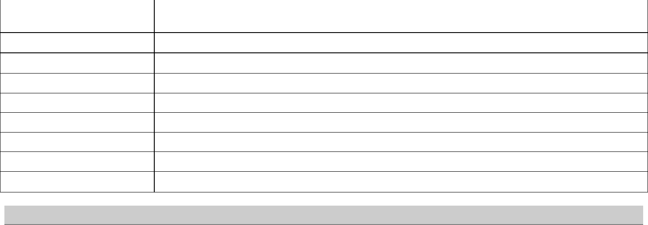

PROFESSIONAL EXPERIENCE:

Client: Rigelsky Inc

Role: Java/J2EE Developer (Intern)

Responsibilities:

April 2021– Present

- Designed and developed UI using Spring MVC, AngularJS, Servlets, JavaScript, Java, CSS, XML and HTML.

- Development, deployment and testing of the Web services using the Apache Axis API. Developed the UI pages using HTML, Java script, AJAX, JQUERY, JSP and tag libraries.

- Designed and developed the REST based Microservices using the Spring Boot.

- Created Test Plan, writing of Systems Test Cases, Unit Test Cases.

- Implemented Log4j API for exception handling, logging of the errors, warnings, messages, stack traces.
- Configured Maven dependencies for application building processes that created Pom.xml files.

- Extensively used Git for version controlling and regularly pushed the code to GitHub.

- debuggers throughout the code.

ENVIRONMENT:

Java, J2EE, JSP, Servlets, Spring MVC, AngularJS, Servlets, JSP, JavaScript, CSS, XML, HTML, Apache, JMS, REST, Oracle, Maven, Log4j, JUnit, GitHub, Windows.

EDUCATION DETAILS:

Bachelor of Arts, Luther College, Decorah, Iowa | Jan. 2022
Major: Data Science

Language: English (proficient), Amharic (native), Chinese (elementary)

Cumulative GPA: 3.2

CERTIFICATION:

- Java Developer Training Course by Tech Tutor ( Feb 2021)

REFERENCES:

- Available upon request

AWARDS AND HONORS:

Martin Luther Award Diversity Scholarship; Luther College Dean’s List; Leadership Award; International Woman Student Award.

