PENTECOST UNIVERSITY
FESAC

Secure Login Authentication System with Two-Factor Authentication and Role-Based Access
Assignment Report

Name: Addo Eric
Student ID: PUIT24210065
Programme: Information Technology
Date: October 2026

Table of Contents
1. Introduction and objectives
2. Technologies used
3. System architecture
4. Database design
5. User identification and registration
6. Two-factor authentication
7. Sessions
8. Role-based authorization
9. Salt and pepper password protection
10. Other protections
11. Deleted accounts, backup and restore points
12. Reports, the database view and the password demonstration
13. Implementation details
14. Testing
15. Limitations and future improvements
16. Conclusion
17. Instructions for running the application

1. Introduction and objectives
Almost every application that stores personal information needs to answer two questions: who is this user? and what are they allowed to do? This project builds a small but realistic authentication system that answers both questions and protects the passwords it stores.
The objectives, taken from the assignment brief, were to implement:
- User identification and registration: users create an account and later prove who they are.
- Two-factor authentication (2FA): a password alone is not enough; a one-time code is also required.
- Role-based authorization: what a user may do depends on a role (admin or student) that the server enforces.
- Salt and pepper: passwords are stored using a salted hash combined with a secret server-side pepper.
The system has a mobile and web interface built with Expo, and a PHP and MySQL backend that runs locally on XAMPP or Laragon. The same code is also deployed online at https://puit24210065.vercel.app, so that it can be tried from a public link.

2. Technologies used
Layer | Technology | Why it was chosen
Interface | Expo, React Native, TypeScript | One code base for Android, iOS and the browser, as required by the brief.
Navigation | Expo Router | File-based routing; the same routes work on phone and web.
Token storage (phone) | Expo SecureStore | Uses the iOS Keychain and Android Keystore.
API | PHP 8.1+ (no framework, no Composer) | Runs on any XAMPP or Laragon installation without extra downloads.
Database | MySQL / MariaDB with PDO | Prepared statements, foreign keys, unique indexes.
Password hashing | password_hash()  /  password_verify()  , Argon2id (bcrypt fallback) | Built into PHP, adaptive and salted.
Email | A small SMTP client written for the project | Sends the one-time code; no external library needed.
Online hosting | Vercel (static site +  vercel-php  functions) | Serves the Expo web build and runs the same PHP API under  /api  , over HTTPS.
Online database | Aiven MySQL 8.4 | Managed MySQL reachable from Vercel, with an encrypted (TLS) connection.
Online email | Gmail SMTP with an App Password | Delivers the one-time codes on the public site.

Development tools: Visual Studio Code, Git and GitHub, and the AI coding assistant Claude Opus 5.5 (Anthropic), which was used to help write the code, tests and documentation.

3. System architecture
Phone (Expo Go) ─┐ ┌─ users ├── HTTPS/JSON ──► PHP REST API ──►├─ otp_challenges (MySQL) Browser (Expo web)┘ (Bearer token public/index.php├─ sessions or HttpOnly └ Kernel └─ rate_limits cookie) └ AuthService
- Client. The Expo app has three signed-out screens (sign in, register, verify code) and three signed-in screens (dashboard, profile, administration). A route guard sends signed-out users to the sign-in screen, but this is only for convenience; the real checks are made by the server.
- API.public/index.php is the only entry point. The Kernel class handles routing, CORS, CSRF checks, session lookup and role checks, and returns response objects, which makes the whole API testable without a web server. AuthService contains the business logic (registration, password check, one-time code, sessions), AdminService the administrator features (deleting accounts, backup, restore points, reports, database view, password demo) and AuditLog the event log. Other small classes handle passwords, tokens, rate limiting, validation and email.
- Database. All access uses PDO prepared statements. Timestamps are generated by the application in UTC so behaviour does not depend on the database server's time zone.
- Configuration. Secrets (pepper, database password, SMTP password) live only in backend/.env on the server. The server refuses to start if the configuration is unsafe, for example if the pepper is missing, CORS is a wildcard, or the development one-time-code mode is enabled in production.
- Online version. On Vercel, api/index.php simply includes backend/public/index.php, so the public site runs the same PHP code. The website and the API share one domain, so the session cookie stays first-party. Settings come from Vercel's encrypted environment variables instead of .env, the database is Aiven MySQL (TLS verified against Aiven's CA certificate), and codes are emailed through Gmail.

4. Database design
Table | Purpose | Important columns and constraints
users | One row per account | email  (unique),  password_hash  ,  role  (  ENUM('student','admin')  , default  student  ),  created_at  ,  last_login_at  ,  deleted_at  (set when an admin deletes the account)
otp_challenges | A pending or used second-factor challenge | challenge_hash  (unique),  otp_hash  ,  attempts  ,  expires_at  ,  used_at  ; foreign key to  users  with  ON DELETE CASCADE
sessions | Login sessions | token_hash  (unique),  expires_at  ,  revoked_at  ; foreign key to  users
rate_limits | Counters for abuse prevention | bucket  (primary key, a hash),  hits  ,  window_start
auth_events | Log of security events for the reports | event  ,  user_id  (foreign key,  ON DELETE SET NULL  ),  ip  ,  detail  ,  created_at
restore_points | Saved configurations | label  ,  created_by  ,  created_at  ,  user_count  ,  config  (each account's role and deleted status, as JSON)

Design decisions:
- The email column is unique, so the database itself rejects duplicates even if two requests race.
- Neither the one-time code, the challenge identifier, nor the session token is stored in readable form. Only hashes are stored (see sections 6 and 7).
- Indexes exist on foreign keys and on expiry columns, which are used when looking up sessions and cleaning old rows.
- Deleted accounts are not erased: deleted_at marks them, so the data stays in the database and can be restored.
- The complete script is backend/database/schema.sql. An existing database from the first version is upgraded with backend/database/migrations/002_student_role_backup_reports.sql (renames the role user to student, adds deleted_at and the two new tables).

5. User identification and registration
Registration (POST /api/register). The client validates the form first (name length, email format, password rules, matching confirmation) to give instant feedback. The server then validates the same rules again, because client checks can be bypassed. The password must be 12 to 128 characters long, contain at least one letter and one digit, must not be a very common password, and must not equal the email address. The email is converted to lower case; if an account with that email already exists the server answers 409. The role of a new account is always student; the request body cannot choose a role.
Sign-in, step 1 (POST /api/login). The server looks up the account by email and verifies the password. For an unknown email it still performs a hashing operation, so that response time does not reveal whether an account exists. A wrong password and an unknown email produce exactly the same response (401, "Invalid email or password."). At this point the user is not signed in: no session exists until the second factor is verified.

6. Two-factor authentication
After a correct password the server:
- generates a six-digit code with random_int(), PHP's cryptographically secure generator;
- creates a random 256-bit challenge identifier and returns it to the app;
- stores only a keyed hash of the code (HMAC-SHA256, keyed with a secret derived from the pepper) and a hash of the challenge identifier;
- delivers the code by email through the SMTP server configured in .env.
Sign-in, step 2 (POST /api/verify-otp). The app sends the challenge identifier and the code. The server enforces:
- Expiry: a code is valid for five minutes.
- Attempt limit: five wrong guesses lock the code. The attempt counter is increased with a single atomic SQL statement before the comparison, so parallel requests cannot gain extra guesses.
- Single use: the code is marked as used with UPDATE ... WHERE used_at IS NULL; only the request that changes the row succeeds, so a code cannot be replayed.
- Replacement: asking for a new code, or signing in again, invalidates the previous code.
- Account-level limit: wrong guesses are also counted per account across challenges, so repeatedly starting a new sign-in does not reset the guess budget.
Development mode. To demonstrate the system without an email server, OTP_DELIVERY=dev makes the API return the code in its response, and the app shows it in a clearly labelled "Development mode" box. The server refuses to start with this setting when APP_ENV=production, so the code can never be exposed by a production deployment. The setting is off unless it is written into .env.

7. Sessions
When the code is correct the server creates a random 256-bit session token and stores its SHA-256 hash, together with an expiry time (8 hours by default). If the database were leaked, the stored values could not be used as sessions.
- Native app: the token is returned once and kept in Expo SecureStore (Keychain / Keystore). It is sent as a Bearer header.
- Web: the token is never given to JavaScript. It is sent as an HttpOnly cookie (Secure when configured, with SameSite). localStorage is deliberately not used, because any script on the page could read it. Because browsers attach cookies automatically, the server also protects cookie-based state-changing requests against cross-site request forgery: logout requires an allowed Origin header and a custom X-Client-Type header.
- Logout sets revoked_at in the database, so the token stops working immediately, even if someone copied it.

8. Role-based authorization
There are two roles, student and admin. For every protected request the server finds the session, loads the user from the database and checks the role. The interface hides the administrator menu (Users, Backup, Reports, Database, Password demo) from students, but that is only for usability: every admin endpoint (/api/admin/...) returns 403 Forbidden to a student and 401 to a visitor without a session, whatever the client code or request contains. Changing a role in the database takes effect on the next request.
Public registration cannot create administrators. The first administrator is created on the server by registering normally and then running php bin/set-role.php you@example.com admin; only someone with access to the server can do this. Alternatively, the server setting ADMIN_EMAILS lists administrator email addresses. A listed account is promoted only after a successful login with both the password and the emailed code, which proves the person controls that inbox. The name a user types and the act of registering never grant the admin role. The online version uses this setting.

9. Salt and pepper password protection
- Salt.password_hash() generates a unique random salt for every password and stores it inside the hash string. Two users with the same password therefore get different hashes, and precomputed (rainbow) tables are useless.
- Pepper. A secret value, at least 32 characters, is kept in the server configuration, never in the database or the app. Before hashing, the password is passed through HMAC-SHA256 keyed with the pepper, and the result is given to password_hash(). An attacker who steals only the database cannot even start guessing passwords offline without the pepper. This pre-hashing step also avoids bcrypt's 72-byte limit.
- Algorithm. Argon2id is used when PHP supports it, otherwise bcrypt with cost 12. password_needs_rehash() upgrades old hashes at the next successful login.
- Plaintext passwords are never stored, logged or returned by the API.
The cost of the pepper is that it cannot be rotated without forcing password resets, because it is part of every hash. This is listed under limitations.

10. Other protections
- Rate limiting (stored in MySQL): 8 failed sign-ins per email and 30 requests per IP per 15 minutes; 30 code attempts per IP; at most 10 registrations per hour per IP; a 30-second cooldown between code requests. Responses are 429 with a Retry-After header.
- Prepared statements everywhere, so input cannot change the meaning of a query.
- CORS allows only the exact origins listed in .env, never *, because cookies are involved.
- Safe errors. Authentication failures are generic. Unexpected errors return a generic message while details go to the server log. Misconfiguration returns 500/503 without naming settings or values.
- Response headers: Cache-Control: no-store, X-Content-Type-Options, a restrictive Content-Security-Policy, and Strict-Transport-Security in production.

11. Deleted accounts, backup and restore points
Deleting an account. On the Users page an administrator can delete an account. The row is not removed: the server sets deleted_at, and the account is then shown as deleted (struck through) in the list and counted separately. A deleted account cannot log in (it gets the same "Invalid email or password." message as anyone else), its open sessions are ended at once and any pending code is cancelled. As a second line of defence, the session check itself also refuses any account marked as deleted. An administrator cannot delete their own account. A deleted account can be restored with the same data and password.
Full database backup. On the Backup page an administrator downloads the whole database as one SQL file (GET /api/admin/backup): for each of the six tables it contains DROP TABLE, CREATE TABLE and INSERT statements with every row. Restoring is done by importing the file into MySQL (phpMyAdmin → Import, or the mysql command), which replaces all current data with the data in the backup. Password hashes are included, so restored accounts keep their passwords; plain passwords are never in it, and neither is the pepper, because the pepper is not stored in the database. Only administrators can download a backup, and every download is logged.
Restore points. A restore point is different from a backup: it saves only the configuration, that is, each account's role and whether it is deleted. Applying a restore point puts that configuration back and changes nothing else: names, emails and password hashes stay as they are, and accounts created after the restore point are left alone. This lets an administrator undo, for example, a wrong role change or a mistaken deletion without touching any data. To avoid locking themselves out, the server refuses to apply a restore point that would remove the administrator's own admin access. Sessions of accounts that the restore point marks as deleted are ended.

12. Reports, the database view and the password demonstration
Event log and reports. The server records security events in the auth_events table: registrations, correct passwords, failed logins (an unknown email is stored masked, for example n***@example.com), wrong codes, successful logins, logouts and every administrator action (delete, restore, backup, restore points). Passwords and codes are never written to the log. The Reports page shows the number of accounts by role and status, active sessions, the number of restore points and the time of the last backup; successful logins per day for the last seven days; the count of each event type; and the 25 most recent events with time, account, detail and IP address. In the browser the page can be printed or saved as PDF.
Password demonstration. To show salt and pepper working, the Password demo page (administrators only) takes any sample password and shows each step: the password combined with the pepper using HMAC-SHA256 (only a shortened result is shown and the pepper itself never leaves the server); the random salt; the final Argon2id hash; a second hash of the same password with a different salt and therefore a different result; and three checks with password_verify(): the correct password is accepted, a wrong password is rejected, and the correct password without the pepper is rejected. Nothing typed on this page is saved or logged.
Database view. So that everything can be shown from the administrator portal, the Database page (administrators only) shows all six tables exactly as they are stored, with the number of rows in each and the newest 50 rows. It makes the security visible: the password_hash column holds only Argon2id hashes (with the salt inside), the pepper appears nowhere, sessions holds only SHA-256 hashes of tokens, otp_challenges only HMACs of the codes, and a deleted account is simply a row with a deleted_at time. The page is read-only; changes are made on the Users and Backup pages (Figure 17).

13. Implementation details
Area | Where
Entry point and routing, CORS, CSRF, role guard | backend/src/Http/Kernel.php  ,  backend/public/index.php
Registration, login, OTP, sessions | backend/src/Services/AuthService.php
Deleting accounts, backup, restore points, reports, database view, password demo | backend/src/Services/AdminService.php
Event log | backend/src/Services/AuditLog.php
Salt and pepper | backend/src/Security/Passwords.php
Secure random values | backend/src/Security/Tokens.php
Rate limiting | backend/src/Security/RateLimiter.php
Email (SMTP) and development delivery | backend/src/Mail/
Validation | backend/src/Validation/Validator.php  ,  mobile/src/lib/validation.ts
Configuration safety checks | backend/src/Config.php
Database schema and upgrade | backend/database/schema.sql  ,  backend/database/migrations/
Command-line tools | backend/bin/setup-db.php  ,  set-role.php  ,  generate-secret.php
App screens | mobile/app/
API client, session state, secure storage | mobile/src/lib/api.ts  ,  auth.tsx  ,  storage.ts

The interface is deliberately simple: a header bar with the application name and (when logged in) the menu links Dashboard, Profile and Logout, plus Users, Backup, Reports, Database and Password demo for administrators, with the page content below it. Forms are a single column with a maximum width, so the same layout works on a phone and in a desktop browser. The admin user list is a plain table that scrolls sideways on narrow screens. Forms show a loading state on the button, field-level errors and readable messages.

14. Testing

14.1 Automated backend tests (PHP)
backend/tests/run.php contains 75 tests that call the API kernel directly against a separate test database (login_auth_test). They cover every item required by the brief:
Requirement | Test file
Registration succeeds; duplicates (including different letter case) are rejected; validation; SQL-injection input | registration.php
Passwords are stored as salted, peppered hashes (plaintext absent, wrong pepper fails, same password gives different hashes) | registration.php
Correct and incorrect password; identical generic errors for unknown email | login_and_otp.php
OTP success, wrong code, attempt limit, expiry (exactly 300 s), reuse, replacement, resend, delivery failure; hashes only in the database | login_and_otp.php
Session creation, invalid and expired sessions, logout and revocation, web cookie flow and CSRF checks | login_and_otp.php
Admin can list users; normal user gets 403; anonymous gets 401; role comes from the database; no hashes in output | authorization.php
CORS (allowed origin, rejected origin, never  *  ), 404/405/400/413/415, security headers, rate limits (account, IP, registration, OTP guessing) | http_and_abuse.php
Configuration errors handled safely (missing/short/placeholder pepper, dev OTP in production, wildcard CORS, insecure cookies, bad SMTP, database down) and no dev OTP in production responses | configuration.php
Every admin endpoint refuses students (403) and visitors (401); deleting marks the account, ends its sessions and blocks login; restoring; no self-delete; CSRF headers on cookie actions; restore points change only roles and deleted status; full backup contents; reports counts; database view (all six tables, hashes only, no password or pepper); password demo (different salts, pepper never shown, nothing saved) | admin_tools.php

How the tests were run. On the development computer, Windows Smart App Control blocked php.exe, and no MySQL server could be started. The suite was therefore run with tools/wasm-runner (npm test): PHP 8.3 compiled to WebAssembly, running inside Node.js, with an in-memory SQLite database instead of MySQL. A small translation layer (tools/wasm-runner/compat.php) rewrites the few MySQL-only statements (ON DUPLICATE KEY UPDATE, TRUNCATE, SET FOREIGN_KEY_CHECKS, one DATE_ADD in a test). The application code itself is not changed. Because this PHP build has no Argon2 support, the bcrypt fallback was the algorithm exercised.
Result:
75 passed, 0 failed (1084 assertions)
To check that the tests really detect faults, three bugs were deliberately introduced in a copy of the code, one at a time. Each was caught: removing the admin role check failed 2 authorization tests; making codes valid for 99,999 seconds failed the five-minute expiry test; and no longer marking codes as used failed 4 OTP tests (including "a code can be used only once"). The same was done for the new features: letting deleted accounts keep their sessions, letting a restore point change names, removing the CSRF check on admin actions and showing the full peppered value in the demo were each caught by the new tests. (The first of these was at first not caught, because deleting an account also ends its sessions; a test that marks an account as deleted directly in the database was added, and it now fails as it should.)
Not yet verified against MySQL. The MySQL schema (database/schema.sql), the MySQL form of the rate-limit query and the duplicate-key error code (1062) were not exercised by this run. The schema and the rate-limit query were later used on the online MySQL database (section 14.4), but the test suite itself has not run against MySQL. On a computer where XAMPP or Laragon works, run:
cd backend php tests/run.php
and add the output here:
(paste the output of php tests/run.php here, including the final "N passed, M failed" line)

14.2 Client checks that were actually run
Check | Command | Result
TypeScript type check (strict mode) | npm run typecheck  in  mobile/ | Completed with no errors
Client validation unit tests | npm test  in  mobile/ | 6 tests, 6 passed, 0 failed
Production web build | npx expo export --platform web | Succeeded; output in  mobile/dist  (one JavaScript bundle, about 1.1 MB, and  index.html  )
Secrets in build output | search of the built JavaScript for  DB_PASS  ,  APP_PEPPER  ,  SMTP_PASS | None found

14.3 End-to-end tests over HTTP and in a browser
The unit tests above call the API classes directly, so they skip the code that reads real HTTP requests and writes real responses (headers, cookies, public/index.php). Two further checks covered that path, using the real PHP API served by tools/wasm-runner (npm run api), again with SQLite instead of MySQL:
- HTTP checks (26 passed, 0 failed): register, duplicate and invalid registration, wrong password, login with code, wrong code with attempts remaining, correct code, code reuse refused, bearer-token session, normal user refused on the admin route (403), anonymous refused (401), logout and revocation, CORS for allowed and unknown origins, a browser sign-in from a disallowed origin refused, the HttpOnly; SameSite=Lax session cookie, promotion with the real bin/set-role.php, the admin user list without password hashes, and cookie logout refused without the CSRF headers.
- Browser test (74 passed, 0 failed): the web build was opened in a headless Edge browser and driven through a script in three sessions (desktop student, phone-sized administrator, desktop administrator) against the real PHP API. Besides the login checks below, it deletes and restores an account on the Users page, downloads a full backup, saves and applies a restore point, opens the Reports and Database pages, runs the Password demo, and confirms that a student is refused (403) on the Users, Backup, Reports, Database and Password demo pages.
While these were being set up, a database-locking error appeared. It was caused by the test environment (SQLite file locks on a mounted Windows folder), not by the application, and was fixed in the runner. Some early runs also failed one step each because the script checked the page before the server had finished hashing the password; the script was changed to wait for each result. No bugs were found in the PHP application code.
Earlier, before the backend could be run, the same browser script was used against a small mock API to develop the interface. The browser checks were: redirect to sign-in when signed out; empty and weak inputs rejected on the client; registration; generic error for a wrong password; moving to the code screen; wrong then correct code; dashboard and role display; session survives a reload through the cookie; no token in localStorage or sessionStorage; the session cookie is not readable from JavaScript; profile page; the administration page listing users for an administrator and showing "Access denied (403)" for a normal user; sign-out and redirect. Two bugs found by this process (a confusing error when the API address was wrong, and a spurious "session ended" message at start-up) were fixed.

14.4 Tests of the online version (real MySQL and real email)
The deployed site at https://puit24210065.vercel.app was tested on 11 October 2026.
- Database setup:backend/database/schema.sql was run unchanged on Aiven MySQL 8.4.11 over a verified TLS connection and created the four tables. This is the first run of the project against real MySQL.
- Automated live checks (17 passed, 0 failed): health check reaching the database; Strict-Transport-Security and no-store headers; registration (a new account gets the lowest role); duplicate email in different letter case refused (409); invalid input refused (422); wrong password refused with the generic message (this also exercises the MySQL form of the rate-limit query); correct password sends the code by email, and the response does not contain the code; masked email hint; a wrong code is refused with 4 attempts left; no session without the code (401); the admin route refused without a session (401); CORS allows only the site's own origin; finishing a sign-in from another origin is refused (403).
- Manual check: an account was registered on the public site with a personal Gmail address, the emailed code arrived and was entered, and the account was signed in. That account was then made an administrator directly in the database (the online equivalent of bin/set-role.php).
- Second round (18 October 2026), after adding the administrator features: before upgrading, a copy of all live data was saved; then the upgrade script 002_student_role_backup_reports.sql was applied to the live database and the new version was deployed. The 17 live checks passed again. A temporary administrator account was then used for 12 more live checks, all passed: the emailed code was accepted; the user list showed the Argon2id preview; a restore point was saved; a test account was deleted and could no longer log in; applying the restore point brought it back (configuration only); a full backup was downloaded; the reports counted these actions; the password demo used Argon2id, gave two different salts and refused the password without the pepper; and the restored account could log in again. Finally the backup file was imported into a separate, empty MySQL database, and every table had exactly the same number of rows as the original, which shows the backup can really be restored. The temporary accounts were removed afterwards.
- Problem found and fixed: the first live run failed to send email (SMTP error 535, "username and password not accepted") because the App Password had been created in a different Google account from the sender address. The application handled it safely: it answered 503 and kept no code. Using the matching account fixed it.

14.5 Screenshots
Figures 1–10 and 13–17 were captured from the web version of the app running against the real PHP API on the local computer (tools/wasm-runner, development mode, so the code is shown on screen instead of being emailed; that PHP build has no Argon2, so Figure 16 shows bcrypt). Figures 11 and 12 are from the online MySQL database.
Figure 1. Login screen.
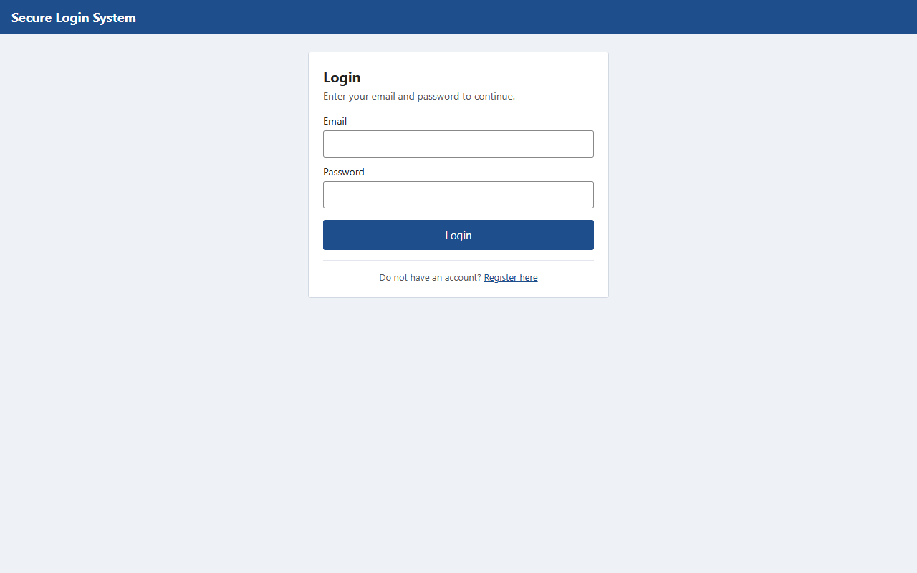
Figure 2. Registration with client-side validation errors.
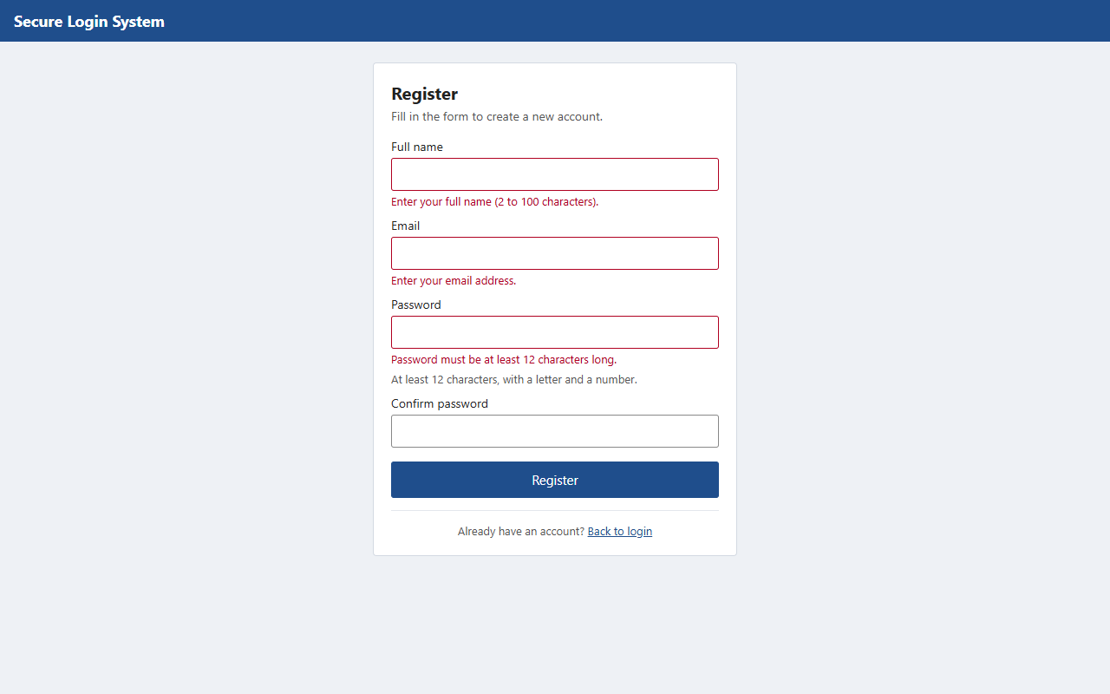
Figure 3. After a successful registration the user is returned to the login screen with a message.
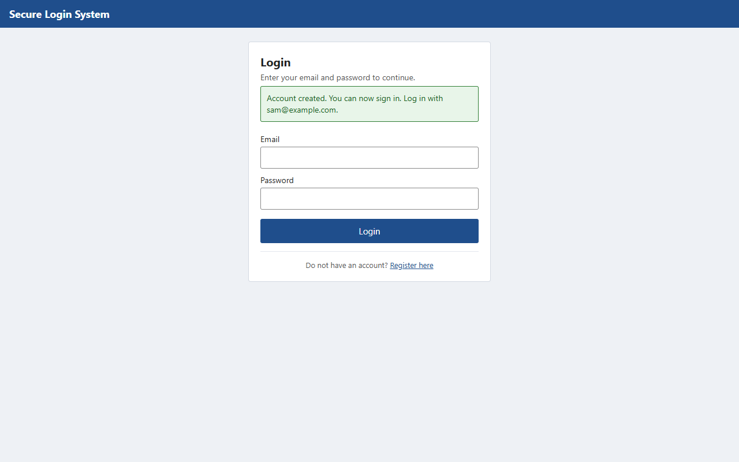
Figure 4. Two-factor step after the correct password. In development mode the code is shown in the yellow box; online it is emailed.
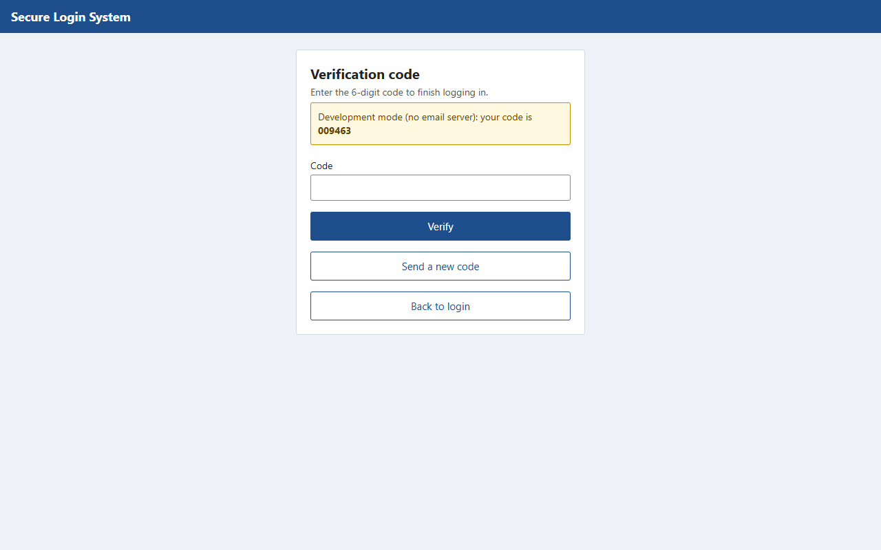
Figure 5. A wrong code is refused (the server also counts the attempt).
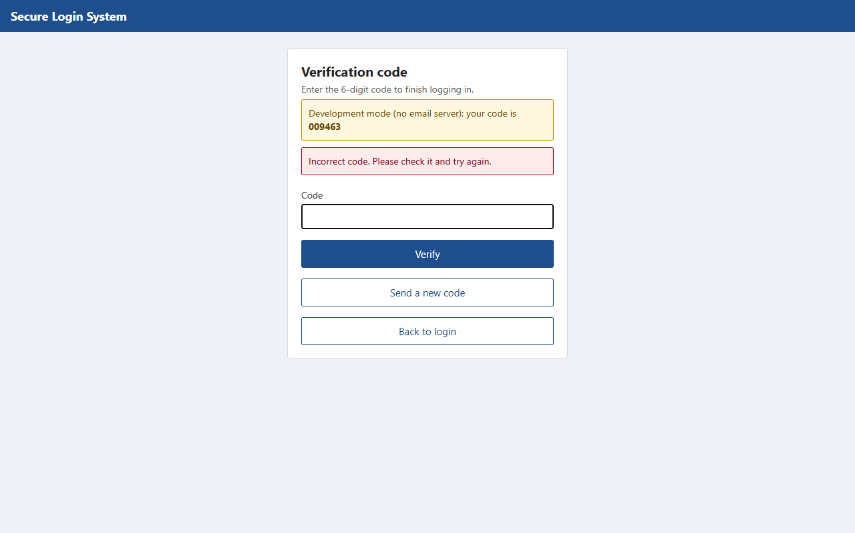
Figure 6. Dashboard of a standard user after password + code.
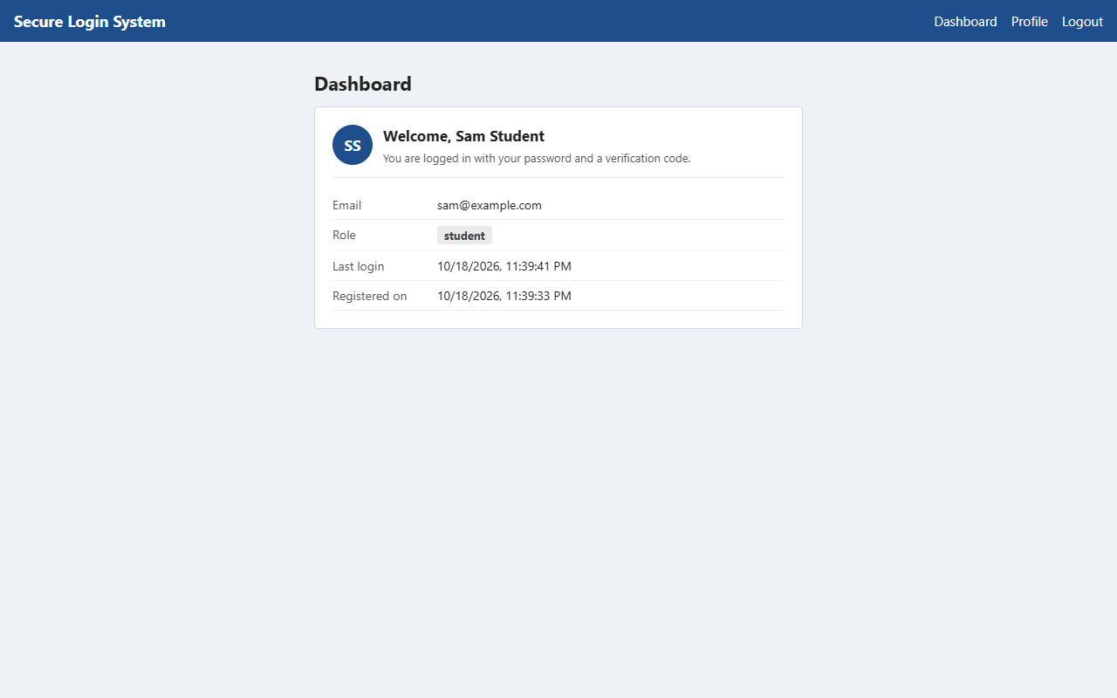
Figure 7. Profile page showing the role.
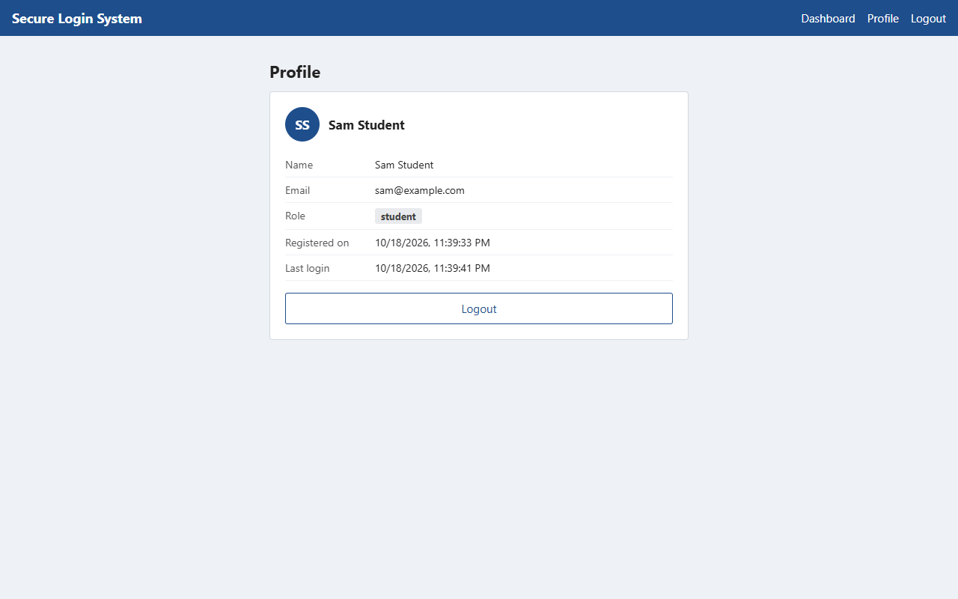
Figure 8. A standard user who opens the admin page by typing its address is refused by the server (403).
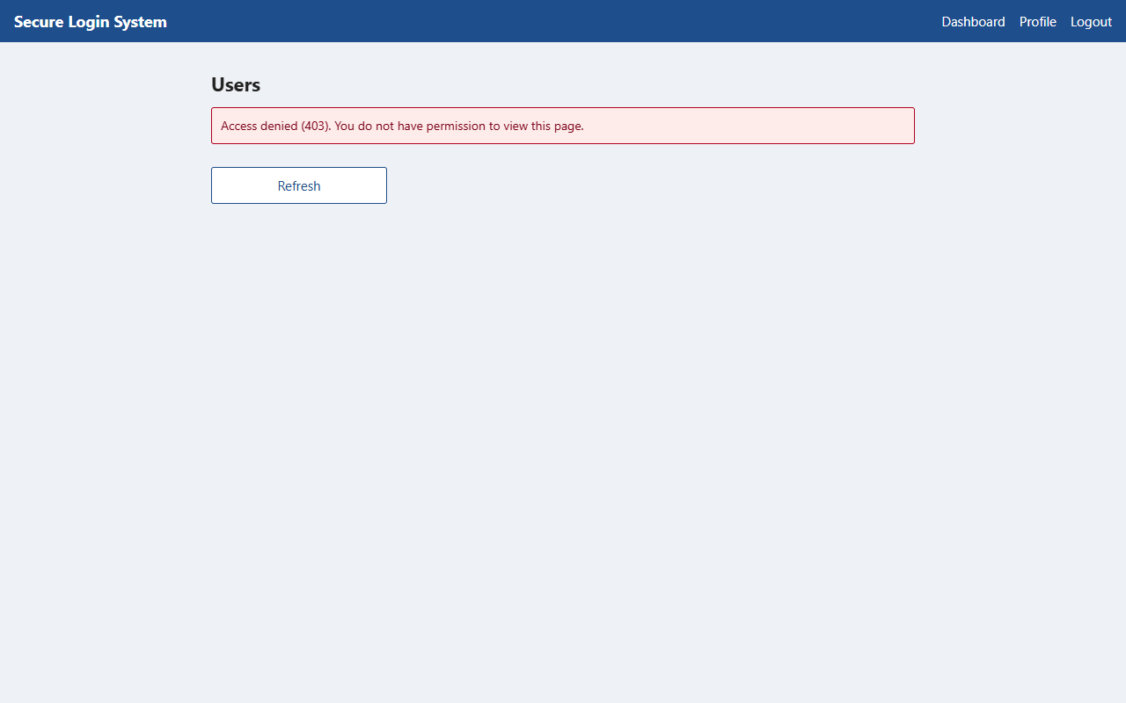
Figure 9. The Users page for an administrator. Only a shortened preview of each stored hash is sent.
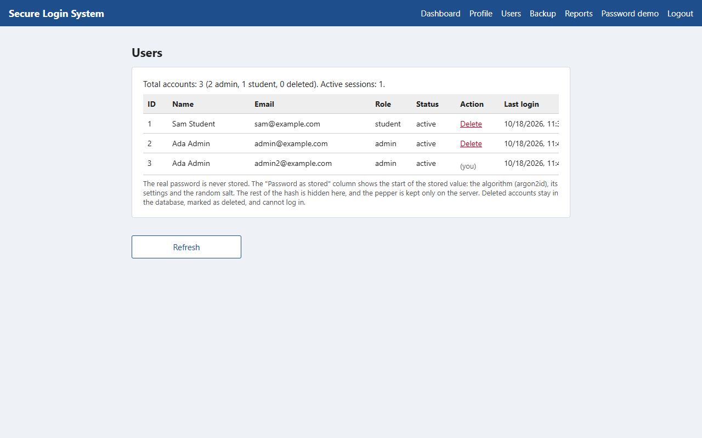
Figure 10. The dashboard at phone width.
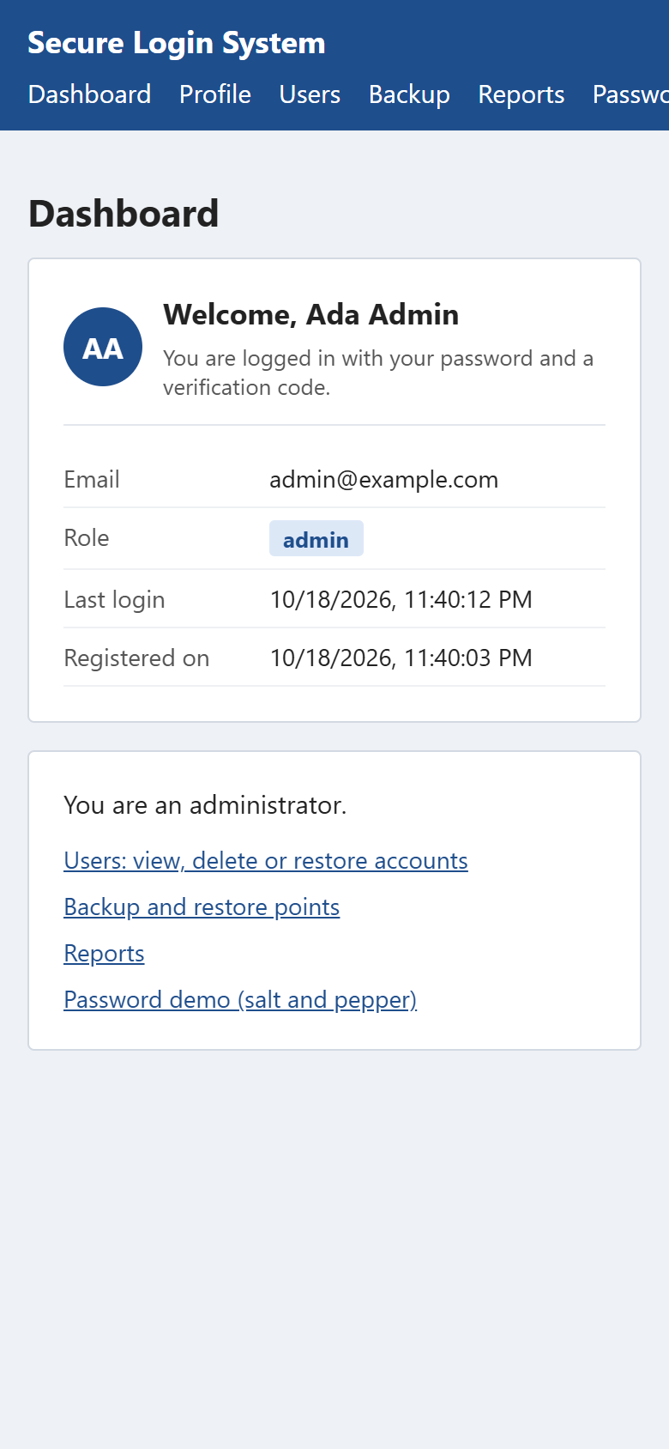
Figure 11. The users table in the online MySQL database. The password column contains only the Argon2id hash produced by password_hash(); the salt is inside the hash and the pepper is not stored.
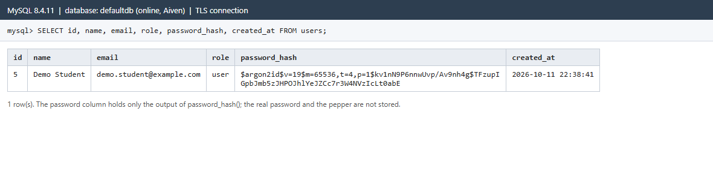
Figure 12. The live database: all six tables, with passwords, session tokens and codes stored only as hashes.
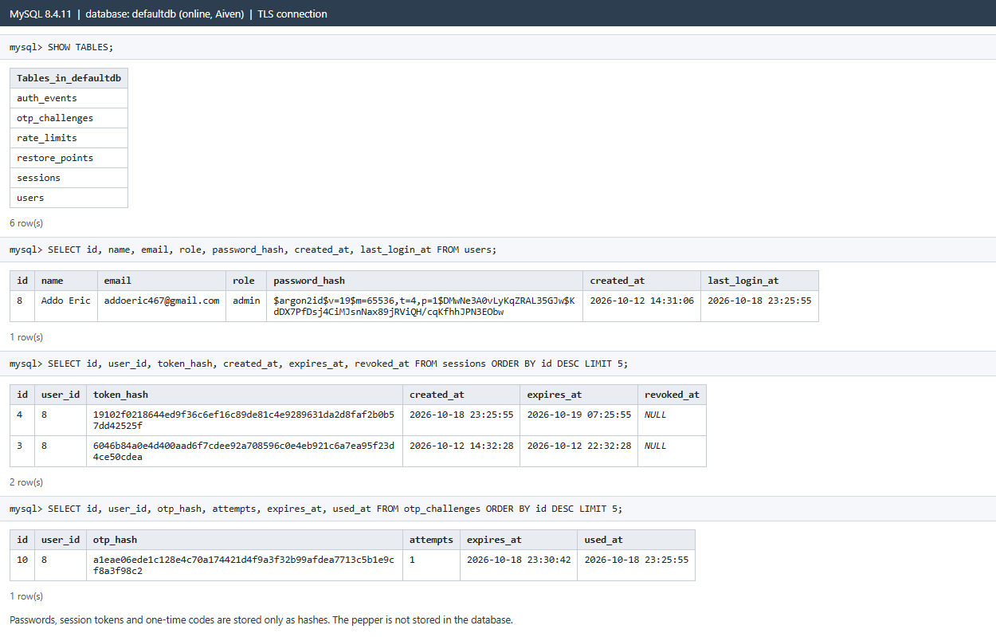
Figure 13. An account marked as deleted: it stays in the list (struck through) and can be restored.
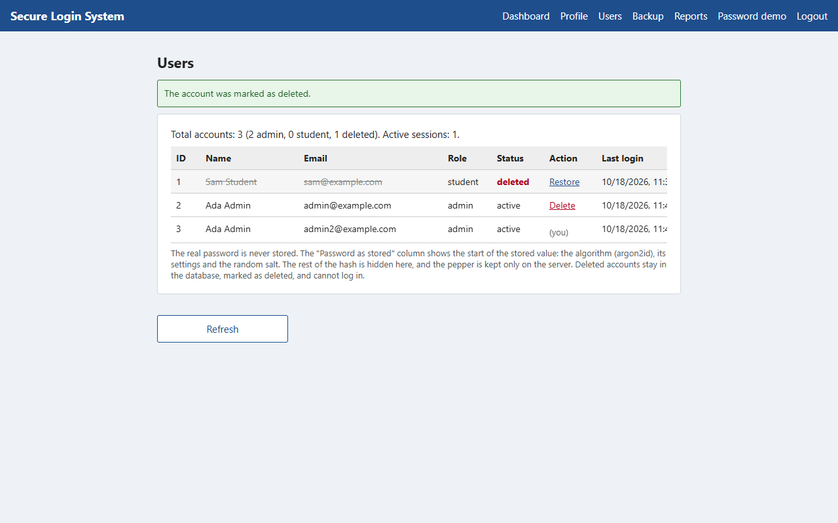
Figure 14. Backup page: full database backup (download) and restore points (configuration only).
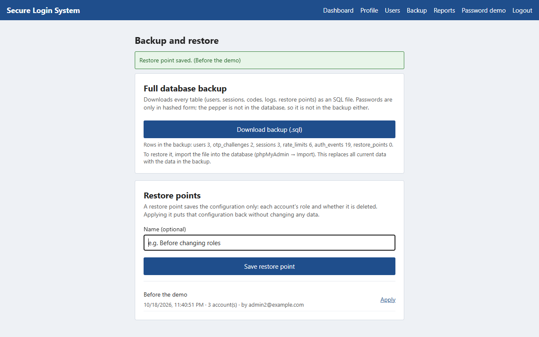
Figure 15. Reports page: accounts and successful logins per day.
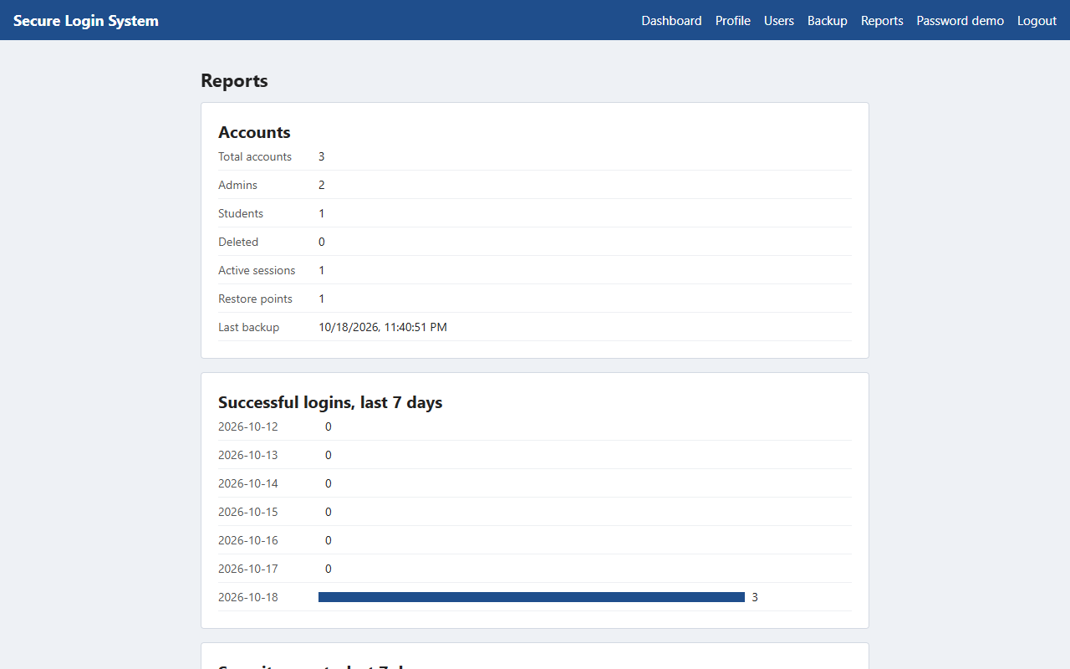
Figure 16. Password demo: the pepper step, two different salts and hashes for the same password.
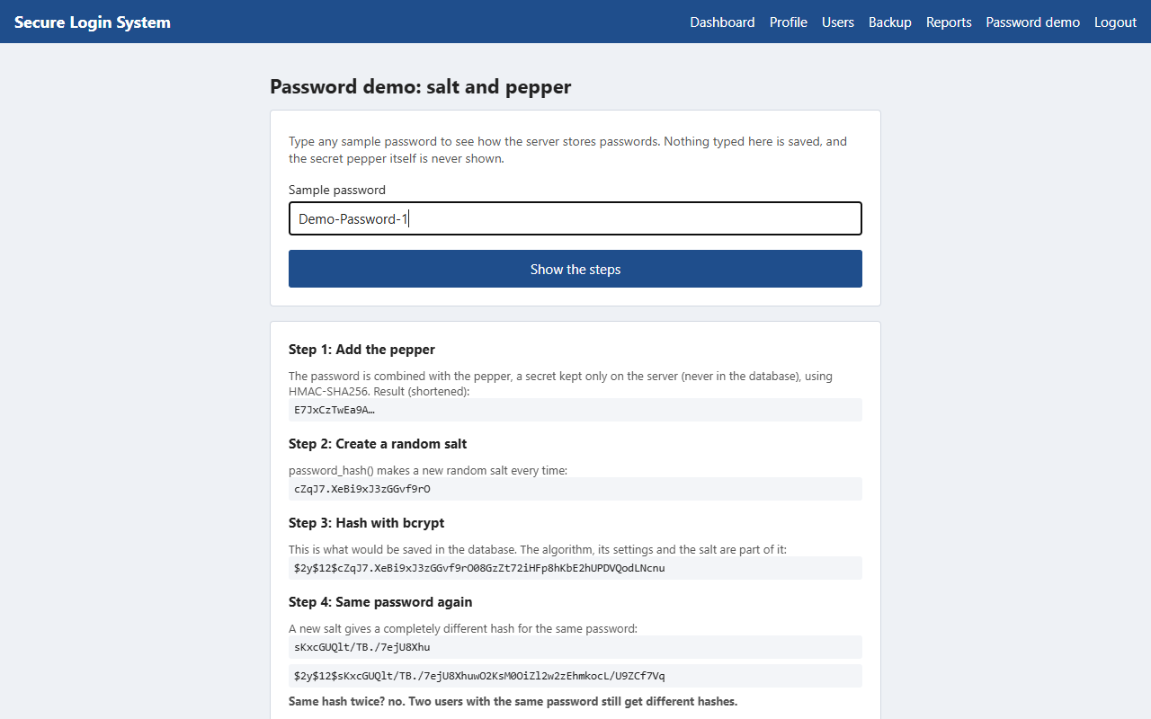
Figure 17. Database page: every table as stored; passwords appear only as hashes.
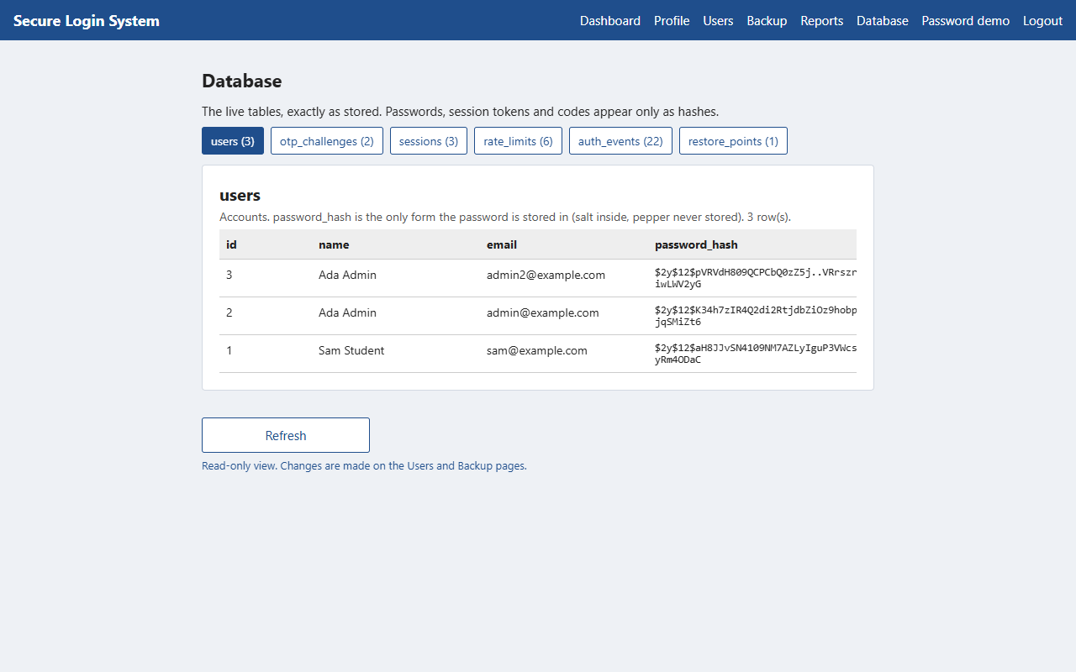
Still to add from a local XAMPP or Laragon run: the terminal output of php tests/run.php, and the app running in Expo Go on a phone.

15. Limitations and future improvements
- The backend tests were run with PHP in WebAssembly against SQLite, not yet against MySQL (section 14.1).
- The pepper is a single secret; rotating it would require a re-hash migration (for example storing a pepper version with each hash) or forced password resets.
- Account lockout is per email, so an attacker can temporarily lock a victim's login by sending wrong passwords. A CAPTCHA or progressive delays would reduce this.
- Registration reveals whether an email is already registered (needed for a clear error message). Email verification would avoid this.
- No password reset, email verification or "remember this device" feature; sessions are fixed-length.
- Roles are changed only from the command line or the ADMIN_EMAILS setting; there is no page for changing roles.
- Restoring a full backup is done in phpMyAdmin or with the mysql command, not from the app, and it replaces all data. Restore points cover only roles and deleted status.
- The event log keeps growing; old entries are not yet archived or deleted automatically.
- The second factor is an emailed code, which is only as secure as the mailbox. Authenticator apps (TOTP) or WebAuthn passkeys are stronger.
- Rate limits are stored in MySQL and keyed by IP address, which can be inaccurate behind shared networks or proxies.
- The online version depends on three free or trial services (Vercel, Aiven, Gmail). Gmail limits sending to about 500 emails a day, codes can land in spam folders, and the first request after a quiet period can be slow while Vercel starts the PHP function.

16. Conclusion
The project implements the four required elements: users are identified through validated registration and a password check; a second factor (a single-use, expiring, attempt-limited one-time code) is required before a session is created; authorization depends on a role that the server reads from the database on every protected request; and passwords are protected with a per-password salt plus a server-side pepper. Sessions are random, stored only as hashes, expire and can be revoked, and the web version avoids storing tokens where scripts can read them. Administrators can also mark accounts as deleted without losing their data, download a full database backup, save and apply restore points that change only the configuration, view reports built from a security event log, view every database table as stored, and demonstrate salting and peppering step by step.
The interface was built, type-checked, unit-tested and compiled for the web. The backend's 75 tests pass, and the whole system was tested end to end over HTTP and in a browser with the real PHP code, using SQLite in place of MySQL. The online version was then tested against real MySQL with real emailed codes, and sign-in works there. The full test suite has still to be run against a local XAMPP or Laragon MySQL.

17. Instructions for running the application
See README.md for the full step-by-step guide. In short, on Windows with XAMPP and Node.js installed:
# 1. start MySQL in the XAMPP Control Panel cd backend copy .env.example .env # then put the output of php bin/generate-secret.php after APP_PEPPER= php bin/setup-db.php # new database; an older one is upgraded with database/migrations/002_*.sql php tests/run.php # backend tests php -S localhost:8000 -t public public/index.php # in a second terminal cd mobile npm install npm test npx expo start # press w for the browser
To make an administrator: register in the app, then php bin/set-role.php you@example.com admin. The online version is at https://puit24210065.vercel.app. How it is set up (Vercel, Aiven MySQL, Gmail) is described in docs/DEPLOYMENT.md, section 0.

