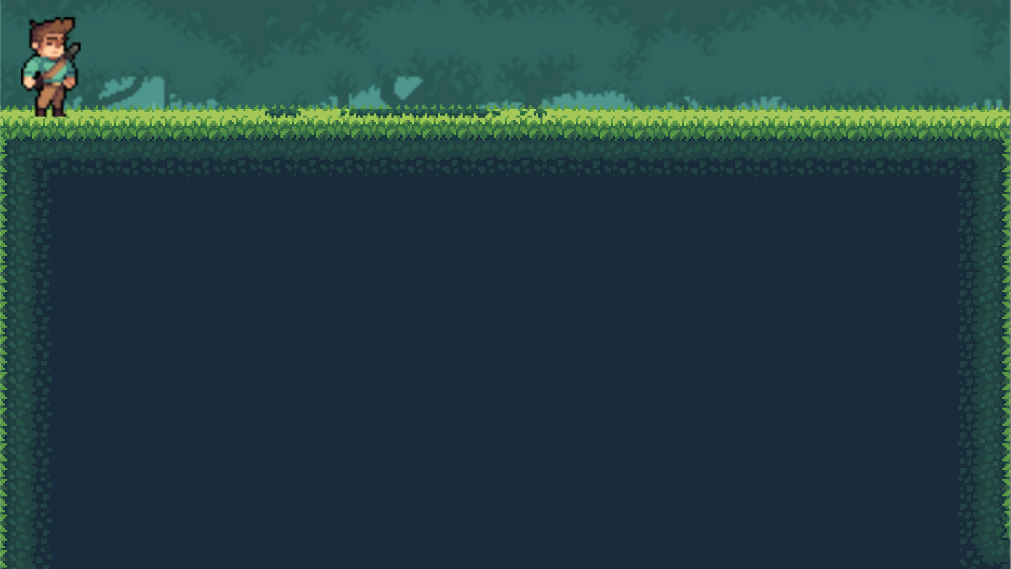



Game Design Document



***‘JUMP and don’t get boned!’***- Adrian Kwok

|  |  |  |
| --- | --- | --- |
| Table of Contents  [1 Game Overview](https://n-xovwktmtjsnaxyc2mwes2xu7pohqedmdm6zjw5q-2lu-script.googleusercontent.com/userCodeAppPanel)................................3  [2 High Concept](https://n-xovwktmtjsnaxyc2mwes2xu7pohqedmdm6zjw5q-2lu-script.googleusercontent.com/userCodeAppPanel).................................3  [3 Synopsis](https://n-xovwktmtjsnaxyc2mwes2xu7pohqedmdm6zjw5q-2lu-script.googleusercontent.com/userCodeAppPanel).................................... 3  [4 Game Objectives](https://n-xovwktmtjsnaxyc2mwes2xu7pohqedmdm6zjw5q-2lu-script.googleusercontent.com/userCodeAppPanel)..............................3  [5 Game Rules](https://n-xovwktmtjsnaxyc2mwes2xu7pohqedmdm6zjw5q-2lu-script.googleusercontent.com/userCodeAppPanel)...................................3  [6 Game Play](https://n-xovwktmtjsnaxyc2mwes2xu7pohqedmdm6zjw5q-2lu-script.googleusercontent.com/userCodeAppPanel)....................................4  [6.1 Game Controls](https://n-xovwktmtjsnaxyc2mwes2xu7pohqedmdm6zjw5q-2lu-script.googleusercontent.com/userCodeAppPanel)............................4  [6.2 Maps](https://n-xovwktmtjsnaxyc2mwes2xu7pohqedmdm6zjw5q-2lu-script.googleusercontent.com/userCodeAppPanel).....................................4  [7 Players](https://n-xovwktmtjsnaxyc2mwes2xu7pohqedmdm6zjw5q-2lu-script.googleusercontent.com/userCodeAppPanel)......................................4  [7.1 Characters](https://n-xovwktmtjsnaxyc2mwes2xu7pohqedmdm6zjw5q-2lu-script.googleusercontent.com/userCodeAppPanel)...............................4  [7.2 Metrics](https://n-xovwktmtjsnaxyc2mwes2xu7pohqedmdm6zjw5q-2lu-script.googleusercontent.com/userCodeAppPanel)..................................4  [7.3 States](https://n-xovwktmtjsnaxyc2mwes2xu7pohqedmdm6zjw5q-2lu-script.googleusercontent.com/userCodeAppPanel)...................................4  [7.4 Weapons](https://n-xovwktmtjsnaxyc2mwes2xu7pohqedmdm6zjw5q-2lu-script.googleusercontent.com/userCodeAppPanel)..................................4  [8 NPC](https://n-xovwktmtjsnaxyc2mwes2xu7pohqedmdm6zjw5q-2lu-script.googleusercontent.com/userCodeAppPanel)..........................................5  [8.1 Enemies](https://n-xovwktmtjsnaxyc2mwes2xu7pohqedmdm6zjw5q-2lu-script.googleusercontent.com/userCodeAppPanel)..................................5  [8.1.1 Enemy States](https://n-xovwktmtjsnaxyc2mwes2xu7pohqedmdm6zjw5q-2lu-script.googleusercontent.com/userCodeAppPanel).........................5  [8.1.2 Enemy Spawn Points](https://n-xovwktmtjsnaxyc2mwes2xu7pohqedmdm6zjw5q-2lu-script.googleusercontent.com/userCodeAppPanel)...................5  [8.2 Allies / Companions](https://n-xovwktmtjsnaxyc2mwes2xu7pohqedmdm6zjw5q-2lu-script.googleusercontent.com/userCodeAppPanel)......................5  [8.2.1 Ally States](https://n-xovwktmtjsnaxyc2mwes2xu7pohqedmdm6zjw5q-2lu-script.googleusercontent.com/userCodeAppPanel)..........................5  [8.2.2 Ally Spawn Points](https://n-xovwktmtjsnaxyc2mwes2xu7pohqedmdm6zjw5q-2lu-script.googleusercontent.com/userCodeAppPanel)....................5  [9 Art](https://n-xovwktmtjsnaxyc2mwes2xu7pohqedmdm6zjw5q-2lu-script.googleusercontent.com/userCodeAppPanel)..........................................6  [9.1 Setting](https://n-xovwktmtjsnaxyc2mwes2xu7pohqedmdm6zjw5q-2lu-script.googleusercontent.com/userCodeAppPanel)..................................6  [9.2 Level Design](https://n-xovwktmtjsnaxyc2mwes2xu7pohqedmdm6zjw5q-2lu-script.googleusercontent.com/userCodeAppPanel).............................6  [9.3 Audio](https://n-xovwktmtjsnaxyc2mwes2xu7pohqedmdm6zjw5q-2lu-script.googleusercontent.com/userCodeAppPanel)....................................7  9.4 What you Developed.......................7  10 Genre.......................................7   |  | | --- | |  | | Game Development Team Members    PRODUCER  Adrian Kwok    PRODUCTION MANAGER  Adrian Kwok    PRODUCTION COORDINATOR  Adrian Kwok  GAME DESIGNERS  Adrian Kwok  SYSTEMS/IT COORDINATOR  Adrian Kwok  PROGRAMMERS  Adrian Kwok  TECHNICAL ARTISTS  Adrian Kwok  AUDIO ENGINEERS  Adrian Kwok  UX TESTERS  Adrian Kwok |

|  |
| --- |
|  |

# 1 Game Overview

Title: Jungle Jump

Platform: PC Standalone + iOS

Genre: Endless Survival Runner

Rating: (10+) ESRB

Target: Casual gamer (aging from 12 - 30)

Release date: November 27, 2017

Publisher: CS583

Jungle Jump is a side-scrolling, endless survival running game set in a jungle filled with skeletons. The Player plays as an explorer who is cursed to run endlessly in a mysterious jungle. (The curse begins when the game is started by the player.) Being that he is in a 2D world with no weapons of any kind, his only option is to jump over the skeleton obstacles that come his way. Points are accumulated continuously throughout the time the Player survives until the explorer inevitably dies. The goal is to obtain the highest score, or to survive the longest.

# 2 High Concept*

Jungle Jump sets the Player in a mysterious jungle filled with many skeleton enemies waiting to kill the explorer the Player controls. The only way to avoid them, being that the world takes place in a 2D world, is to jump over them as you are only a mere explorer who is cursed to run endlessly.

# 3 Synopsis*

A novice explorer finds himself cursed to run in a mysterious jungle, filled with undead enemies. The only way to survive is to avoid the enemies by jumping, so JUMP and don’t get boned

# 4 Game Objectives*

The objective of this game is to survive for as long as possible by jumping over skeletons as you run towards them.

# 5 Game Rules*

When the player starts the game, the explorer runs endlessly at a constant pace. The Player must jump over each skeleton enemy that comes their way in order to survive.

# 6 Game Play*

## 6.1 Game Controls

Space – Jump

6.2 Maps

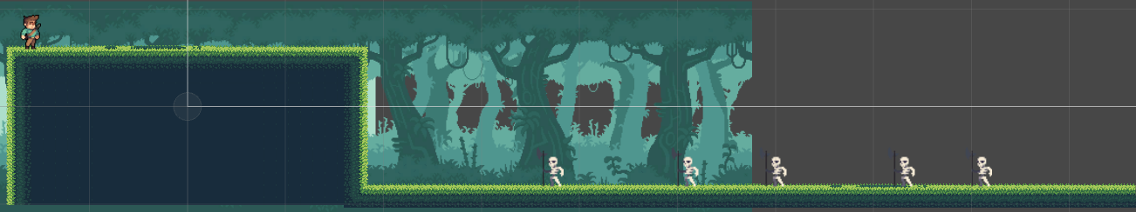

# 7 Players (optional)

## 7.1 Characters

A novice explorer decides to go exploring by himself, only to find himself in a mysterious jungle where he is cure

## 7.2 Metrics

Speed: 0.8

Max Health: One hit kill

Attack Damage: N/A

Time to attack: N/A

## 7.3 States

Idle: The idle state is a cycled animation where the Player just stands on a hill breathing.

Move: The movement animation is a cycled animation where the player runs and will be triggered when the game starts.

## 7.4 Weapons

N/A

# 8 NPC (optional)

## 8.1 Enemies

Skeletons tasked with the purpose to eliminate anyone in the Jungle.

### 8.1.1 Enemy States

Idle: The idle state is a cycled animation where the skeleton just stands on the floor pretending to breath.

Notice: The notice animation is a single animation where the skeleton widens its eyes and body flashes white when Player comes into proximity with the skeleton.

Attack: The attack animation is a single animation where the skeleton swings his weapon down toward the Player comes within proximity of the skeleton.

### 8.1.2 Enemy Spawn Points

There are only really five enemies that respawn over at the same spot when they exit the camera view.

## 8.2 Allies / Companions

N/A

### 8.2.1 Ally States

N/A

### 8.2.2 Ally Spawn Points

N/A

# 9 Art *

## 9.1 Setting

The game takes place in a mysterious jungle with green grass and water puddles. The background is filled with luscious trees in the background.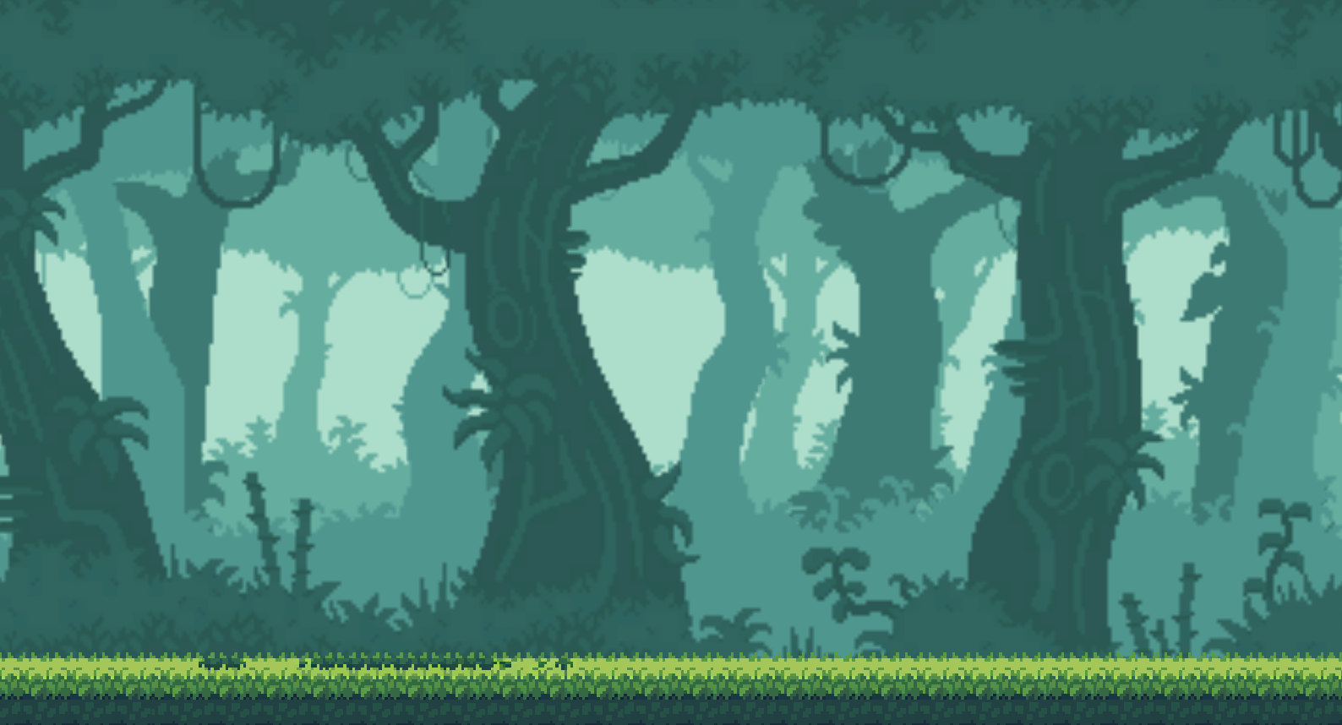

## 9.2 Level Design

The level consists of the jungle setting starting off with a hill where the Player starts. After the game starts, the hill will move out of screen and never reappear again, while the skeletons and flat flooring will continuously respawn over and over until the game is terminated or until a scene is loaded. The background moves with a parallaxing effect with two images scrolling and respawning on the right side to create and endless background effect. The same concept is applied to the skeletons and low flooring in order create the endless running game.



## 9.3 Audio

|  |  |  |
| --- | --- | --- |
| Name | Category | Description |
| Ambient.mp3 | Background music | Plays during the game |
| Hit.aiff | FX | When Player loses |
| Jump.wav | FX | When Player jumps |
| Jungle.wav | Background music | Plays during the game |
| OtherButtons.wav | FX | Plays when button is pressed |
| startButton.wav | FX | Plays once when game is started |
| swing.wav | FX | Skeleton attack sound |

9.4 What you Developed

I composed the level with free assets of sprites and sounds. The animations were implemented in script along with the animation manager. I also created all the scripts that controlled the scrolling of all objects, the button manager, and any other script found used in the game. They were developed with the help of Unity Documentation as well as online tutorials. Credits to these sources can be found in game on the credits scene accessed by the always available credits button.

10 Genre

The game is a side scrolling video game with an endless running aspect where, when the game starts, the overall setting is continuously cycling from the right side of the scene to the left side until a scene is loaded by the game.