PROJECT REPORT
AI-Based Resume Screening & Job Recommendation System
Built using Natural Language Processing and Machine Learning (TF-IDF + Cosine Similarity)
Technology stack: Python · Flask · scikit-learn · NLTK · pdfplumber · python-docx
Report prepared for: Addrik Kalyan

1. Abstract
The AI-Based Resume Screening and Job Recommendation System is a web application that automates an early stage of the recruitment process. A candidate uploads a resume in PDF or DOCX format; the system extracts the document text, identifies technical skills using natural language processing, and compares those skills against a catalogue of job postings using a TF-IDF vectorizer and cosine similarity. The result is a ranked list of recommended job roles, each with a similarity percentage and an explainable resume score (matched skills divided by required skills).
The system also includes user accounts (registration and login), a dashboard that stores the most recent analysis per user, and an administrator module for managing the job catalogue and viewing registered users. The application was built with Flask, scikit-learn, and NLTK, and was installed, run, and tested directly by the project owner on a local machine, with the workflow confirmed end-to-end across registration, resume upload, job recommendation, and administration.

2. Introduction

2.1 Problem Statement
Traditional recruitment requires a recruiter to manually read every submitted resume, identify relevant skills, and judge fit against open roles. This does not scale well: it is slow, inconsistent between reviewers, and easy to make errors on when application volume is high.
This project addresses that problem by automating four steps that are normally done by hand:
- Reading the resume document and extracting its text
- Identifying the candidate’s technical skills
- Matching those skills against a set of job descriptions
- Producing a ranked, scored list of suitable roles

2.2 Objectives
Main objective: to develop a working system that automatically screens an uploaded resume and recommends suitable job opportunities using NLP and a machine learning similarity model.
Supporting objectives:
- Extract text reliably from both PDF and DOCX resumes
- Identify technical skills from free-form resume text
- Represent both resumes and job postings numerically so they can be compared mathematically
- Rank job postings by relevance using cosine similarity
- Present an explainable score alongside the similarity ranking
- Provide an administrative interface to maintain the job catalogue

2.3 Existing (Manual) Process
In a manual process, a candidate submits a resume, a recruiter reads it, checks it against a list of required skills, and decides whether to shortlist the candidate for a role. This is time-consuming, does not scale to large applicant volumes, and is dependent on each reviewer’s judgement and attention.

2.4 Proposed System
The proposed system replaces the manual steps with an automated pipeline: resume upload, text extraction, NLP-based skill extraction, a TF-IDF and cosine similarity model that ranks job postings, and a scoring step that expresses the match as a simple percentage. The full pipeline is illustrated in Section 4 (Workflow).

3. System Architecture
The application follows a layered architecture: a browser-based frontend renders server-side templates, a Flask backend implements all business logic in clearly separated modules, and a lightweight data layer persists users, job postings, and the trained recommendation model.
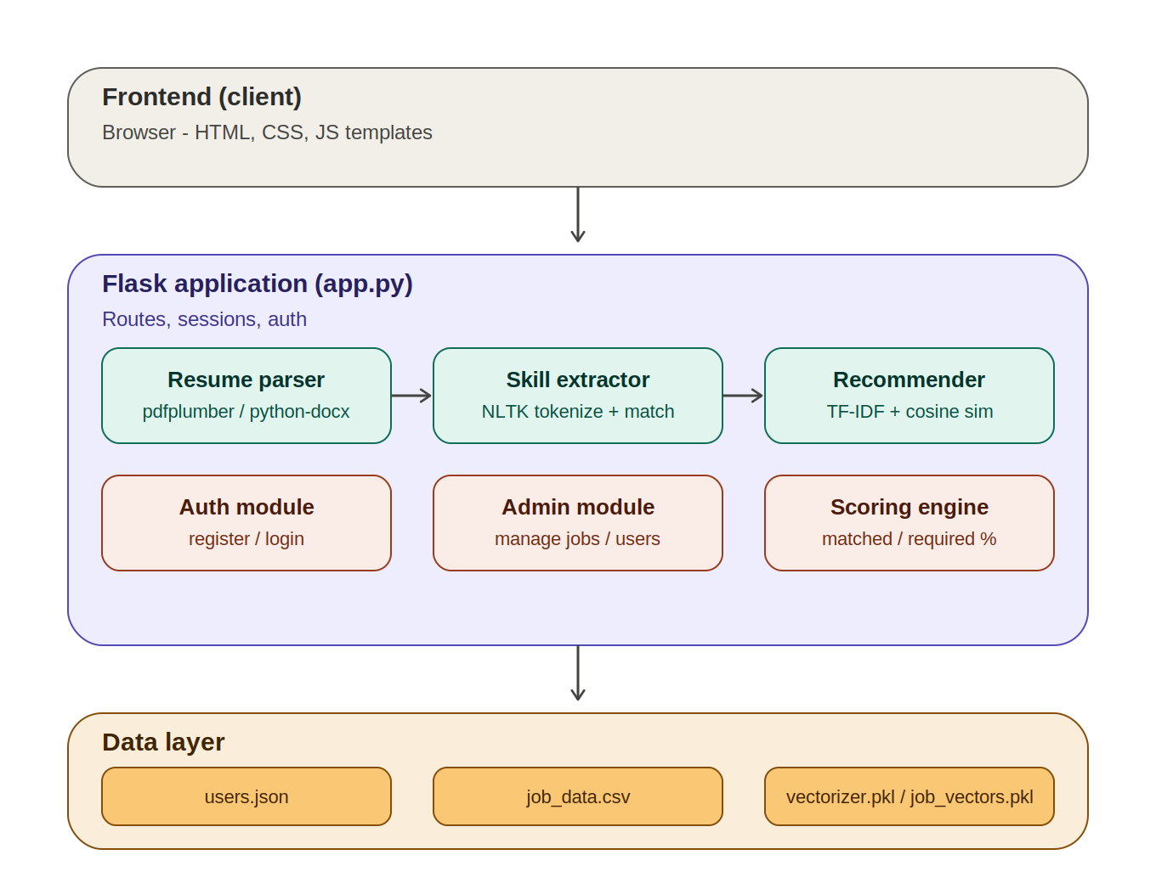
Figure 1: System architecture diagram

3.1 Frontend Layer
The frontend is rendered server-side using Flask’s Jinja2 templating with plain HTML, CSS, and a small amount of JavaScript for client-side file validation. There is no separate single-page application framework; every page is returned by a Flask route.

3.2 Application Layer (Flask)
app.py is the single entry point for all HTTP routes. It is organised into the seven functional modules described in Section 5, and is responsible for session management, request handling, and calling into the NLP/ML utilities for any resume-related request.

3.3 Data Layer
Three forms of persistence are used:
- users.json - a JSON file holding registered users, their hashed passwords, last uploaded resume filename, and last extracted skill list
- job_data.csv - a CSV file holding the job catalogue (title, company, required skills, description) that the admin module edits directly
- vectorizer.pkl and job_vectors.pkl - the trained TF-IDF vectorizer and the pre-computed TF-IDF matrix for every job, so recommendation requests do not need to retrain the model each time
This file-based approach was chosen so the project can be installed and run with no external database server. The data access functions are written behind a small abstraction layer (config/database.py) with the same shape a MongoDB collection would expose, so the storage backend can be swapped for MongoDB later without changing the rest of the application.

4. Workflow
Every resume submission passes through the same seven-stage pipeline, shown below. The first three stages prepare the resume for comparison; the middle two stages run the machine learning model; the final two stages turn the model output into something the user can read.
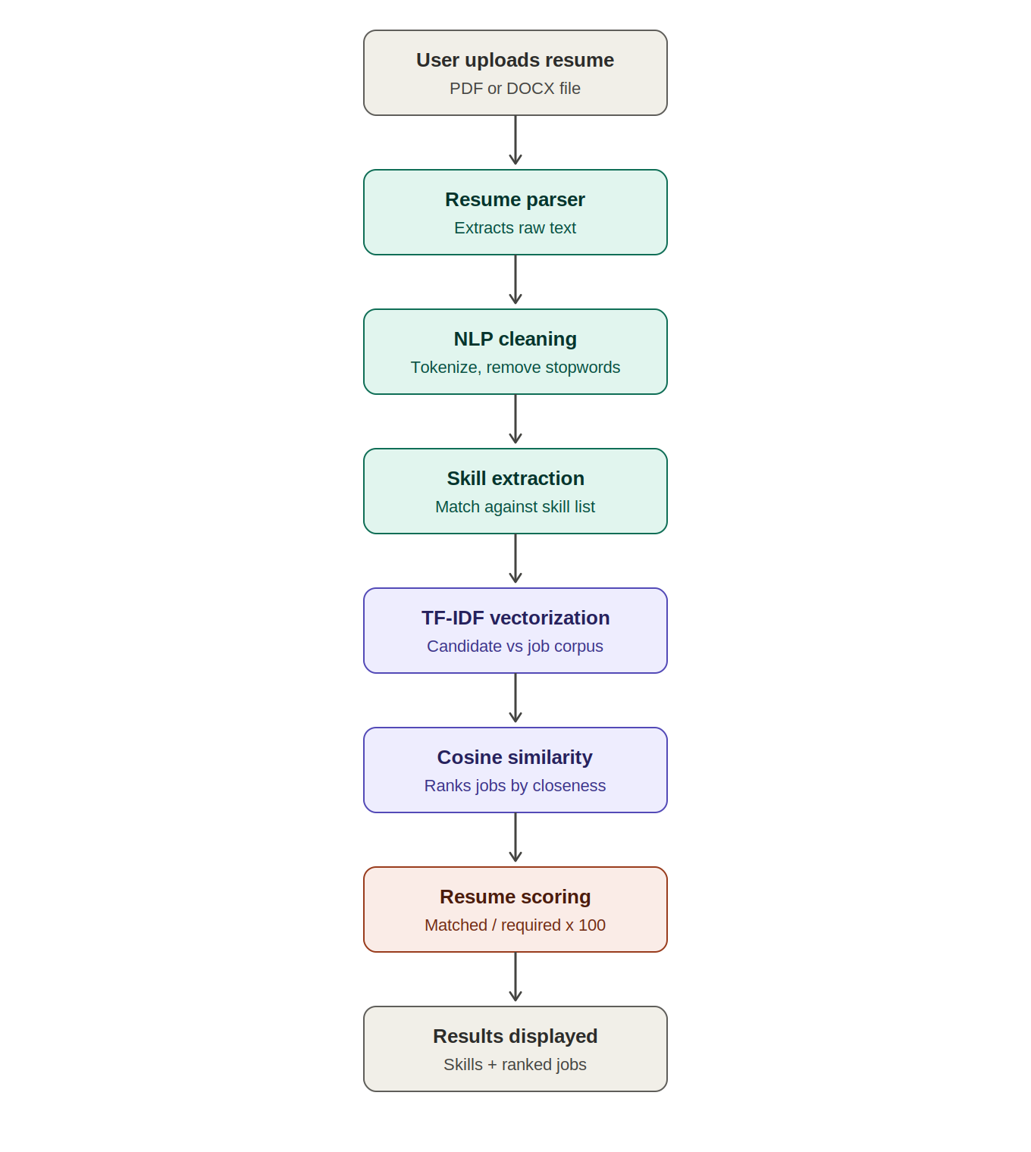
Figure 2: Resume screening and recommendation workflow

4.1 Stage-by-stage description
- Resume upload - the user selects a PDF or DOCX file through the upload form; the file is validated client-side for type and size, then sent to the server.
- Resume parsing - the server extracts raw text using pdfplumber for PDFs or python-docx for Word documents, including table cell content.
- NLP cleaning - the extracted text is lower-cased, cleaned of irrelevant characters, and tokenized; stopwords are removed using NLTK.
- Skill extraction - the cleaned text is matched against a curated list of roughly 70 technical skills, including multi-word skills such as "machine learning" and "power bi".
- TF-IDF vectorization - the candidate’s extracted skills are converted into a TF-IDF vector using the same vectorizer that was fit on the job catalogue, so both sides of the comparison live in the same vector space.
- Cosine similarity - the candidate vector is compared against every job vector; cosine similarity produces a 0-1 score per job, which is converted to a percentage and used to rank the recommendations.
- Resume scoring and display - for each recommended job, a second, simpler score is calculated as (matched required skills / total required skills) x 100, and both the similarity percentage and the resume score are shown to the user alongside the list of matched and missing skills.

5. Module Description
The system is organised into seven functional modules, matching the structure of the original project brief:
# | Module | Function | Implementation
1 | User registration / login | Account creation and authentication | app.py routes; Werkzeug password hashing
2 | Resume upload | Accepts PDF/DOCX files from the user | app.py (/upload route); upload_resume.html
3 | Resume parser | Extracts raw text from the uploaded file | utils/resume_parser.py - pdfplumber, python-docx
4 | Skill extraction (NLP) | Cleans text and identifies known technical skills | utils/skill_extractor.py - NLTK tokenization
5 | Job recommendation | Ranks jobs by similarity to candidate skills | utils/recommendation.py - TF-IDF + cosine similarity
6 | Resume scoring | Calculates a matched-skills percentage per job | utils/recommendation.py - (matched / required) x 100
7 | Admin module | Add, update, delete jobs; view registered users | app.py (/admin routes); admin.html

6. Technology Stack
Layer | Technologies
Frontend | HTML, CSS, JavaScript (Jinja2 templates rendered by Flask)
Backend | Python 3, Flask, Werkzeug (sessions and password hashing)
AI / ML / NLP | scikit-learn (TfidfVectorizer, cosine_similarity), NLTK (tokenization, stopwords)
Document parsing | pdfplumber (PDF), python-docx (DOCX)
Data storage | JSON file (users), CSV file (job postings), pickled TF-IDF model artifacts
Tooling | VS Code, Python virtual environment (.venv), pip

7. Screens and Testing Evidence
The application was installed and run by the project owner in a local VS Code / Python virtual environment, and exercised through the full workflow below. Screenshots were captured directly from the running application.

7.1 Home Page
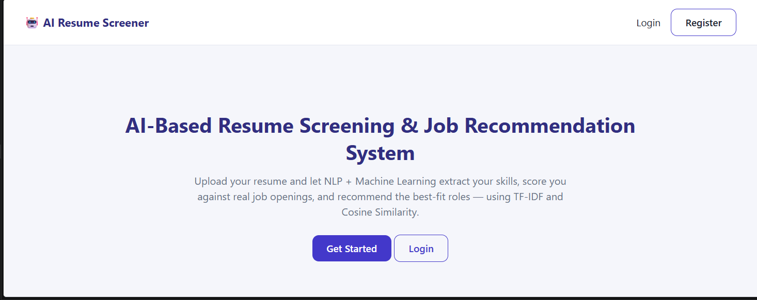
Figure 3: Home page

7.2 Account Registration
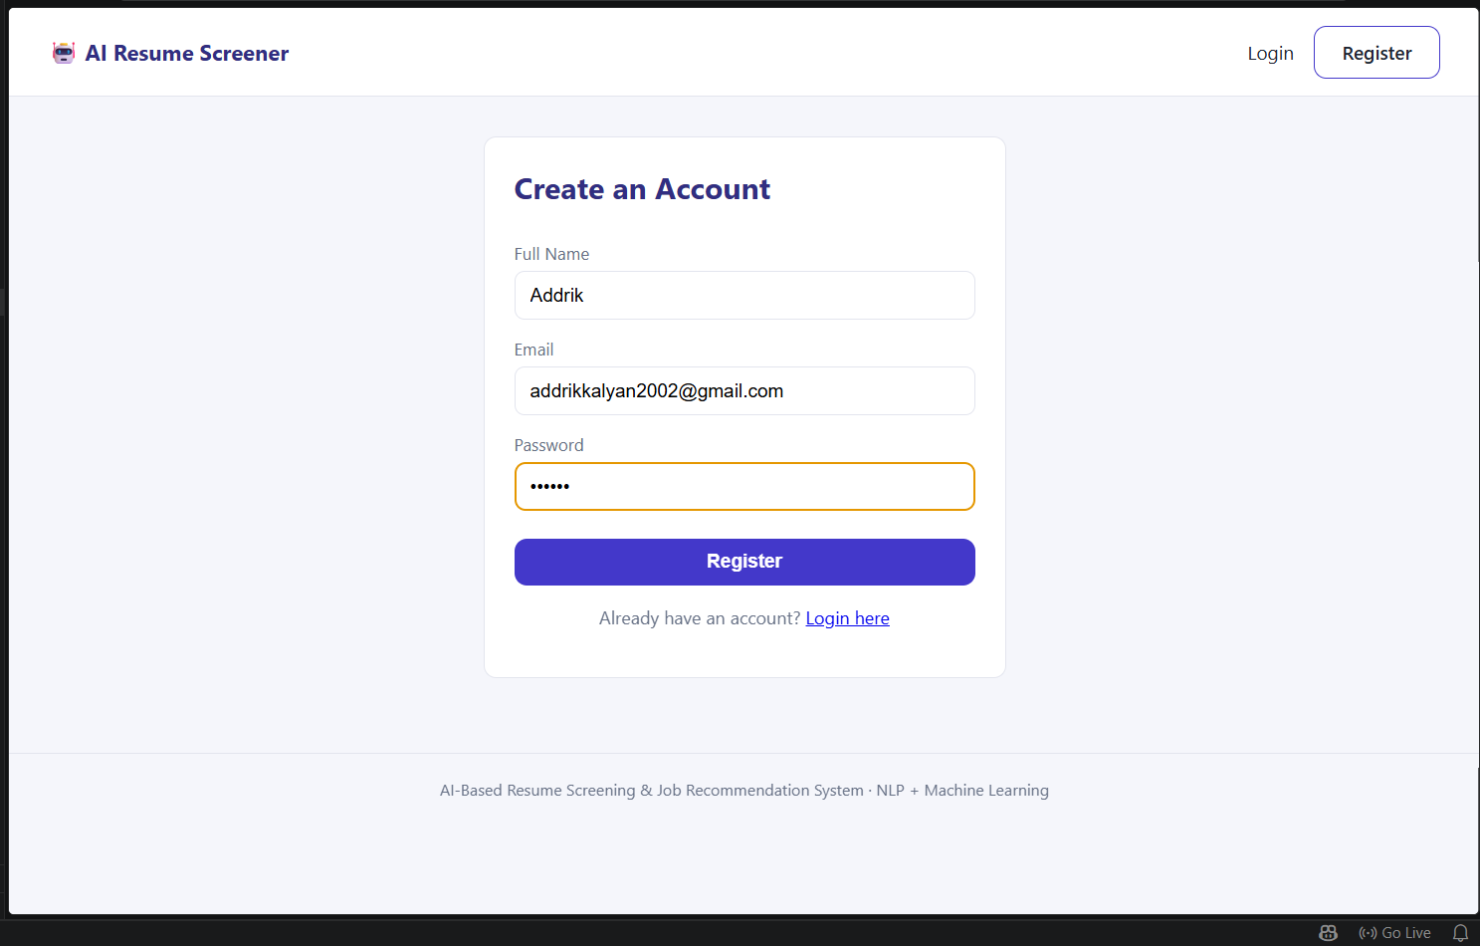
Figure 4: Account registration page

7.3 Login
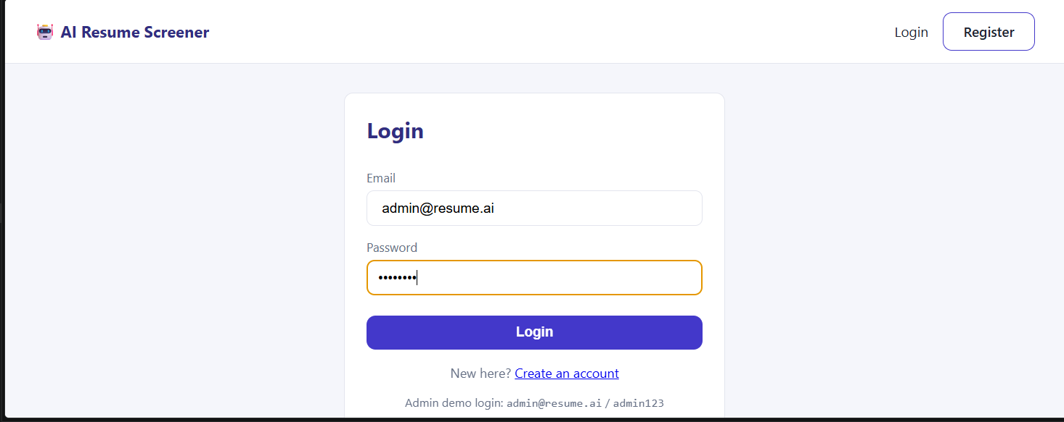
Figure 5: Login page

7.4 Resume Upload
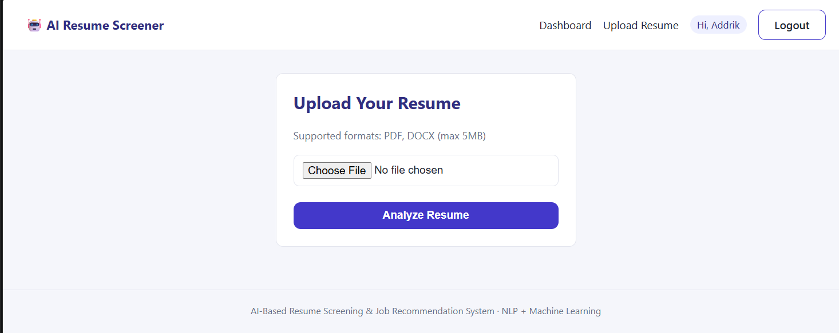
Figure 6: Resume upload page

7.5 Extracted Skills and Recommended Jobs
After upload, the system displayed the candidate’s extracted skill set, including python, mongodb, sql, machine learning, deep learning, data science, pandas, numpy, tensorflow, scikit-learn, nlp and others - confirming that the NLP extraction stage correctly read a real, non-trivial resume.
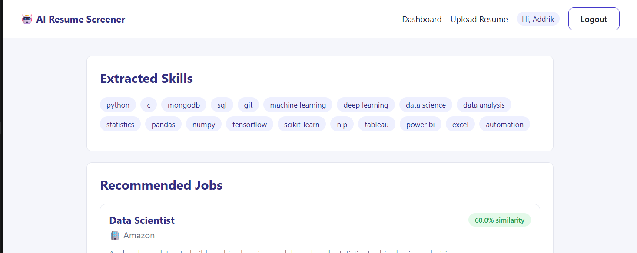
Figure 7: Extracted skills from an uploaded resume
The same resume produced a ranked job list led by Data Scientist at Amazon (60% similarity, 100% resume score, 6 of 6 required skills matched), followed by Data Analyst, ML Engineer, AI Research Engineer and NLP Engineer in descending order of similarity - demonstrating that the TF-IDF and cosine similarity ranking responded sensibly to the candidate’s actual skill profile.
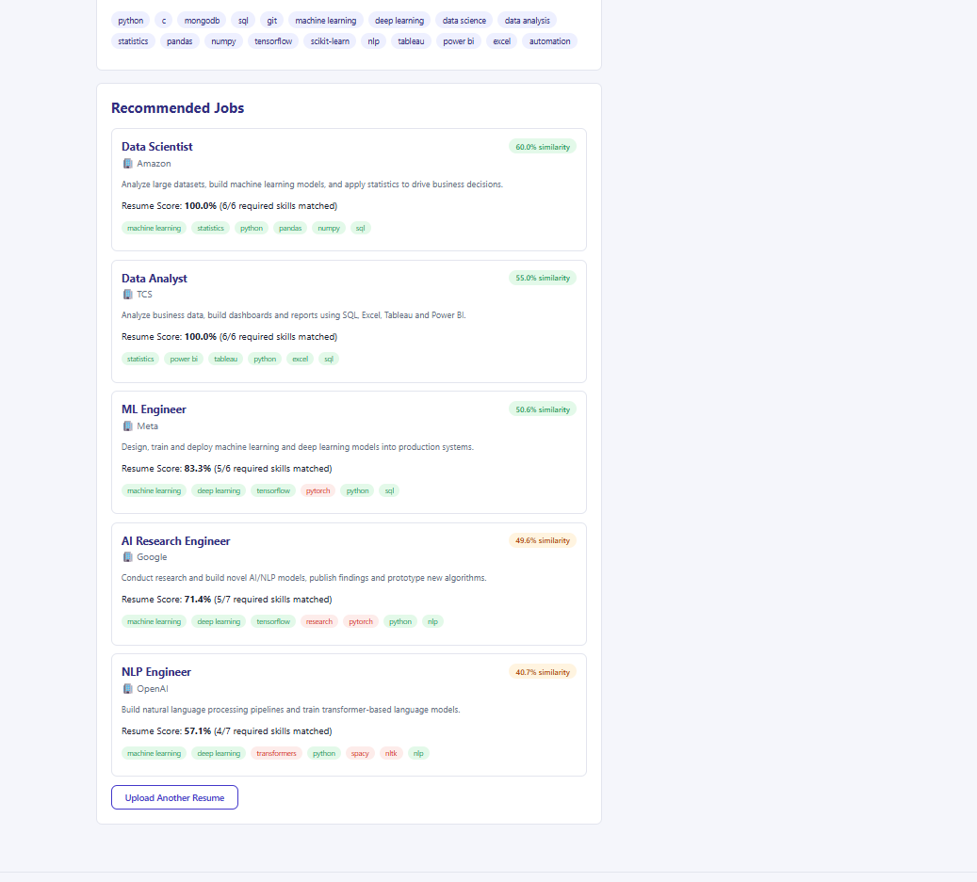
Figure 8: Ranked job recommendations with similarity and resume score

7.6 Admin Panel
The seeded administrator account can add new job postings (title, company, required skills, description) directly from the browser; saving a job rewrites job_data.csv and retrains the TF-IDF model automatically so the new posting is immediately recommendable.
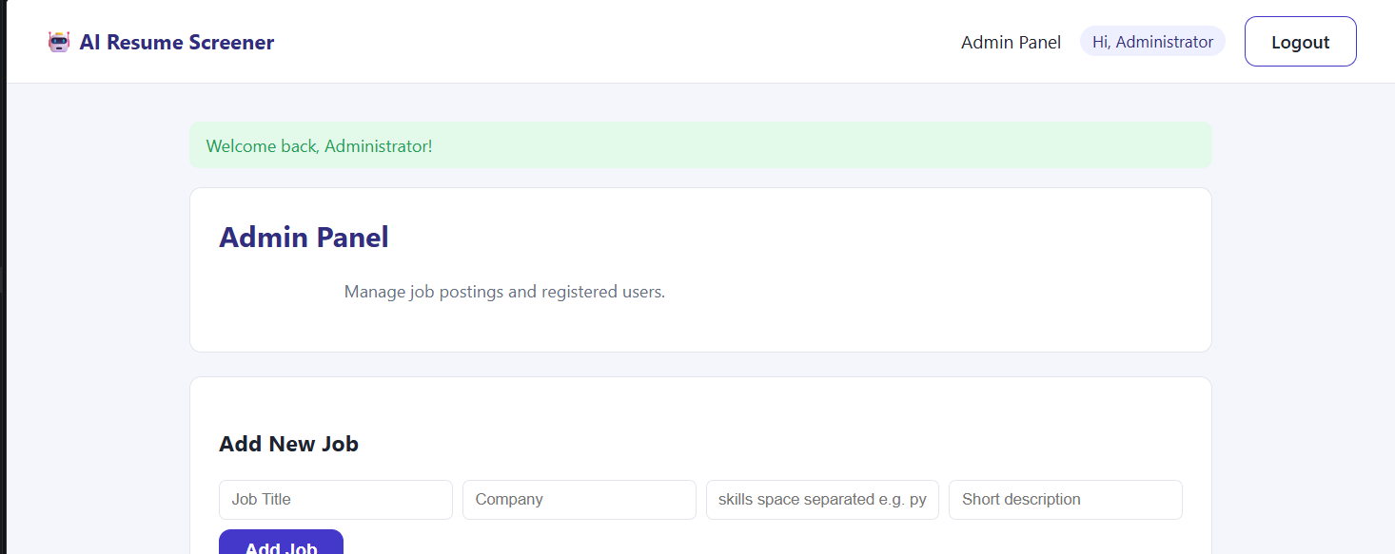
Figure 9: Administrator panel - job management
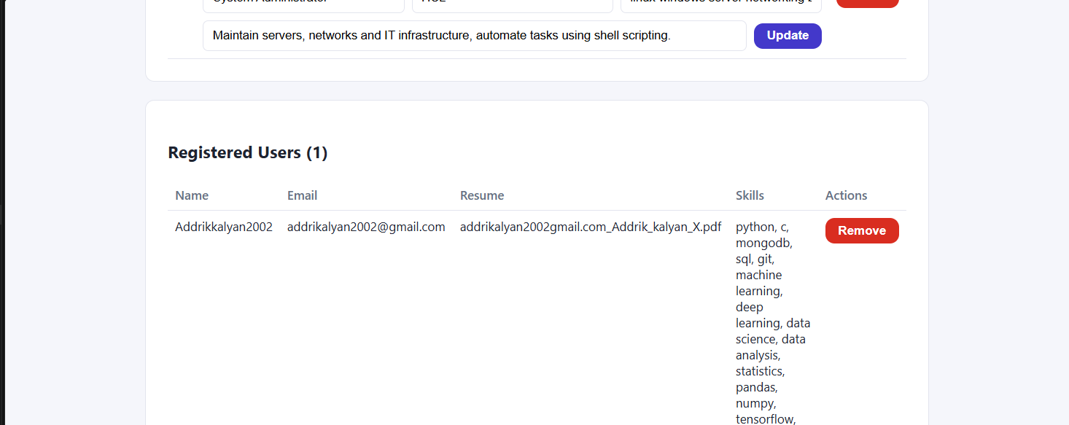
Figure 10: Administrator panel - registered users

8. Testing Summary
The table below summarises the functional tests carried out against the running application, all of which produced the expected result.
Test case | Action | Observed result
Account registration | Created a new account via the Register page | Account stored successfully; redirected to login
Login | Logged in with registered credentials | Session created; redirected to user dashboard
Resume upload (PDF) | Uploaded a PDF resume containing Python/ML skills | Text extracted correctly; 19 skills identified
Skill extraction | Reviewed extracted skills against resume content | All listed technical skills correctly detected
Job recommendation | Viewed ranked job list after upload | Data Scientist (Amazon) ranked first at 60% similarity, 100% resume score
Admin login | Logged in with the seeded admin account | Redirected to Admin Panel
Admin - add job | Added a new job posting with custom skills | Job appended to dataset; model retrained automatically
Admin - view users | Opened the registered users table | Registered user, resume filename and extracted skills displayed

9. Future Enhancements
The following extensions were identified in the original project brief and remain open for future work:
- AI interview question generator
- LLM-based HR assistant for conversational candidate screening
- Video resume analysis
- LinkedIn profile analysis
- Salary prediction based on skills and experience
- Automated email notifications to candidates and recruiters

10. Conclusion
The AI-Based Resume Screening and Job Recommendation System meets its stated objectives: it parses real PDF and DOCX resumes, extracts a meaningful set of technical skills using NLP, ranks a catalogue of job postings using a genuine machine learning similarity model (TF-IDF and cosine similarity, not a hardcoded rule set), and exposes that ranking through a usable web interface with supporting registration, login, and administration features. End-to-end testing on a real resume confirmed that the extracted skills and the resulting job ranking both behaved as expected, indicating the pipeline is functioning correctly rather than only superficially.

