Wireframe Storyboard How a Gym user orders food for pickup at Gym (Sketched Version, Balsamiq/UXPin version in the works for final presentation..)

Follow left to Right, The blue circle indicates what the user clicks on next

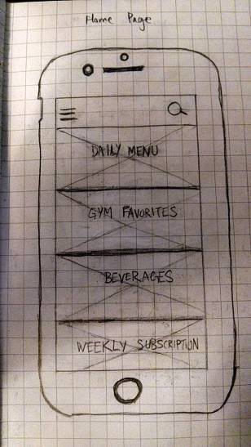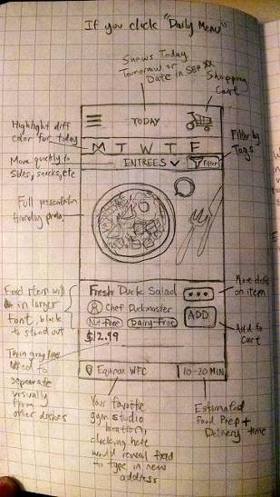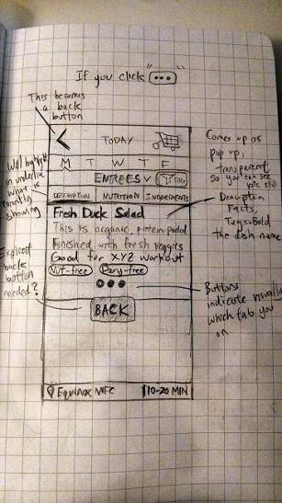

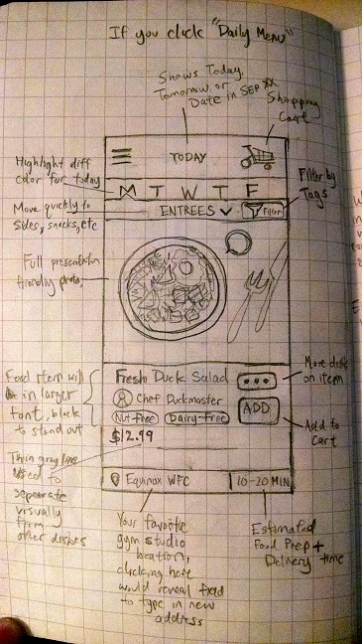

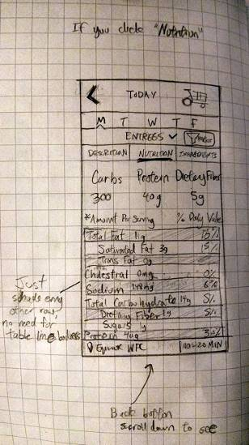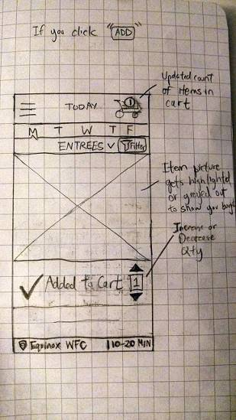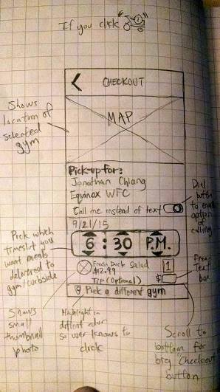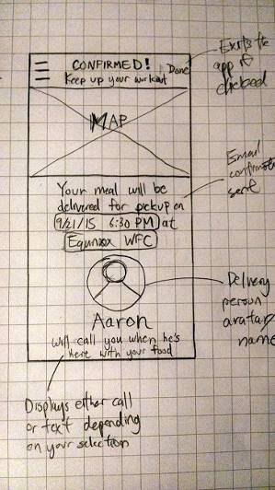

**To be added**

**Second to last screen**

* Slider button “Call me instead of text” should be centered, and the two options should be “Call” or “Text” on the left and right of the slider icon
* Add another centered slider button, two options on left and right should be “Pickup in Gym” or “Pickup curbside outside Gym”. Because maybe not all gyms are going to be explicit partners, or have the storage/refrigerator space inside. So this slider will default to one or another depending if the gym is a partner or not.
* Add pre-defined buttons for 10%, 15%, 18% tip and free form option

**Last screen**

* Caption should be “{Driver name} will {call/text} you when your meal is delivered and ready for pick-up {inside the/curbside outside the} gym.

**Subscription Storyboard instead of pay per meal**

* What screens like look if you subscribe to 1 or 5 day meal plans