**Experiment 8**

**Implementation:**

1. **To scan open ports**

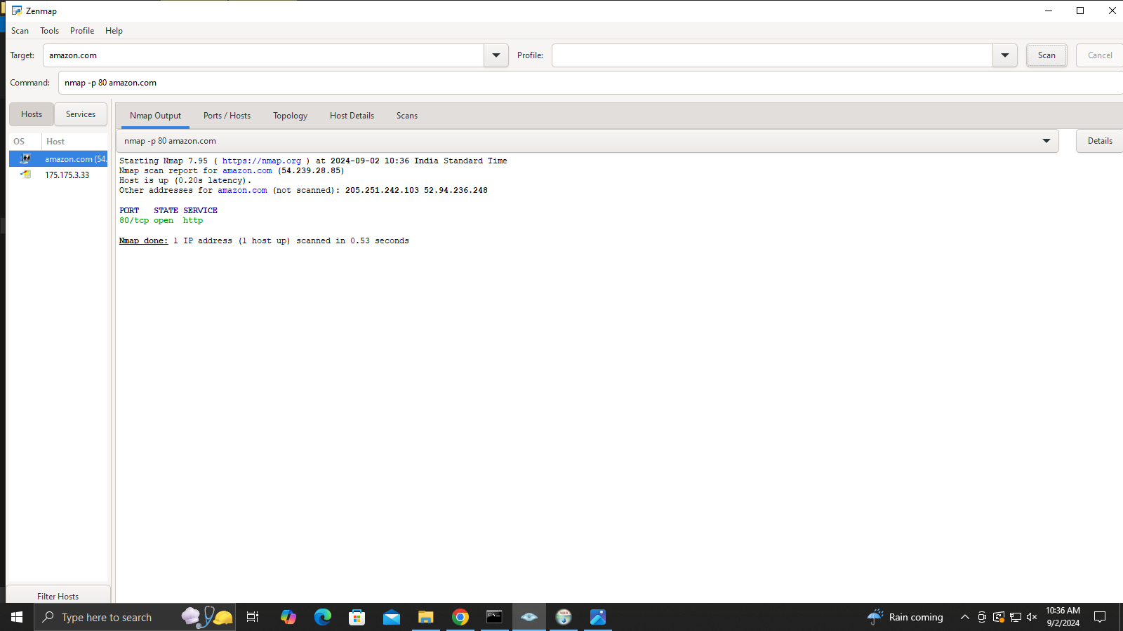

1. **To perform OS fingerprinting**

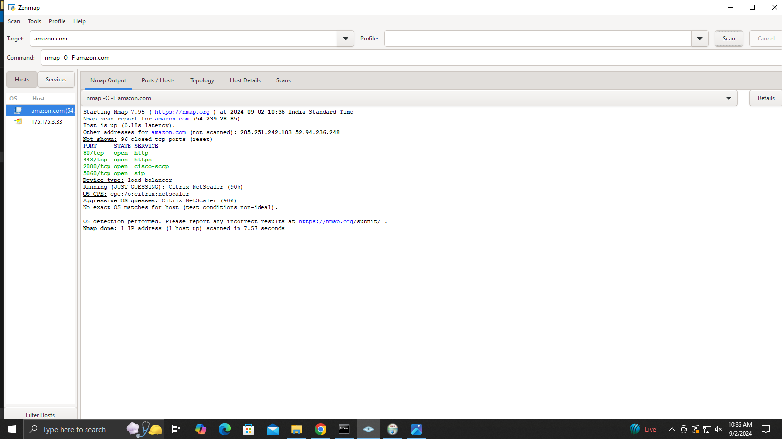

1. **To perform a ping scan**

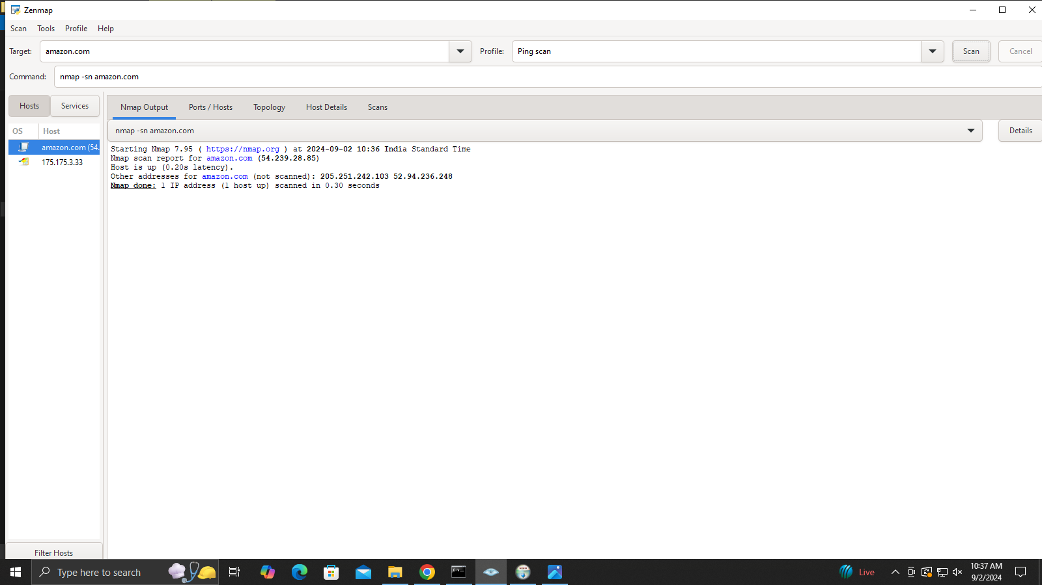

1. **To perform a TCP port scan**

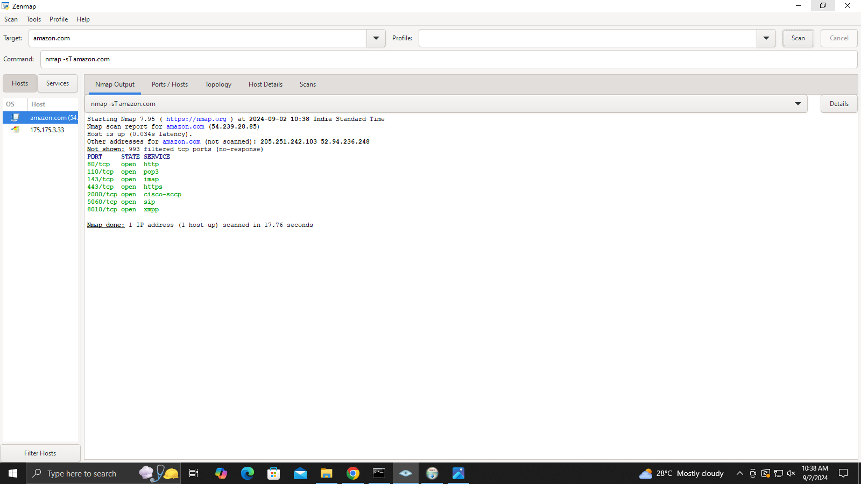

1. **To perform a fast scan**

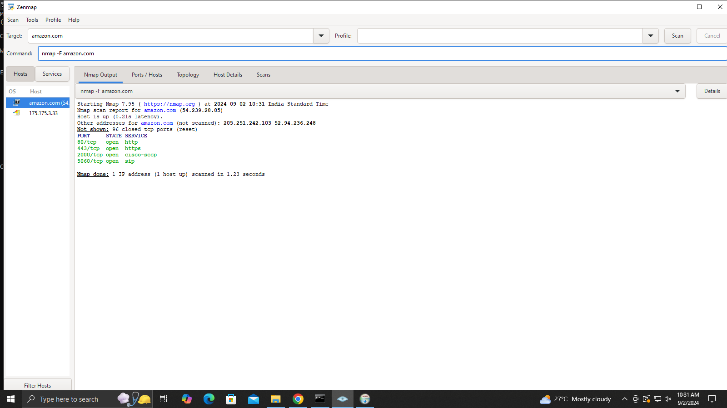

1. **Topology of ping scan**

