**Experiment-9**

**Aim:** Study and Simulation of DOS attack using Hping and other tools

**Learning Objectives:**

* **Understand DOS Attacks**: Gain insights into the mechanics and types of Denial of Service (DOS) attacks, including their impact on network availability and security.
* **Utilize Hping and Tools**: Learn to use Hping and other tools to simulate DOS attacks, analyze network behavior, and assess system vulnerabilities.

**Theory:**

Denial of Service (DOS) attacks are deliberate attempts to disrupt the normal functioning of a targeted server, service, or network by overwhelming it with a flood of illegitimate requests. These attacks can be executed using various methods and tools, and understanding them is vital for cybersecurity professionals.

**Types of DOS Attacks**

1. **Flood Attacks**: These involve overwhelming the target with a massive volume of traffic. Common types include:
   * **SYN Flood**: Exploits the TCP handshake process. The attacker sends a large number of SYN requests to the target but never completes the handshake, causing the server to allocate resources for half-open connections.
   * **UDP Flood**: Sends a flood of UDP packets to random ports on the target, forcing the server to check for applications listening on those ports, which can lead to resource exhaustion.
2. **Application Layer Attacks**: These attacks target specific applications rather than the network itself. Examples include:
   * **HTTP Flood**: The attacker sends a high volume of HTTP requests to exhaust server resources, such as CPU and memory.
   * **Slowloris**: This technique keeps many connections open to the target server by sending partial HTTP requests, ultimately exhausting its available connections.
3. **Distributed Denial of Service (DDoS)**: A more severe variant where multiple compromised systems (often part of a botnet) are used to launch an attack, making it harder to mitigate because the traffic comes from many different sources.

**Tools for Simulating DOS Attacks**

* **Hping**: A command-line packet generator and analyzer that allows users to craft custom TCP/IP packets. It is versatile and can be used for various tasks, including network testing, firewall testing, and simulating DOS attacks. Users can modify packet types, flags, and other attributes to create realistic attack scenarios.
* **Other Tools**: Other commonly used tools for simulating DOS attacks include:
  + **LOIC (Low Orbit Ion Cannon)**: A simple network stress testing application that allows users to perform DOS attacks using a graphical interface.
  + **Metasploit**: While primarily a penetration testing tool, it has modules that can simulate various attacks, including DOS.

**Impact of DOS Attacks**

The effects of DOS attacks can be devastating for organizations:

* **Service Outage**: Websites and services become inaccessible, leading to loss of revenue and customer trust.
* **Increased Operational Costs**: Organizations may need to invest in additional resources to mitigate attacks or recover from their impacts.
* **Reputational Damage**: Frequent outages can damage an organization’s reputation, making customers hesitant to engage.

**Mitigation Strategies**

Understanding DOS attacks is crucial for implementing effective defenses:

* **Rate Limiting**: Limiting the number of requests a server will accept from a single IP address.
* **Firewalls and Intrusion Detection Systems**: Configuring firewalls to filter malicious traffic and employing IDS to detect unusual patterns indicative of an attack.
* **Traffic Analysis**: Regular monitoring of network traffic to identify and respond to anomalies quickly.

**Learning Outcomes:**

* **Practical Skills:** Demonstrate the ability to configure and execute DOS attack simulations using Hping and analyze the results to identify weaknesses in network defenses.
* **Critical Analysis:** Evaluate the effectiveness of different mitigation strategies and propose solutions to enhance network resilience against DOS attacks.

**Implementation:**

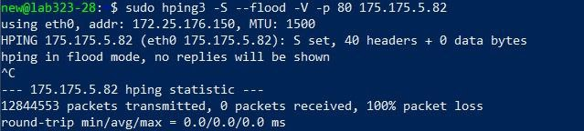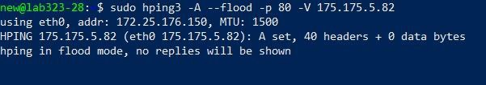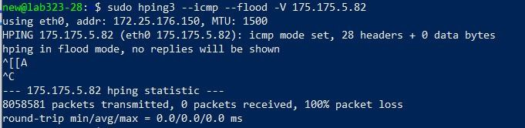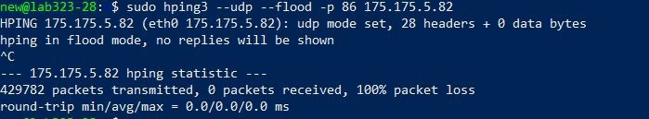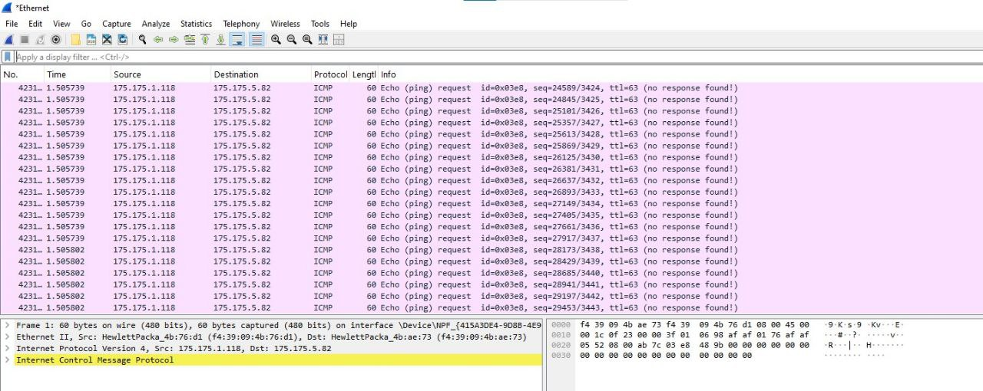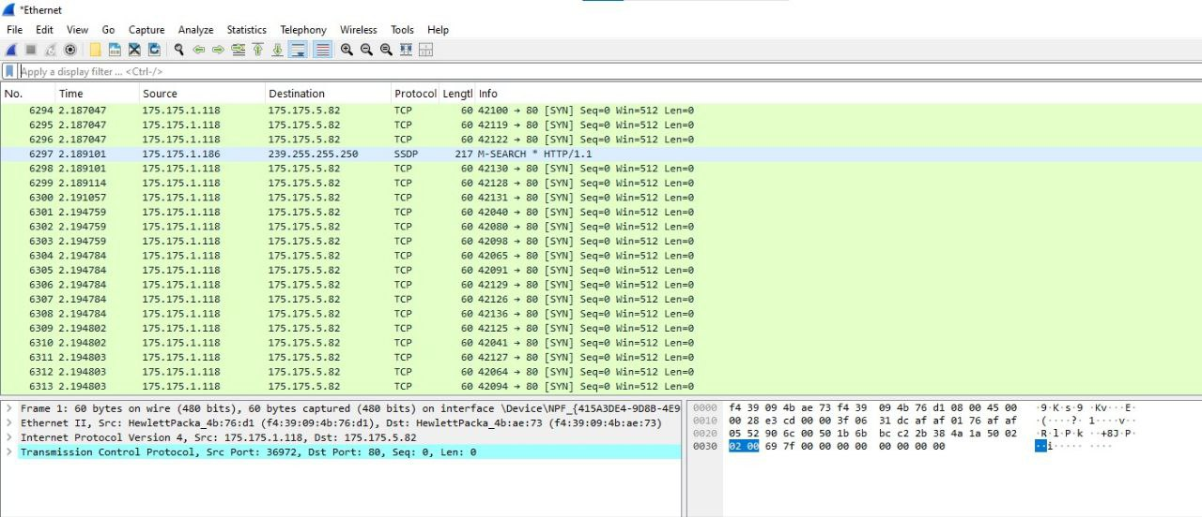

**Conclusion:**

The practical exploration of DOS attacks, especially through tools like Hping, deepens understanding of both the theoretical and practical aspects of cybersecurity. By simulating these attacks, learners can better appreciate the strategies attackers use and the vulnerabilities they exploit. This knowledge is essential for developing robust defenses, ensuring that organizations can maintain service availability even in the face of potential threats. As the digital landscape continues to evolve, ongoing education and training in these areas remain critical for effective cybersecurity management.