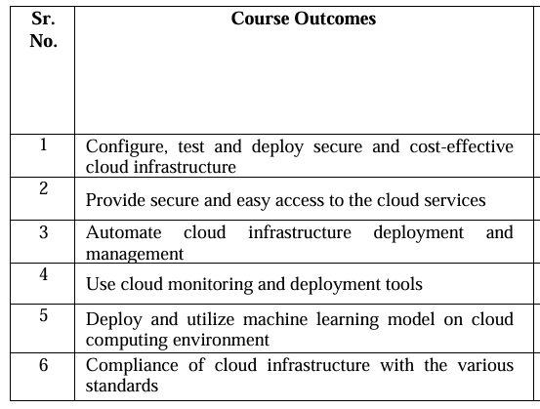



|  |  |
| --- | --- |
| **PSO 1** | To develop the culture of augmenting existing technologies to create scalable IT solutions. |
| **PSO 2** | To combine various technologies like IoT, Cloud and Analytics to provide integrated solutions to real time problems of government /industries. |
| **PSO 3** | To master in molding any problem into a web/internet-based solutions. |

|  |  |
| --- | --- |
| **PO 1** | Engineering knowledge |
| **PO 2** | Problem analysis |
| **PO 3** | Design / development of solutions |
| **PO 4** | Conduct investigations of complex problems |
| **PO 5** | Modern tool usage |
| **PO 6** | The engineer and society |
| **PO 7** | Environment and sustainability |
| **PO 8** | Ethics |
| **PO 9** | Individual and team work |
| **PO 10** | Communication |
| **PO 11** | Life-long learning |
| **PO 12** | Project management & finance |

**Professional Skills - V**

