**Experiment 4: Deploying Web-Application using AWS Amplify**

**Aim:** Design and deploy the cloud-based application with scalability feature.

**Learning Objective**:

* Learn how to design cloud-based applications with built-in scalability on AWS.
* Understand the process of deploying and managing scalable cloud resources using AWS Amplify.

**Tools:** AWS, Git, GitHub

**Theory:**

Hosting a web application on AWS involves several integrated steps, starting with setting up version control and culminating in the deployment of your application using AWS Amplify.

1. **Initializing a Git Repository**:

The process begins by setting up version control for your project. In your local project directory, you initialize a Git repository with the command git init. This command creates a hidden .git directory that tracks the history of your files, allowing you to manage changes and collaborate with others. You then add your files to the repository using git add . and commit them with git commit -m "Initial commit", capturing a snapshot of your project at that point in time.

1. **Connecting to GitHub**:

Next, you link this local repository to a remote repository on GitHub. This is done by creating a new repository on GitHub, copying its URL, and connecting it to your local repo using git remote add origin <your-repo-url>. This connection allows you to push your local commits to GitHub with git push -u origin main. From this point, your code is stored remotely on GitHub, making it accessible for collaboration, version control, and deployment.

1. **Deploying with AWS Amplify**:

With your code hosted on GitHub, you can now deploy your web application using AWS Amplify. AWS Amplify is a comprehensive development platform that simplifies the process of deploying and managing web applications on AWS. By connecting your GitHub repository to AWS Amplify, you enable continuous integration and continuous deployment (CI/CD) for your application. Amplify automatically pulls the latest code from your GitHub repo, builds the application, and deploys it to an AWS-hosted environment. This process includes setting up hosting, configuring a custom domain if needed, and managing SSL certificates for secure communication.

Additionally, AWS Amplify provides powerful features like real-time updates, authentication, and analytics, which can be integrated into your application as needed. The platform’s user-friendly interface and automated workflows make it an ideal solution for deploying modern web applications with minimal manual intervention.

**Lab Outcome:**

* Successfully design and deploy a cloud-based application that can scale according to demand using AWS.
* Demonstrate the ability to manage and optimize the scalability features of AWS services effectively.

**Implementation:**

* 1. **Creating React Application**

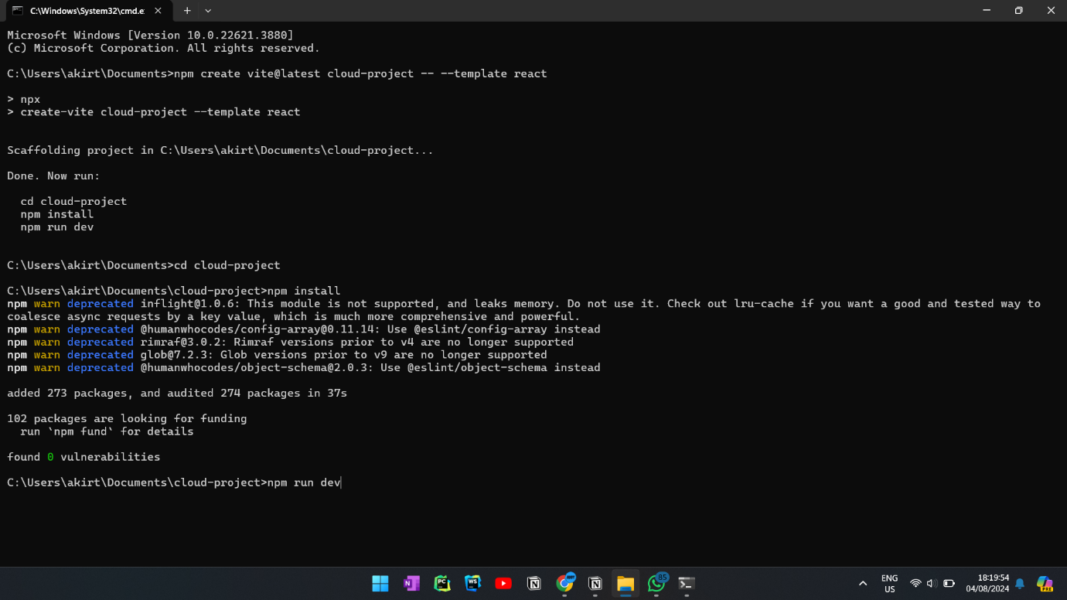

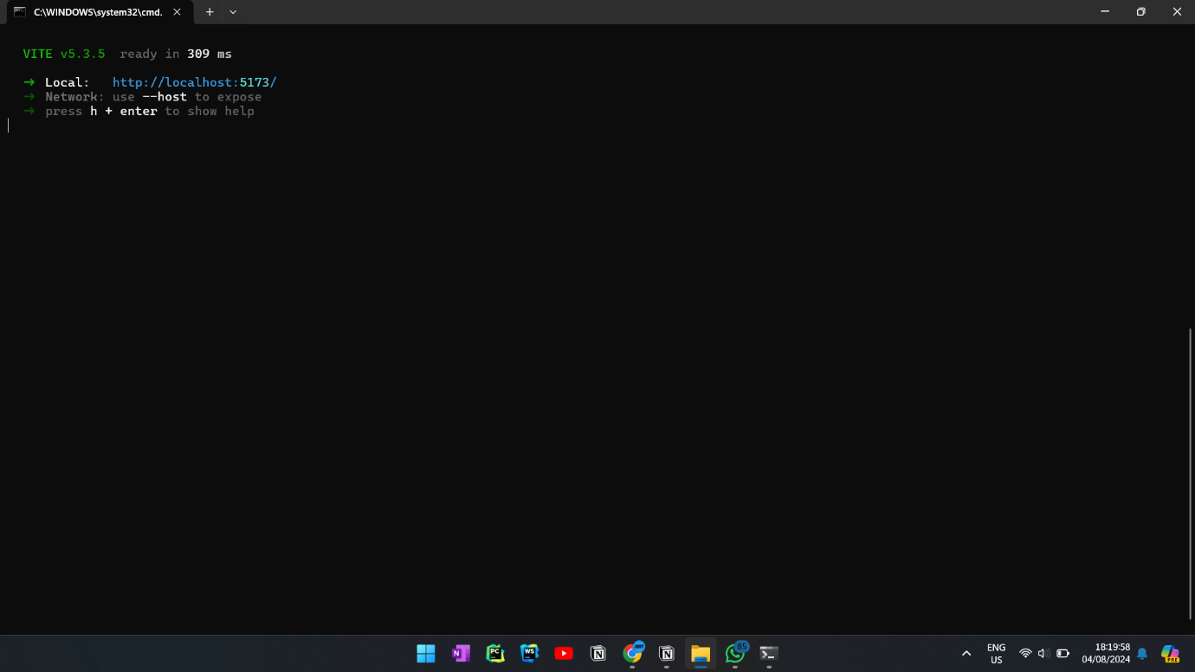

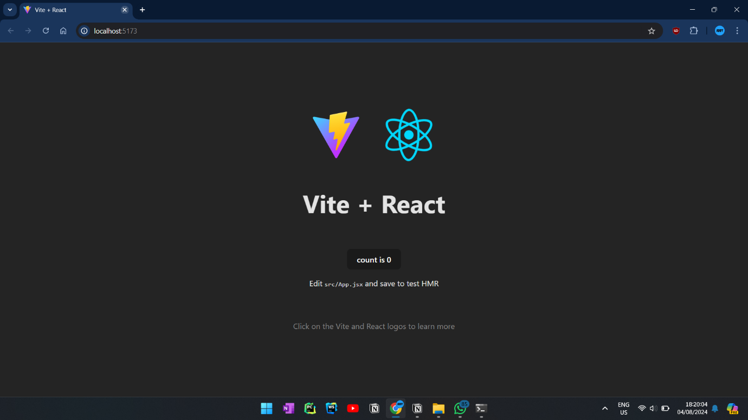

1. **Initializing Git Repository & Connecting to GitHub**

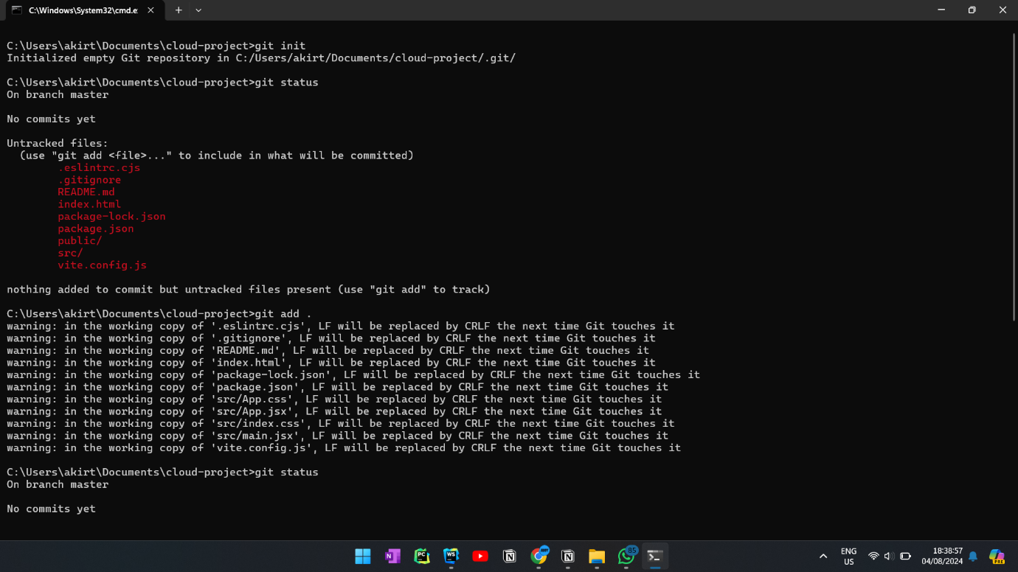

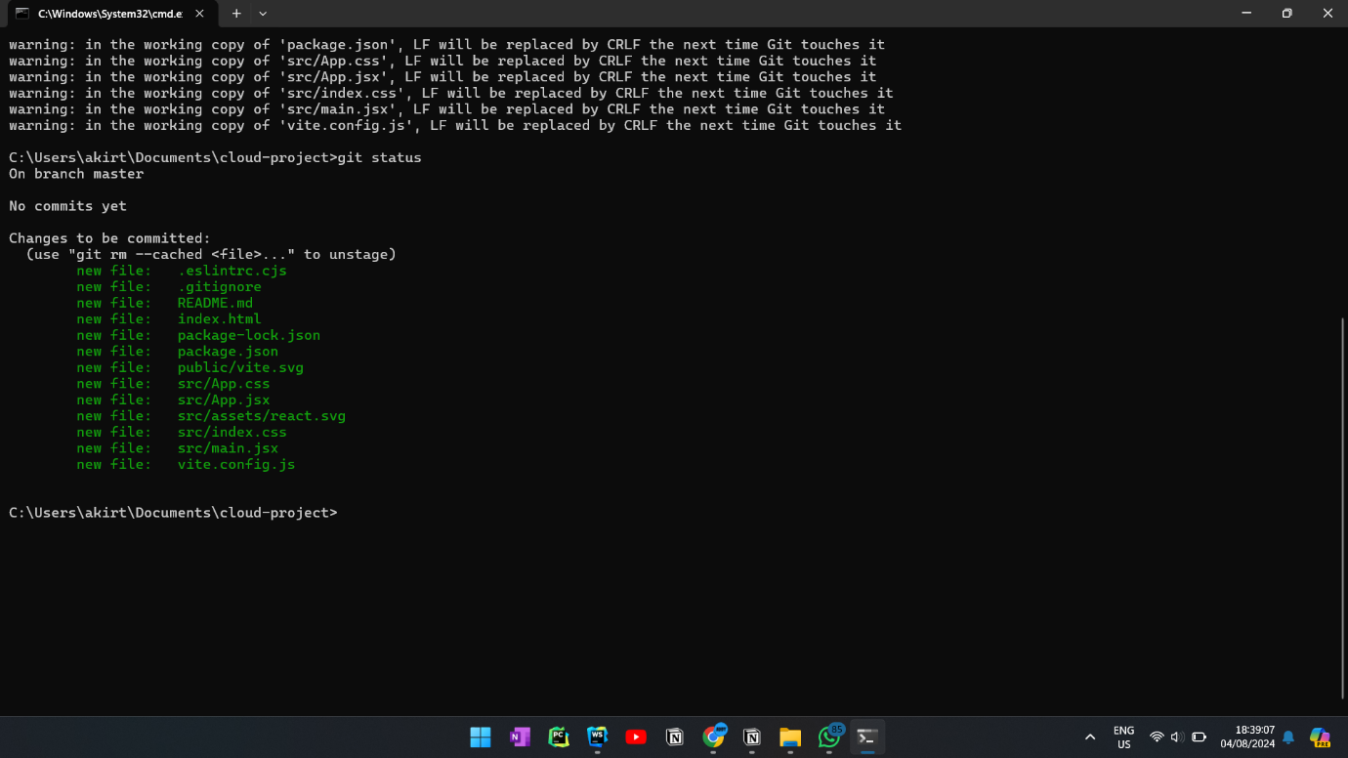

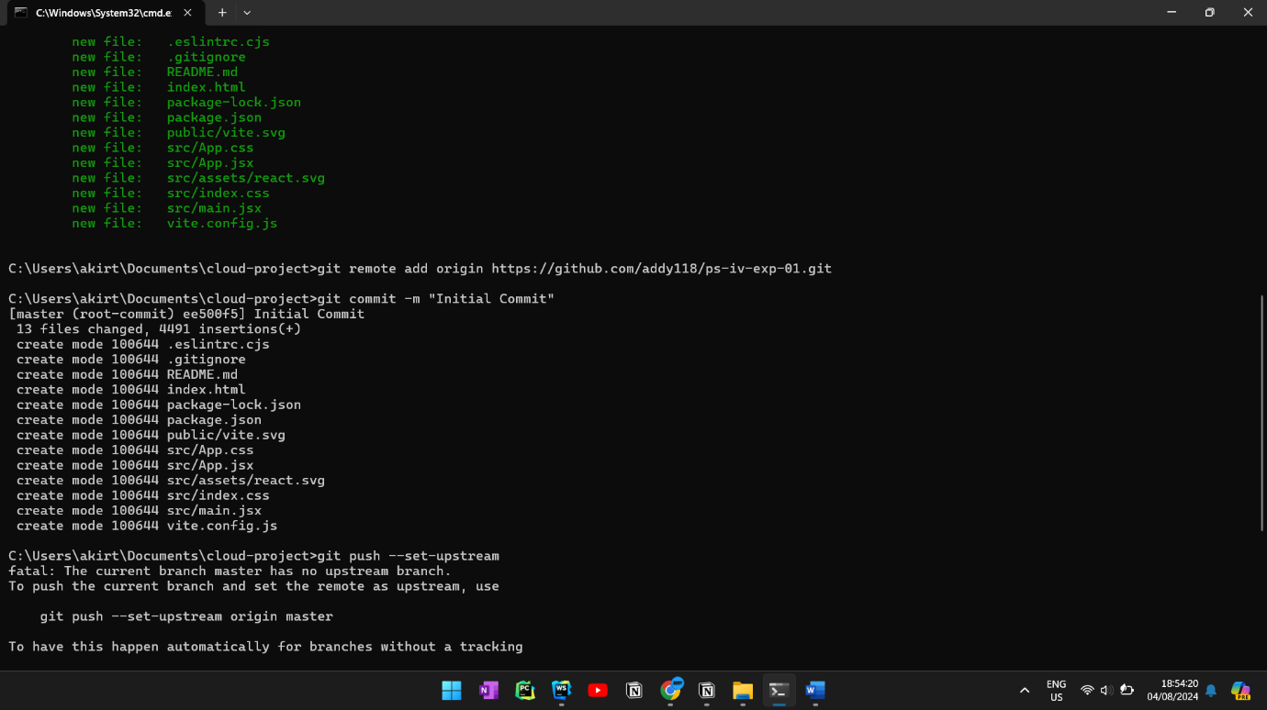

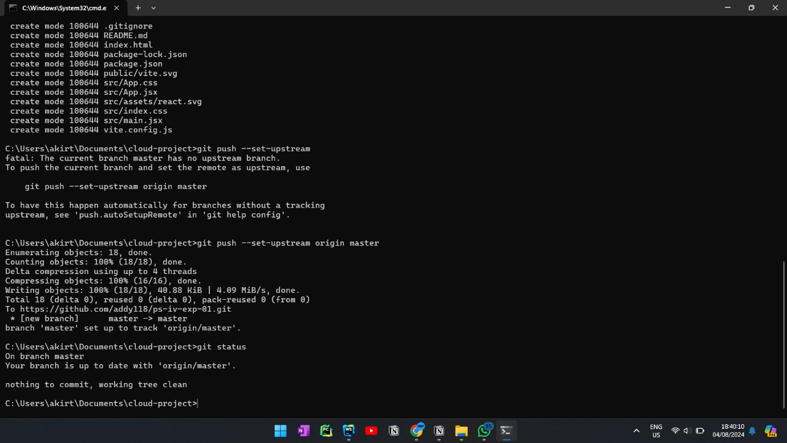

1. **Deploying with AWS Amplify:** <https://master.d1qn6phllk0jv4.amplifyapp.com/>

