**EXPERIMENT NO: - 11**

**Aim:** To implement application that uses cloud services to create machine learning model

**Learning Objectives:**

* To create machine learning model with the help of cloud services.
* Train and evaluate the machine learning model with the help of cloud services.

**Software/Tools Required:** Amazon Web Services (AWS)

**Theory:**

Using AWS SageMaker for the implementation of a machine learning application necessitates an organized approach that combines model training, data preparation, and cloud deployment. A fully managed service called SageMaker offers resources for creating, refining, and implementing machine learning models on a large scale. Because of this, it's the perfect option for developers and data scientists who want to concentrate on creating models rather than worrying about the supporting systems.

Any machine learning project must begin with data preparation, which is gathering, organizing, and converting data into a format that can be used for training. Amazon S3, a scalable object storage service offered by AWS, is a storage option for data. After uploading their datasets to S3, users can use SageMaker's integrated data processing features. For example, users can see and preprocess data with SageMaker Data Wrangler without requiring complex scripting. This covers feature engineering, data normalization, and handling missing values—all of which are essential for enhancing model performance.

Once the data is prepared, the next step is model training. SageMaker offers a range of built-in algorithms optimized for various machine learning tasks, including regression, classification, and clustering. Users can also bring their own custom models or leverage popular frameworks such as TensorFlow, PyTorch, or Scikit-learn. SageMaker handles the underlying infrastructure, allowing users to easily scale their training jobs using powerful GPU or CPU instances. During training, SageMaker provides real-time metrics and logs, enabling users to monitor the model's performance and make necessary adjustments.

It's crucial to assess the model's performance using a different test dataset after it has been trained. With the use of integrated assessment metrics, SageMaker offers instruments for evaluating model accuracy. Using SageMaker's Hyperparameter Tuning Jobs, which automate the search for the best-performing model configurations, users can evaluate results and fine-tune hyperparameters. Better predictions in practical applications result from this iterative training and assessment process, which also makes sure the final model is robust and well-generalized to new data.

**Result/Output:**

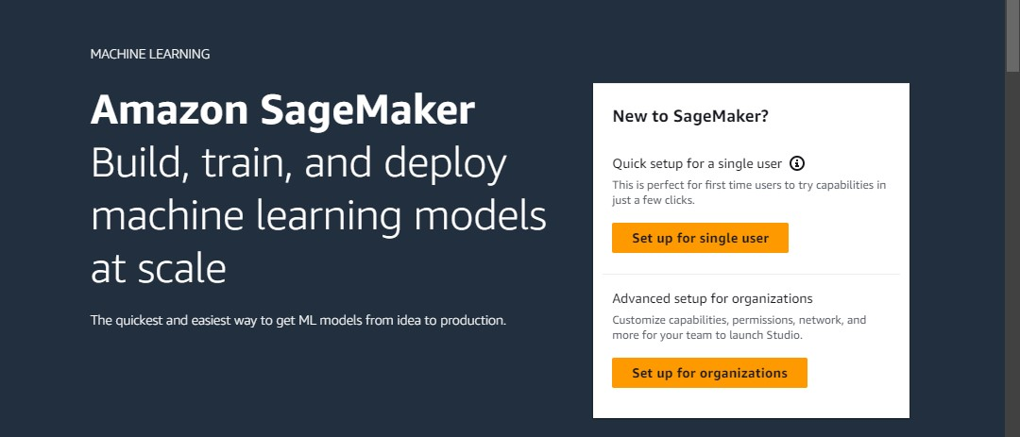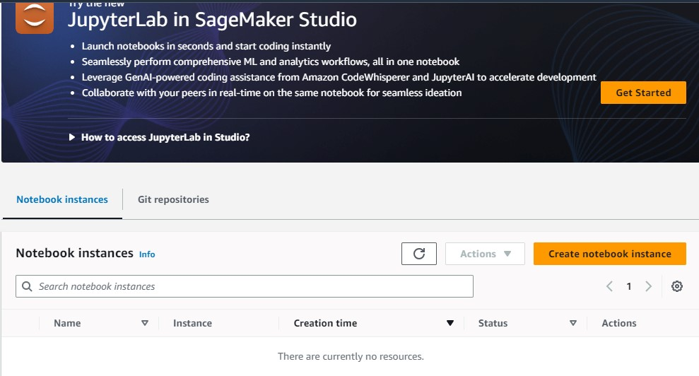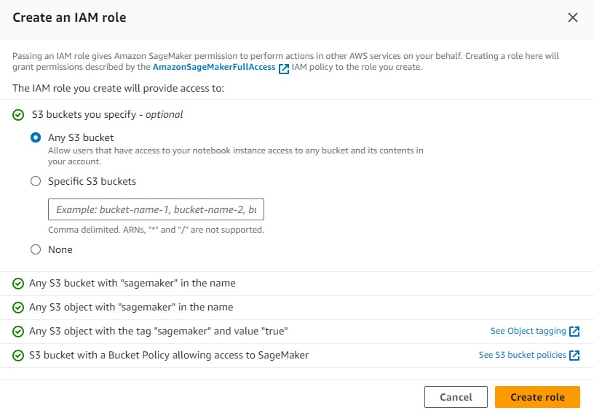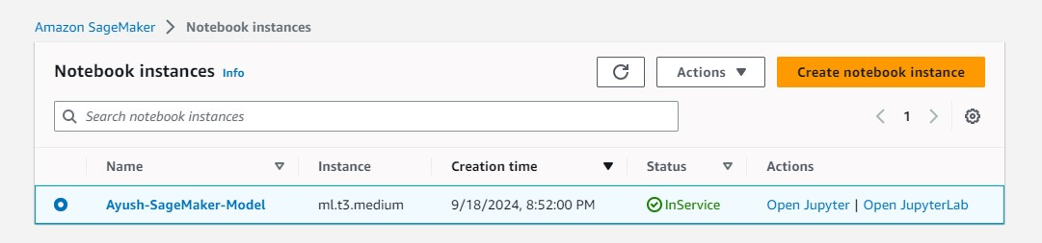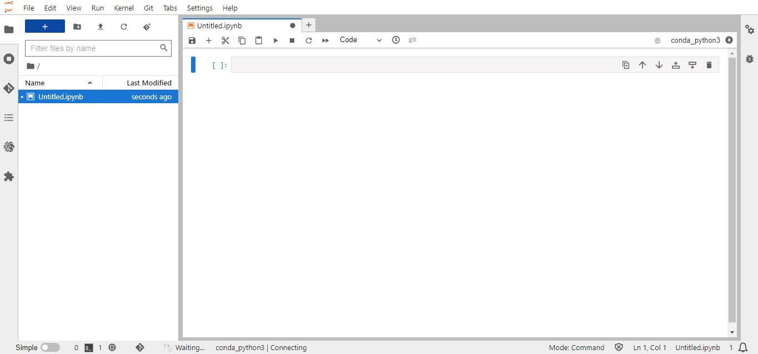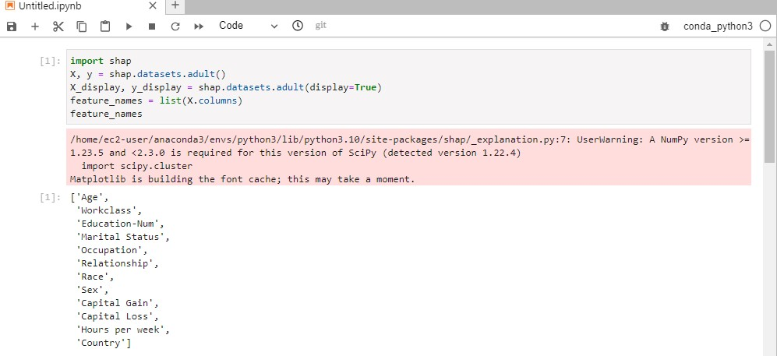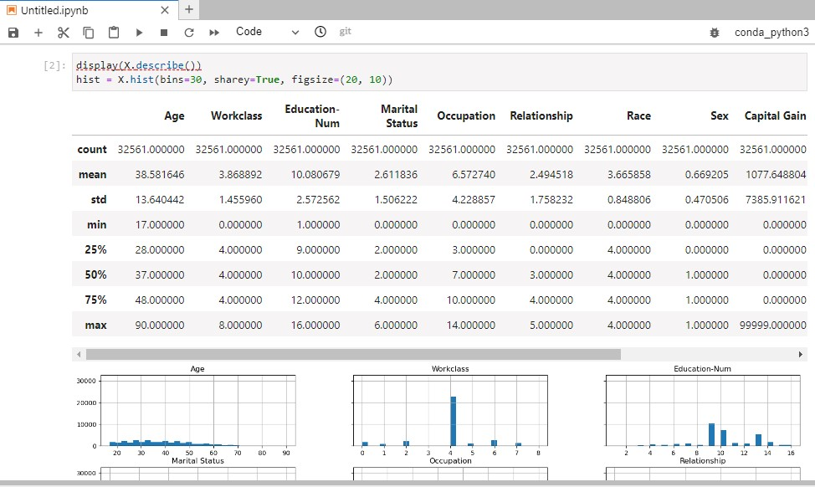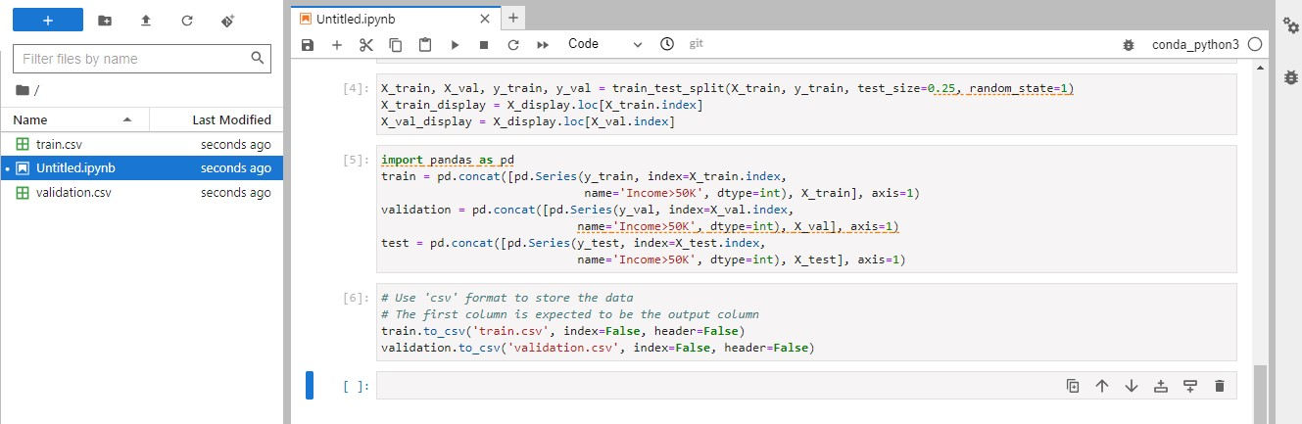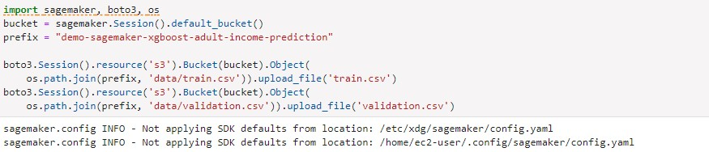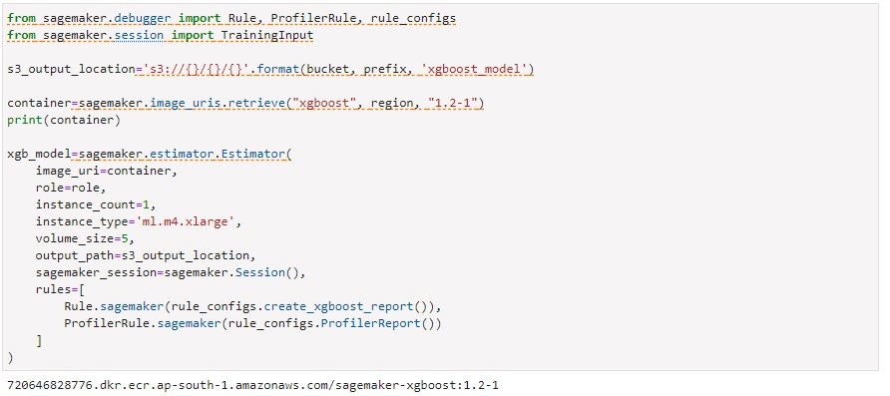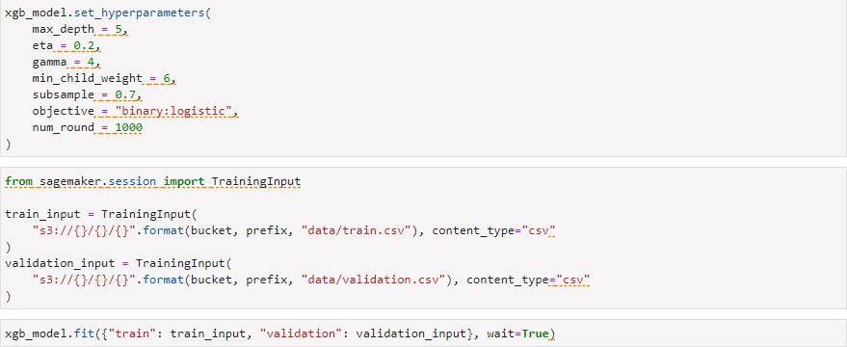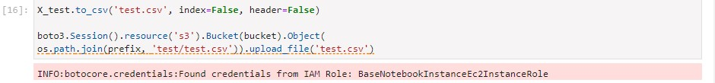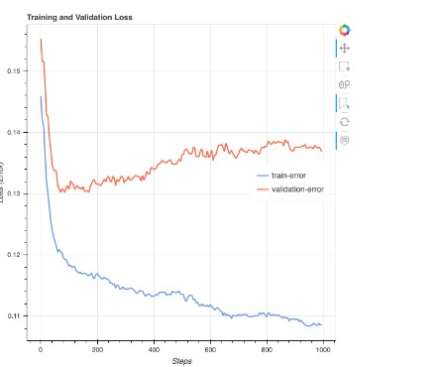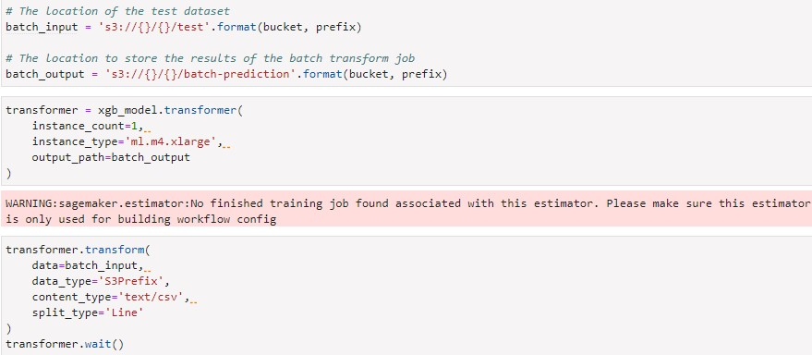

**Conclusion:** To sum up, AWS SageMaker provides a strong and effective framework for creating machine learning applications by combining model training, deployment, assessment, and data preparation into a streamlined process. Because of its managed services, developers and data scientists can concentrate on creating superior models rather than worrying about the intricacies of infrastructure administration. With capabilities like scalable training materials, automatic data processing, and ongoing monitoring, SageMaker guarantees that users can build resilient and adaptable machine learning systems that produce precise forecasts in practical situations.