**EXPERIMENT NO: - 12**

**Aim:** To implement Natural Language API service of Cloud Services.

**Learning Objectives:**

**●** To use Natural Language API of Cloud Services.

**Software/Tools required:** Amazon Web Services (AWS)

**Theory:**

With the help of Amazon Comprehend, a potent natural language processing (NLP) technology, developers can extract meaning and insights from text. Amazon Comprehend is able to extract meaningful information from vast amounts of unstructured text, including entities, key phrases, sentiment, and themes, by utilizing machine learning algorithms. With the help of this service, companies may increase text analysis automation, boost text-based decision-making processes, and improve client experiences.

The capacity of Amazon Comprehend to recognize and classify entities—such as individuals, groups, places, dates, and more—within text is one of its primary features. Users may now effectively filter and arrange data, which facilitates the extraction of pertinent insights from papers, customer reviews, and social media content. The service also includes key phrase extraction, which helps with content indexing and summarizing by helping users identify the most important terms in a text.

The sentiment analysis capability of Amazon Comprehend is another noteworthy feature. It can identify the emotional tone of a text and classify it as positive, negative, neutral, or mixed. Businesses looking to determine customer sentiment via reviews, polls, or social media interactions will find this functionality especially useful. Through comprehending customer feedback regarding their offerings, companies can arrive at well-informed judgments and execute focused enhancements.

Language detection is another feature of Amazon Comprehend that helps identify the language of the text being processed automatically. This makes it possible for multinational companies that handle multilingual data to process and analyze content more effectively. Additionally, companies can improve the accuracy of domain-specific terms by customizing the service with a bespoke vocabulary, which increases the relevancy of the insights produced.

**Result/Output:**

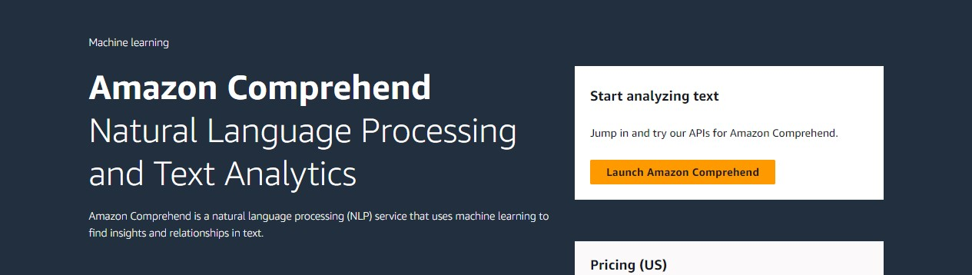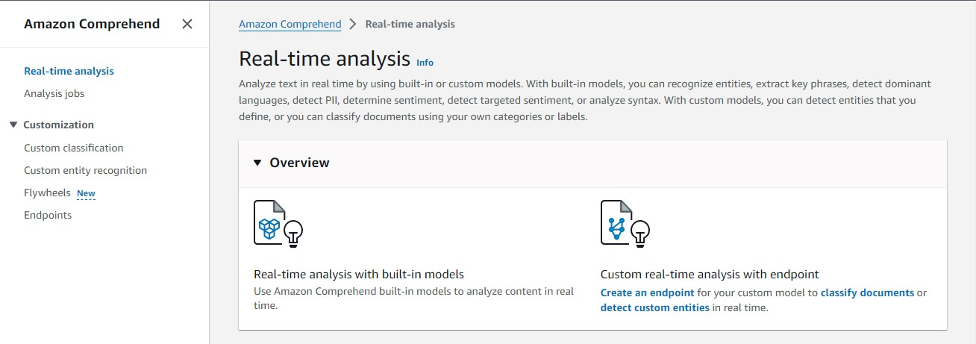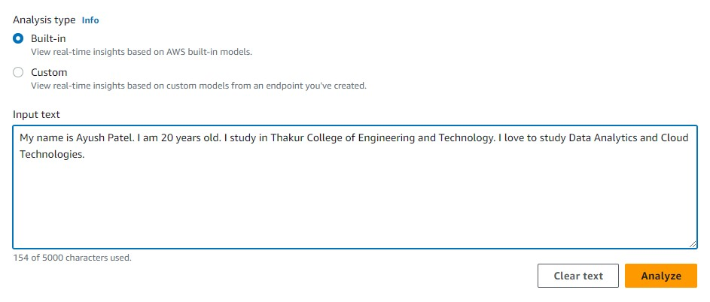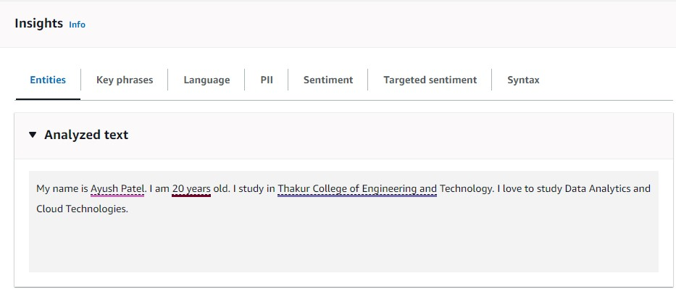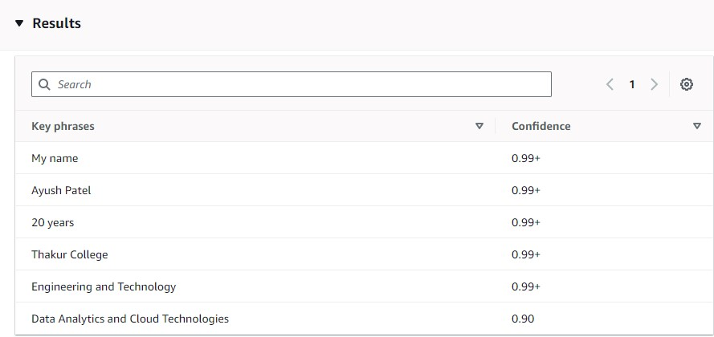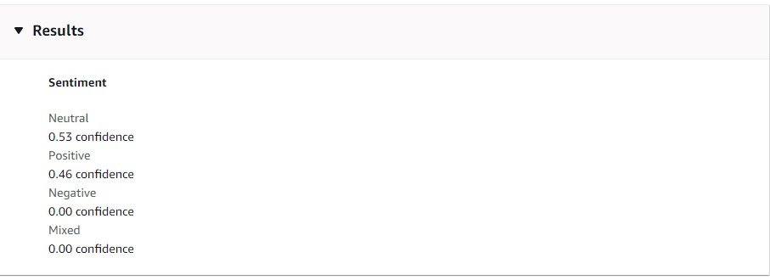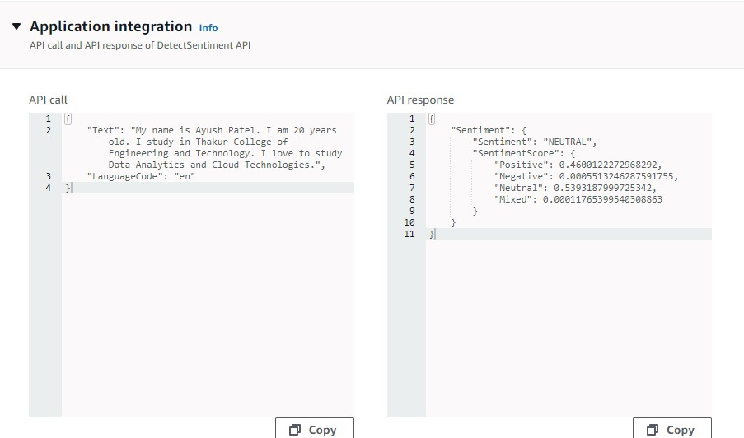

**Conclusion:** In conclusion, businesses may extract valuable insights from unstructured text data by using Amazon Comprehend, a complete and potent natural language processing technology. Businesses can automate text analysis using its capabilities, which span from entity recognition and sentiment analysis to language detection and key word extraction. This gives them a better grasp of customer patterns and sentiment. Utilizing Amazon Comprehend helps businesses increase customer satisfaction, make better decisions, and streamline processes. In an increasingly data-driven world, it's a priceless tool.