**EXPERIMENT NO: - 13**

**Aim:** To implement the application that converts audio to text with the help of cloud services.

**Learning Objectives:**

* To convert audio to text with the help of cloud services.
* To convert multiple languages (like Hindi) into text with the help of cloud services.

**Software/Tools Used:** Amazon Web Services (AWS)

**Theory:**

You would use Amazon Transcribe, a service created especially for automatic speech recognition (ASR), to construct an application that uses AWS to convert audio to text. Amazon Transcribe is perfect for applications like data analysis from spoken information, accessibility aids, and transcription services because it enables developers to translate spoken language in audio files into written text. The quality and usability of the transcriptions are improved by features like speaker recognition and bespoke terminology, which are supported in many languages.

The transcription process is asynchronous, so once it's underway, you can use your program to work on other projects while you wait for the results. You can monitor the project's progress till it is finished on a regular basis. After transcription is finished, the output can be accessed using a URL that Amazon Transcribe sends you. This URL leads to a JSON file that has the text that has been transcribed along with extra metadata. This method simplifies the process and makes it simple to incorporate into different applications.

You might create a web interface that lets users upload audio files to be processed by Amazon Transcribe in order to improve the user experience. The outcomes may be kept in a database for later examination or shown on the webpage. Amazon Transcribe can be used in conjunction with other AWS services such as Lambda for serverless processing and S3 for storage to construct a reliable and scalable application that effectively manages audio-to-text conversion.

**Result/Output:**

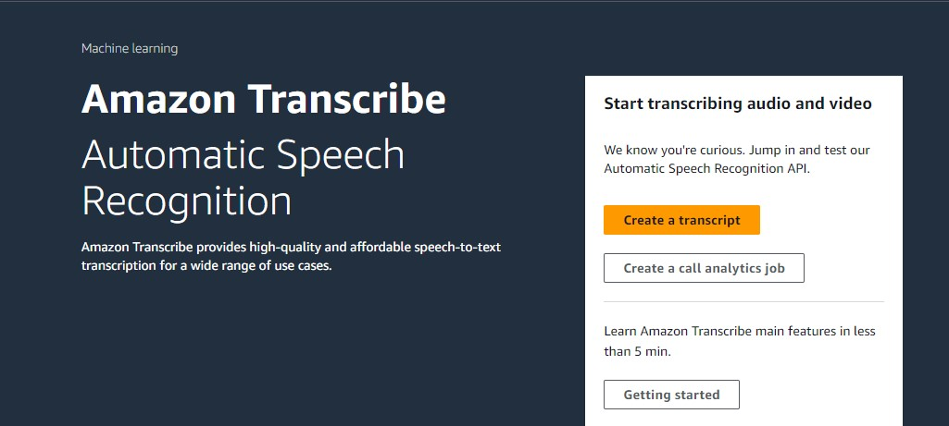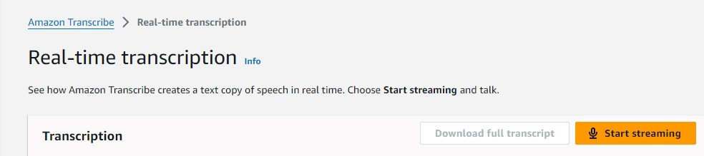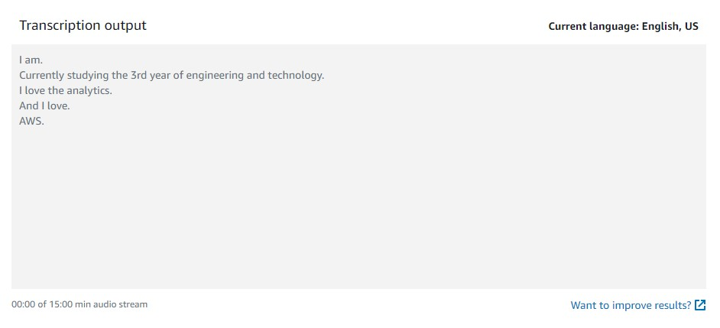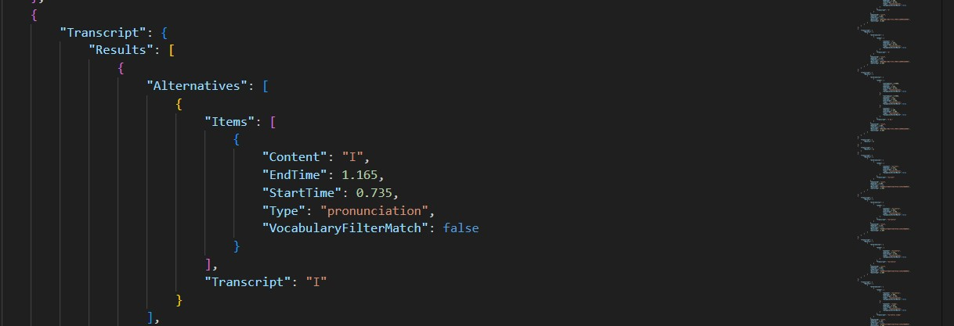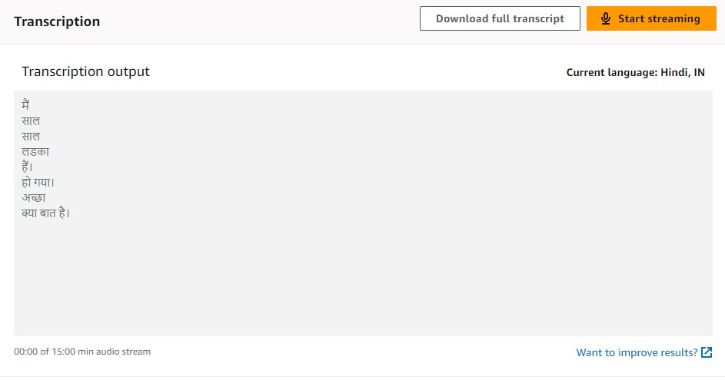

**Conclusion:** To sum up, developers wishing to incorporate voice recognition into their apps have a reliable and effective option when using Amazon Transcribe for audio-to-text conversion. Transcribing audio files or streams is made simple for users by utilizing AWS's capability, opening up a plethora of applications, from accessibility improvements to transcription services. The service may be tailored to meet different demands thanks to its capabilities, which include speaker identification, support for numerous languages, and real-time processing. All things considered, Amazon Transcribe improves the usefulness of audio content in a variety of industries while also streamlining the process of turning speech to text.