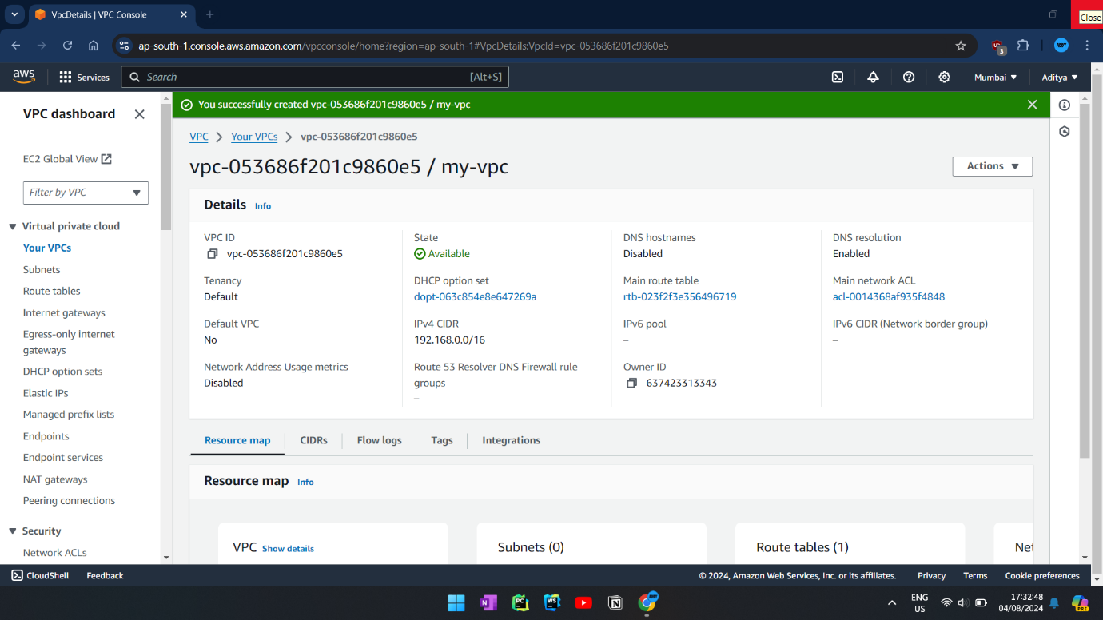**VPC:**

**SUBNET:**

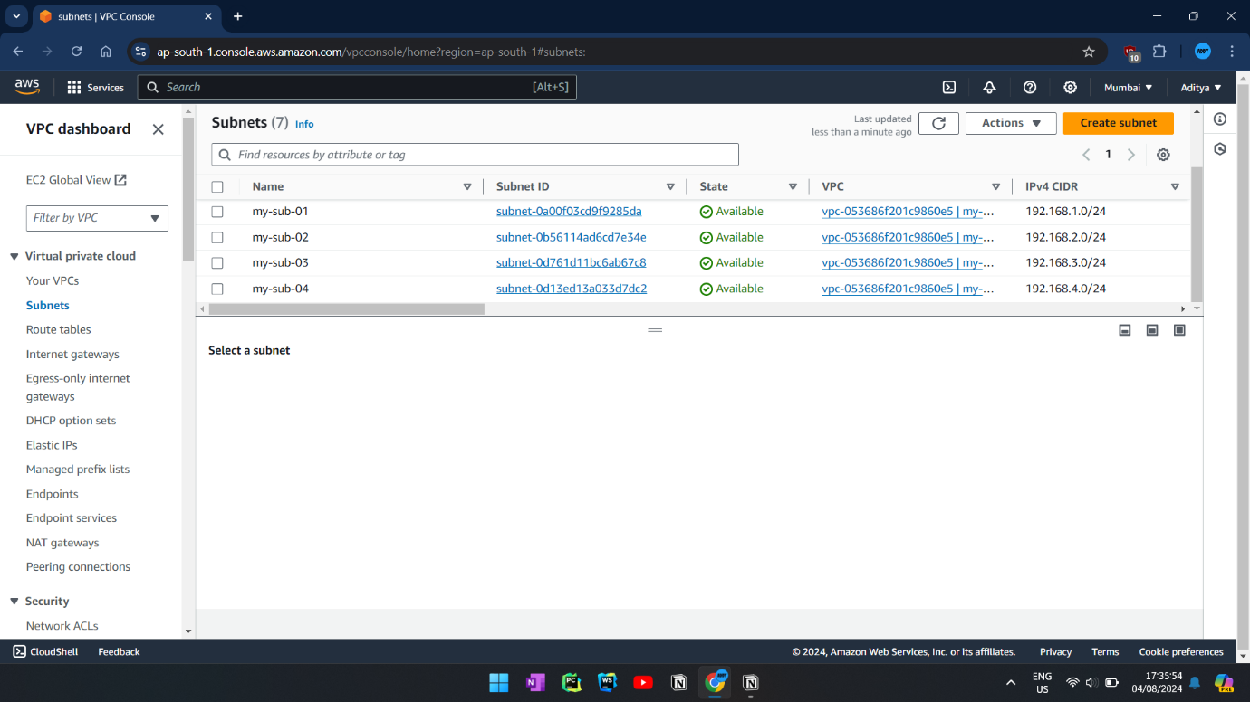

**EC2 INSTANCE:**

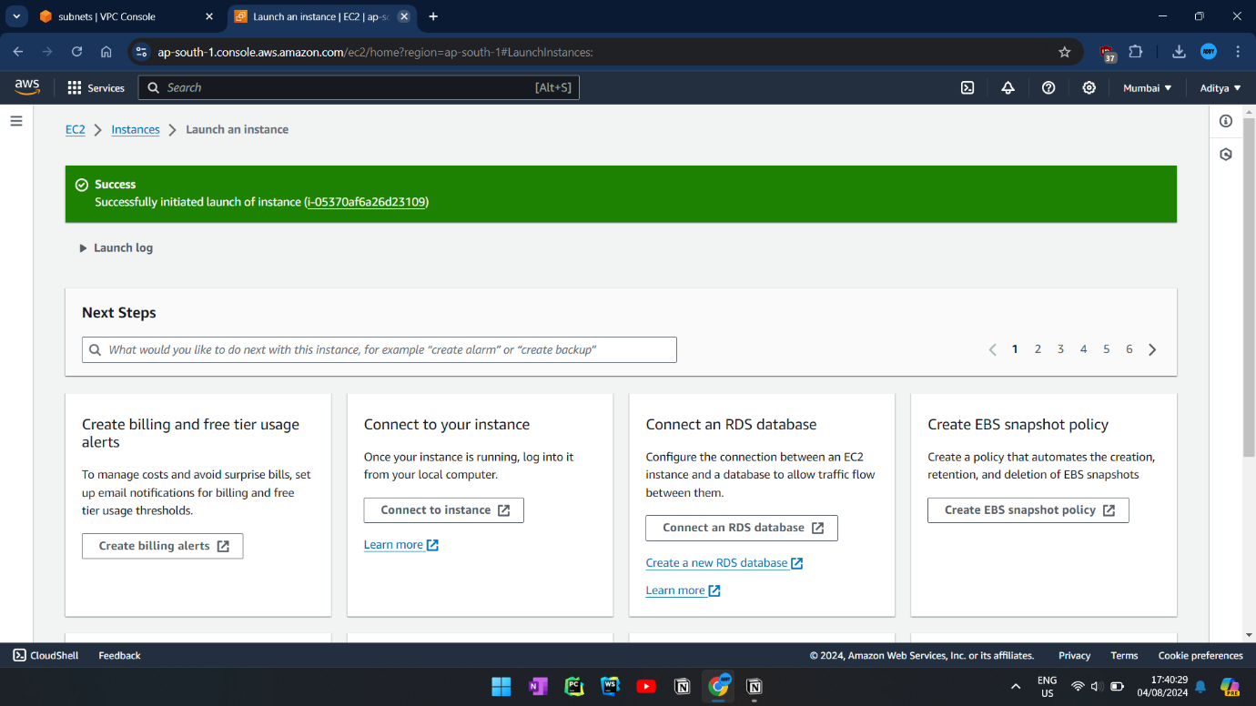

**ERROR CONNECTING:**

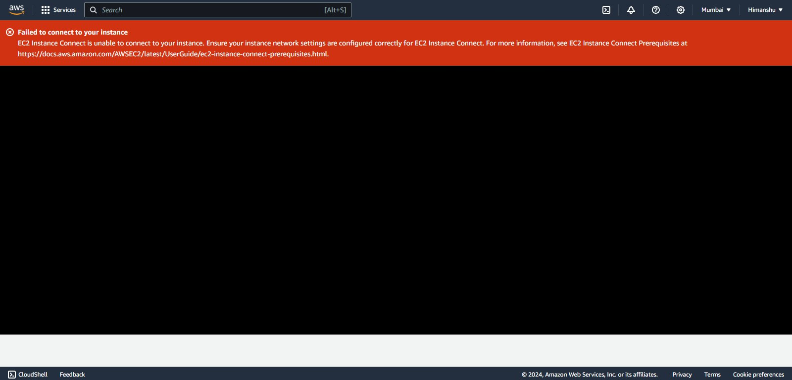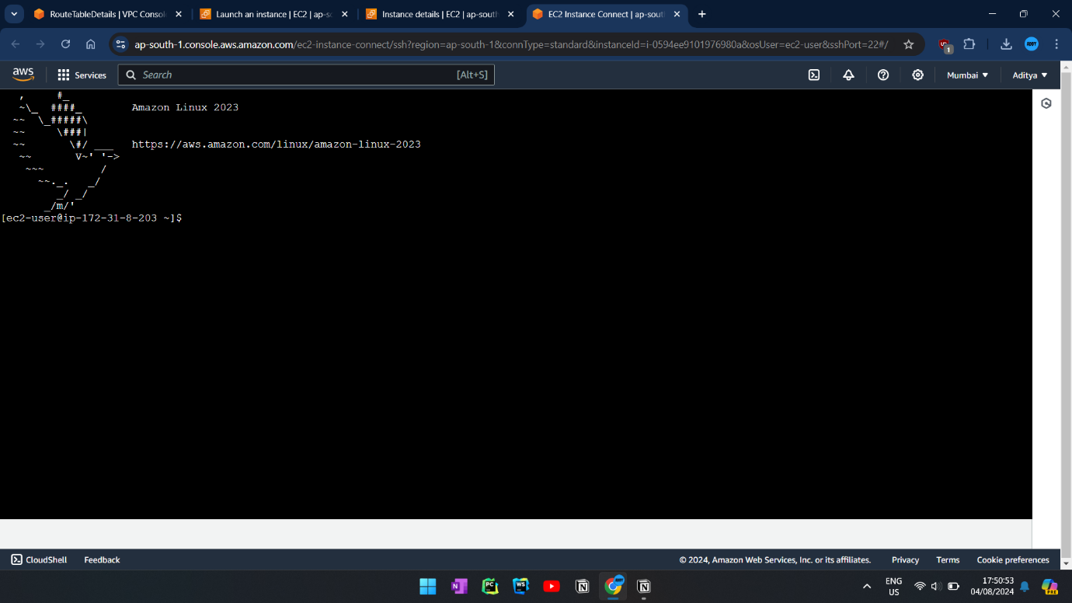

**INTERNET GATEWAY:**

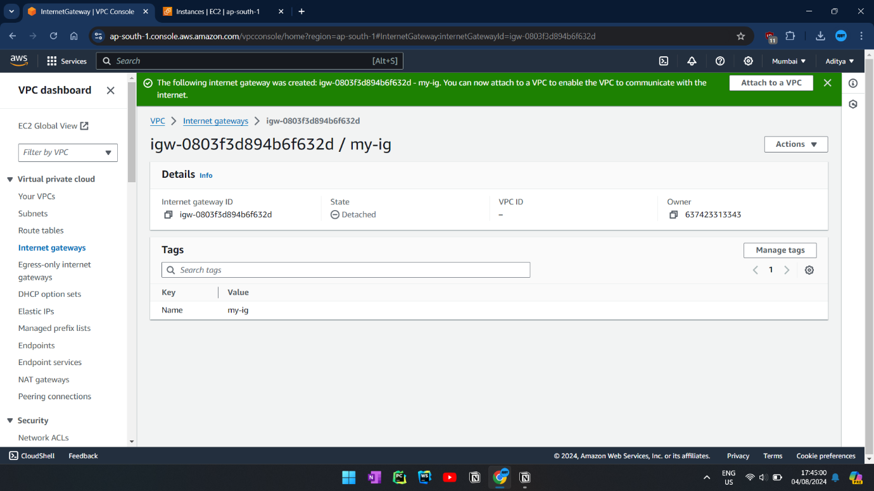

**INTERNET GATEWAY WITH VPC:**

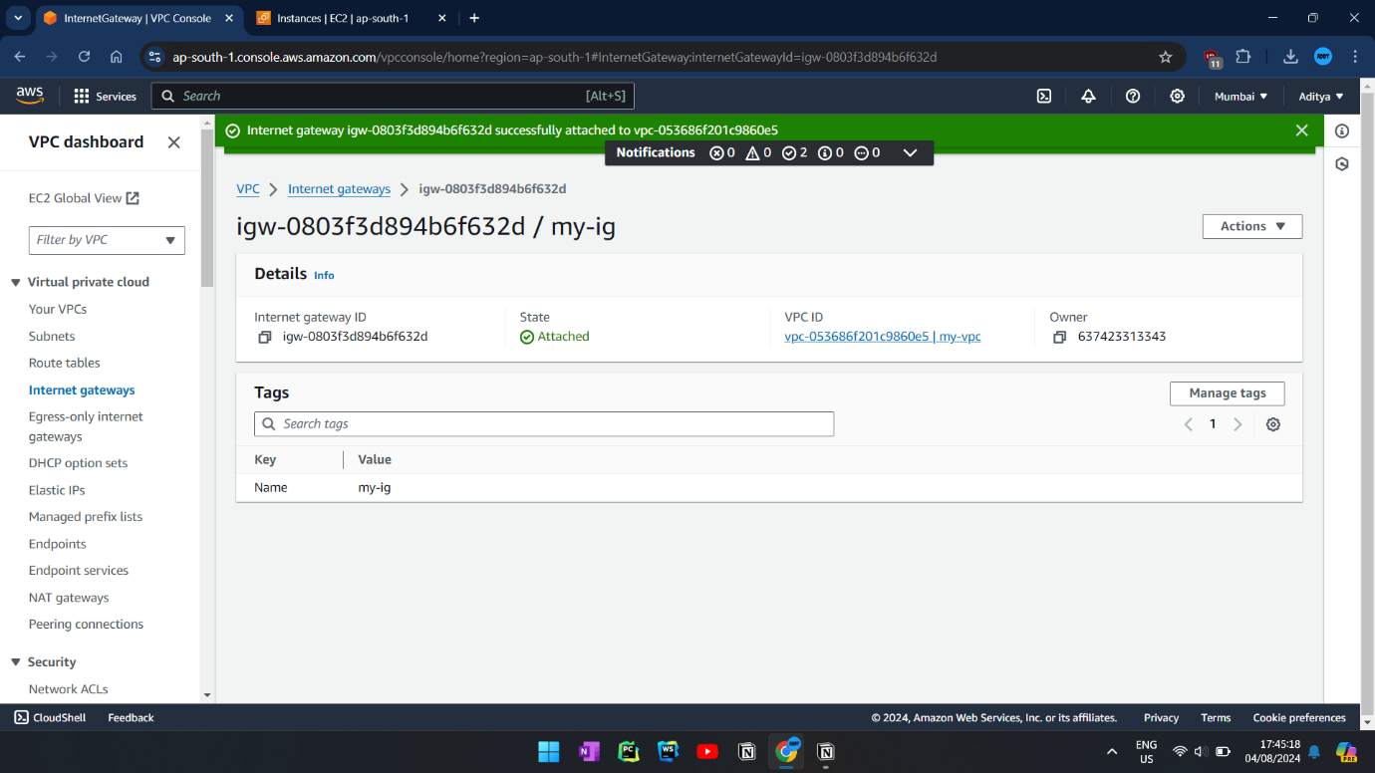

**ROUTE TABLE WITH IG:**

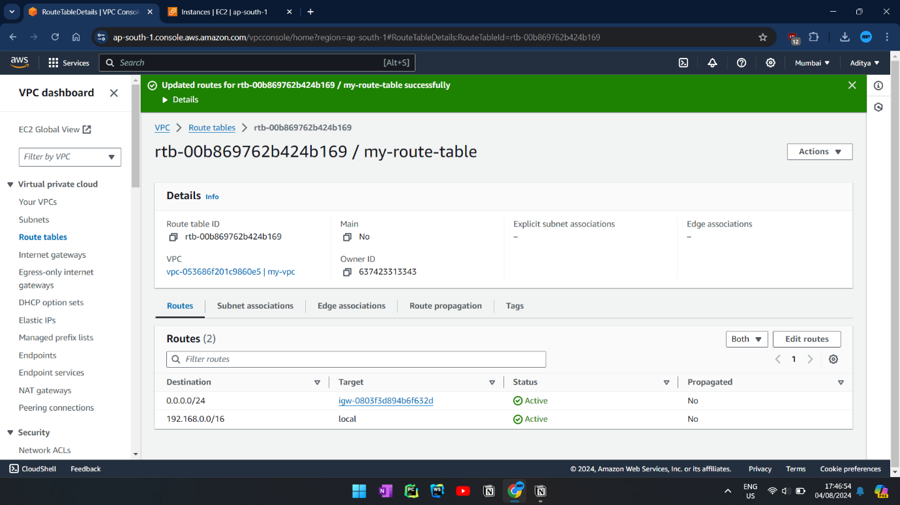

**ROUTE TABLE WITH SUBNET ASSOCIATION:**

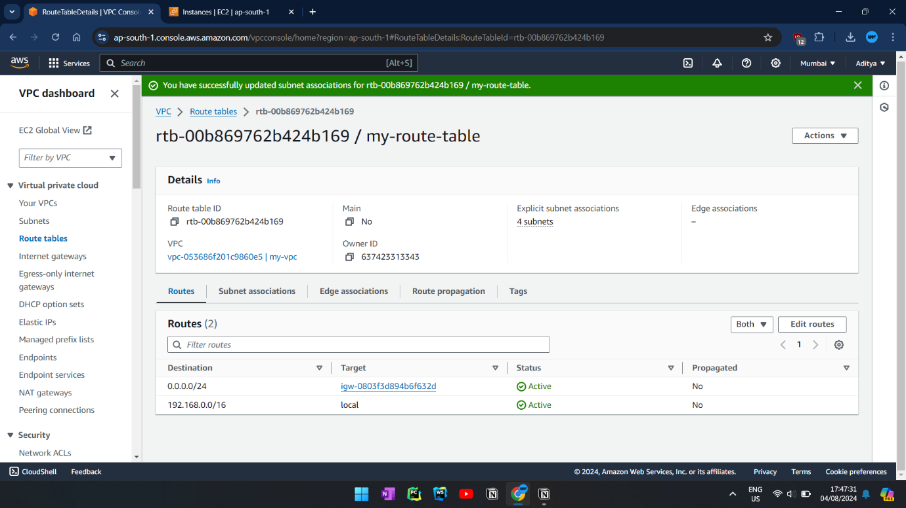

**EC2 CONNECTION:**

