**Experiment 8: Create API and access the cloud services using the API.**

**Aim:** Create API and access the cloud services using the API.

**Learning Objective:**

Learn to design, implement, and deploy APIs to interact with cloud services for automating and managing resources securely.

**Tools:** AWS

**Theory:**

1. Introduction to Creating APIs and Accessing Cloud Services

* **Purpose of APIs**: APIs (Application Programming Interfaces) facilitate communication between applications and cloud services, allowing you to programmatically manage and interact with cloud resources. By using APIs, you can automate tasks, integrate services, and streamline operations.
* **Types of APIs**: Cloud providers offer various APIs for different services. For instance, AWS provides REST APIs through services like AWS API Gateway for creating and managing APIs, and SDKs like Boto3 for Python to interact with AWS services. Understanding the specific API types and their use cases is crucial for effective cloud management.

1. Creating and Configuring an API

* **Defining Endpoints**: When creating an API, define endpoints that correspond to specific operations (e.g., creating a new database instance or uploading a file). Each endpoint should have a clear purpose and support the appropriate HTTP methods (GET, POST, PUT, DELETE).
* **Configuring API Settings**: Set up authentication, such as API keys or OAuth tokens, to secure access. Configure request and response formats, and implement error handling and rate limiting to ensure robust and reliable API performance.

1. Integrating the API with Cloud Services

* **Connecting to Cloud Services**: Use cloud provider SDKs or directly make API calls to interact with cloud resources (e.g., creating EC2 instances or managing S3 buckets). Ensure that your API is correctly configured to handle these interactions, including setting up necessary permissions and access controls.
* **Security Considerations**: Implement security best practices, such as using HTTPS to encrypt data in transit and configuring IAM roles or permissions to control access to cloud resources.

1. Testing and Verification

* **Testing API Functionality**: Test your API by making requests to the endpoints and verifying that they perform the expected actions on cloud services. Use tools like Postman or curl for manual testing, and write automated tests to ensure consistent behaviour.
* **Verifying Cloud Integration**: Check that the API correctly interacts with cloud services by verifying that resources are created, modified, or deleted as intended. Monitor API responses and cloud service states to ensure proper functionality.

1. Best Practices for API Management

* **Documentation and Versioning**: Document your API endpoints, request parameters, and response formats clearly. Implement versioning to manage changes and ensure backward compatibility.
* **Monitoring and Logging**: Use cloud-based monitoring tools like AWS CloudWatch to track API performance and log requests and responses. This helps in identifying issues, optimizing performance, and maintaining security.

**Implementation:**

1. Create a Lambda Function

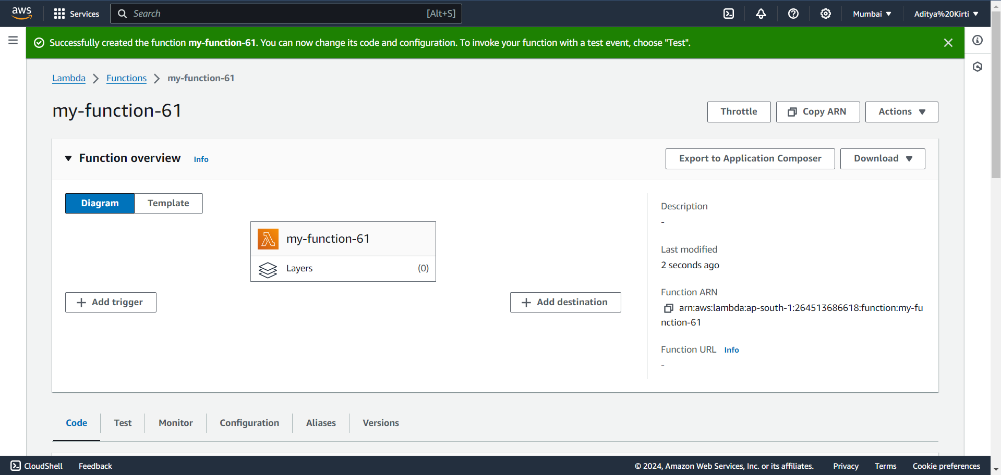

1. Create an HTTP API

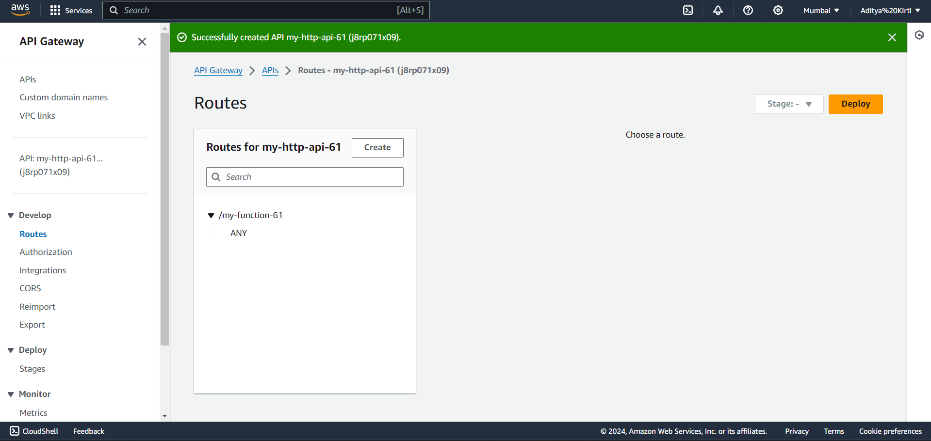

1. Test your API

