## Experiment - 10

## Aim: To explore and configure various parameters and tools for effective monitoring and management of cloud services.

## Learning Objectives:

* Learners will understand the importance of cloud monitoring and management in maintaining optimal performance and security.
* Learners will be able to identify key metrics and parameters for monitoring different cloud services.
* Learners will gain hands-on experience with popular cloud monitoring and management tools.
* Learners will be able to set up alerts and automated responses to specific events or thresholds.

## Tools:

Cloud provider's native monitoring tools (e.g., Amazon CloudWatch, Azure Monitor, Google Cloud Monitoring), third-party monitoring solutions (e.g., Datadog, New Relic, Prometheus)

## Theory:

### Cloud Monitoring and Management

Cloud monitoring and management involve the continuous observation, analysis, and control of cloud resources and services to ensure optimal performance, availability, and security. Key aspects include:

1. Performance Monitoring: Tracking resource utilization, response times, and throughput.
2. Availability Monitoring: Ensuring services are accessible and functioning as expected.
3. Security Monitoring: Detecting and responding to potential security threats.
4. Cost Monitoring: Tracking and optimizing cloud spending.

### Key Monitoring Parameters

Different cloud services require monitoring of various parameters:

1. Compute (VMs, containers):
   * CPU utilization
   * Memory usage
   * Disk I/O
   * Network throughput
2. Storage:
   * Disk space usage
   * Read/write latency
   * I/O operations per second (IOPS)
3. Databases:
   * Query performance
   * Connection count
   * Buffer cache hit ratio
4. Networking:
   * Bandwidth utilization
   * Packet loss
   * Latency
5. Application Performance:
   * Response time
   * Error rates
   * Request count

### Cloud Monitoring Tools

Cloud providers offer native monitoring solutions:

1. Amazon CloudWatch
2. Azure Monitor
3. Google Cloud Monitoring

These tools provide:

* Metrics collection and visualization
* Log analytics
* Alerting capabilities
* Integration with other cloud services

Third-party monitoring tools often offer multi-cloud support and advanced features:

1. Datadog
2. New Relic
3. Prometheus with Grafana

### Best Practices for Cloud Monitoring

1. Define clear monitoring objectives aligned with business goals.
2. Implement a comprehensive monitoring strategy covering all critical resources and services.
3. Set up meaningful alerts with appropriate thresholds to avoid alert fatigue.
4. Use automation for routine tasks and responses to common issues.
5. Regularly review and update monitoring configurations as your infrastructure evolves.
6. Implement proper access controls and security measures for monitoring tools.

## Implementation:

1. Set up access to your cloud provider's monitoring tool or a third-party solution.
2. Configure basic monitoring for a sample application or infrastructure: a. Set up CPU and memory monitoring for virtual machines. b. Configure network traffic monitoring for load balancers. c. Set up database performance monitoring.
3. Create custom dashboards to visualize key metrics.
4. Configure alerts for critical thresholds: a. Set up an alert for high CPU usage on a VM. b. Create an alert for elevated error rates in your application.
5. Explore log analytics capabilities: a. Set up log collection for your application. b. Create queries to analyze log data for specific events or errors.
6. Implement an automated response to a specific alert (e.g., auto-scaling a service based on CPU usage).
7. Explore cost monitoring features and set up budget alerts.
8. Review the monitoring setup and make adjustments as needed.

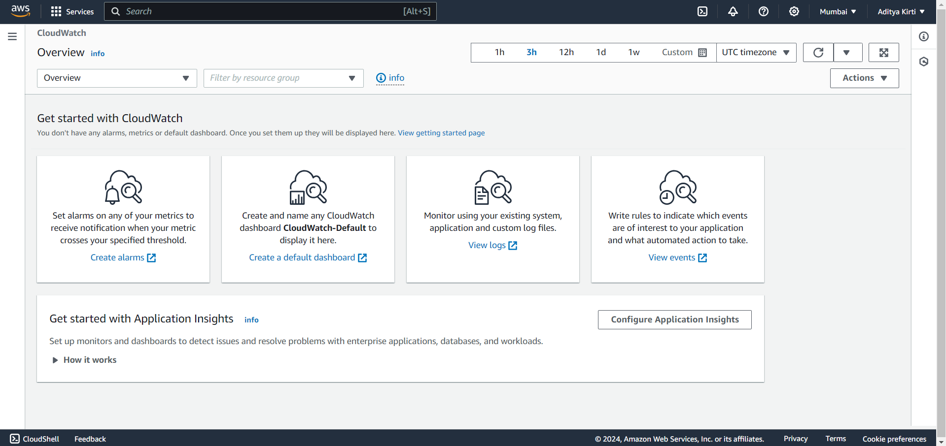

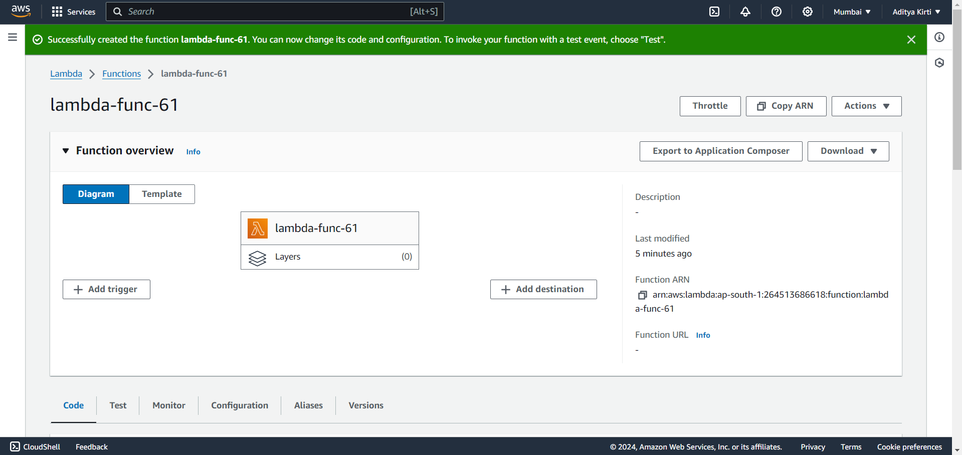

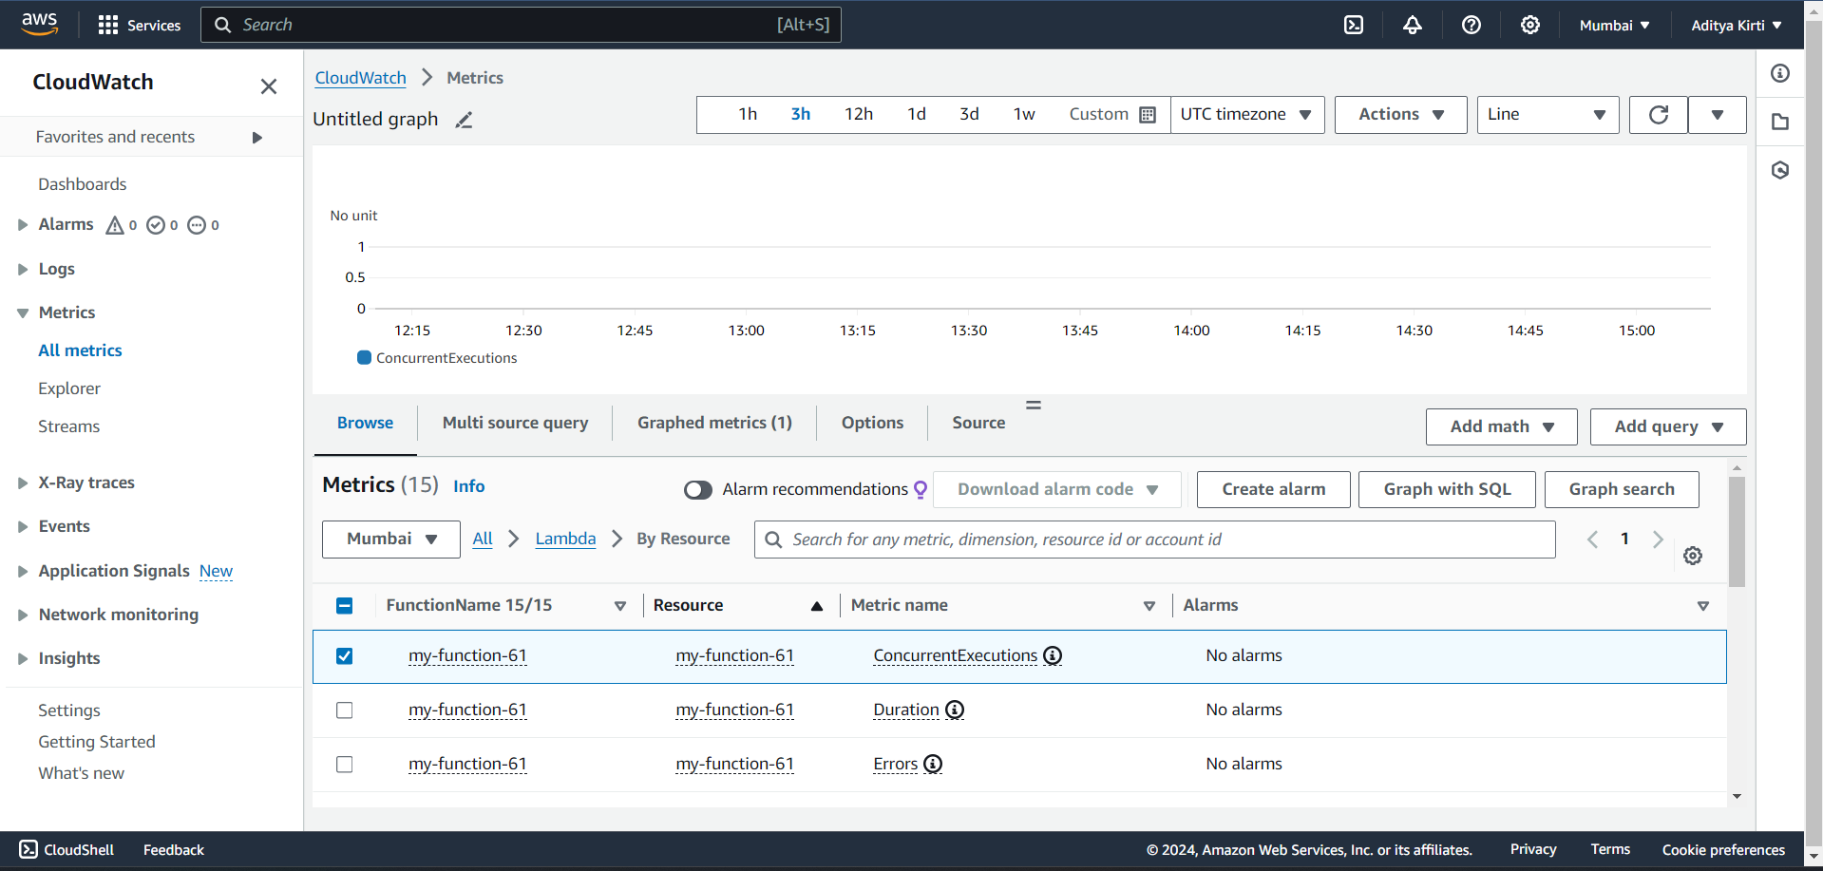

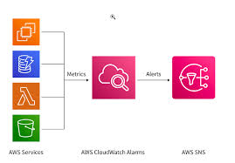

## Lab Outcome:

* Successfully configure monitoring for various cloud services using both native and third-party tools.
* Demonstrate the ability to create meaningful dashboards and alerts for cloud resources.
* Apply best practices in cloud monitoring and management to ensure optimal performance and security.
* Understand the importance of continuous monitoring and how it contributes to maintaining a robust cloud infrastructure.

This lab provides hands-on experience with cloud monitoring and management tools, enabling learners to apply these crucial skills in real-world cloud environments. It emphasizes the importance of proactive monitoring in maintaining efficient, secure, and cost-effective cloud operations.