**EXPERIMENT NO: - 14**

**Aim:**  Case study on various standards developed for the efficient use and high security of cloud computing.

**Learning Objectives:**

* To understand the security features of cloud computing.
* To understand the robust and effective security features of cloud computing.

**Software/Tools Required:**  Amazon Web Services (AWS)

**Theory:**

Cloud computing has completely changed the way businesses handle, store, and use data. Concerns about operational effectiveness, data integrity, and security are brought up by this move to cloud settings. To address these issues, a number of standards have been created to help enterprises with their cloud adoption plans.

As a top cloud service provider, Amazon Web Services (AWS) has made a name for itself by upholding a number of industry standards that optimize security and operational effectiveness. Important guidelines like PCI DSS, NIST SP 800-53, and ISO/IEC 27001 help AWS keep its customers' environments safe. Information security management is the main focus of ISO/IEC 27001, which guarantees that AWS has strict procedures in place to safeguard sensitive data. AWS complies with the security and privacy controls outlined in NIST SP 800-53, which helps clients in regulated industries comply. For businesses that process credit cards, PCI DSS is especially important as it requires strict security requirements that AWS incorporates into its services.

The National Institute of Standards and Technology's NIST SP 800-53 is a comprehensive catalog of security and privacy measures that AWS uses to meet compliance obligations, especially for businesses in regulated industries like finance and government. Amazon makes it possible for its clients to more effectively fulfill their own regulatory duties by matching its security measures with these established procedures. Furthermore, every company that handles credit or debit card transactions must to adhere to the PCI DSS standard. Due to its PCI DSS compliance, which guarantees that it satisfies strict standards for protecting cardholder data, AWS is a favoured option for financial institutions and e-commerce companies.

AWS provides a comprehensive range of security services that are intended to enhance data security and simplify compliance procedures in order to meet these criteria. One essential tool that helps businesses create user roles and permissions and make sure that only authorized users have access to particular resources is Amazon Identity and Access Management (IAM). AWS Identity and Access Management (IAM) is a web service that helps you securely control access to AWS resources. With IAM, you can manage permissions that control which AWS resources users can access. You use IAM to control who is authenticated (signed in) and authorized (has permissions) to use resources. IAM provides the infrastructure necessary to control authentication and authorization for your AWS accounts. After a user is set up in IAM, they use their sign-in credentials to authenticate with AWS. Authentication is provided by matching the sign-in credentials to a principal (an IAM user, federated user, IAM role, or application) trusted by the AWS account. Next, a request is made to grant the principal access to resources. Access is granted in response to an authorization request if the user has been given permission to the resource. For example, when you first sign in to the console and are on the console Home page, you aren't accessing a specific service. When you select a service, the request for authorization is sent to that service and it looks to see if your identity is on the list of authorized users, what policies are being enforced to control the level of access granted, and any other policies that might be in effect. Authorization requests can be made by principals within your AWS account or from another AWS account that you trust. Once authorized, the principal can take action or perform operations on resources in your AWS account. For example, the principal could launch a new Amazon Elastic Compute Cloud instance, modify IAM group membership, or delete Amazon Simple Storage Service buckets.

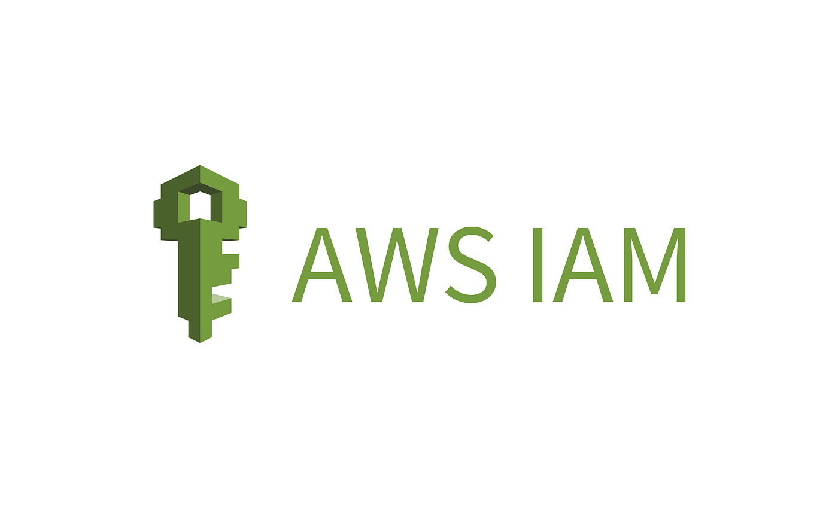

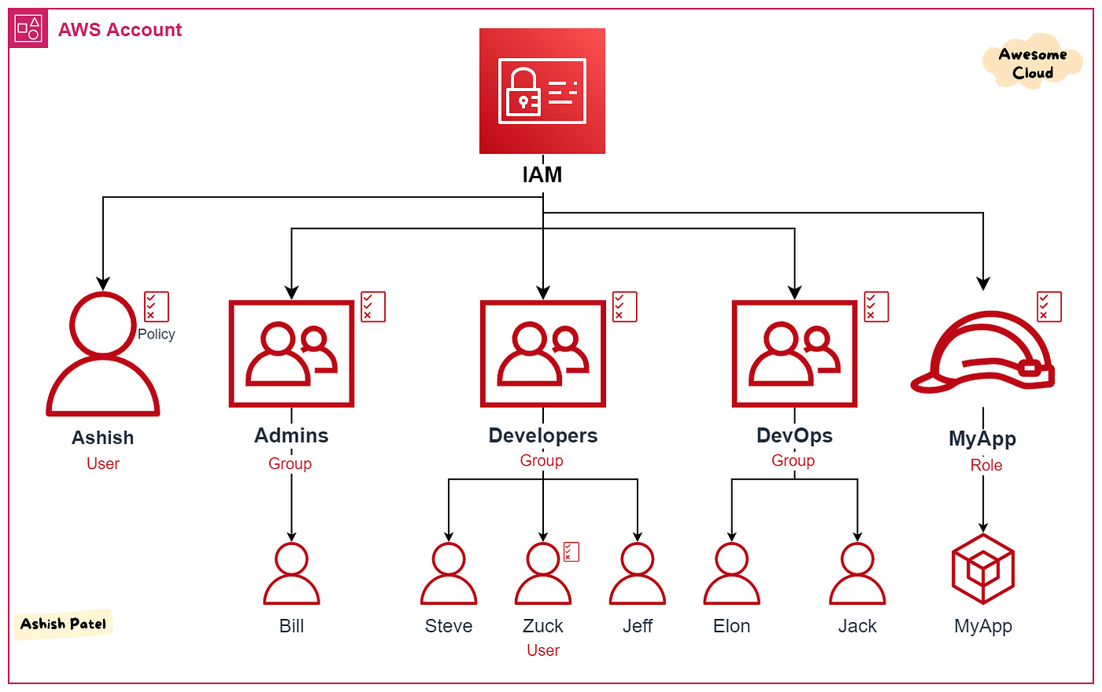

This fine-grained control lessens the possibility of data breaches and illegal access. Similar to this, AWS Shield offers sophisticated defence against Distributed Denial of Service (DDoS) assaults, guaranteeing application availability and dependability through real-time threat detection and mitigation.

AWS Shield is a managed distributed denial of service (DDoS) protection service that safeguards applications running on AWS. It provides dynamic detection and automatic inline mitigations that minimize application downtime and latency, so there is no need to engage AWS Support to benefit from DDoS protection.

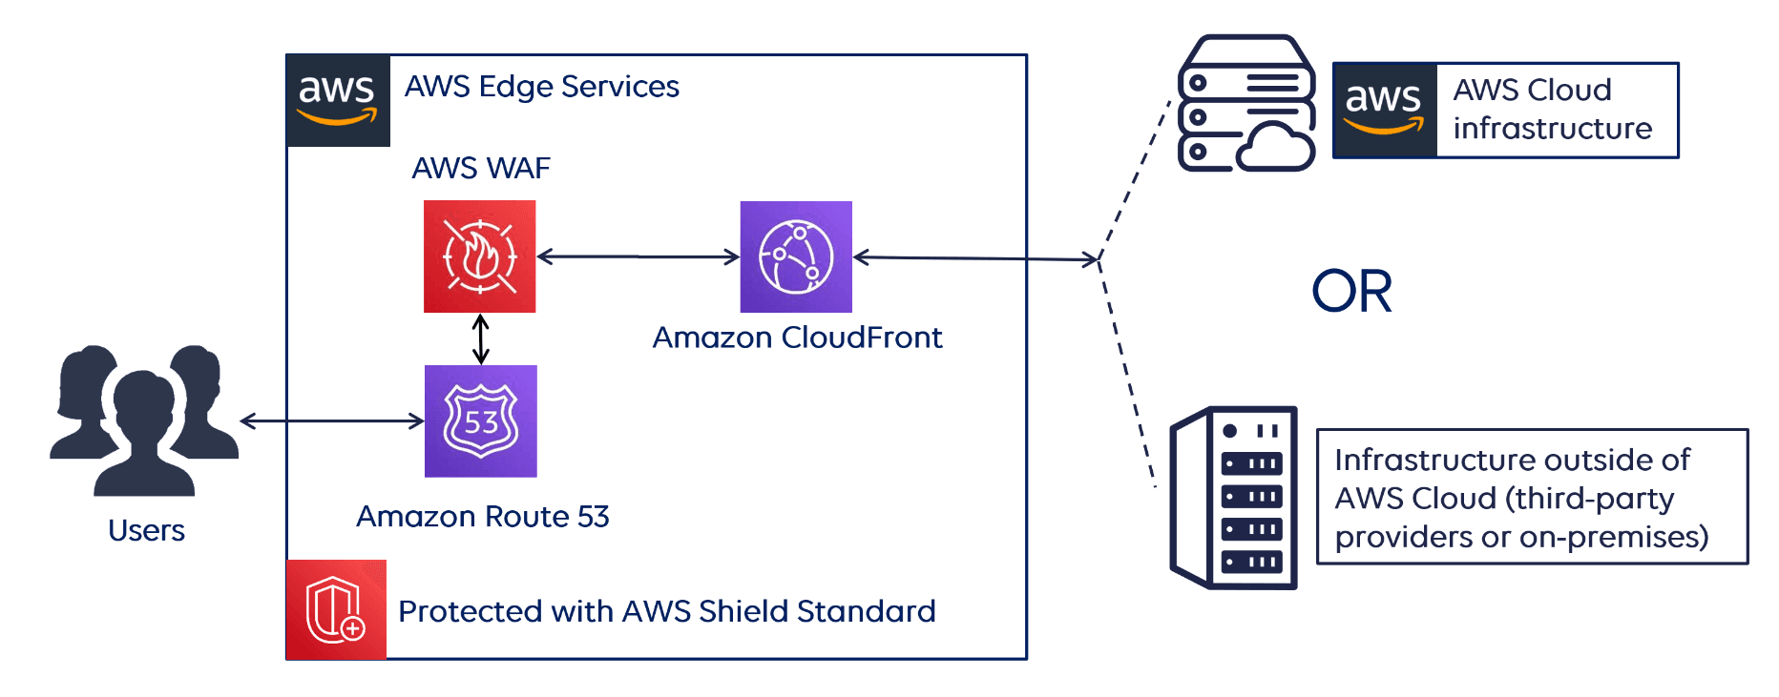

AWS Key Management Service (KMS) is vital for managing encryption keys, which are necessary for protecting sensitive data both in transit and at rest, in addition to these fundamental services. Organizations can adhere to the highest security standards and establish robust encryption procedures while keeping control over their cryptographic keys by utilizing KMS. Additionally, Amazon GuardDuty functions as a threat detection service, constantly keeping an eye out for illegal activity and harmful activities on workloads and AWS accounts. By taking a proactive stance, companies can improve their overall security posture by promptly identifying possible security threats and taking appropriate action.

AWS KMS keys (KMS keys) are the primary resource in AWS KMS. You can use a KMS key to encrypt, decrypt, and re-encrypt data. It can also generate data keys that you can use outside of AWS KMS. Typically, you'll use symmetric encryption KMS keys, but you can create and use asymmetric KMS keys for encryption or signing, and create and use HMAC KMS keys to generate and verify HMAC tags. An AWS KMS key is a logical representation of a cryptographic key. A KMS key contains metadata, such as the key ID, key spec, key usage, creation date, description, and key state. Most importantly, it contains a reference to the key material that is used when you perform cryptographic operations with the KMS key.

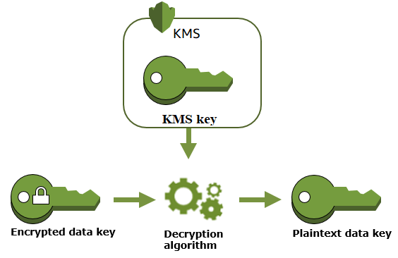

By incorporating these security services while adhering to accepted standards, AWS fortifies its infrastructure and gives businesses the confidence to use cloud technology. Because of this strategic alignment, users of AWS are more confident that they can deploy apps and handle data safely in the face of a constantly changing threat landscape. Because of its strong security measures and dedication to compliance, AWS is seen as a trustworthy partner by companies who want to use cloud solutions while upholding high standards of security and operational integrity, even as cyber threats continue to evolve. By means of constant enhancement and adjustment to novel guidelines, AWS sustains its leadership position in cloud security, establishing the norm for other players in the sector.

**Conclusion:** In summary, AWS is a leader in cloud computing security due to its dedication to upholding established security standards like ISO/IEC 27001, NIST SP 800-53, and PCI DSS, as well as its extensive portfolio of security services. Strong controls and tools like Amazon GuardDuty, AWS IAM, AWS Shield, and AWS KMS are just a few of the resources that AWS offers to help businesses safeguard sensitive data and stay compliant in a confusing regulatory environment. In addition to fostering greater user trust, this tactical approach guarantees that enterprises may safely utilize cloud technology while protecting against new dangers. AWS's commitment to security excellence and continual development will be essential in assisting enterprises in securely achieving their operational objectives as the cloud landscape changes.