**EXPERIMENT - 7**

**Aim:** To Create Serverless Computing Model (AWS Lambda)

**Learning Objectives:**

* Learn fundamentals of AWS Lambda
* Create functions of Lambda

**Tools Used:** Amazon Web Services (AWS)

**Theory:**

To create a serverless computing model using AWS Lambda, you start by understanding the fundamental concept of serverless architecture. In traditional computing models, you need to provision and manage servers to run your applications. This includes handling infrastructure concerns such as scaling, patching, and server maintenance. Serverless computing, however, abstracts these responsibilities away from the user, allowing them to focus solely on writing and deploying code. AWS Lambda exemplifies this model by allowing you to run code in response to events without having to manage the underlying server infrastructure.

The process begins with defining the code that you want to execute in response to specific triggers. In AWS Lambda, this code is encapsulated in what is called a "Lambda function." You write this function in a supported programming language, such as Python, Node.js, or Java, and deploy it to AWS Lambda. Once deployed, you configure triggers that will invoke the function. These triggers can be various AWS services like S3 (for file uploads), DynamoDB (for database changes), or API Gateway (for HTTP requests), among others.

This setup allows the Lambda function to run automatically whenever the specified event occurs, providing a seamless and reactive execution model.

Finally, the serverless model offers a pay-as-you-go billing approach, which enhances cost-efficiency. Instead of paying for continuous server uptime, you only incur costs based on the actual execution time of your functions and the resources consumed. This model scales automatically with the workload; if your application experiences a sudden spike in demand, AWS Lambda can handle it by running multiple instances of your function concurrently.

This scalability and efficiency make serverless computing a powerful paradigm for building and deploying applications without the complexity of managing servers and infrastructure.Top of FormBottom of Form

**Implementation/Output:**

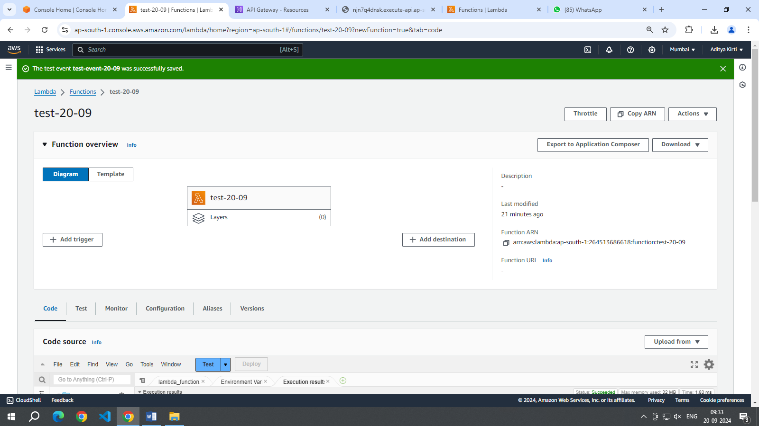

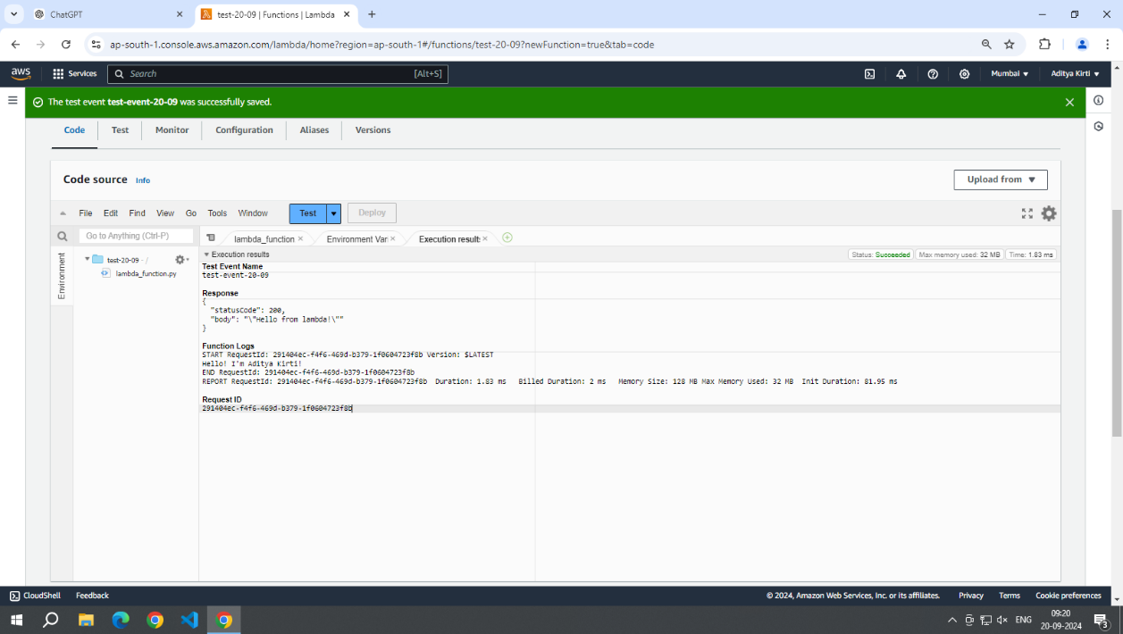

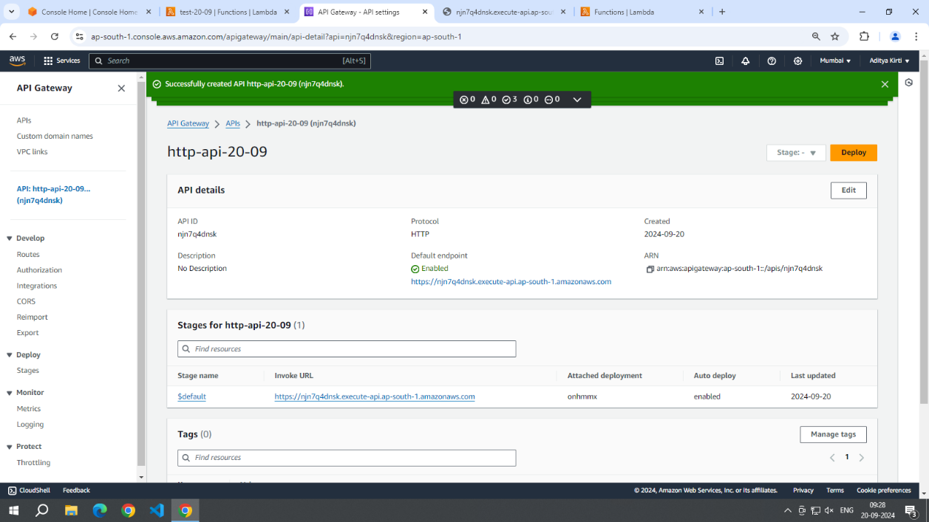

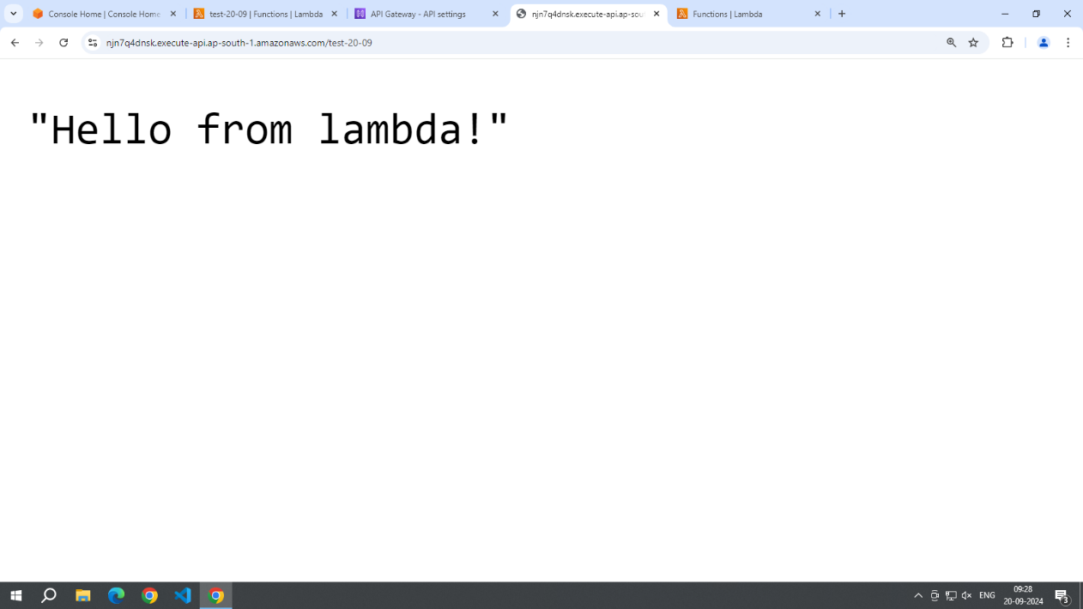

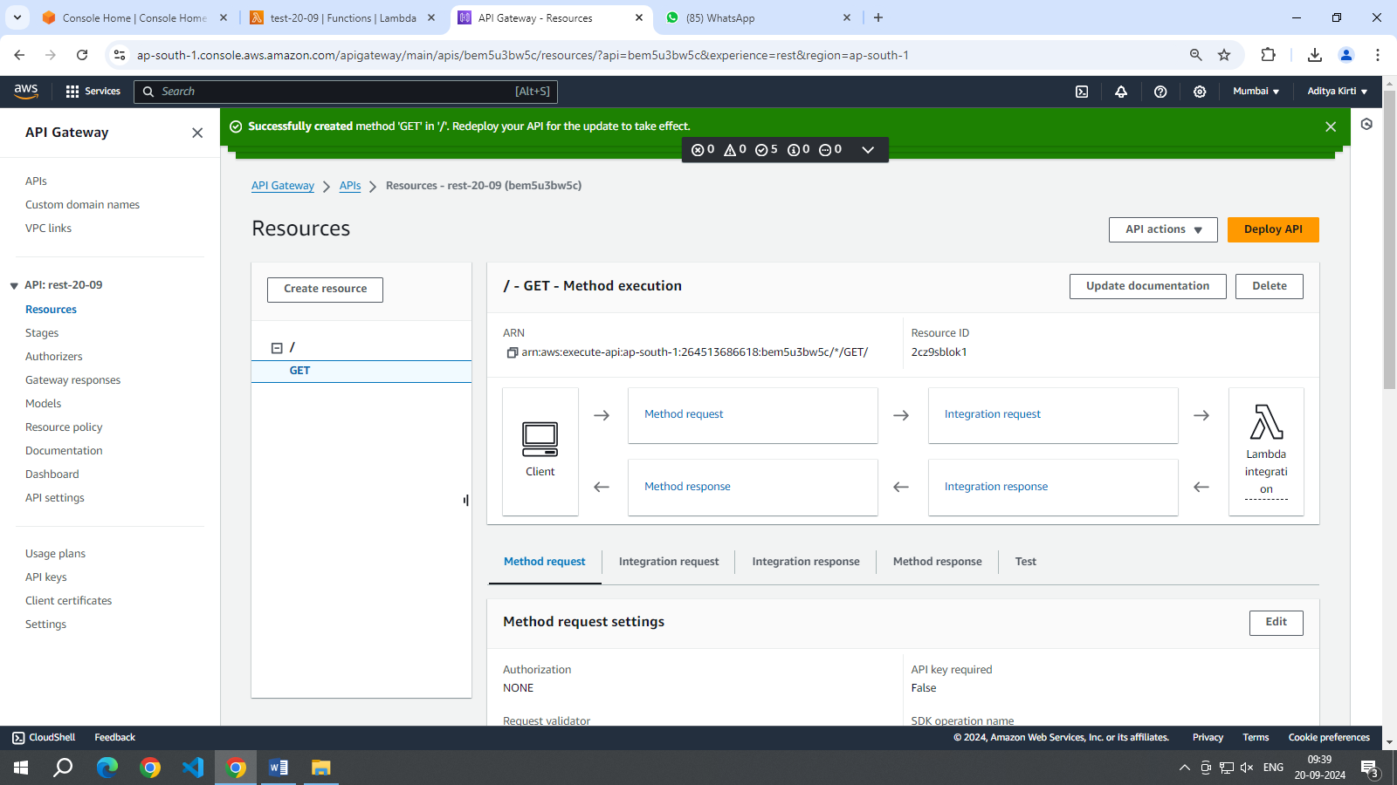

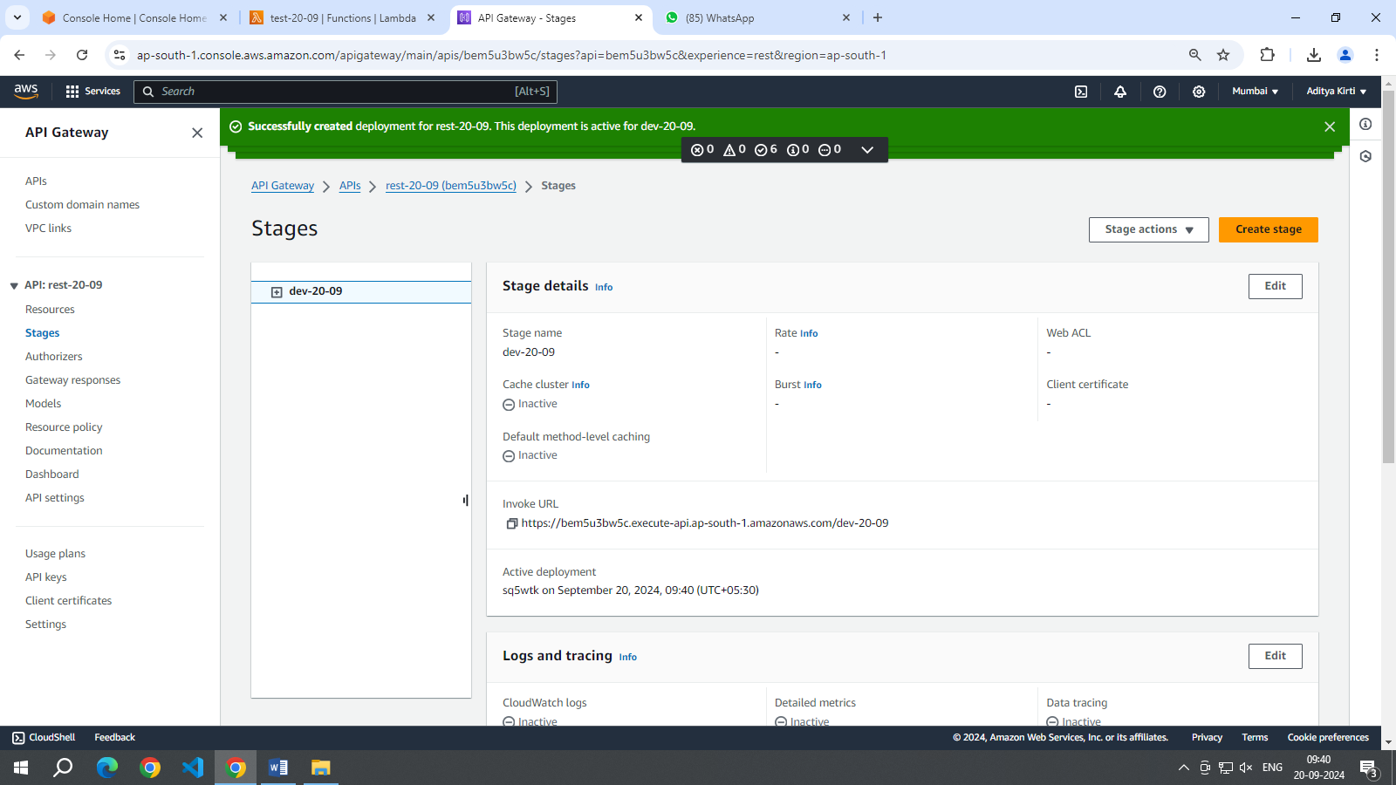

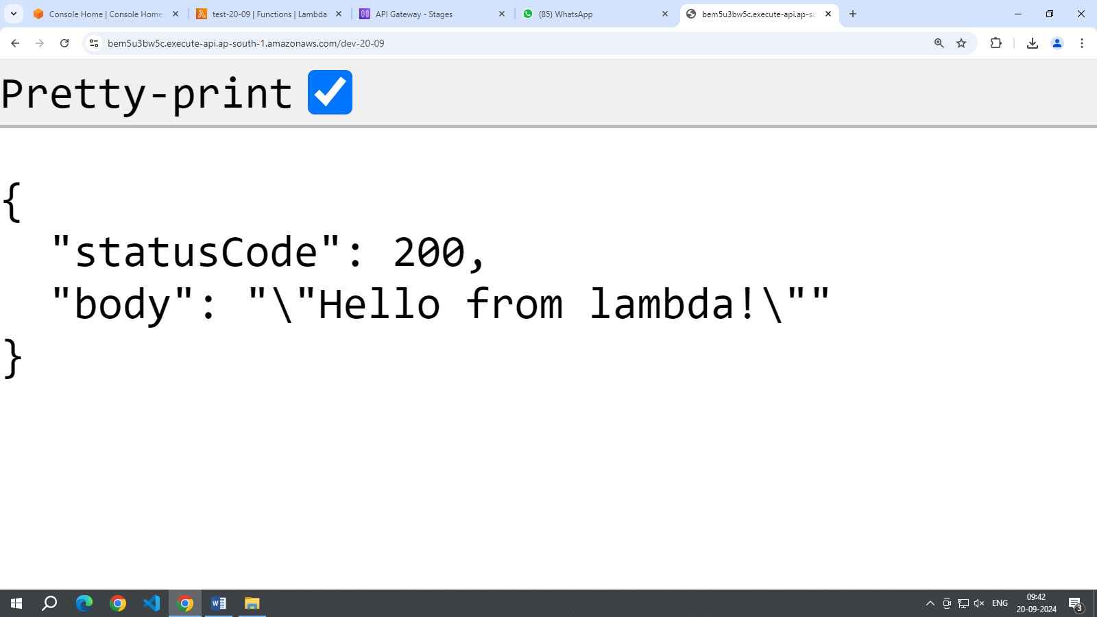

**Conclusion:**  AWS Lambda's serverless computing model revolutionizes application development by eliminating the need for server management and allowing developers to focus solely on their code. By automatically executing functions in response to predefined events and scaling resources as needed, AWS Lambda ensures efficient and cost-effective operation. This paradigm not only simplifies deployment and maintenance but also aligns with modern demands for agility and scalability in software development.