### **Experiment No. 9: GUI Design and Implementation of Mini Project - FairShare**

### **Aim:**

To design and implement a Graphical User Interface (GUI) for the FairShare expense splitting application using appropriate tools and techniques, ensuring usability and functionality.

### **Theory:**

Graphical User Interface (GUI) design is a crucial aspect of software engineering that focuses on creating user-friendly and visually appealing interfaces. A well-designed GUI enhances user experience, ensures accessibility, and improves the overall usability of the system.

**Key Concepts in GUI Design:**

1. **User-Centered Design:**
   * Focuses on the users' needs, goals, and preferences.
   * Involves iterative prototyping and feedback to refine the interface.
2. **Principles of Good GUI Design:**
   * **Consistency:** Uniformity in design elements, such as colors, fonts, and layout.
   * **Feedback:** Providing visual or auditory responses to user actions.
   * **Visibility:** Ensuring critical elements are easy to find and accessible.
   * **Error Prevention:** Designing interfaces to reduce the possibility of user errors.
3. **GUI Development Tools:**
   * Visual Studio
   * JavaFX
   * React
   * Figma, Adobe XD (for prototyping)

**Process of GUI Design and Implementation:**

1. Requirement analysis.
2. Wireframe or mockup creation.
3. GUI design using selected tools.
4. Integration of functionality with back-end logic.

### **Learning Objectives:**

* To understand the principles of GUI design.
* To implement a GUI for a mini-project that is functional and user-friendly.
* To integrate the GUI with the underlying system functionalities.

### **Learning Outcomes:**

At the end of this experiment, students will be able to:

1. Design a functional GUI adhering to usability principles.
2. Implement a GUI using appropriate development tools.
3. Integrate the GUI with the project's back-end.

### **Course Outcomes (COs):**

* **CO6:** Design and develop user-centric software systems with effective GUI.

### **Cognitive Levels of Attainment as per Bloom’s Taxonomy:**

* **L3 (Apply):** Apply GUI design principles to create user-friendly interfaces.
* **L6 (Create):** Design and implement a complete GUI for a mini-project.

### **Programme Outcome (POs):**

* **PO3: Design/Development of Solutions:** Develop systems with well-structured GUI solutions.
* **PO5: Modern Tool Usage:** Utilize advanced tools and technologies for GUI design and development.
* **PO8: Ethics:** Ensure GUI designs are inclusive and accessible to all users.
* **PO10: Project Management and Finance:** Manage GUI design as part of the overall project timeline and resources.

### **Programme Specific Outcome (PSOs):**

* **PSO2:** Integrate various technologies to develop scalable and effective solutions.
* **PSO3:** Design, develop, and test software with a focus on user interaction and usability.

### **Result & Discussion:**

* **Result:** A functional GUI was designed and implemented for the mini-project.
* **Discussion:**
  + The GUI adheres to the principles of usability and accessibility.
  + The interface is consistent with the project requirements and integrates seamlessly with the back-end.

### **Conclusion:**

GUI design is an integral part of software development, directly impacting the usability and success of the application. Through this experiment, students gained practical experience in designing and implementing a GUI for the FairShare application using modern tools and adhering to design principles.

### **Implementation of mini project: Fair Share:**

FairShare aims at simplifying expense splitting and management among friends, groups, and for events. The project consists of the following parameters

For data security, there are two levels of authentication. Regular users can access features related to expense splitting, friend management, and group activities, while administrative access is reserved for system administrators who can manage user accounts, system settings, and generate comprehensive reports.

After login, depending upon the purpose user can access forms like –

* **User-Level Modules:**
  1. **Dashboard** - Overview of expenses, debts, and recent activities
  2. **Expense Form** - To add new expenses with detailed splitting options
  3. **Friends Management** - To add friends and manage connections
  4. **Groups Management** - To create and manage expense groups
  5. **Events Management** - To create events with shared expenses
  6. **Transaction History** - To view past transactions and settlements
  7. **Account Settings** - To manage personal profile and preferences
* **Admin-Level Modules:**
  1. **User Management** - To manage user accounts and access levels
  2. **System Configuration** - To configure system-wide settings
  3. **Currency Management** - To manage supported currencies and exchange rates
  4. **Payment Gateway Integration** - To configure payment service connections
  5. **Activity Logs** - To monitor system usage and identify issues
* **Reports:**

Reports provided by this system are as listed:

* 1. **Expense Summary** - Monthly/yearly expense breakdown
  2. **Settlement Report** - Outstanding and completed settlements
  3. **Group Activity Report** - Expense patterns within groups
  4. **Event Expense Report** - Detailed breakdown of event expenses
  5. **Currency Usage Report** - Analysis of transactions by currency
  6. **Payment Method Report** - Statistics on payment method usage
  7. **User Activity Report** - User engagement and transaction frequency
* **Settlement Report:**

Settlement reports display who owes whom, with amounts, transaction history, and settlement

status.Users can export these reports as PDFs or share them directly with friends.

* **Expense Summary:**

This report shows all expenses categorized by type (food, travel, utilities, etc.), with graphical

representations of spending patterns over time and comparison with previous periods.

* **Group Activity Report:**

This report analyzes expense patterns within groups, showing top contributors, frequent expense

categories, and expense distribution among members.

1. Login Screen

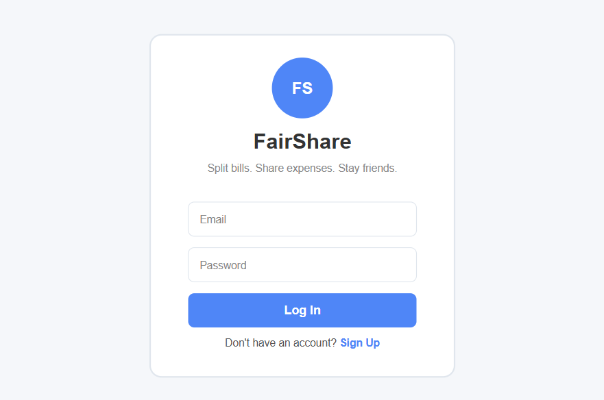

1. Dashboard After Login

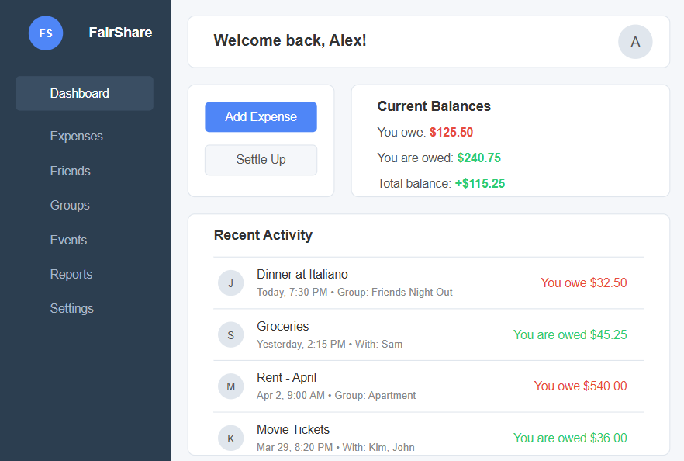

1. **Add New Expense**

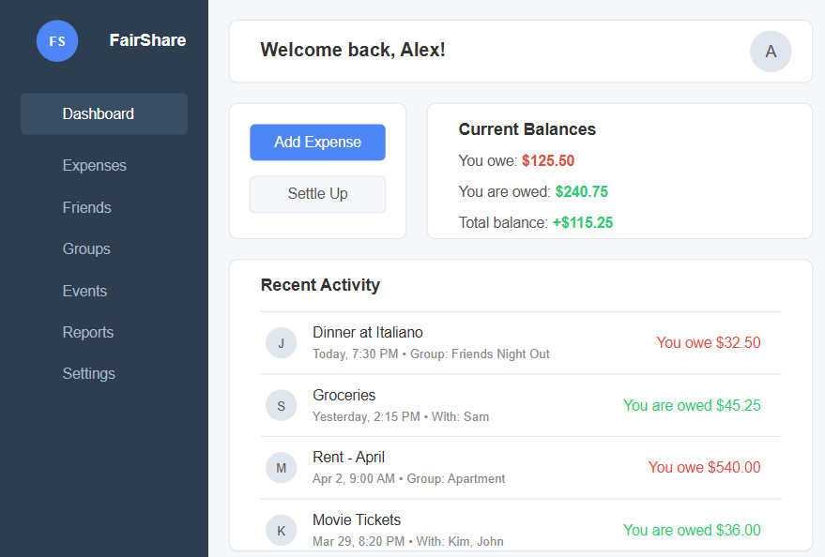

1. Split Options

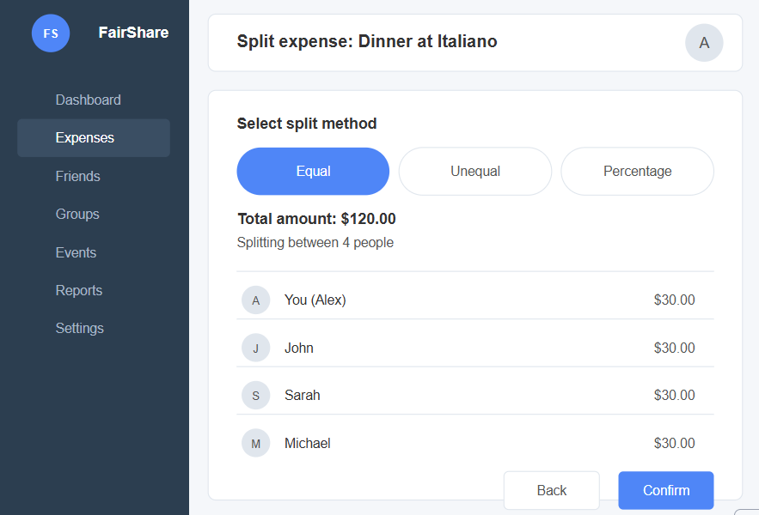

1. Friends Management

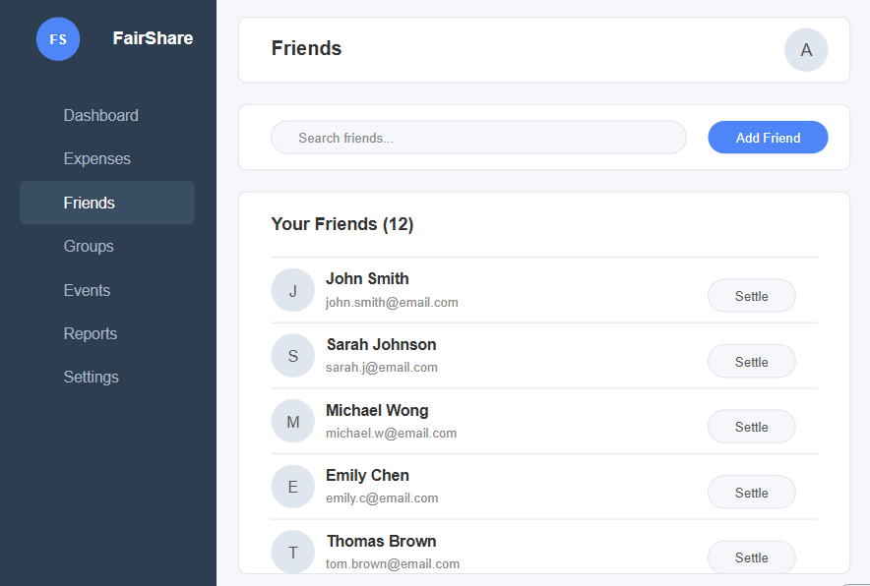

1. Group Creation

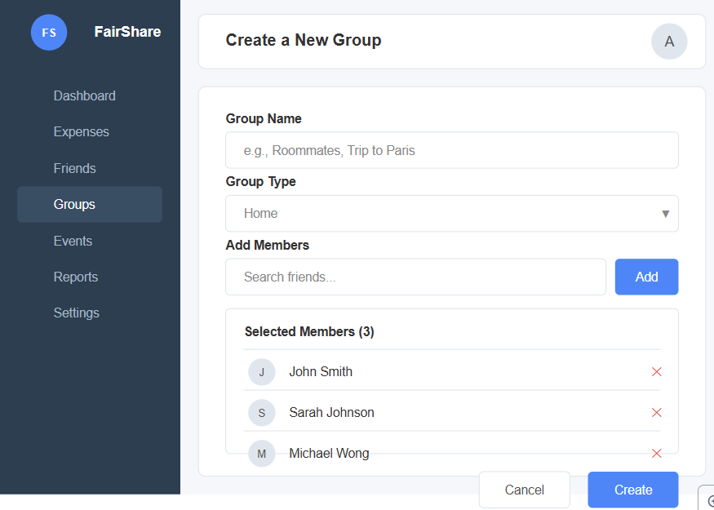

1. Event Management

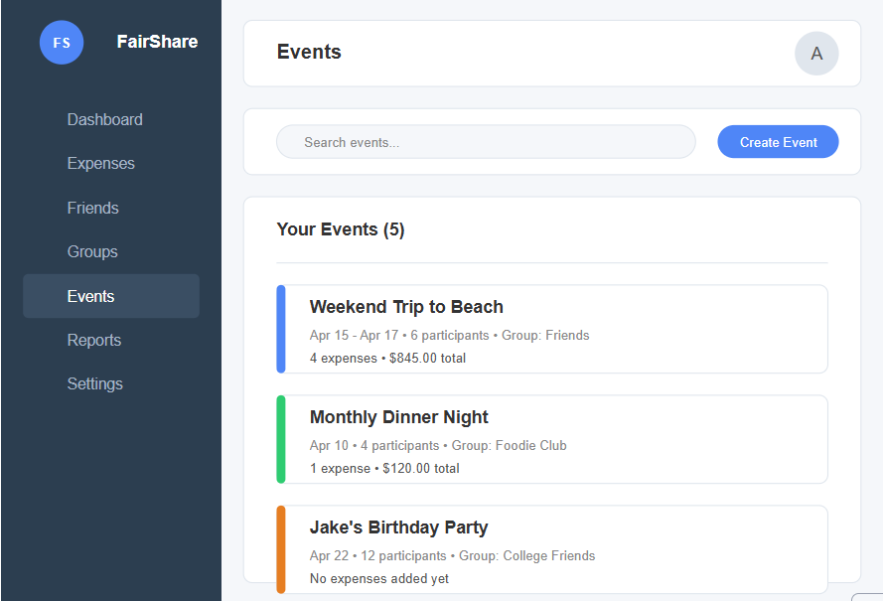

1. Settlement View

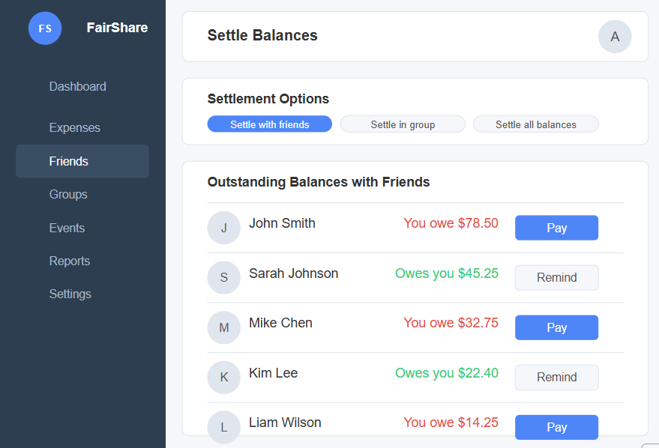

1. Report Generation

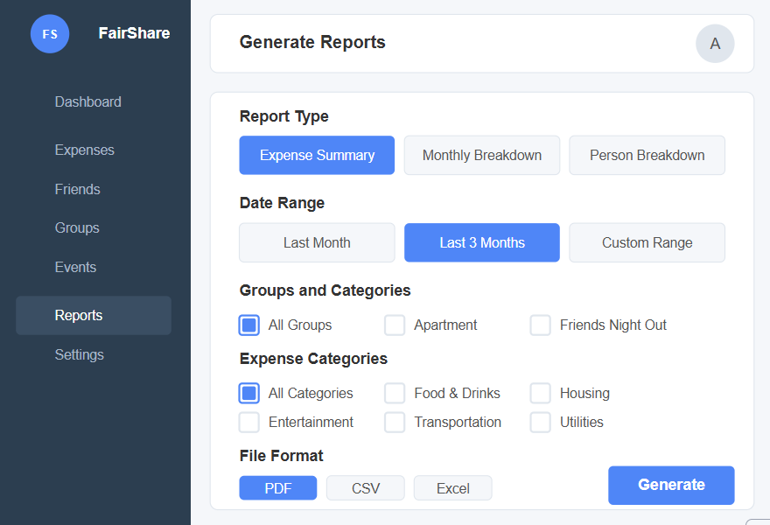

1. Currency Settings

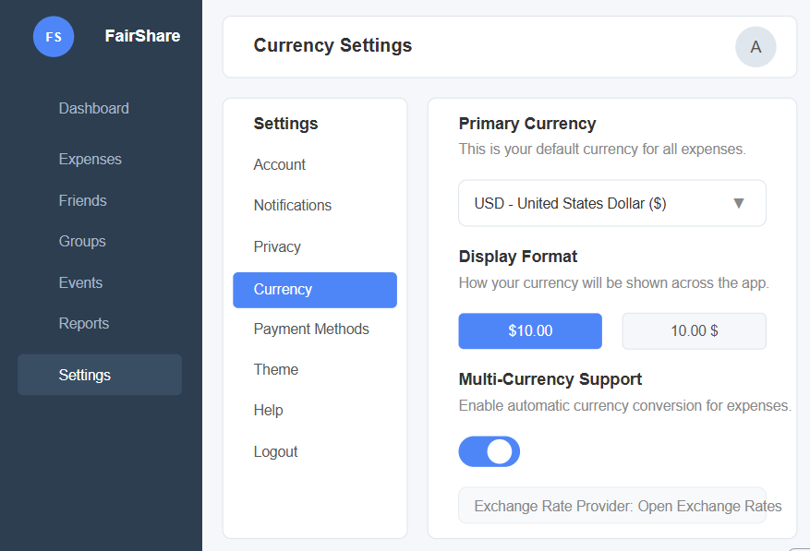

1. Payment Integration

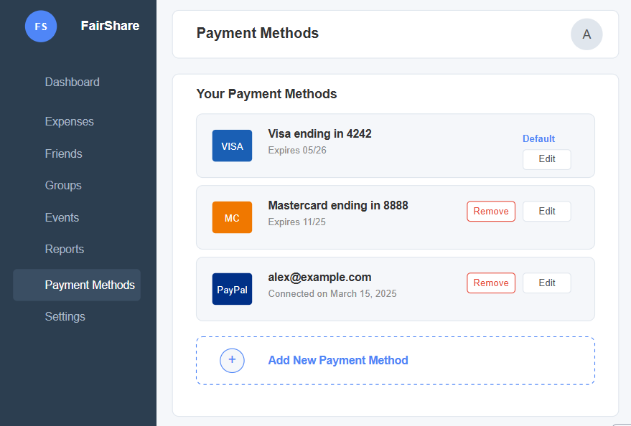

1. Account Settings

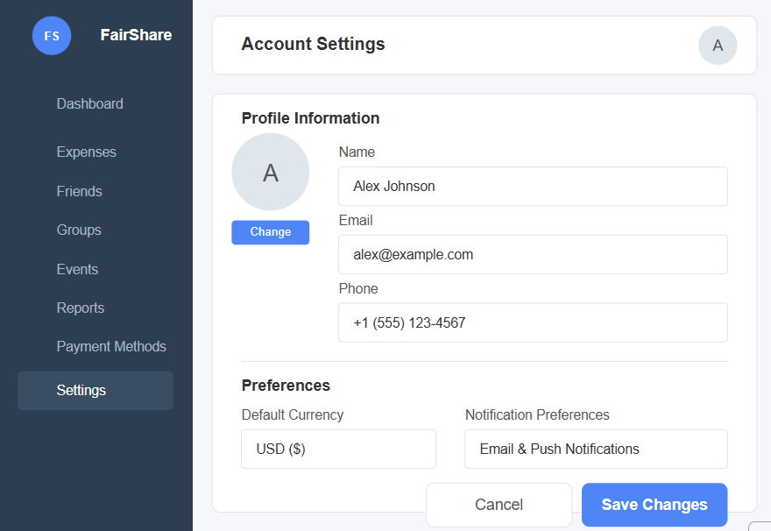

1. Logout Confirmation

