HTML Code:

<!DOCTYPE html>

<html lang="en">

<head>

    <meta charset="UTF-8">

    <meta name="viewport" content="width=device-width, initial-scale=1.0">

    <title>WP Exp 1</title>

    <h1>Details</h1>

</head>

<body>

    <p>Name: Aditya Kirti</p>

    <p>Roll No: 61</p>

    <p>Class: IT-A</p>

    <p>College: Thakur College of Engineering & Technology</p>

    <p>Achievements: 9.73 SGPI</p>

    <p>Skills: Python, HTML, CSS, JavaScript, C </p>

</body>

</html>

Output:

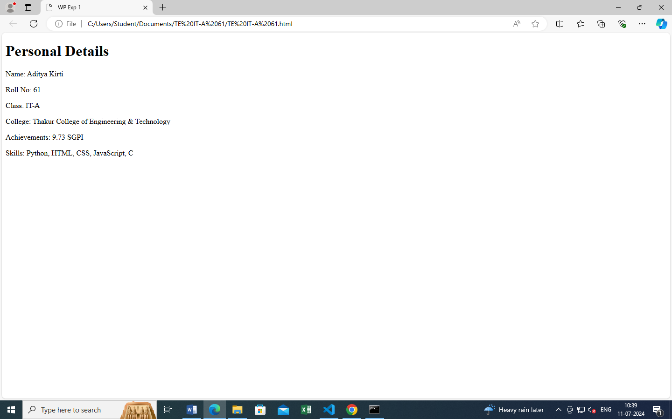

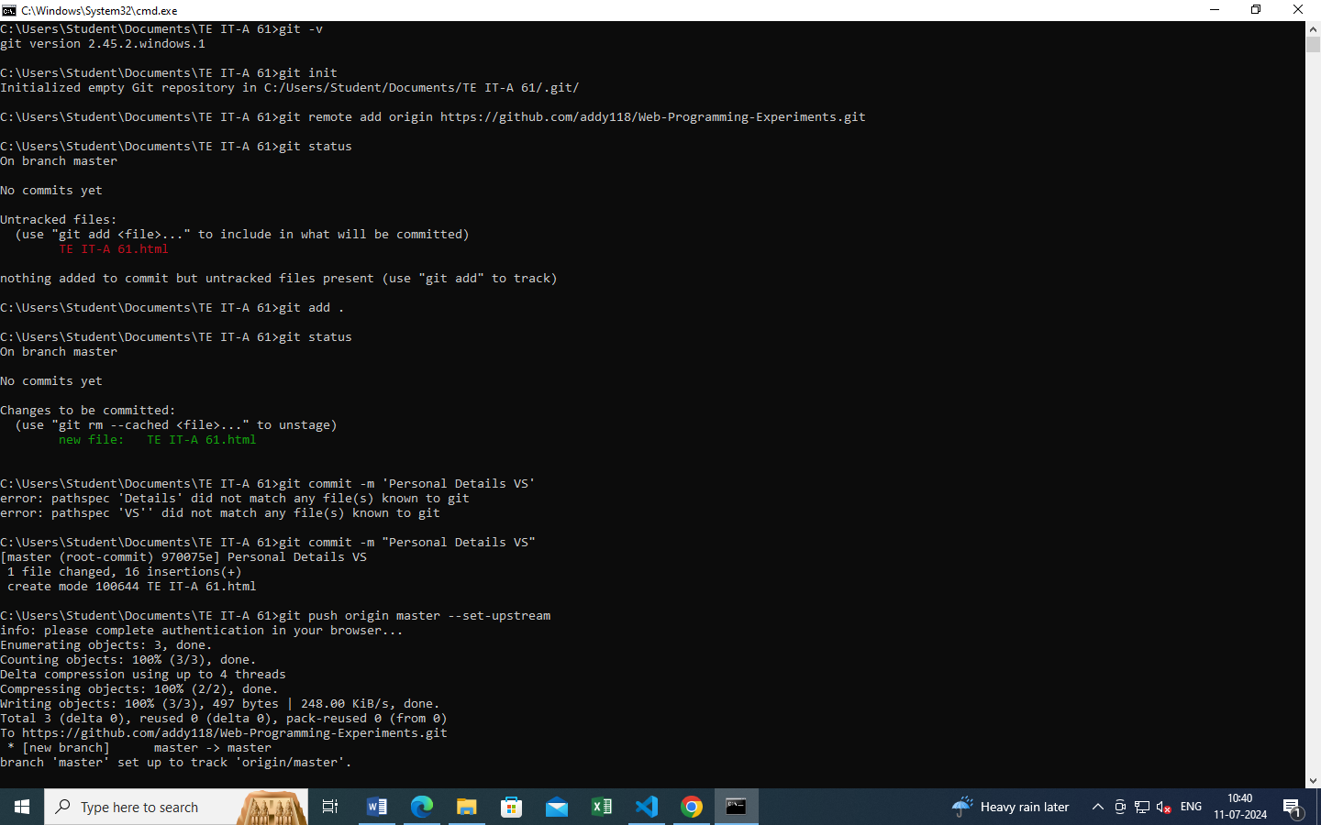Git Commands:

