**Experiment 5**

**Aim:** To design and develop a responsive webpage layout along with a login form using Bootstrap, ensuring compatibility across various devices and screen sizes.

**Learning Objective**:

* Learn how to use Bootstrap to create responsive and structured web layouts efficiently.
* Understand the application of Bootstrap components like carousels, grids, headers, and footers in designing an e-commerce homepage.

**Tools:** HTML, CSS, Bootstrap, Text Editor/IDE

**Theory:**

Responsive web design is a crucial aspect of modern web development, aiming to create webpages that adapt seamlessly to various screen sizes and devices, ensuring an optimal user experience. With the increasing variety of devices—from desktop monitors to mobile phones—webpages must be designed to be fluid and flexible.  
Bootstrap is a popular front-end framework that simplifies the process of creating responsive websites. It provides a grid system, pre-designed components, and utility classes that help developers quickly build responsive layouts. The grid system divides the webpage into a series of rows and columns, allowing content to be arranged and aligned dynamically based on the screen size.   
 In this experiment, we utilize Bootstrap's grid system to create a responsive layout that adjusts to different screen widths (e.g., small, medium, large, and extra-large screens). The grid system consists of 12 columns, and elements can span across multiple columns or be confined to a single one, depending on the desired layout.   
Bootstrap also offers a variety of pre-styled components, including forms, buttons, and navigation bars, which can be customized using CSS. These components follow best practices for accessibility and design, making it easier to develop user-friendly interfaces.  
 A login form is a common element in web applications, used to authenticate users. Using Bootstrap, we can create a sleek and responsive login form that maintains its usability across different devices. The form can be enhanced with features like input validation, custom buttons, and responsive alignment, ensuring it is both functional and aesthetically pleasing.  
 This experiment will demonstrate the practical application of Bootstrap in designing a responsive webpage layout and a login form, emphasizing the importance of responsiveness in web development. By understanding and applying Bootstrap's features, students can develop webpages that provide a consistent and positive user experience across various devices.

### Common Bootstrap classes

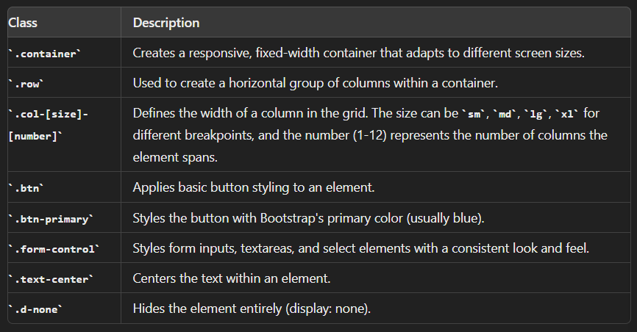

**Implementation Code:**

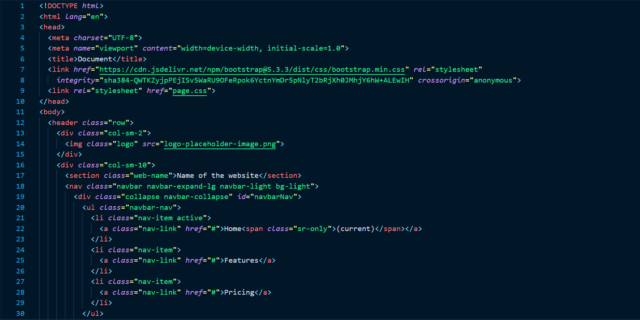

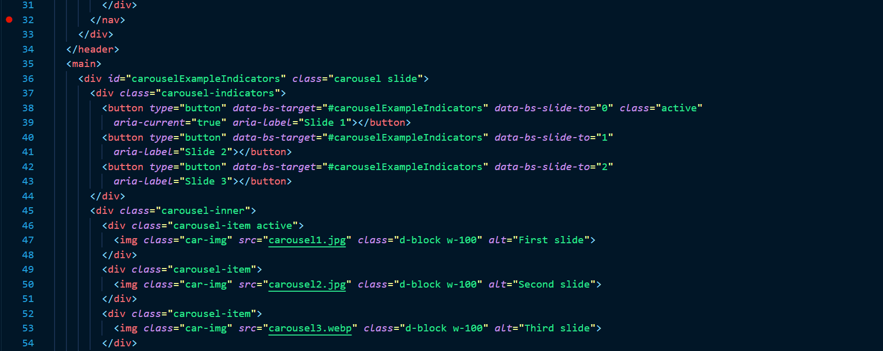



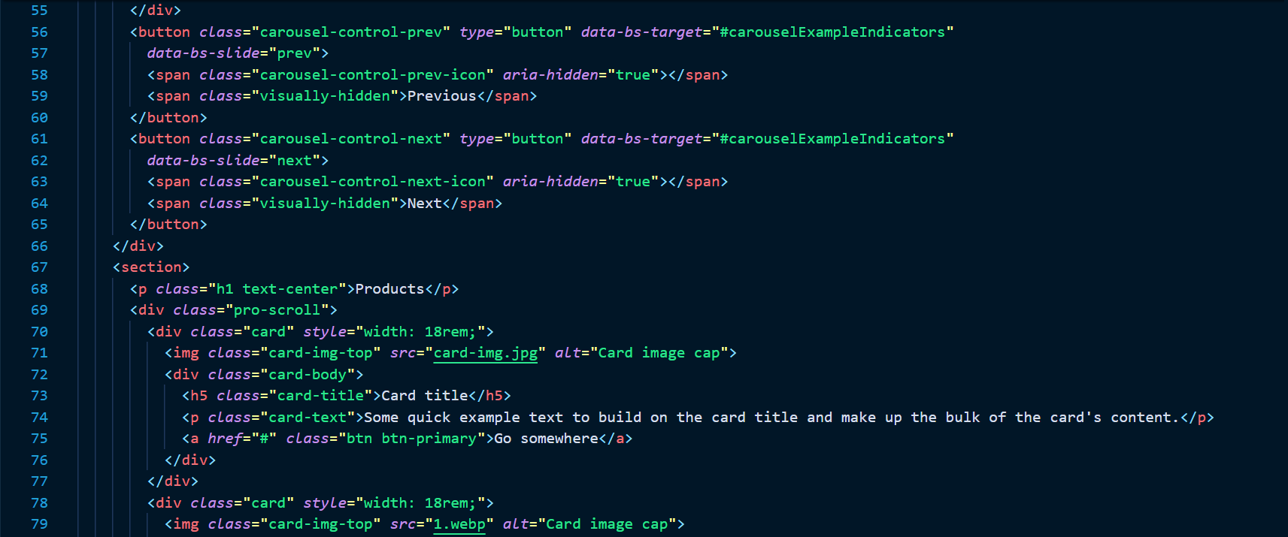

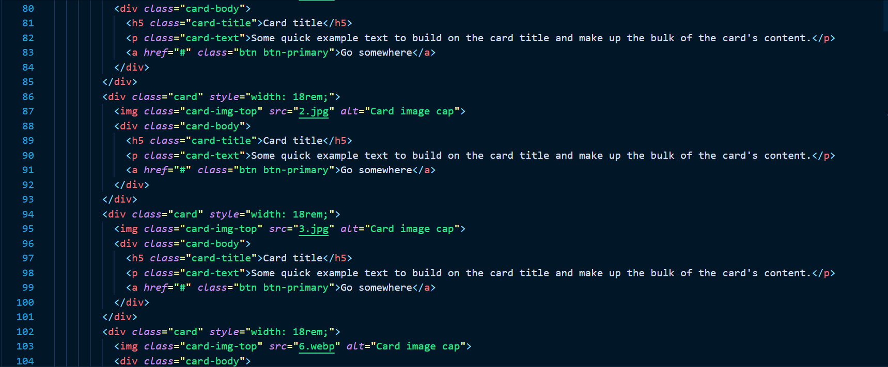

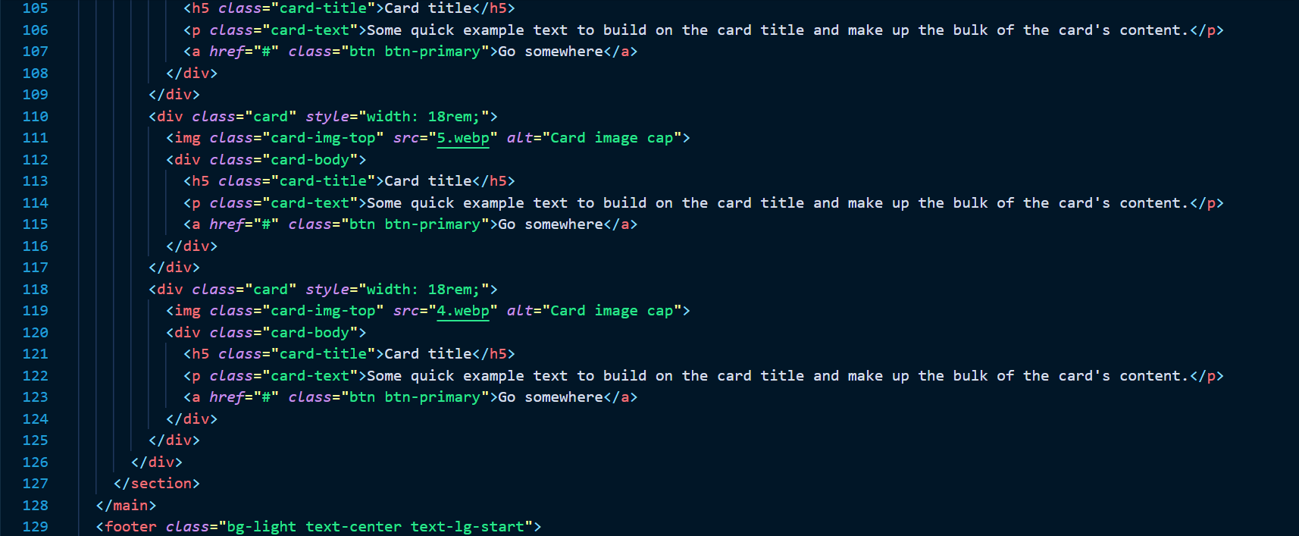



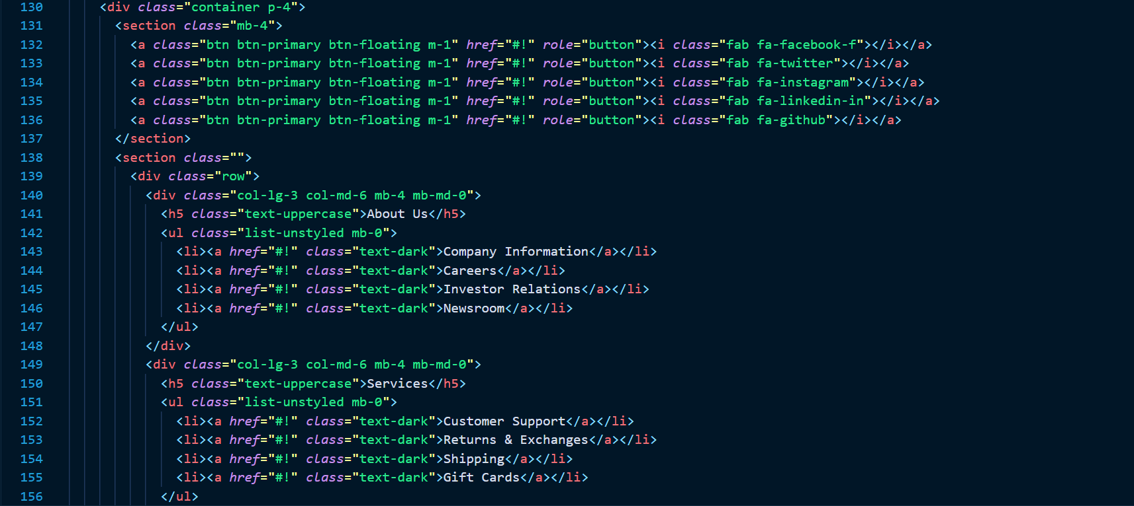

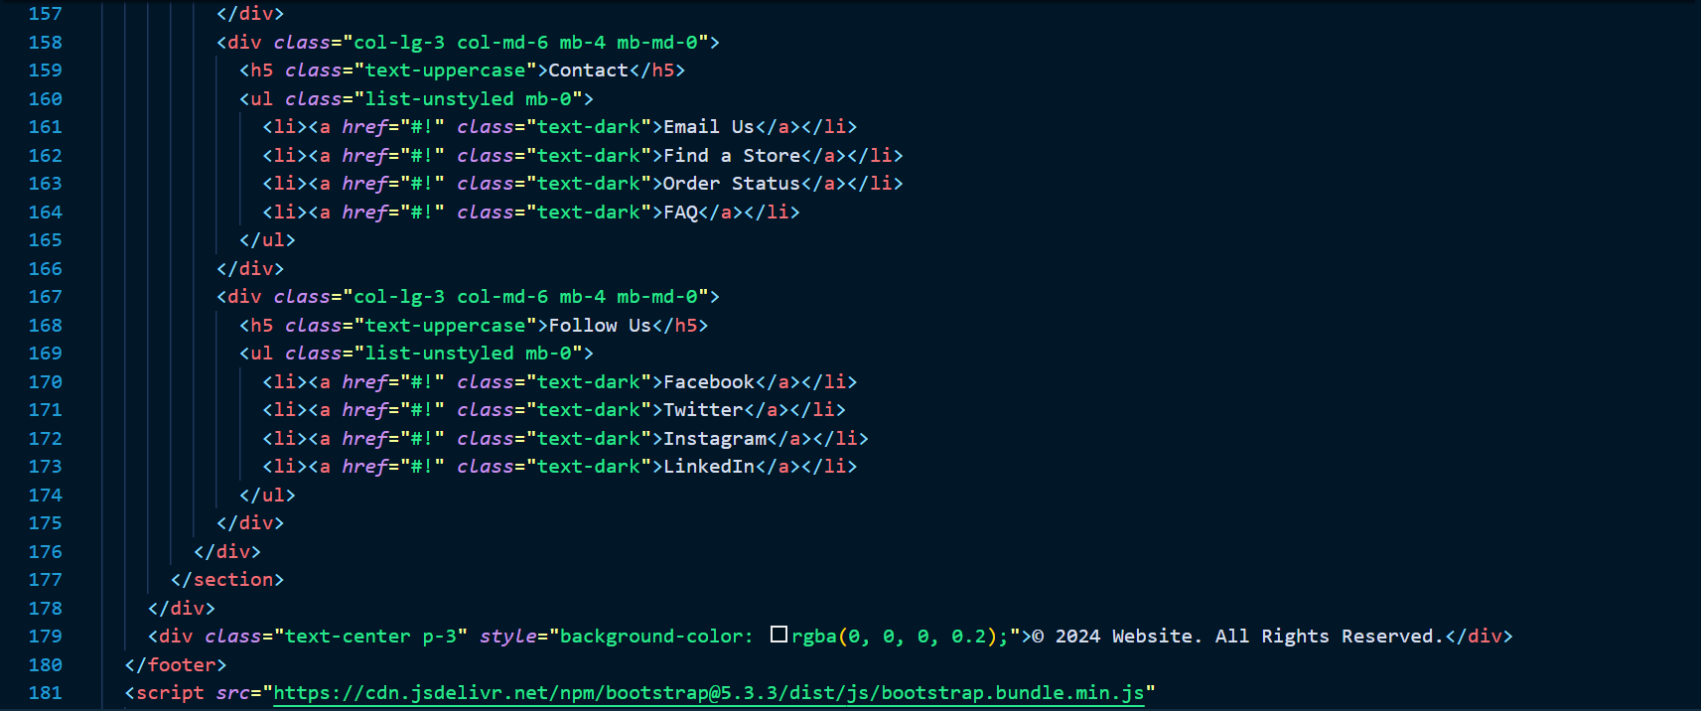



**Output:**

