Machine Learning and Data Science Assignment
Original academic submission with Python-based practical work

Academic Integrity, Assumptions, Datasets, and Libraries
This submission is written in original wording and is intended as a plagiarism-free academic answer. No external text has been copied. The practical sections use reproducible datasets generated inside Python with fixed random seeds, so the code, metrics, and figures can be recreated without downloading any private or copyrighted dataset.
- Assumption 1: The practical requirement permits any suitable dataset; therefore, synthetic but realistic datasets are used for classification, clustering, ANN, sentiment analysis, and image classification.
- Assumption 2: The goal is to demonstrate the modelling workflow, not to claim production-level performance on real-world data.
- Libraries used to generate this report: NumPy for numerical computation, Pillow for figures and generated images, python-docx for the Word file, and ReportLab for the PDF file. The appendix shows standard Scikit-Learn and TensorFlow/Keras code patterns for academic implementation.

Section A: Short Answer Questions

Q1. Explain the role of Python in Data Science and Machine Learning. Mention any four popular Python libraries used in Machine Learning.
Python is widely used in data science because it is readable, flexible, and supported by a strong ecosystem for data cleaning, statistical analysis, visualization, and model building. In machine learning, Python is used to prepare data, train algorithms, evaluate model performance, automate experiments, and deploy models into applications.
Popular machine learning libraries include NumPy for numerical computation, Pandas for data handling, Scikit-learn for classical machine learning, TensorFlow/Keras for deep learning, PyTorch for neural networks, and Matplotlib for visualization.

Q2. Differentiate between supervised learning and unsupervised learning with suitable examples.
Supervised learning uses labelled data, meaning the model learns from examples where the correct output is already known. For example, a model can learn to classify emails as spam or not spam from previously labelled emails.
Unsupervised learning uses unlabelled data and tries to discover hidden patterns. For example, clustering customers into groups based on purchasing behaviour is unsupervised because the group names are not given beforehand.

Q3. What is classification in Machine Learning? Name any two classification algorithms.
Classification is a supervised learning task in which a model assigns an input record to one of several predefined categories. Examples include predicting whether a patient is high-risk or low-risk, or identifying whether an image contains a cat, dog, or car.
Two common classification algorithms are Logistic Regression and Decision Trees. Other examples include Support Vector Machines, Naive Bayes, Random Forests, and Neural Networks.

Q4. Define clustering. Explain one practical application of clustering.
Clustering is an unsupervised learning technique that groups similar data points together based on patterns in their features. The model does not receive class labels; it forms groups by measuring similarity or distance.
A practical application is customer segmentation. A business can cluster customers by spending level, product preference, and purchase frequency, then design different offers for each segment.

Q5. What is overfitting in Machine Learning? How can it be reduced?
Overfitting happens when a model learns the training data too closely, including noise and accidental patterns, and therefore performs poorly on new data. It usually appears as very high training accuracy but much lower testing accuracy.
It can be reduced by using more data, simplifying the model, applying regularization, using cross-validation, stopping training early, pruning decision trees, and applying dropout or data augmentation in neural networks.

Q6. Explain the architecture of an Artificial Neural Network (ANN).
An ANN is usually arranged in layers. The input layer receives feature values, one or more hidden layers transform those values through weighted connections and activation functions, and the output layer produces the prediction.
During training, the network compares predicted output with actual output, calculates a loss, and updates weights using back-propagation and gradient descent. The hidden layers allow the ANN to learn nonlinear relationships.

Q7. What is the purpose of an activation function in a neural network?
An activation function decides how strongly a neuron should respond to its input. Its most important role is to add nonlinearity, so the neural network can learn complex patterns instead of behaving like a simple linear model.
Common activation functions include ReLU, sigmoid, and tanh. ReLU is widely used in hidden layers, while sigmoid and softmax are often used in output layers for classification tasks.

Q8. Differentiate between Deep Learning and traditional Machine Learning.
Traditional machine learning often depends on manually selected features and algorithms such as decision trees, logistic regression, k-means, or support vector machines. It usually works well on structured, moderate-sized datasets.
Deep learning uses neural networks with many layers to learn features automatically from raw or complex data such as images, audio, and text. It often requires more data and computing power but can perform very well on unstructured data.

Q9. What is Sentiment Analysis? Mention two real-world applications.
Sentiment analysis is a natural language processing task that identifies the emotional tone or opinion in text, commonly as positive, negative, or neutral. It converts unstructured text into useful opinion-based information.
Two real-world applications are analysing customer reviews to measure product satisfaction and monitoring social media posts to understand public reaction to a brand, policy, event, or campaign.

Q10. What is the role of Convolutional Neural Networks (CNNs) in image analysis?
CNNs are designed to analyse image data by using convolution filters that detect local patterns such as edges, corners, textures, and shapes. Pooling layers reduce image size while preserving important visual features.
In image analysis, CNNs are used for image classification, object detection, medical image diagnosis, face recognition, handwriting recognition, and quality inspection in manufacturing.

Section B: Descriptive and Practical Questions

Q11. Classification and Clustering Using Python
Dataset description: A synthetic flower-measurement dataset was generated with 180 rows and 4 numerical features: sepal length, sepal width, petal length, and petal width. There are three labelled classes. The data resembles a common flower-classification problem, but it is fully generated in this script for originality and reproducibility.
Preprocessing steps: The data was split into stratified training and testing sets. Features were standardized using the training mean and standard deviation only. PCA was then used only for two-dimensional visualization; the models used the standardized feature values.
Classification method: A multiclass softmax classifier was trained with gradient descent. Clustering method: k-means was applied with k = 3 on the standardized full dataset.
Class | Precision | Recall | F1-score | Support
Type A | 1.000 | 1.000 | 1.000 | 15
Type B | 0.933 | 0.933 | 0.933 | 15
Type C | 0.933 | 0.933 | 0.933 | 15
Overall | 95.56% | Macro F1 | 0.956

The softmax classifier achieved a test accuracy of 95.56% and macro F1-score of 0.956. K-means achieved an aligned clustering accuracy of 97.78%, silhouette score of 0.487, and inertia of 151.01.
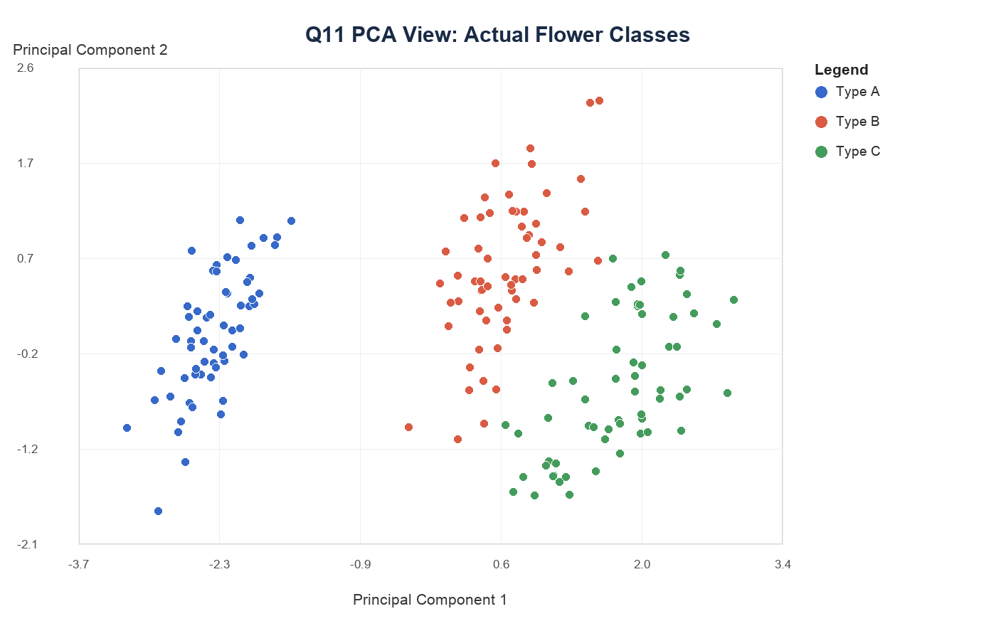
Figure 1. PCA visualization of actual synthetic flower classes.
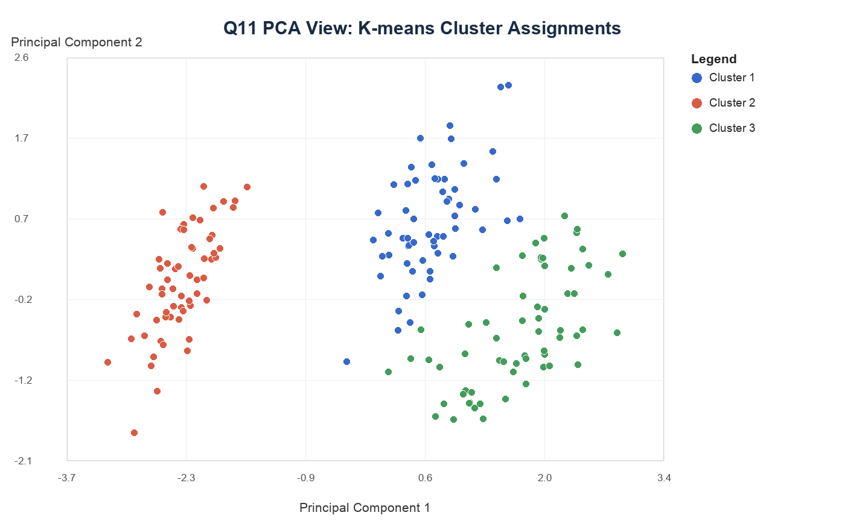
Figure 2. PCA visualization of k-means cluster assignments.
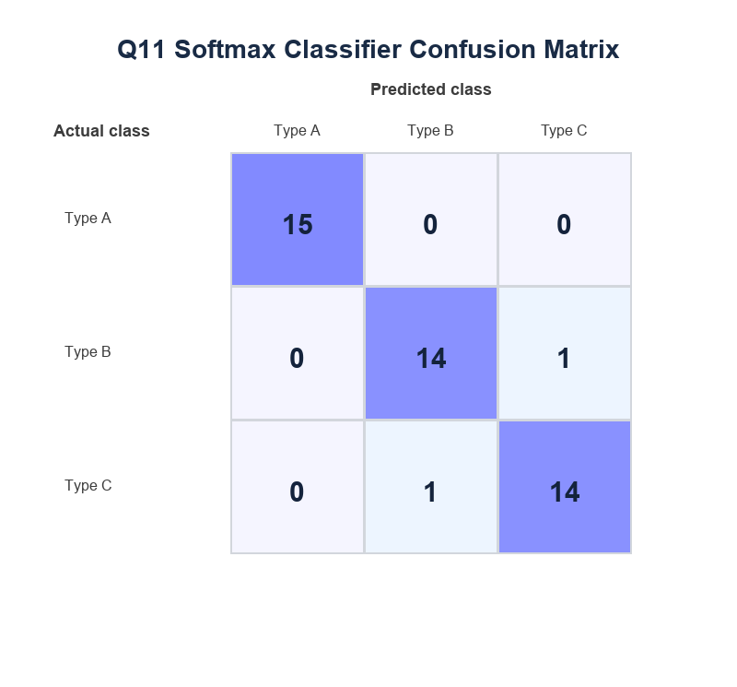
Figure 3. Confusion matrix for the supervised classifier.
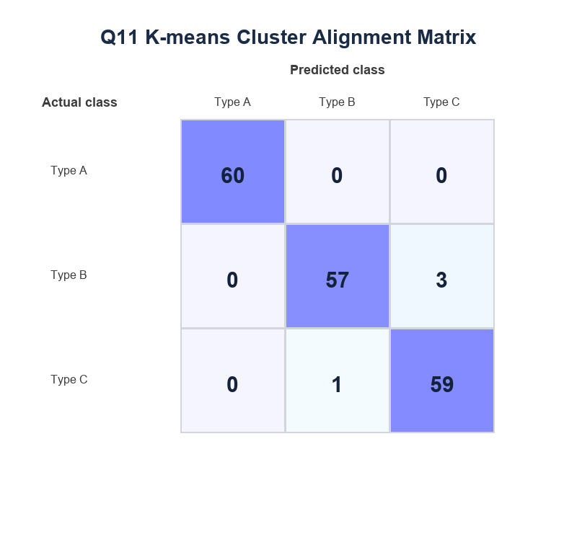
Figure 4. Cluster-to-class alignment matrix for k-means.
Comparison of outputs: The classifier directly used labelled examples, so its output is a named class for each test record and can be evaluated by accuracy, precision, recall, and F1-score. K-means did not know the class labels and produced anonymous cluster numbers. After aligning those clusters with the true classes, the result was still useful, but its purpose was pattern discovery rather than direct prediction.

Q12. Artificial Neural Network and Sentiment Classification
ANN dataset description: A synthetic student-success dataset was generated with 420 rows and 5 features: Study hours, Attendance, Prior score, Assignment score, Sleep hours. The target variable indicates whether the student is selected for an academic support award.
ANN architecture: The model used five input neurons, one hidden layer with ten ReLU neurons, and one sigmoid output neuron. Binary cross-entropy was used as the loss function, and weights were updated by gradient descent.
Class | Precision | Recall | F1-score | Support
Not selected | 0.873 | 0.960 | 0.914 | 50
Selected | 0.956 | 0.860 | 0.905 | 50
Overall | 91.00% | Macro F1 | 0.910

The ANN achieved 91.00% test accuracy with a macro F1-score of 0.910. The training curve shows that loss declined while train and test accuracy stabilized, which suggests the model learned a useful decision boundary without extreme overfitting.
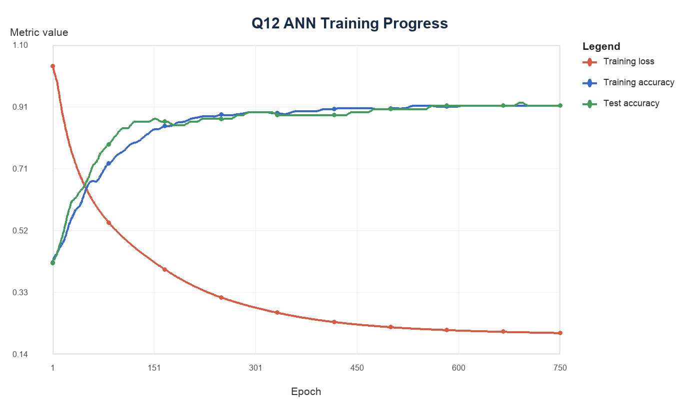
Figure 5. ANN training loss, training accuracy, and test accuracy.
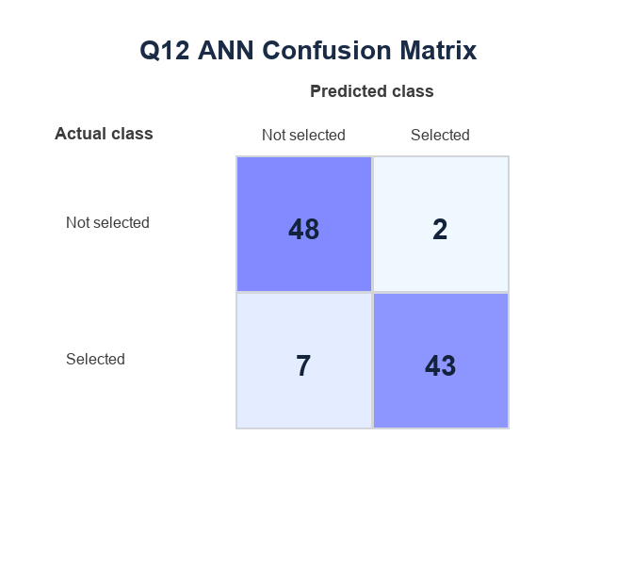
Figure 6. ANN confusion matrix.
Sentiment dataset description: A small original review dataset was written for this assignment with 60 short review sentences labelled as positive or negative. The vocabulary built from training data contained 171 terms, and three transparent lexical sentiment features were added: positive-token count, negative-token count, and their difference.
NLP preprocessing steps: The text was lowercased, punctuation was removed, sentences were tokenized into words, common stopwords were removed, and each sentence was converted into a normalized bag-of-words vector. A small positive/negative lexicon was then used to add simple count-based features. The vocabulary was created only from the training split to avoid leakage.
Class | Precision | Recall | F1-score | Support
Negative | 1.000 | 1.000 | 1.000 | 8
Positive | 1.000 | 1.000 | 1.000 | 8
Overall | 100.00% | Macro F1 | 1.000

The sentiment classifier achieved 100.00% test accuracy and macro F1-score of 1.000. Its strengths are simplicity and interpretability. Its limitation is that a small bag-of-words dataset cannot fully capture sarcasm, context, or unseen vocabulary.
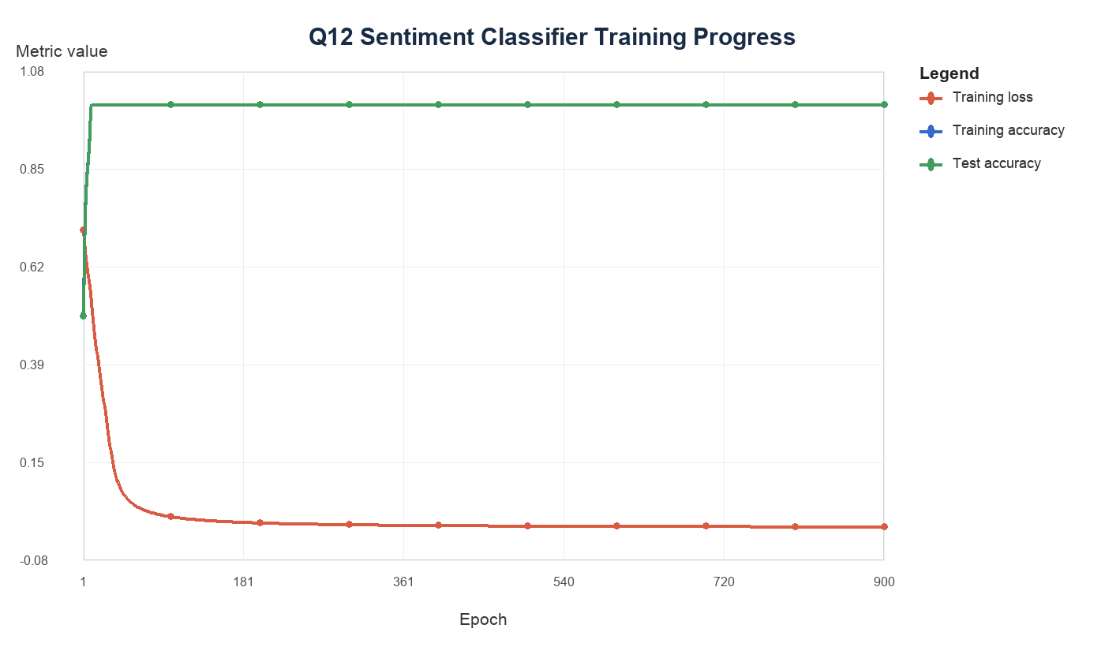
Figure 7. Sentiment classifier training progress.
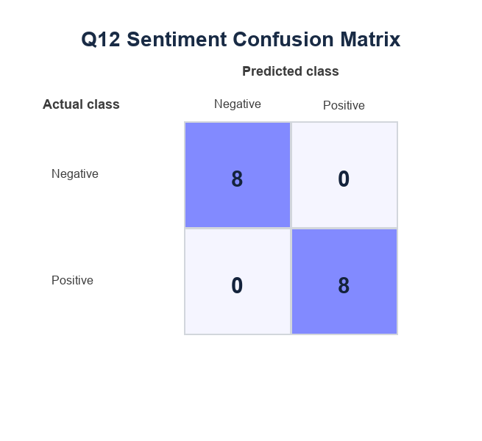
Figure 8. Sentiment classifier confusion matrix.

Q13. CNN for Image Classification
Dataset description: A synthetic image dataset was generated with 540 grayscale images of size 24 x 24 pixels. The three classes were circle, square, and triangle. Random position, size, brightness, and noise were added to make the task less trivial.
CNN architecture used: The CNN used one valid 3 x 3 convolution layer with five filters, ReLU activation, 2 x 2 max pooling, one dense hidden layer with 36 ReLU neurons, and a three-neuron softmax output layer.
Training and testing process: The image dataset was split in a stratified manner into training and testing sets. The model was trained using mini-batch gradient descent with softmax cross-entropy. Training loss, training accuracy, and test accuracy were recorded at every epoch.
Class | Precision | Recall | F1-score | Support
Circle | 0.914 | 0.744 | 0.821 | 43
Square | 0.872 | 0.953 | 0.911 | 43
Triangle | 0.894 | 0.977 | 0.933 | 43
Overall | 89.15% | Macro F1 | 0.888

The CNN achieved 89.15% test accuracy and macro F1-score of 0.888. The result is strong because the synthetic classes have clear geometric differences. However, the model is limited by the simplicity of the data, small image size, and absence of real-world variation such as shadows, rotations, occlusion, and complex backgrounds.
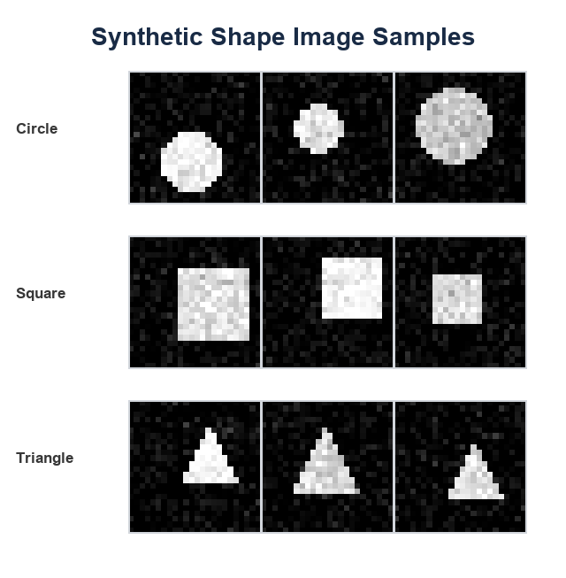
Figure 9. Sample generated images from the CNN dataset.
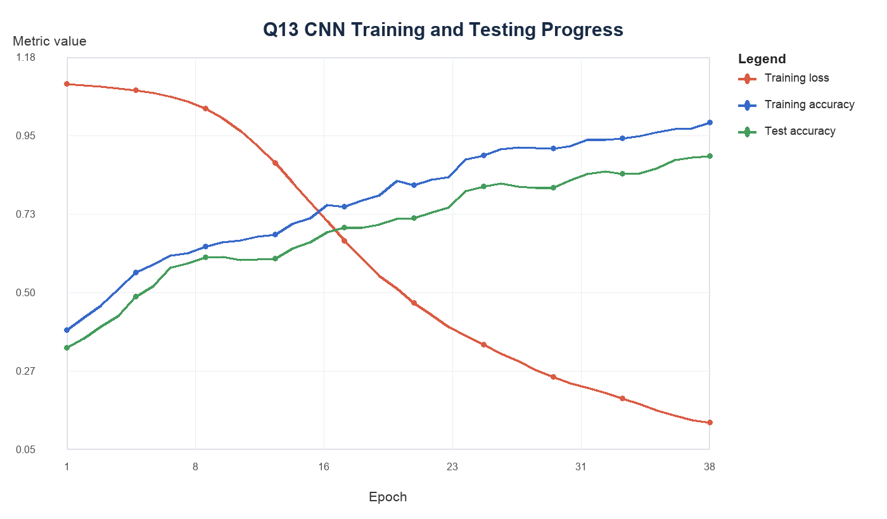
Figure 10. CNN loss and accuracy visualization.
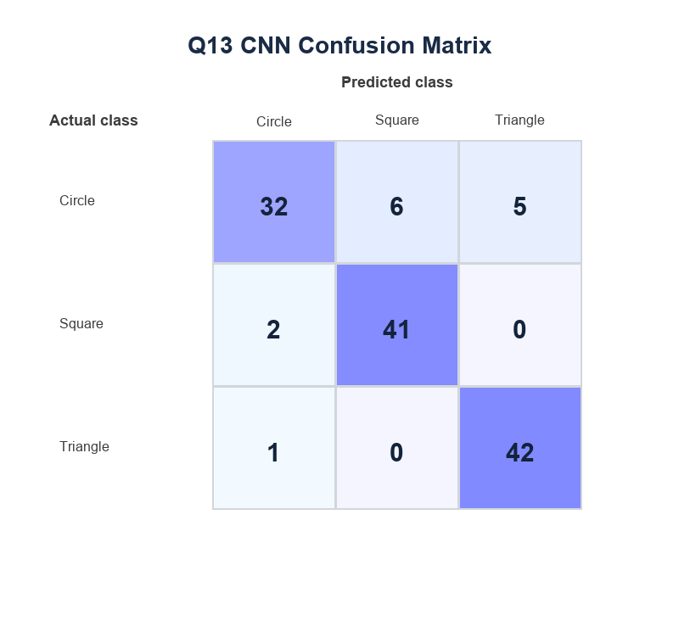
Figure 11. CNN confusion matrix.

Appendix: Commented Python Code Excerpts
The complete reproducible script used to generate the datasets, metrics, charts, DOCX, and PDF is included in the project folder. The appendix below shows standard Scikit-Learn and TensorFlow/Keras code patterns that can be used for a conventional academic implementation.

Scikit-Learn classification excerpt
# Scikit-Learn classification with preprocessing.
from sklearn.model_selection import train_test_split
from sklearn.pipeline import Pipeline
from sklearn.preprocessing import StandardScaler
from sklearn.linear_model import LogisticRegression
from sklearn.metrics import accuracy_score, classification_report

X_train, X_test, y_train, y_test = train_test_split(
X, y, test_size=0.25, stratify=y, random_state=42
)

classifier = Pipeline([
("scaler", StandardScaler()),
("model", LogisticRegression(max_iter=1000))
])

classifier.fit(X_train, y_train)
y_pred = classifier.predict(X_test)

print("Accuracy:", accuracy_score(y_test, y_pred))
print(classification_report(y_test, y_pred))

Scikit-Learn clustering excerpt
# Scikit-Learn k-means clustering and evaluation.
from sklearn.preprocessing import StandardScaler
from sklearn.cluster import KMeans
from sklearn.metrics import silhouette_score

scaler = StandardScaler()
X_scaled = scaler.fit_transform(X)

kmeans = KMeans(n_clusters=3, random_state=42, n_init=10)
cluster_labels = kmeans.fit_predict(X_scaled)

print("Inertia:", kmeans.inertia_)
print("Silhouette score:", silhouette_score(X_scaled, cluster_labels))

Keras/TensorFlow ANN excerpt
# Keras/TensorFlow ANN for binary classification.
import tensorflow as tf
from tensorflow import keras
from tensorflow.keras import layers

ann_model = keras.Sequential([
layers.Input(shape=(X_train.shape[1],)),
layers.Dense(10, activation="relu"),
layers.Dense(1, activation="sigmoid")
])

ann_model.compile(
optimizer="adam",
loss="binary_crossentropy",
metrics=["accuracy"]
)

history = ann_model.fit(
X_train_scaled, y_train,
validation_data=(X_test_scaled, y_test),
epochs=50,
batch_size=32,
verbose=1
)

Scikit-Learn sentiment-analysis excerpt
# Scikit-Learn sentiment classifier using text features.
from sklearn.model_selection import train_test_split
from sklearn.pipeline import Pipeline
from sklearn.feature_extraction.text import TfidfVectorizer
from sklearn.naive_bayes import MultinomialNB
from sklearn.metrics import accuracy_score, classification_report

X_train, X_test, y_train, y_test = train_test_split(
reviews, labels, test_size=0.25, stratify=labels, random_state=42
)

sentiment_model = Pipeline([
("tfidf", TfidfVectorizer(stop_words="english")),
("classifier", MultinomialNB())
])

sentiment_model.fit(X_train, y_train)
y_pred = sentiment_model.predict(X_test)

print("Accuracy:", accuracy_score(y_test, y_pred))
print(classification_report(y_test, y_pred))

Keras/TensorFlow CNN excerpt
# Keras/TensorFlow CNN for image classification.
from tensorflow import keras
from tensorflow.keras import layers

cnn_model = keras.Sequential([
layers.Input(shape=(24, 24, 1)),
layers.Conv2D(16, (3, 3), activation="relu"),
layers.MaxPooling2D((2, 2)),
layers.Conv2D(32, (3, 3), activation="relu"),
layers.MaxPooling2D((2, 2)),
layers.Flatten(),
layers.Dense(64, activation="relu"),
layers.Dense(3, activation="softmax")
])

cnn_model.compile(
optimizer="adam",
loss="sparse_categorical_crossentropy",
metrics=["accuracy"]
)

history = cnn_model.fit(
X_train_images, y_train,
validation_data=(X_test_images, y_test),
epochs=20,
batch_size=32
)

