Who Takes the Next Step? Static, Dynamic, Look-Ahead and Self-Organised Task Sharing in Cooperative VR Assembly
Research proposal with a preregistered analysis plan
Asmae El HARTI · a.elharti@aui.ma
School of Science and Engineering, Al Akhawayn University in Ifrane
Supervisor: Prof. Rachid LGHOUL · October 2026
Summary. When two people assemble something together, someone has to decide who does which step. A plan made in advance lets everyone know their next step, and a system that hands out steps as people become free can adapt to delays. We expect each approach to win in a different way, and we expect the difference to depend on whether people can anticipate, that is, fetch their next part before it can go in. We built a two-person VR app for Meta Quest 3 in which pairs assemble a 13-step two-stage gearbox. We compare four ways of sharing the steps: a static plan (A), dynamic assignment of ready steps (B), dynamic assignment with look-ahead (C), and no assignment at all, where the pair organises itself (D). Before testing anyone, we built a simulation that reads the same task file and applies the same rules as the app, and checked it against the app itself (within 3 %). The simulation predicts that B is slower than a good static plan (+17 %) and that look-ahead recovers most of that loss (−10 % against B). Both predictions keep their direction under every assumption we varied. We use it to fix the static plan, the hypotheses and the sample size: 12 pairs, every pair doing every condition twice in a balanced order. Three hypotheses are tested as preregistered: H1, B slower than A; H2, C faster than B; H3, being assigned a step costs time each time. Everything else is estimated with confidence intervals.

1. Motivation
Assembly work in industry is rarely a one-person job. Two technicians fitting a gearbox, a pump or a frame have to agree on who holds, who fastens and who fetches the next part. Training for this usually happens on real hardware, which is expensive, ties up equipment and is hard to repeat under the same conditions for every trainee. Virtual reality has long been used for assembly and maintenance training (Seth, Vance & Oliver, 2011; Gavish et al., 2015), but mostly with one trainee working alone.
With two people, a question appears that a single-user trainer never has to answer: who takes the next step? A work instruction can fix the roles before the start ("you do the input side, I do the output side"). A system can instead hand each step to whoever is free, at the moment they are free, because a VR trainer always knows the state of the assembly and where every person and part is. Or nobody decides, and the pair sorts it out by talking. Each option is easy to argue for. A fixed plan is predictable, a dynamic one adapts, and self-organisation needs no system at all. Nobody has measured how these options compare for two people working on the same assembly.

2. Background and the gap

2.1 VR assembly and shared virtual spaces
Reviews of VR assembly simulation describe systems for planning and training assembly sequences, from desktop prototypes to immersive setups (Seth et al., 2011). Gavish et al. (2015) found that trainees who used VR or AR platforms for an industrial maintenance and assembly task made fewer unsolved errors than trainees who used videos and printed instructions. Collaborative virtual environments let several people share one virtual space through avatars (Churchill & Snowdon, 1998). For a cooperative task they offer two things this study relies on: each person can see where the other one is, and the system can record both people at the same time.

2.2 Coordination in teams
Teamwork research lists coordination, shared mental models and mutual performance monitoring among the core parts of effective teamwork (Salas, Sims & Burke, 2005). Teams coordinate explicitly, by talking and planning, or implicitly, by anticipating each other's needs without being told (Entin & Serfaty, 1999; Rico, Sánchez-Manzanares, Gil & Gibson, 2008). A fixed plan supports implicit coordination: everyone knows the whole sequence and can work ahead. Dynamic assignment takes the coordination away from the people and hands it to the system. This study asks what that does to the team's work.

2.3 Task allocation, from robots to people
Multi-robot research separates allocation decided once in advance from allocation repeated as the situation changes (Gerkey & Matarić, 2004). In human–robot assembly, Petzoldt et al. (2022) found that dynamic allocation adapted better to delays and shortened the cycle time when the task had enough parallel steps. Schmidbauer, Zafari, Hader and Schlund (2023) found that 25 experienced shop-floor workers preferred adaptive task sharing with a cobot to a fixed allocation and were more satisfied with it. Hoffman (2019) proposed objective measures of the fluency of shared work, such as idle time and concurrent activity, which we adopt.

2.4 The gap
Three things are missing. First, the studies above pair a person with a robot. Two people, both of whom can be surprised by a new assignment, have not been compared under these allocation rules. Second, "static against dynamic" mixes two properties: dynamic rules adapt, but static plans let people anticipate. No study has separated the two. Third, these studies predict only a direction. None says in advance how big the effect should be, under which assumptions, or how many participants are needed to see it.

3. What this study adds
- Four policies, one task, the same people. Static (A), dynamic (B), dynamic with look-ahead (C) and self-organised (D). Every pair does all four in a balanced order, so the comparison is within pairs.
- Adaptation and anticipation separated. C is our own rule. It keeps B's adaptivity and adds A's anticipation by handing out a step that will be ready soon, so its part can be fetched before it is needed. Comparing A, B and C shows how much each property contributes.
- Simulation before data. A simulator that reads the same task file and applies the same rules as the app predicts the size of every effect, shows which predictions survive changed assumptions, chooses the best static plan for A (so A is not a straw man) and sets the sample size. It reproduces the app's scripted test runs within 3 %. The predictions are stored before any participant is tested.
- A mechanism, measured. Restart latency is the time a person needs to set off for their next step. We measure it in every condition. It tests the explanation behind H1 and goes back into the simulator after the study, to see whether the model then matches what people did.
- An open, tested tool. The app, the simulator and the analysis are one package. A different assembly needs only a new task file.

4. Research questions and hypotheses
RQ1 (efficiency). How do the four ways of sharing steps affect how fast a pair finishes? RQ2 (mechanism). Does being told the next step cost time at each step? RQ3 (people). How do workload, role clarity, talking and preference differ between the four?
Confirmatory hypotheses. All three are one-sided and tested together with Holm's correction (Holm, 1979):
- H1. Pairs take longer to finish with dynamic assignment (B) than with the static plan (A). Predicted: +17 %. Under the assumptions we varied: +5 to +32 %.
- H2. Pairs finish faster with look-ahead (C) than with dynamic assignment (B). Predicted: −10 %, from −8 to −11 %.
- H3. Restart latency is longer when steps are assigned (B, C) than when they are known in advance (A).
Estimated with 95 % confidence intervals, without a directional test, because the simulation's answer depends on assumptions we cannot check in advance: C against A (predicted +6 %, range −4 to +19 %), D against A and against C, waiting time, walking, errors, fluency, talking, workload, role clarity and preference.

5. The prototype
CoAssembly is built in Godot 4.7 with Godot XR Tools and OpenXR and runs standalone on Meta Quest 3 headsets. A Linux build of the same project runs on the researcher's PC. It is a research tool: parts are built from simple shapes, and a part is installed by releasing it close to the right spot.
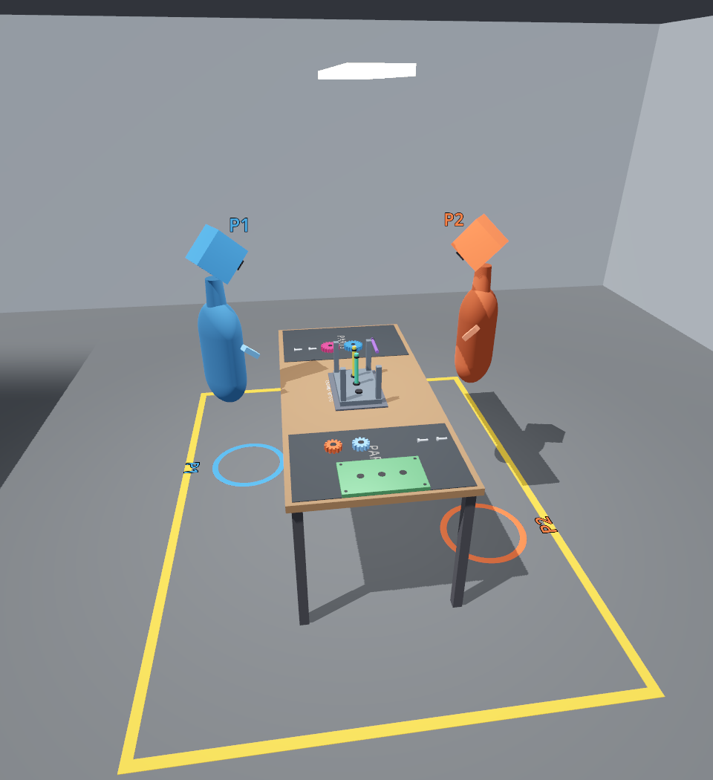
Figure 1. The virtual workshop. Parts start in trays at both ends of a 2 m table and are assembled on the fixture in the middle. The rings mark where each participant starts.

5.1 The task
Pairs assemble a two-stage gearbox in 13 steps (Figure 2): a housing, three shafts, four gears that mesh in two stages, a cover and four bolts. Once the housing is in, all three shafts can go in at once, and the four bolts can be done in parallel. Each bolt also has to be tightened: the person who put it in keeps a hand on it for 3 seconds while it turns into place. This gives the steps different lengths, as in real assembly. We designed the task so that the way work is shared can matter. Our first version had 8 steps, and its static split was already close to the best possible schedule, which left nothing for the other conditions to improve. Parts are put into the trays by a rule fixed before any simulation: one large part per tray, and shafts, gears and bolts alternate between the trays by step number.
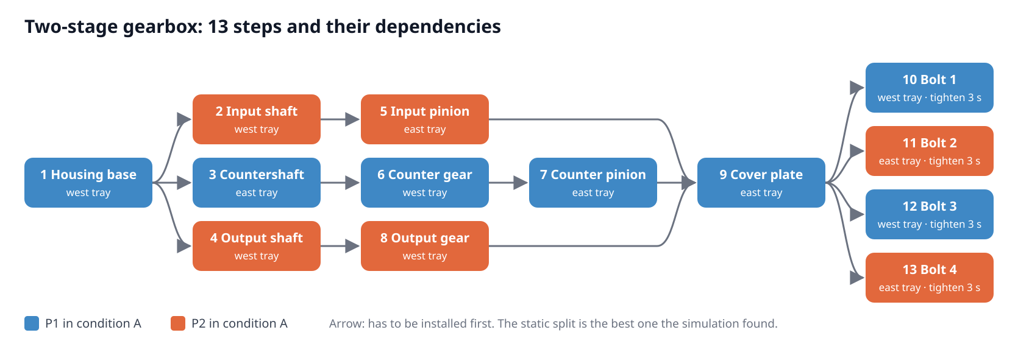
Figure 2. The 13 steps and their dependencies. Colours show the static plan used in condition A, which is the best of all 8,190 possible splits in simulation (Section 6.2).
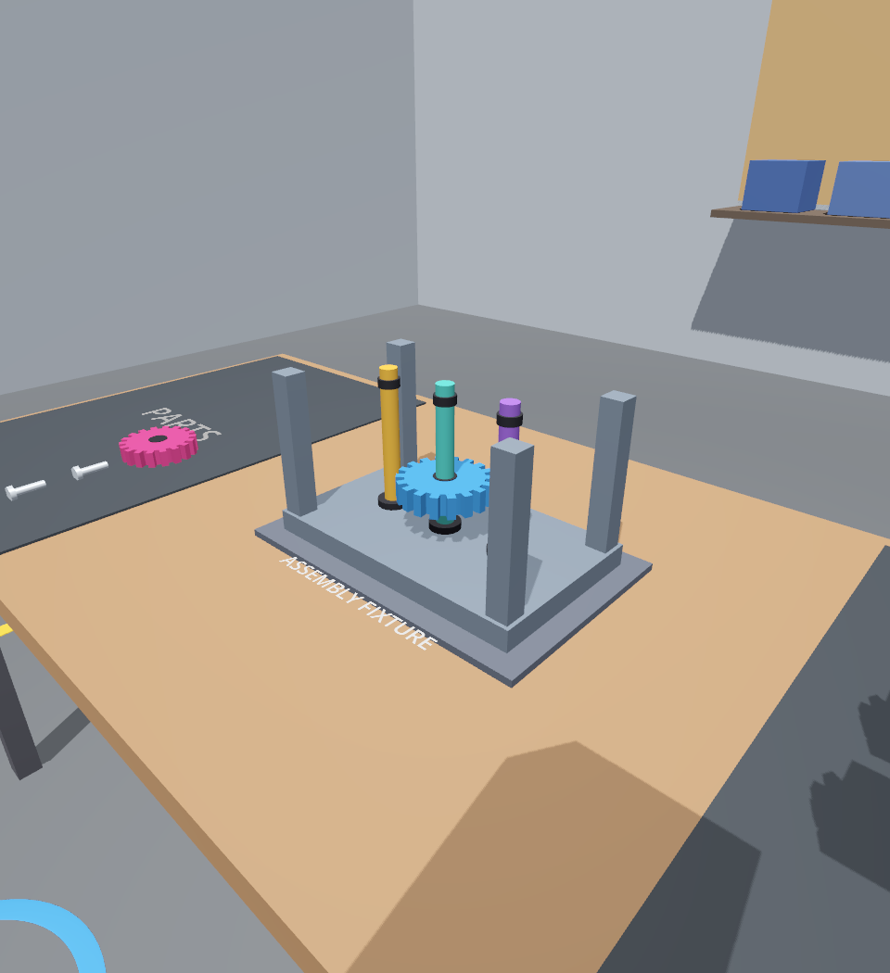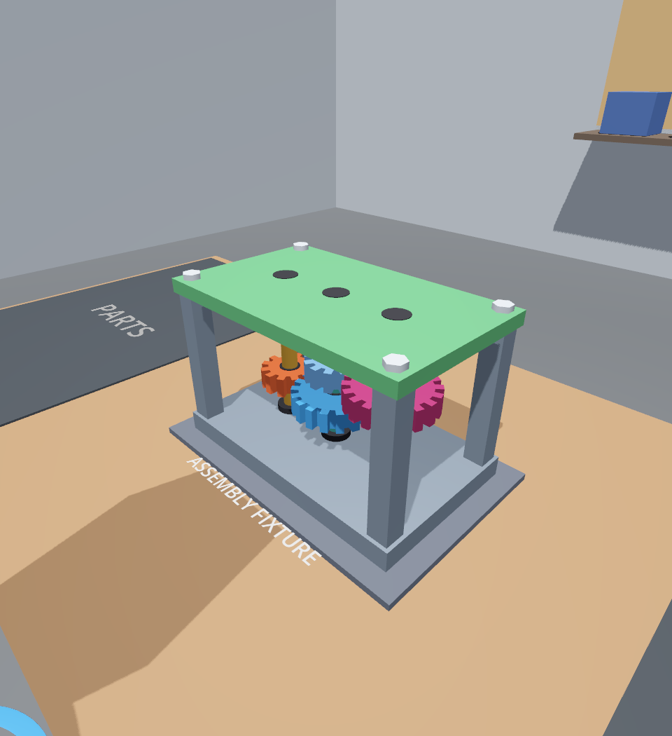
Figure 3. The gearbox during assembly and finished.

5.2 The four conditions
A, static. Each participant has a fixed list of steps, the best split found by the simulation: P1 does steps 1, 3, 6, 7, 9, 10, 12 and P2 does steps 2, 4, 5, 8, 11, 13. They may pick up any part on their own list, so they can fetch a part before its step is ready and wait with it at the fixture.
B, dynamic. Nobody owns a step in advance. Four times a second, and right after every installation, the app looks for participants with no open step and for steps that are ready and not yet assigned. It assigns the closest pair first, by horizontal distance between the person's head and the part, then the next closest. A participant may only pick up the part of the step they were given.
C, look-ahead. As in B, but when no ready step is left for a free participant, the app can give them a step that is waiting only on steps someone is already working on. They can fetch that part and wait with it, as in A. Ready steps always go first.
D, self-organised. The app assigns nothing. Any part that nobody else holds can be picked up, and picking it up claims its step until the part is installed or put down. Every ready part glows for both participants, and the step board lists them. The pair decides between themselves who does what.
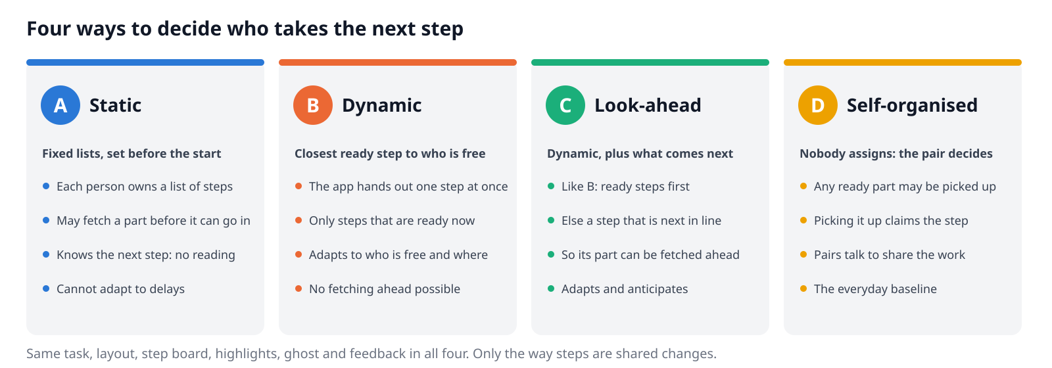
Figure 4. The four conditions. Only the way steps are shared changes.
Everything else is identical: the layout, the step board in front of each participant, the glow on the current part, a see-through "ghost" showing where it goes, and the feedback when something goes wrong. Each condition gives the information that naturally comes with its rule: a list in A, one step at a time in B and C, the ready steps in D. This is part of the manipulation, and we describe it as such.

5.3 Interaction and feedback
Participants use the Quest controllers (grip to grab) or their bare hands (fist to grab, pinch to click) and move by walking. Grabbing from a distance is switched off, so getting a part means going to it. A part snaps in when released within 5 cm of its spot and within 30° of upright. A wrong placement turns the part red, plays a buzz, vibrates the controller and sends the part back to its tray.

5.4 Networking and data
The headsets and the researcher's PC share a dedicated Wi-Fi router (Figure 5). The PC hosts the session, checks every grab and placement against the rules and writes the data. Devices running different builds refuse to connect, so a session can never mix two versions of the task. Each headset streams head and hand poses at 20 Hz and part movements at 30 Hz. A voice-activity detector on each headset turns its microphone signal into a yes/no "speaking" value; no audio is stored or sent.
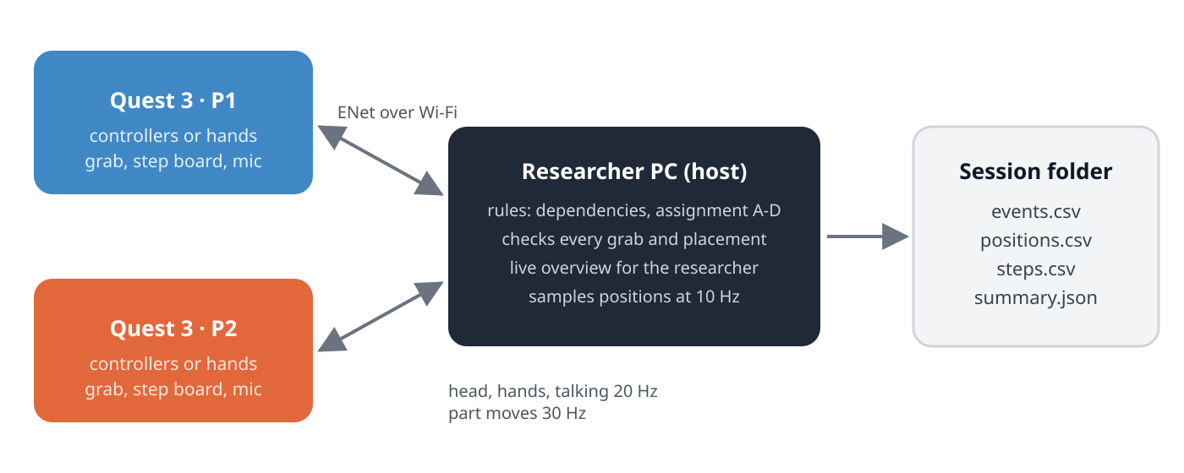
Figure 5. Setup. The researcher's PC hosts the session and does not take part in the task.
For each session the host writes an event log (every grab, release, installation, tightening, error, assignment and claim, plus network delay every 2 s), positions of both participants at 10 Hz, one row per step and a summary. A script merges all sessions into analysis tables.

5.5 How the software is tested
- 69 unit checks of the rules, including a full run of every condition by two simulated participants. Each run must finish without a deadlock and with work for both people.
- An end-to-end test that starts two separate copies of the app talking over the network. Each copy is played by a script that also makes every kind of error on purpose. For all four conditions and several random seeds, the logged errors must match the intended ones exactly, every step must be done by the person it belonged to, and every tightened bolt must take its full 3 seconds. During development it caught two bugs in the app and one in the scripted player, all fixed.
- A check that the simulator and the app agree (Section 6.4).

6. Simulation before data
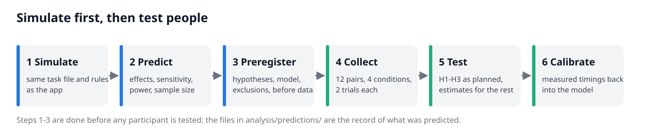
Figure 6. The order of work. Steps 1 to 3 are finished, and their outputs are stored, before any participant is tested.

6.1 The model
The simulator plays a session as a sequence of timed actions for two people: react, walk to the part, pick it up, walk to the fixture, wait if the step is not ready yet, place, and tighten. It uses the same task file, the same assignment rule (greedy, closest pair first) and the same definition of waiting as the app. Each simulated pair is played in all four conditions, so differences are paired as in the study. All timings are assumptions until the pilot replaces them; they are listed below and stored with the script.
Assumption | Value | Why
Walking speed (side-stepping in a headset) | 0.8 m/s, varies between people (lognormal, σ = 0.15) | slower than normal walking; replaced from pilot data
Picking a part up / placing it | 1.0 s / 2.0 s median; housing and cover ×1.25 | VR grabbing and aligning; replaced from pilot data
Tightening a bolt | 3 s + 0.5 s to get the hand onto it | 3 s is fixed by the app
Failed placement (part goes back to its tray) | 6 % of placements | replaced from pilot data
Restart after a step: A / B and C / D | 0.3 s / 0.8 s / 1.2 s median | known next step / reading a new one / agreeing with the partner
Fetching ahead in A when the next step is blocked | always | varied from never to always in the sensitivity analysis
Practice effect | power law, exponent 0.15, after two practice runs | the usual form of learning curves

6.2 Giving the static plan its best chance
Condition A is only as good as its plan, and a poor plan would make the dynamic conditions look good. We therefore simulated every one of the 8,190 ways to split the 13 steps between two people. The best 40 were run again 400 times each, and the best eight were confirmed with fresh random numbers. The best plan gives one person the whole critical path (countershaft, counter gear, counter pinion, cover), which is also what an experienced planner would do. It finishes in 42.9 s on average; the worst split takes 80.1 s. This plan is used in A.

6.3 Predictions and how much they depend on the assumptions
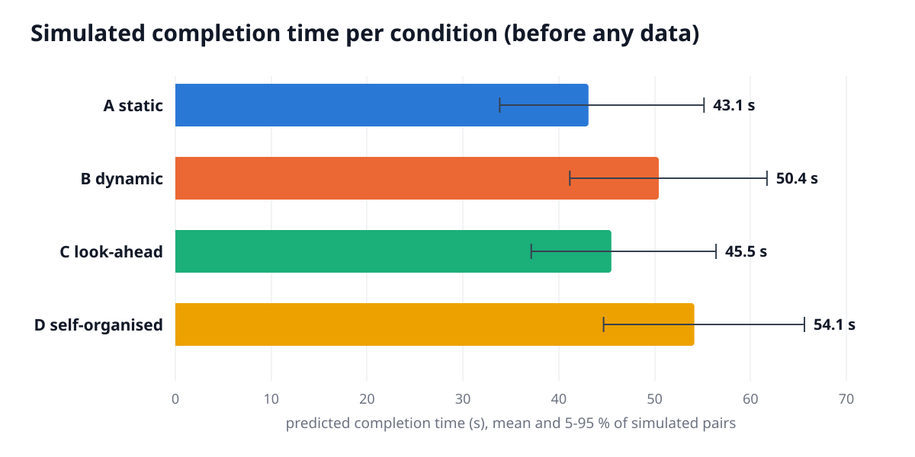
Figure 7. Predicted completion time in the first trial (5,000 simulated pairs). Bars: mean; whiskers: 5th to 95th percentile.
B is predicted to be 17 % slower than A. Two things cost B time: it cannot fetch ahead, and reading a new assignment adds a little time at every step. Look-ahead (C) recovers most of the loss and is 10 % faster than B. It still ends 6 % behind the optimised static plan, which already knows the critical path. Self-organisation (D) is predicted to be slowest, but that prediction rests almost entirely on the assumed cost of agreeing who does what. We also tried giving C a critical-path priority rule (Hu, 1961). It did not help, so C stays simple.
We then changed one assumption at a time (Figure 8). Two predictions keep their direction under every change: B is slower than A, and C is faster than B. These became H1 and H2. Two do not: the sign of C against A depends on how long people take to read an assignment, and the size of D's disadvantage depends on how long they take to agree. These are estimated, not tested for a direction, and restart latency is measured directly (H3) so the explanation can be checked.
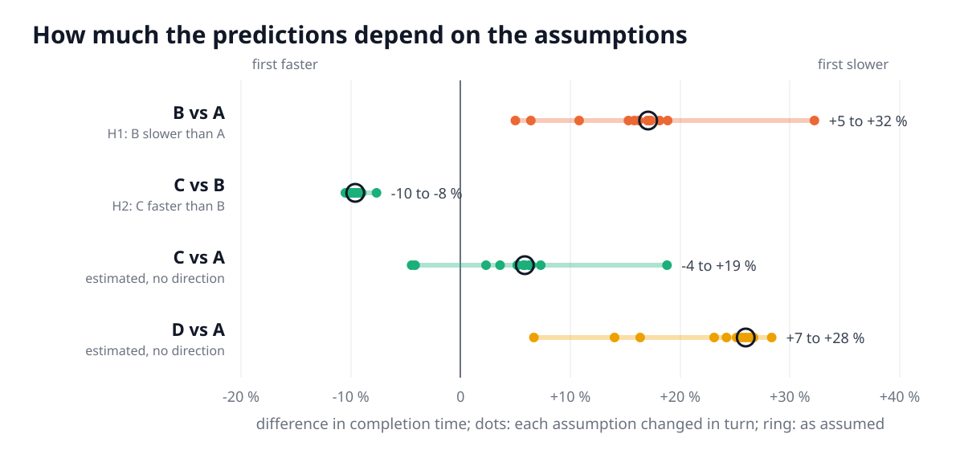
Figure 8. Predicted differences when each assumption is changed in turn (fetching ahead never or half the time, slow or instant reading, faster or slower walking, more or fewer errors, slower placing, more variation between people, no coordination cost).

6.4 Does the simulator do what the app does?
A prediction is only useful if the model follows the same rules as the app. We ran the app's two scripted test players over the network in each condition and simulated the same scripted players. The simulator's completion times were within 2 to 3 % of the app's, and the conditions came out in the same order (Figure 9). This check is repeated automatically by a test script.
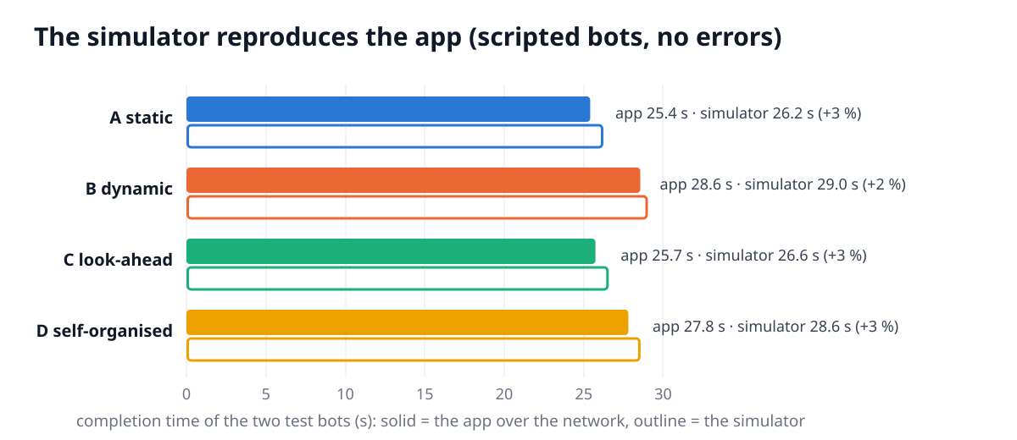
Figure 9. Completion times of the app's scripted test players over the network and of the simulator, by condition.

6.5 Sample size
We simulated whole studies (pairs, Williams order, two trials per condition, practice effect, differences between pairs) and analysed each one with exactly the planned model. With 12 pairs, the chance that H1, H2 and H3 are all supported is 99 % if the predicted effects are true. Because the predictions might be too optimistic, we also checked the smallest effect we would still care about: a 10 % difference in completion time. For that effect, 12 pairs give 89 % power for H1 and 88 % for H2 (8 pairs: 75 % and 73 %; 16 pairs: 95 % and 96 %). We chose 12 pairs, which is also the size that balances the four orders of the Williams design (Lakens, 2022). The simulated power for H3 is less informative, because the model builds in a difference in restart latency. The test is still worth running, since the pilot and the study measure that latency directly.

7. Method

7.1 Participants
24 adults (12 pairs), recruited among students and staff of Al Akhawayn University. Inclusion: 18 or older, normal or corrected vision. Exclusion: epilepsy or seizures, a recent concussion, strong motion sickness in earlier VR use. Pairs form from people who sign up together or by availability. We record whether partners knew each other, their VR and gaming experience, and their handedness.

7.2 Design
One within-pairs factor with four levels (A, B, C, D). Each pair does two trials per condition, in blocks, giving 8 trials. The order of the blocks follows a Williams design (Williams, 1949): every condition appears once in every position and directly follows every other condition exactly once. Each of the four orders is used by three pairs, and which pair gets which order is fixed in advance by a seeded random draw (schedule in the analysis folder). Learning is handled in three ways: two solo practice runs before the study, a balanced order, and trial position as a term in every model.

7.3 Apparatus
Two Meta Quest 3 headsets running the same CoAssembly build, a laptop hosting the session, and a dedicated Wi-Fi router. Each participant has their own cleared play area of at least 2.5 × 2 m. The two areas do not overlap, because the partner's avatar is not where the partner really stands. Participants may talk normally.

7.4 Procedure (about 60 minutes per pair)
- Information sheet, consent (including the yes/no speaking measure), demographics (5 min).
- Simulator Sickness Questionnaire, baseline (Kennedy et al., 1993).
- Headset fitting and a scripted tutorial: grabbing, the step board, the ghost and tightening (5 min).
- Practice: each participant assembles the gearbox alone, twice, at the same time on their own headset (about 6 min).
- Four blocks in the pair's order. Each block has a scripted 30-second explanation of the condition, two trials, then the block questionnaire: NASA-TLX, role clarity and the collaboration items (about 6 min per block). There is a short break outside VR after the second block.
- SSQ again, the System Usability Scale for the app overall (Brooke, 1996), ranking of the four conditions, and a short interview (10 min).
The researcher reads all instructions from a script, does not comment on performance and does not tell participants the hypotheses. A participant can stop at any time.

7.5 Measures
Measure | Definition | Level
Completion time (H1, H2) | Start to the last step done (the last bolt tight) | trial
Restart latency (H3) | From the moment a person is free and has a next step (in D: when a ready step is free) to setting off: first grab, or head speed above 0.3 m/s in two samples in a row. Median per person and trial | person × trial
Waiting time | Time with no step that can be installed, while standing still or already holding the part | person × trial
Fluency (Hoffman, 2019) | Share of time both are busy (holding a part or tightening), and only one | trial
Fetching ahead | Parts picked up before their step could go in | trial
Walking | Horizontal head path | person × trial
Errors | Wrong part, wrong sequence, wrong place, dropped | person × trial
Talking | Share of samples with speech (voice activity, no audio kept) | trial
Workload | Raw NASA-TLX, six subscales 0–100 (Hart & Staveland, 1988; Hart, 2006) | person × block
Role clarity | Four 7-point items written for this task from the role-ambiguity construct of Rizzo, House and Lirtzman (1970) (Appendix A); reliability reported | person × block
Preference | Ranking of the four conditions, and interview | person
Usability and sickness | SUS once at the end; SSQ before and after | person

7.6 Preregistered analysis
The plan below, the hypotheses, the predictions in Section 6 and the analysis script are registered on the Open Science Framework before the first participant (Nosek, Ebersole, DeHaven & Mellor, 2018). The script has already been run end to end on a simulated full-size data set.
- Exclusions, decided now: practice runs; trials that do not finish; trials with tracking below 8 Hz or a median network delay above 100 ms. A pair that loses a whole condition is replaced by a new pair with the same order. Every exclusion is reported. The confirmatory models are also run without the data-quality exclusions.
- Confirmatory models. Linear mixed models with condition and trial position as fixed effects and a random intercept per pair. For restart latency there is also a random intercept per participant. Completion time and latency are log-transformed, so effects read as percentages. H1: B − A > 0. H2: C − B < 0. H3: the mean of B and C minus A > 0, on latency. All three are one-sided at α = .05, with Holm's correction.
- Estimates. C − A, D − A and D − C, with 95 % confidence intervals and two-sided p-values, interpreted as estimates.
- Secondary outcomes. The same model for waiting, walking, errors, fluency, talking, NASA-TLX and role clarity, with Holm's correction within this family. Preference is tested with a Friedman test on the ranks.
- Robustness. Wilcoxon signed-rank tests on pair means for H1 and H2. A model that adds the previous block's condition, as a carry-over check. Residual checks. If the mixed model does not converge, the same model with fixed effects for pair, which the script does automatically and reports.
- After the test (exploratory): the measured walking speed, handling times, error rate and restart latencies replace the assumptions in the simulator. Comparing the recalibrated predictions with the observed effects shows what the model missed.
The stopping rule is 12 complete pairs. Any deviation from this plan will be listed in the paper with its reason.

7.7 Pilot
Before recruiting, two lab members run the full procedure on the real headsets. The pilot checks grabbing and tightening with controllers and with hands, the snap tolerance, the voice-activity threshold, network delay, the timing of the session and the questionnaires. Pilot sessions also feed the simulator's calibration command. If the recalibrated power with 12 pairs falls below 80 % for a 10 % effect, the sample size is raised before preregistration. Pilot data are not part of the analysis.

8. Threats to validity and how they are handled
Threat | How it is handled
Learning: the same gearbox is built ten times | Two practice runs; Williams order; trial position in every model; a practice effect built into the power simulation
Carry-over between conditions | Williams design balances which condition follows which; carry-over check in the robustness analysis
A straw-man static plan | A uses the best of all 8,190 splits
Predictions built into the model | Only predictions that survive every changed assumption are tested for a direction; the others are estimated
Simulator differs from the app | Same task file and rules; agreement with the app within 3 % (automatic test)
Conditions differ in information, not only in allocation | Described as part of the manipulation; layout, highlights, ghost and feedback are identical
Many outcomes, false positives | Three confirmatory tests with Holm's correction; separate Holm family for secondary outcomes; everything else as estimates
Researcher influence, demand effects | Scripted instructions; hypotheses not told; the software measures everything automatically
Technical problems (tracking, network) | Logged continuously; exclusion rules fixed in advance
Partners who know each other | Recorded; added as a covariate in an exploratory model
Simplified task (no tools, weight or torque) | Stated as a limit; the claim is about coordination, not about manual skill

9. Ethics and data
We will apply to the university ethics committee before any recruitment. Participants are identified only by pair number and P1/P2. The app records no names, audio or video. The microphone is used only to decide, many times a second, whether someone is speaking, and only that yes/no value is kept. This is explained in the consent form. Session files stay on an encrypted laptop. The anonymous tables, the analysis script and the app are shared openly with the paper. The main risk is mild simulator sickness: trials are short, there are breaks, and the SSQ is used to watch for it.

10. Timeline
Weeks | Work
1 – 2 | Ethics application. Hardware pilot, calibration of the simulator, fixes.
3 | Freeze the software build; preregistration on OSF.
4 – 6 | Data collection: 12 pairs, two pairs per day on two days a week.
7 – 8 | Preregistered analysis, then recalibration and exploratory analysis.
9 – 10 | Paper, poster and open release of data and code.

11. What the study contributes, whatever the outcome
If H1 and H2 are supported, the study shows that how much dynamic assignment helps a pair depends on whether people can work ahead, and that a simple look-ahead rule recovers most of what a reactive rule loses. If H1 fails, the reading cost and the loss of anticipation are smaller for people than the model assumes. Restart latency and the recalibrated model will show which one. If H2 fails, anticipation is not what makes static plans fast for people. The estimates for self-organisation give the first measured cost of a pair negotiating its own work in a shared virtual space. A result in any direction is informative, because the hypotheses, the analysis and the predicted effect sizes are fixed before any data are collected. The app, the simulator and the analysis pipeline can be reused with any assembly that can be written as a task file.
Limits. The participants are university students, the gearbox is simplified, and each condition is short. The assignment rules use distance and dependencies only, not skill or preference. The questionnaire on role clarity is our own and is validated only by its reliability in this sample. These limits restrict how far the results generalise to real workshops, and the paper will state them.

References
Brooke, J. (1996). SUS: A “quick and dirty” usability scale. In P. W. Jordan, B. Thomas, B. A. Weerdmeester & I. L. McClelland (Eds.), Usability Evaluation in Industry (pp. 189–194). Taylor & Francis.
Churchill, E. F., & Snowdon, D. (1998). Collaborative virtual environments: An introductory review of issues and systems. Virtual Reality, 3(1), 3–15.
Entin, E. E., & Serfaty, D. (1999). Adaptive team coordination. Human Factors, 41(2), 312–325.
Gavish, N., Gutiérrez, T., Webel, S., Rodríguez, J., Peveri, M., Bockholt, U., & Tecchia, F. (2015). Evaluating virtual reality and augmented reality training for industrial maintenance and assembly tasks. Interactive Learning Environments, 23(6), 778–798.
Gerkey, B. P., & Matarić, M. J. (2004). A formal analysis and taxonomy of task allocation in multi-robot systems. The International Journal of Robotics Research, 23(9), 939–954.
Hart, S. G. (2006). NASA-Task Load Index (NASA-TLX); 20 years later. Proceedings of the Human Factors and Ergonomics Society Annual Meeting, 50(9), 904–908.
Hart, S. G., & Staveland, L. E. (1988). Development of NASA-TLX (Task Load Index): Results of empirical and theoretical research. In P. A. Hancock & N. Meshkati (Eds.), Human Mental Workload (pp. 139–183). North-Holland.
Hoffman, G. (2019). Evaluating fluency in human–robot collaboration. IEEE Transactions on Human-Machine Systems, 49(3), 209–218.
Holm, S. (1979). A simple sequentially rejective multiple test procedure. Scandinavian Journal of Statistics, 6(2), 65–70.
Hu, T. C. (1961). Parallel sequencing and assembly line problems. Operations Research, 9(6), 841–848.
Kennedy, R. S., Lane, N. E., Berbaum, K. S., & Lilienthal, M. G. (1993). Simulator Sickness Questionnaire: An enhanced method for quantifying simulator sickness. The International Journal of Aviation Psychology, 3(3), 203–220.
Lakens, D. (2022). Sample size justification. Collabra: Psychology, 8(1), 33267.
Nosek, B. A., Ebersole, C. R., DeHaven, A. C., & Mellor, D. T. (2018). The preregistration revolution. Proceedings of the National Academy of Sciences, 115(11), 2600–2606.
Petzoldt, C., Niermann, D., Maack, E., Sontopski, M., Vur, B., & Freitag, M. (2022). Implementation and evaluation of dynamic task allocation for human–robot collaboration in assembly. Applied Sciences, 12(24), 12645.
Rico, R., Sánchez-Manzanares, M., Gil, F., & Gibson, C. (2008). Team implicit coordination processes: A team knowledge-based approach. Academy of Management Review, 33(1), 163–184.
Rizzo, J. R., House, R. J., & Lirtzman, S. I. (1970). Role conflict and ambiguity in complex organizations. Administrative Science Quarterly, 15(2), 150–163.
Salas, E., Sims, D. E., & Burke, C. S. (2005). Is there a “Big Five” in teamwork? Small Group Research, 36(5), 555–599.
Schmidbauer, C., Zafari, S., Hader, B., & Schlund, S. (2023). An empirical study on workers' preferences in human–robot task assignment in industrial assembly systems. IEEE Transactions on Human-Machine Systems, 53(2), 293–302.
Seth, A., Vance, J. M., & Oliver, J. H. (2011). Virtual reality for assembly methods prototyping: A review. Virtual Reality, 15(1), 5–20.
Williams, E. J. (1949). Experimental designs balanced for the estimation of residual effects of treatments. Australian Journal of Scientific Research, Series A, 2(2), 149–168.

Appendix A. Block questionnaire (after the second trial of each condition)
Role clarity (7-point, 1 = strongly disagree, 7 = strongly agree; mean of the four items):
- I knew exactly what I had to do next.
- I knew which parts were my responsibility.
- I was sure that what I did was what the task needed.
- It was clear how the work was divided between us.
Collaboration (7-point, analysed one by one, exploratory):
- My partner and I got in each other's way.
- I often had to wait for my partner.
- I felt in control of what I did.
- I would like to work this way on a real assembly.
Workload: raw NASA-TLX: mental, physical and temporal demand, performance, effort, frustration (0–100 each).

Appendix B. End of session
- Rank the four ways of working from the one you liked best (1) to the one you liked least (4).
- Interview: Which way did you prefer, and why? Was there a moment when you did not know what to do? When did you talk about who does what? Did you ever pick up a part before you could use it, and why?
Data definitions, the exclusion rules and every number in this proposal come from files in the app folder: analysis/predictions/ (simulation outputs), analysis/schedule.csv (orders), analysis/analyse.py (the analysis) and data/gearbox_task.json (the task).

