SOP for FS-Avoidance behavior chambers built by Zengyou
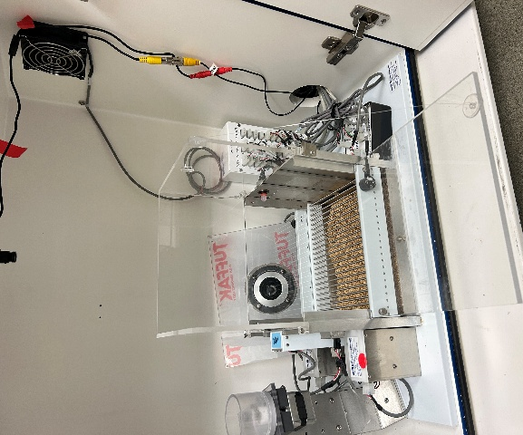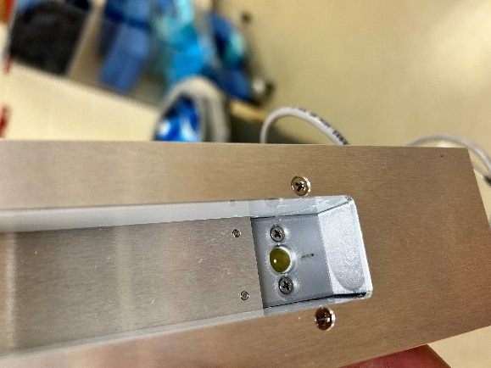
- Environmental Habituation
  - Bring the mice to the testing room and allow them to habituate to the environment for at least 30 minutes.
- Turn On Equipment
  - Turn on the computer and cameras using the power switch.
- Set Up Camera Monitoring
  - Open Blue Iris and confirm the camera views for Boxes 5–8.
- Set Up Med-PC
  - Open Med-PC.
  - Enter/check the initial parameters for each cage, including the subject ID and protocol.
- Pre-Test Check
Before starting, confirm:
  - Syringe pump: Ensure 0.2% saccharin solution is loaded and all tubing is filled.
  - FS device: Confirm the setting is approximately 0.3 mA.
- Start Behavioral Testing
  - Place the mice in the behavioral chambers.
  - Start the appropriate Med-PC program for each mouse.
- After Testing
  - Return the mice to their home cages.
  - Record the number of rewards and FS count for each mouse.
  - Measure and record the remaining volume of saccharin solution.
- Clean the Chambers
  - Clean the chambers with 70% ethanol.
  - Allow the chambers to dry before starting the next batch.

