Instruction Manual for iMOSS-MV V1
Purpose
The Video Frame Labeler is a user-friendly, open-source software designed to manually score mobility and immobility (or other binary behaviors) in behavioral experiments such as the Tail Suspension Test (TST) and Forced Swim Test (FST). Researchers can efficiently annotate video frames, categorizing behavior as either mobility or immobility while maintaining precise frame control.
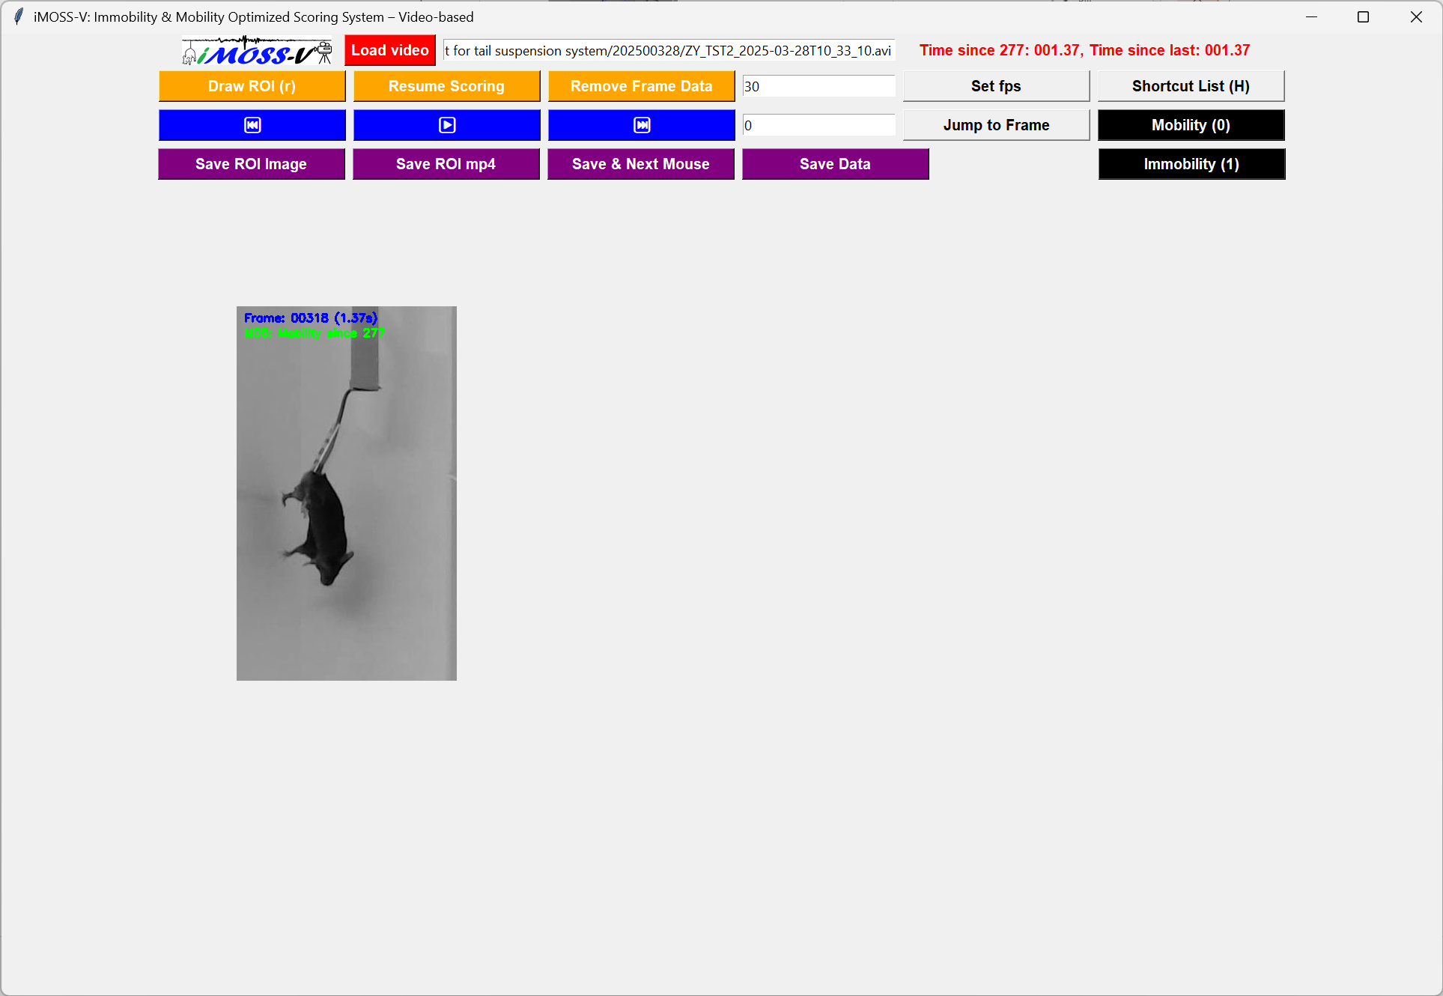
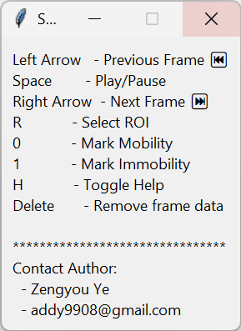
Key Features & Advantages
- Flexible Interaction: Supports both button clicks and keyboard shortcuts for efficient scoring.
- Precise Frame Control: Easily play, pause, move forward, or rewind frame-by-frame for accurate annotation.
- Region of Interest (ROI) Selection: Define and save ROIs for individual subjects, ensuring consistent tracking across frames.
- Data Management:
  - Save annotations as CSV files for easy analysis.
  - Reload previously annotated data for continued analysis or presentation.
  - Prevent accidental overwrites with smart saving mechanisms.
- Real-Time Time Display: Converts frame numbers into MM:SS.SS format for easier interpretation.
- Open-Source & Budget-Friendly: Designed for labs with limited resources, making video scoring accessible without expensive commercial software.
How to Use
1. Load a Video File
- Click Browse to select a video file (AVI format preferred).
- Click Load Video to open and process the video.
2. Select Region of Interest (ROI)
- Click Select ROI, and a pop-up window will appear.
- Define an ROI by dragging a box over the desired area, then confirm with Space or Enter.
- Assign a Mouse ID to track the subject.
- The ROI will be saved and displayed on the canvas.
3. Play & Navigate the Video
- Play/Pause: Use the button or press Space.
- Move Forward/Backward: Click buttons or use Right/Left Arrow Keys.
- Jump to Specific Frame: Enter a frame number manually.
4. Annotate Behavior
- Press 0 for Mobility.
- Press 1 for Immobility.
- Annotations will be saved automatically per frame.
5. Save & Reload Data
- Click Save to export the scored data (CSV format, timestamped filename).
- When reloading a video, existing ROIs will be detected, and a warning will prompt confirmation before clearing them.
- Previously saved data can be reloaded for continued analysis.
Additional Notes
- ROIs are preserved per session unless cleared manually.
- Ensure consistent FPS settings for accurate frame-time conversion.
- Data integrity is maintained with built-in duplicate checks when saving.
This tool simplifies manual behavioral scoring, ensuring flexibility, precision, and ease of use for researchers conducting stress behavior studies.

