MERIDIAN TECHNOLOGIES
Annual Board Strategic Review | Opening Remarks | Catherine Park, CEO

Meridian has a profitable foundation and a narrowing window.
The enterprise franchise is real. The AI transition is urgent. The board's alignment on three decisions will determine the next chapter.
I have spent my first year listening, diagnosing, and making early moves — segment P&Ls, the Helio acquisition, Copilot GA. I want to use this session to be direct with the board about where we are, what the three biggest issues are, and what I need from you today.

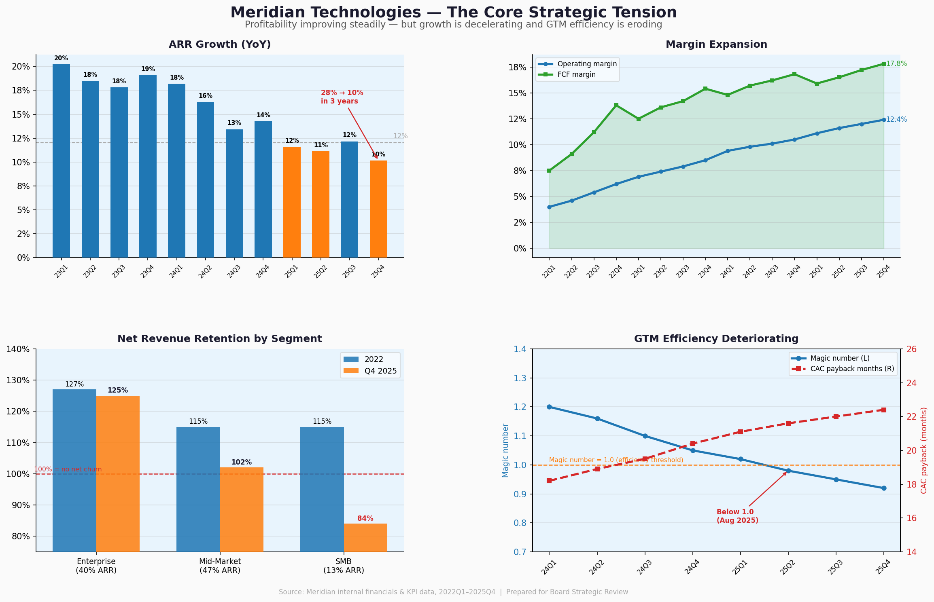
Exhibit 1 — The Core Strategic Tension: profitability expanding while growth decelerates and GTM efficiency erodes. Source: Meridian internal data, 2022Q1–2025Q4.
ISSUE 01 AI IS EXISTENTIAL — AND WE ARE STILL EARLY
The entire collaboration software category is repricing around agentic AI. We shipped Copilot to GA in September 2025. We ended the year with 710 paying seats and ~$3.5M in Copilot ARR — real proof of concept, but less than 1% of revenue. The enterprise governance suite — the feature regulated customers need to standardize on Copilot — is our Q1 2026 priority. Until it ships, our most valuable customers cannot fully commit. Meanwhile Atlassian announced agentic Jira last month and will be in our enterprise deals more directly than before. | Key evidence  - 710 paying Copilot seats at year-end vs. zero twelve months prior; 44% attach rate on enterprise renewals in Q4 (target: 40%)  - Asana shipped full agent suite November 2025; Monday now larger than Meridian by ARR; ClearAI raised $120M at $1B+ valuation  - 31% of engineering open-ends cited 'roadmap thrash' — three AI pivots in 18 months — as top frustration (Employee Survey, Oct 2025)  - CPO: net engineering hires in 2026 will be ~25, vs. 80 assumed in the plan — execution capacity is constrained

ISSUE 02 TWO OF THREE SEGMENTS ARE BROKEN — GROWTH DEPENDS ON 140 LOGOS
SMB ARR declined 23% in 2025. NRR is 84%. Gross logo churn is 22% annually. Mid-market — our largest segment at 47% of ARR — grew only 6% with NRR compressed from 115% (2022) to 102% (Q4 2025). Our entire growth story now rests on approximately 140 enterprise customers. The GTM efficiency numbers confirm the problem: magic number crossed below 1.0 in Q2 2025 and CAC payback has risen from 18 to 22 months. We are spending more on sales and marketing than we are generating in new ARR. | Key evidence  - SMB: ARR fell from $68M (Q4 2024) to $52M (Q4 2025); NRR 84%; gross logo churn 22.1% annualized  - Mid-market NRR: 115% in 2022 → 102% in Q4 2025; primary cause is customers demanding AI features bundled at no cost  - Enterprise: NRR 125%, ARR +21% YoY — the single healthy segment, representing 40% of total ARR  - Magic number 0.92 (Q4 2025), down from 1.20 eighteen months ago; CAC payback 22.4 months vs. 18.2 months

ISSUE 03 EXECUTION CAPACITY IS THE BINDING CONSTRAINT
We are running a platform transition, a business model shift to consumption pricing, an acquisition integration, a microservices refactor, and a segment reorganization — simultaneously. In 2025, 6 of 12 roadmap commitments slipped one quarter, two were deferred outright. Engineering net adds in 2026 will be approximately 25, not the 80 the plan assumed. Senior engineering compensation is below market. The people team has flagged 15–25 specific attrition risks in Q1 2026. The Helio retention equity has a cliff in 2026 — the engineers who accelerate our AI roadmap have an exit window. | Key evidence  - Resource management module and GxP environment both deferred from 2025; workflow automation slipped 2 quarters  - Employee survey: 27% of senior engineers cited compensation as a concern; people team warns of specific Q1 2026 attrition risk  - Helio: retention equity vests over 4 years — compensation cliff in 2026 creates attrition risk for the agent-builder roadmap  - 2026 draft roadmap has 6 major commitments; CPO's own risk section states engineering capacity cannot support all 6 on current trajectory

MY ONE ASK OF THE BOARD TODAY
I am not asking for approval of a new strategic plan today — that comes at Q1 2026. I am asking the board to align on three decisions before we leave this room, because each one is blocking execution:
Decision 1 — AI positioning: Are we an agentic work platform (AI-first, PM as one surface) or a PM tool with AI features? This changes R&D priorities, sales motion, and pricing model. I have a strong view. I need the board's conviction before Investor Day on March 11.
Decision 2 — Consumption pricing: The move from per-seat to per-seat-plus-consumption for Copilot is a strategic decision, not a product decision. The CFO and CRO need board direction to finalize the model. Every quarter we delay costs us enterprise renewals.
Decision 3 — Roadmap prioritization: The 2026 AI roadmap has six major commitments. Engineering can execute three well or six poorly. I will present my recommended three. I need the board to hold the line with me when stakeholders push for the other three.

The foundation Lenore built is real. The window to lead the agentic transition is open. Let's use this session well.

CONFIDENTIAL — For Board of Directors use only | Meridian Technologies, Inc. | Annual Strategic Review

