ASSIGNMENT 1

NAME – ADITYA KUMAR
ROLL NO. – 2025UGPI009
BRANCH – PRODUCTION AND INDUSTRIAL ENGINEERING

1. Write a C program to count vowels, consonants, digits, and special characters in a string.
ANSWER :-
#include <stdio.h>
#include <ctype.h>

int main()
{
char a[100];
int i = 0, vwl = 0, cons = 0, digit = 0, spcl = 0;
printf("Enter a string ");
scanf("%[^\n]", a);
while (a[i] != '\0')
{
char p = tolower(a[i]);
if (isalnum(p))
{
if (p == 'a' || p == 'e' || p == 'i' || p == 'o' || p == 'u')
vwl++;
else if (isdigit(p))
digit++;
else
cons++;
}
else{
spcl++;}
i++;
}
printf("Vowels = %d \nConsonants = %d \nDigits = %d \nSpecial Characters = %d\n", vwl, cons, digit, spcl);
return 0;
}
OUTPUT:-
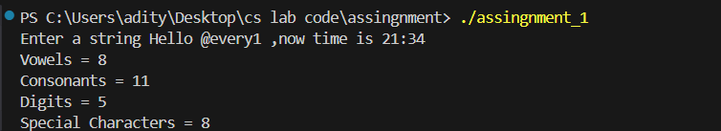

2. Write a C program to remove all spaces from a string.
ANSWER :-
#include <stdio.h>

int main()
{
char str[100];
int i = 0, j = 0;
printf("Enter a string: ");
scanf("%[^\n]", str);
while (str[i] != '\0')
{
if (str[i] != ' ')
{
str[j] = str[i];
j++;
}
i++;
}
str[j] = '\0';
printf("String after removing spaces: %s", str);
return 0;
}
OUTPUT:-
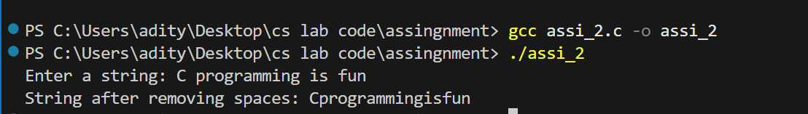

3. Write a program that:
a. Reads a number
b. Counts how many digits are greater than the digit immediately to their left
ANSWER :-
#include <stdio.h>

int main()
{
int a, c = 0, count = 0, b, d;
printf("Enter the number: ");
scanf("%d", &a);
int n = a;
while (n != 0)
{
n = n / 10;
c++;
}
n = a;
for (int i = 1; i < c; i++)
{
b = n % 10;
n = n / 10;
d = n % 10;
if (b > d)
{
count++;
}
}
printf("Digits greater than the previous digit = %d", count);
return 0;
}
OUTPUT:-
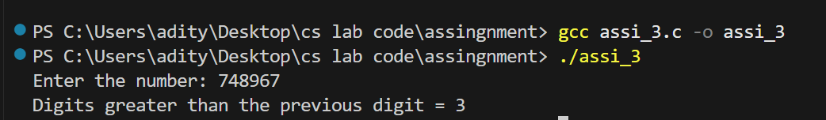

4. Given a number N, print: distance = (next prime after N) – (previous prime before N).
ANSWER :-
#include <stdio.h>

int prime(int);
int prime(int a)
{
for (int i = 2; i < a; i++)
{
if (a % i == 0)
{
return 0;
}
}
return 1;
}
int main()
{
int n, i = 0, np, pp;
printf("Enter N: ");
scanf("%d", &n);
for (int j = 2;; j++)
{
if (j < n)
{
if (prime(j))
{
pp = j;
}
}
if (j > n)
{
if (prime(j))
{
np = j;
break;
}
}
}
printf("Previous Prime = %d\n", pp);
printf("Next Prime = %d\n", np);
printf("Distance = %d", np - pp);
return 0;
}
OUTPUT:-
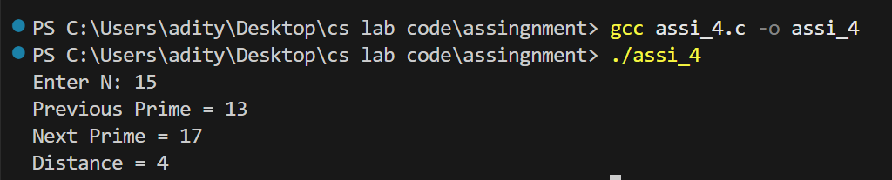

5. Given a string, print all characters that appear only once in the string.
ANSWER :-
#include <stdio.h>

int main()
{
char str[100];
int i = 0;
printf("Enter a string: ");
scanf("%[^\n]", str);
while (str[i] != '\0')
{
int c = 0, j = 0;
while (str[j] != '\0')
{
if (str[i] == str[j])
c++;
j++;
}
if (c == 1)
printf("%c ", str[i]);
i++;
}
return 0;}
OUTPUT:-
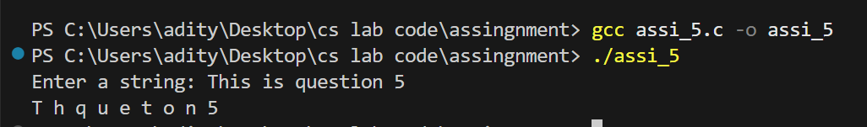

6. Convert a sentence into the length of each word.
ANSWER :-
#include <stdio.h>

int main()
{
char str[100];
int c = 0;
printf("Enter a string: ");
scanf("%[^\n]", str);
for (int i = 0;; i++)
{
if (str[i] == ' ' || str[i] == '\0')
{
printf("%d ", c);
c = 0;
if (str[i] == '\0')
break;
}
else
c++;
}
return 0;
}

OUTPUT:-
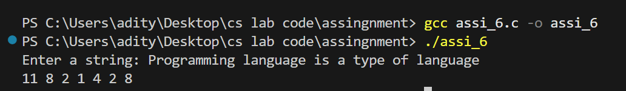

7. Convert a sentence such that:
a. 1st letter → uppercase
b. 2nd → lowercase
c. 3rd → uppercase
Continue alternately. Ignore spaces.
ANSWER :-
#include <stdio.h>
#include <ctype.h>

int main()
{
char str[100];
int c = 0;
printf("Enter a string: ");
scanf("%[^\n]", str);
for (int i = 0; str[i] != 0; i++)
{
if (str[i] == ' ')
{
printf(" ");
continue;
}
if (c % 2 == 0)
printf("%c", toupper(str[i]));
else
printf("%c", tolower(str[i]));
c++;
}
return 0;
}
OUTPUT:-
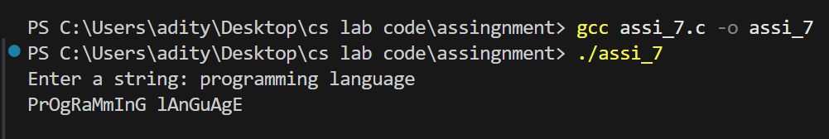

8. For each character in a string, print the distance from 'a'.
ANSWER :-
#include <stdio.h>

int main()
{
char str[100];
int a;
printf("Enter a string: ");
scanf("%[^\n]", str);
a = 'a';
for (int i = 0; str[i] != 0; i++)
{
printf("%c - %d\n", str[i], str[i] - a);
}
return 0;
}

OUTPUT:-
