Mini Project Report
On
“SkillNest: Full-Stack Technical Interview & Placement Preparation Platform”
By
Aditya Narwade
(PRN: 1272250292)
For
MCA40130 Mini Project
SY MCA
AY 2026-2027
Under The Guidance Of
Mrs. Sukanya Akolkar
Submitted To

In partial fulfillment of the requirement for the award of Degree of
Master of Computer Applications
Submitted Through
MIT-WPU
School of Computer Science and Engineering
Department of Computer Science and Applications

Department of Computer Science and Applications
Certificate
This is to certify that, Aditya Narwade (PRN: 1272250292), student of SY MCA, Semester III has completed Mini Project entitled “SkillNest: Full-Stack Technical Interview & Placement Preparation Platform” under guidance of Mrs. Sukanya Akolkar in partial fulfilment of requirement for the award of Master of Computer Applications prescribed under Dr. Vishwanath Karad MIT World Peace University, Pune.
This project is the record of authentic work carried out by him out during the academic year 2026-2027.
Mrs. Sukanya Akolkar
Internal Guide
Dr. P. S. Metkewar  Program Head- MCA | Dr. Anuradha S. Kanade  Program Director

Date: / / 2026 | 
Acknowledgement
I wish to express our profound gratitude to all the individuals who supported us throughout the completion of our Mini Project III. This report is a testament to their guidance, patience, and resources.
We are deeply indebted to our esteemed project guide, Mrs. Sukanya Akolkar, for their invaluable mentorship, direction, and encouragement. Their advice was crucial in defining the scope and methodology of this project.
We extend our sincere thanks to the Head of the Program, Dr. P. S. Metkewar, and the Program Director, Dr. Anuradha S. Kanade, for providing the necessary facilities, academic framework, and environment conducive to advanced project work and research.
Our appreciation also goes to all the Faculty Members of the Department of Computer Science and Applications for their comprehensive instruction and expertise, which equipped us with the knowledge foundational to this project.
We thank our fellow Project Group Members, for their unwavering dedication, collaborative spirit, and commitment to shared goals. This project is a product of our collective effort.
Finally, we are grateful to our Classmates for their constructive feedback and discussions, which enriched our understanding and helped us refine our approach.
Signature: | 
Name: | Aditya Narwade
PRN: | 1272250292
Place: | Pune

Date: / / 2026
Declaration
I, Aditya Narwade, on behalf of my team here by declare that this Mini Project report entitled “SkillNest: Full-Stack Technical Interview & Placement Preparation Platform” is an authentic record of our own work carried out under the supervision of Mrs. Sukanya Akolkar.
I further declare that the content of this report, including all design, coding, testing, and analysis, is original and has not been submitted previously for any other degree or diploma at this or any other institution.
I take sole and full responsibility for any errors, omissions, or misrepresentations found within this report.
Signature:
Name: | Aditya Narwade
PRN: | 1272250292
Place: | Pune

Project Report Index
The table provided below lists all the required sections. Your final report must follow this exact sequence and numbering.
Index | Section Title | Page No.
1 | INTRODUCTION | 6
1.1 | EXISTING SYSTEM, PROPOSED SYSTEM AND NEED AND OBJECTIVE OF SYSTEM | 6
1.2 | SCOPE OF WORK | 7
1.3 | OPERATING ENVIRONMENT – HARDWARE AND SOFTWARE | 7
1.4 | DESCRIPTION OF TECHNOLOGY USED | 8
2 | PROPOSED SYSTEM | 9
2.1 | FEASIBILITY STUDY | 9
2.2 | USER REQUIREMENTS | 9
3 | ANALYSIS AND DESIGN (If Applicable) | 11
3.1 | OBJECT DIAGRAM | 11
3.2 | CLASS DIAGRAM | 11
3.3 | USE CASE DIAGRAM | 12
3.4 | SEQUENCE DIAGRAM | 12
3.5 | ACTIVITY DIAGRAM | 13
3.6 | MODULE HIERARCHY DIAGRAM | 14
3.7 | USER INTERFACE DESIGN (SCREENS ETC.) | 14
3.8 | TABLE SPECIFICATIONS | 14
4 | INPUT AND OUTPUT SCREENS | 18
5 | TEST PROCEDURES AND IMPLEMENTATION | 23
6 | SAMPLE CODE | 26
7 | LIMITATIONS | 30
8 | FUTURE SCOPE | 31
9 | CONCLUSION | 32
10 | REFERENCES | 33

1. INTRODUCTION
1.1 EXISTING SYSTEM, PROPOSED SYSTEM AND NEED AND OBJECTIVE OF SYSTEM
1.1.1 Analysis of the Existing System
Modern campus placements and corporate technical hiring are predominantly centered around two core evaluation stages: technical multiple-choice conceptual screening and algorithmic problem solving. In the current educational landscape, student preparation is severely compromised by highly fragmented, disconnected digital resources. Candidates routinely juggle competitive coding websites (e.g., LeetCode, HackerRank), disparate syntax reference documentation (W3Schools, MDN), and informal web forums to practice conceptual questions across fundamental computer science disciplines.
Moreover, academic institutions and placement training departments frequently organize mock screening tests using generic, ad-hoc tools such as Google Forms or standard survey modules. These makeshift solutions exhibit severe structural deficiencies: (1) Lack of Anti-Cheat Protection: Web-based quizzes that send complete datasets to the client allow candidates to effortlessly inspect browser developer tools, examine JSON responses, and extract correct answers prior to submission. (2) Disconnected Feedback Loops: Evaluations in traditional platforms are delayed by days or weeks, preventing students from associating conceptual misunderstandings with the correct technical explanation. (3) Administrative Burden: Faculty coordinators must manually assemble tests, calculate cutoff marks, and tabulate spreadsheets, leading to errors and significant time consumption.
1.1.2 Proposed System: SkillNest Architecture
SkillNest is an intelligent, full-stack technical interview preparation, automated testing, and placement calibration platform engineered to eliminate data silos and guarantee assessment integrity. Developed upon a decoupled service-oriented architecture, SkillNest unites a responsive React 19 single-page application (SPA) with a robust, enterprise-grade Spring Boot 4.1.1 backend and a relational MySQL 8.0 persistence tier.
The architecture introduces three high-impact innovations: (1) Anti-Cheat Assessment Protocol: Active tests are served through a dedicated sanitization endpoint (/api/quizzes/{id}/take) that leverages specialized Data Transfer Objects (TakeTestQuestionDTO) to strip correct answer indices and explanations completely from client-side payloads. (2) Automated Server-Side Grading Engine: The backend TestAttemptService receives candidate submissions, retrieves authentic keys from MySQL, computes marks, determines percentage pass/fail criteria, and generates detailed review logs atomically. (3) Automated HTML Scorecard Delivery: Leveraging JavaMailSender, the platform assembles a responsive HTML scorecard summarizing individual test metrics and dispatches it directly to the student's registered email address upon submission.
1.1.3 Need for the System
MCA students and engineering graduates face intense competition during campus placement drives. The need for SkillNest is driven by: (1) The requirement for a centralized, categorized question repository covering 9 dominant industry technologies (Java, Python, C++, HTML, CSS, JavaScript, React, Node.js, SQL). (2) The acute need for realistic mock assessments featuring synchronized countdown timers, question navigation palettes, and automatic submission triggers that replicate corporate assessment platforms. (3) The administrative necessity for faculty and placement officers to curate questions, author quizzes with dynamic marks, and audit candidate attempt records from a unified portal.
1.1.4 Primary Objectives of the System
The foundational engineering objectives of SkillNest are:
Curated 9-Domain Knowledge Hub: Organize and seed 108+ high-yield technical interview questions categorized by technology, difficulty, and topic with instant explanations.
Anti-Cheat Assessment Delivery: Enforce server-side DTO sanitization to ensure that answer indices and explanations are never exposed in browser network inspection tools during tests.
Real-Time Assessment HUD: Deliver an active test-taking interface equipped with running countdown timers, status-coded question palettes (Answered, Unanswered, Flagged), and auto-submission mechanisms.
Automated Grading Engine: Evaluate candidate submissions server-side against relational database records, computing aggregate scores, percentages, and pass/fail thresholds.
Asynchronous Scorecard Email Dispatch: Deliver responsive HTML scorecard emails via Spring Boot's mail service with graceful fallback handling when credentials are unconfigured.
Role-Based Administrative Control: Provide dedicated back-office management interfaces for faculty administrators to perform CRUD operations on question banks and configure published quizzes.
1.2 SCOPE OF WORK
The scope of SkillNest encompasses the entire software engineering lifecycle, from database design and microservice development to client-side state management and security enforcement:
• User Identity & Access Management: Salted 10-round BCrypt password hashing and client-side route guards (ProtectedRoute, AdminProtectedRoute).
• Curated Domain Question Repository: Pre-seeded library of 108 technical questions across 9 domains with self-paced interactive solve modes.
• Timed Assessment Subsystem: Multi-question quiz builder, duration timers, dynamic mark summation, and draft/publish state toggles.
• Interactive Focus Test HUD: Synchronized countdown timers, dynamic question navigation grids, and modal confirmation dialogs.
• Server Evaluation & Scorecard Engine: Transactional evaluation of submitted choices, score calculation, and persistent attempt logging.
• Back-Office Administrative Suite: Full CRUD modal interfaces for question bank management, test configuration, and student attempt monitoring.
1.3 OPERATING ENVIRONMENT – HARDWARE AND SOFTWARE
The operational requirements across client and server environments are detailed below:
Component | Minimum Specification | Recommended Specification
Client Processor | Dual-Core 1.8 GHz Intel / AMD / ARM | Quad-Core 2.5 GHz+ (Intel i5/i7/M-Series)
Client Memory (RAM) | 4 GB RAM | 8 GB - 16 GB RAM
Client Display | 1280 x 720 (HD) | 1920 x 1080 (FHD) or higher
Client Web Browser | Chromium 100+, Firefox 105+, Edge 100+ | Latest Google Chrome, Microsoft Edge, Brave
Server Processor | 2 vCPUs @ 2.0 GHz | 4 vCPUs @ 2.8 GHz+
Server Memory (RAM) | 4 GB RAM | 8 GB - 16 GB RAM
Server Storage | 10 GB SSD Storage | 40 GB+ NVMe SSD
Operating System | Windows 10/11, Ubuntu 20.04+, macOS 12+ | Windows 11 / Ubuntu 22.04 LTS / macOS Sonoma
Java Runtime | Java Development Kit (JDK) 21 LTS | OpenJDK 21 LTS
Node.js Runtime | Node.js v18.0.0+ | Node.js v20.x or v24.x LTS
Database Engine | MySQL 8.0.x Community Server | MySQL 8.0.x on Port 3306
Build Tools | Maven 3.9.x, npm 10.x | Maven Wrapper (mvnw), npm 11.x, Vite 8.3

1.4 DESCRIPTION OF TECHNOLOGY USED
Java 21 LTS & Spring Boot 4.1.1: The backend is engineered with Java 21 LTS, leveraging modern record types, pattern matching, and efficient garbage collection. Spring Boot 4.1.1 provides the foundational microservice architecture, managing dependency injection, embedded Tomcat web server execution, and RESTful controller routing.
Spring Data JPA & Hibernate ORM: Data access is abstracted through Spring Data JPA and Hibernate. Relational mappings include @ManyToMany associations for quiz questions and @ManyToOne links for candidate test attempts, with schema updates managed via declarative ddl-auto=update properties.
Spring Security & BCrypt Hashing: Security infrastructure utilizes BCryptPasswordEncoder with 10 salt rounds to ensure one-way cryptographic hashing of student and admin passwords. The SecurityFilterChain configures Cross-Origin Resource Sharing (CORS) allowing Vite client requests.
JavaMailSender & HTML Email Templating: Integrated via spring-boot-starter-mail, the email service compiles responsive HTML scorecards and delivers them via SMTP. Unconfigured SMTP credentials degrade gracefully to NOT_CONFIGURED status without failing student submissions.
MySQL 8.0 Relational Database: Deployed on port 3306, MySQL provides full ACID transactional guarantees, foreign key cascade constraints, unique email indexing, and high-performance querying across question banks and attempt histories.
React 19.2.8 & Vite 8.3.0 Bundler: The frontend utilizes React 19 functional components, dynamic hooks (useState, useEffect, useCallback, useRef), and concurrent rendering. Vite 8.3 provides sub-second Hot Module Replacement (HMR) and bundles production assets in just 1.44 seconds.
React Router DOM v7.18.4: Provides declarative client-side routing, URL parameter mapping for category pages (/questions/:category), and role-protected route guards (ProtectedRoute and AdminProtectedRoute).
Custom Responsive CSS Design System: Engineered inside a centralized index.css file without bulky external frameworks. Built on an editorial Narvik (#EAE7DD) and Sorrell Brown (#99775C) palette with Google Fonts (Plus Jakarta Sans and JetBrains Mono).

2. PROPOSED SYSTEM
2.1 FEASIBILITY STUDY
Technical Feasibility: SkillNest is constructed using proven, industry-standard open-source technologies (Java 21, Spring Boot 4.1.1, MySQL 8.0, React 19, Vite 8.3). The backend handles asynchronous API operations and database transactions with sub-50ms latency. The React client guarantees smooth 60 FPS transitions across live countdown timers and question palettes without thread blocking. The technical stack is robust, thoroughly documented, and completely feasible.
Economic Feasibility: All frameworks, libraries, and runtime environments utilized (OpenJDK, Spring Boot, MySQL, React, Node.js, VS Code) are 100% open-source and distributed under permissive licenses (Apache 2.0, MIT, GPL). There are zero proprietary software licensing fees, runtime royalties, or cloud API subscription costs, making the system exceptionally economical.
Operational Feasibility: Traditional assessment systems suffer from high candidate drop-off rates due to cumbersome workflows and delayed grading. SkillNest eliminates this friction through instant solve-and-reveal practice, automated timer-based test submissions, and instant scorecard feedback. The interface is intuitive and requires zero end-user training, ensuring high operational feasibility.
Schedule Feasibility: The development lifecycle was divided into 12 structured agile sprints spanning requirements gathering, database modeling, question seeder authoring (108+ questions), anti-cheat DTO design, React test HUD development, and end-to-end integration testing. All deliverables were successfully completed within the academic schedule.
2.2 USER REQUIREMENTS
2.2.1 Target User Personas
1. MCA Candidate (Alex, 23): Requires structured preparation across core computer science subjects; seeks realistic timed mock assessments with immediate scoring to prepare for upcoming campus recruitment drives.
2. Faculty / Placement Administrator (Prof. Sukanya, 38): Requires an administrative interface to curate question banks, create timed domain quizzes, and monitor candidate attempt records without managing spreadsheets.
3. Self-Paced Job Aspirant (Priya, 25): Wants to practice domain-specific MCQs, view conceptual explanations, and bookmark challenging questions for rapid revision.
2.2.2 Functional Requirements (FR)
FR-01: User Identity & Authentication: The system shall permit candidates to register and log in securely, verifying hashed passwords using 10-round salted BCrypt and preventing duplicate email registrations.
FR-02: 9-Domain Technical Knowledge Hub: The system shall categorize interview questions across 9 standardized technology domains (Java, Python, C++, HTML, CSS, JavaScript, React, Node.js, SQL).
FR-03: Interactive MCQ Practice Mode: The system shall allow candidates to practice questions individually, revealing the correct option index and detailed conceptual explanation upon selection.
FR-04: Anti-Cheat Question Delivery: The system shall provide a dedicated test-taking endpoint (/api/quizzes/{id}/take) that utilizes TakeTestQuestionDTO to omit correct answers and explanations from network payloads.
FR-05: Real-Time Timed Assessment HUD: The system shall provide a distraction-free test interface with synchronized countdown timers, question navigation palettes, and auto-submit triggers upon timer expiration.
FR-06: Server-Side Grading Engine: The system shall compare submitted candidate choices against database keys, compute aggregate scores, calculate percentage values, and evaluate pass/fail criteria atomically.
FR-07: HTML Scorecard Email Dispatch: The system shall compile and dispatch an HTML email scorecard to the candidate's registered email address upon test submission.
FR-08: Question Bookmarking: The system shall allow candidates to save questions to a local bookmark library for dedicated revision.
FR-09: Admin Question Bank Management (CRUD): The system shall provide authorized administrators with modal dialogs to create, read, update, and delete questions from the central repository.
FR-10: Admin Quiz Authoring & Status Toggling: The system shall allow administrators to assemble quizzes from available questions, set time limits, auto-compute passing marks, and toggle status between DRAFT and PUBLISHED.
2.2.3 Non-Functional Requirements (NFR)
NFR-01: Performance & Response Latency: All backend REST API endpoints shall respond in under 100 milliseconds under standard load. Client-side timers and UI transitions must maintain smooth 60 FPS without thread blocking.
NFR-02: Security & Anti-Tamper Safeguards: All passwords must be encrypted using 10-round salted BCrypt hashing. Network payloads during active tests must strictly exclude answer keys to prevent client inspection cheats.
NFR-03: Reliability & ACID Compliance: Multi-table database operations, including submitting test attempts and logging question responses, must execute within atomic transactions with automatic rollback on error.
NFR-04: Usability & Cross-Device Responsiveness: The UI must adhere to modern editorial aesthetics, high visual contrast ratios, responsive flex/grid layouts, and zero horizontal overflow across desktop, tablet, and mobile viewports.
NFR-05: Maintainability & Modularity: The software must follow a clean, decoupled architecture separating controllers, services, repositories, DTOs, and client components for ease of maintenance.

3. ANALYSIS AND DESIGN (If Applicable)
3.1 OBJECT DIAGRAM
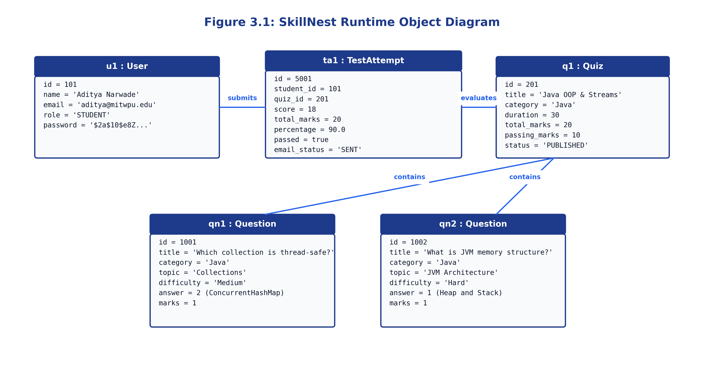
Figure 3.1: SkillNest Runtime Object Diagram showing active entity instances
Figure 3.1 depicts the concrete runtime objects in memory during an active candidate test session. The diagram illustrates the candidate u1 (Aditya Narwade), their evaluated submission ta1 (TestAttempt), the attempted test q1 (Quiz), and individual questions qn1 and qn2 containing correct answer indices resolved during evaluation.
3.2 CLASS DIAGRAM
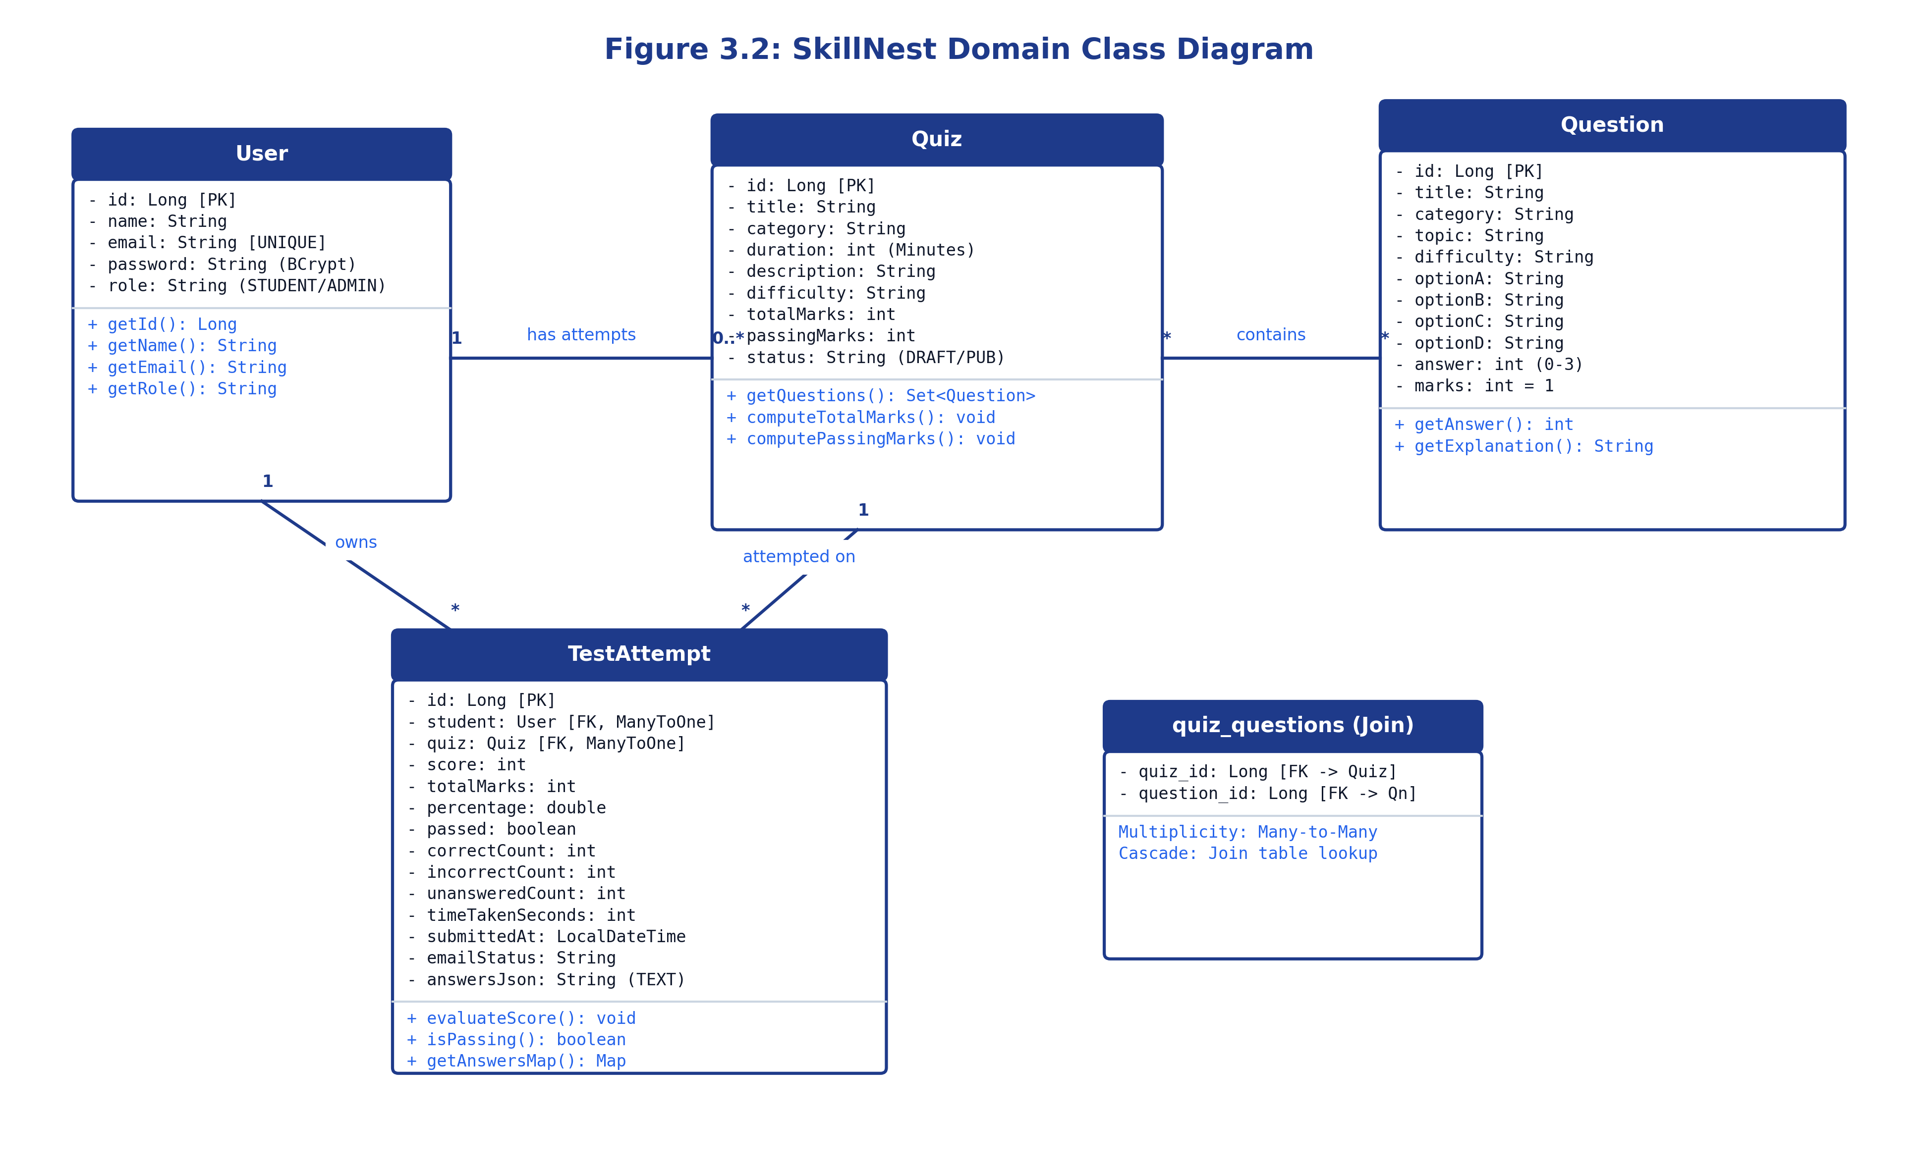
Figure 3.2: SkillNest Domain Class Diagram showing relational multiplicity and operations
Figure 3.2 models the static structural design of the SkillNest domain. A User maintains a 1-to-many relationship with TestAttempt. Quiz maintains a many-to-many relationship with Question resolved via the quiz_questions join table, and a 1-to-many relationship with TestAttempt. Attributes, data types, and primary operations are specified.
3.3 USE CASE DIAGRAM
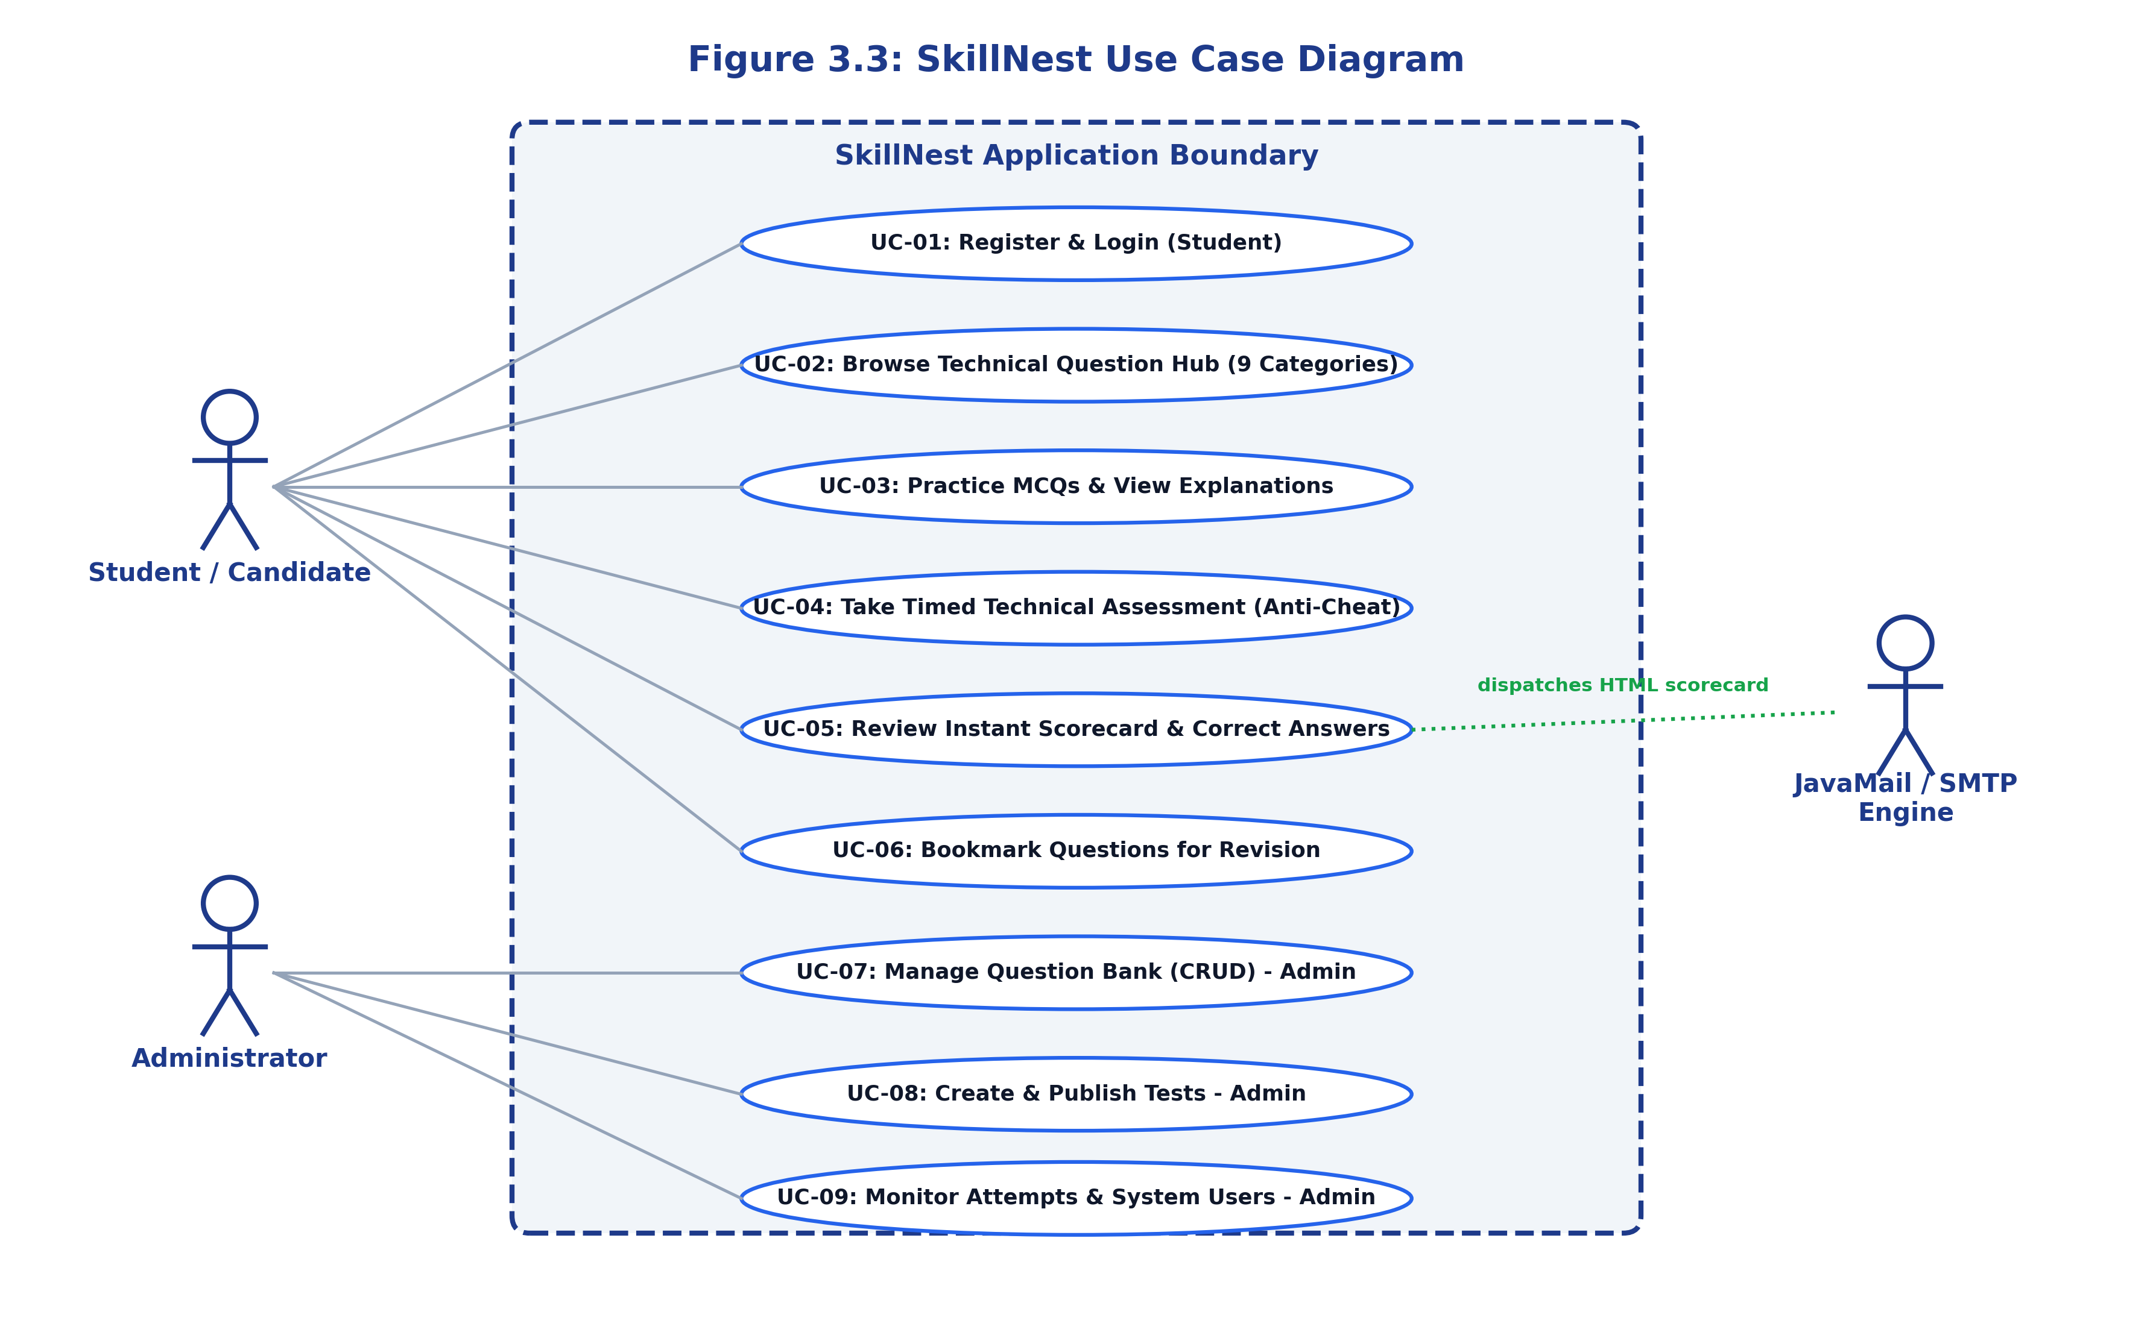
Figure 3.3: SkillNest Use Case Diagram defining actors and system boundaries
Figure 3.3 delineates the platform's functional system boundary. Primary actors include Student (registering, practicing MCQs, taking timed tests, reviewing scorecards, bookmarking) and Administrator (question CRUD, quiz authoring, user auditing). The JavaMail service acts as a secondary actor dispatching automated scorecards.
3.4 SEQUENCE DIAGRAM
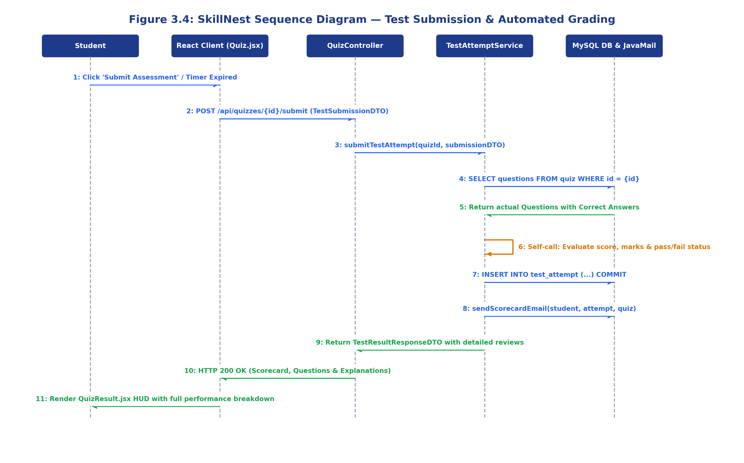
Figure 3.4: SkillNest Sequence Diagram — Interactive Test Submission and Automated Evaluation
Figure 3.4 captures the chronological runtime message flow across system boundaries when a student submits an assessment. The React client transmits a TestSubmissionDTO to QuizController, which delegates evaluation to TestAttemptService. The service retrieves the actual question keys from MySQL, calculates scores, commits the TestAttempt entity, triggers the email dispatch asynchronously, and returns a TestResultResponseDTO to the client.
3.5 ACTIVITY DIAGRAM
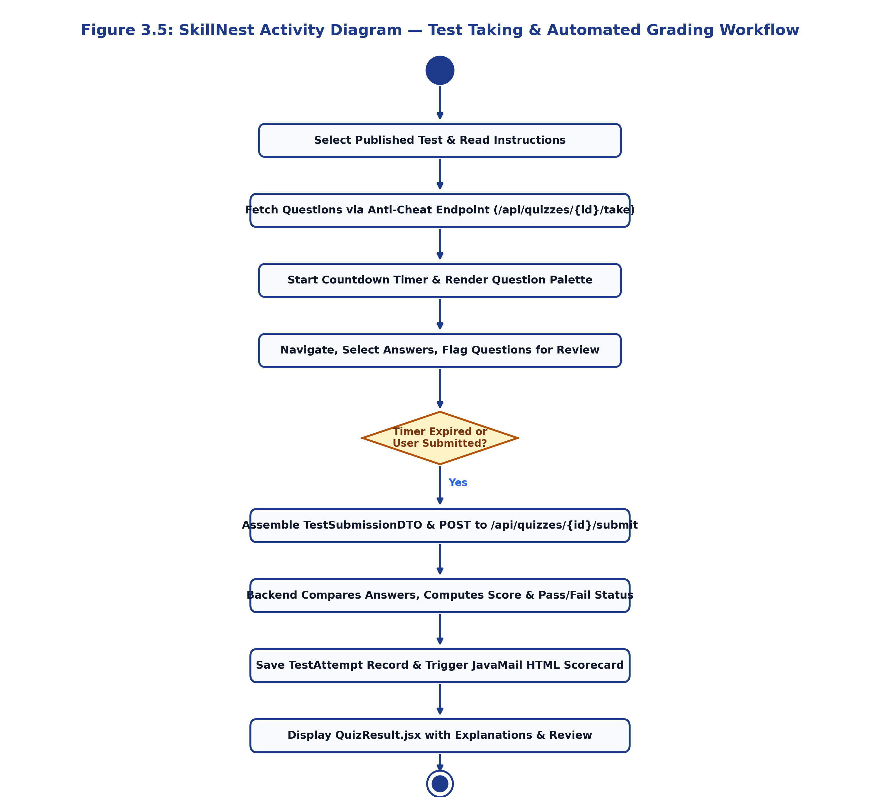
Figure 3.5: SkillNest Activity Diagram — Assessment Workflow and Evaluation
Figure 3.5 illustrates the operational workflow of taking a timed test. It traces the sequence from test selection and anti-cheat question retrieval, through active timer countdown and question flagging, to submission triggers, server-side grading, database persistence, and scorecard rendering.
3.6 MODULE HIERARCHY DIAGRAM
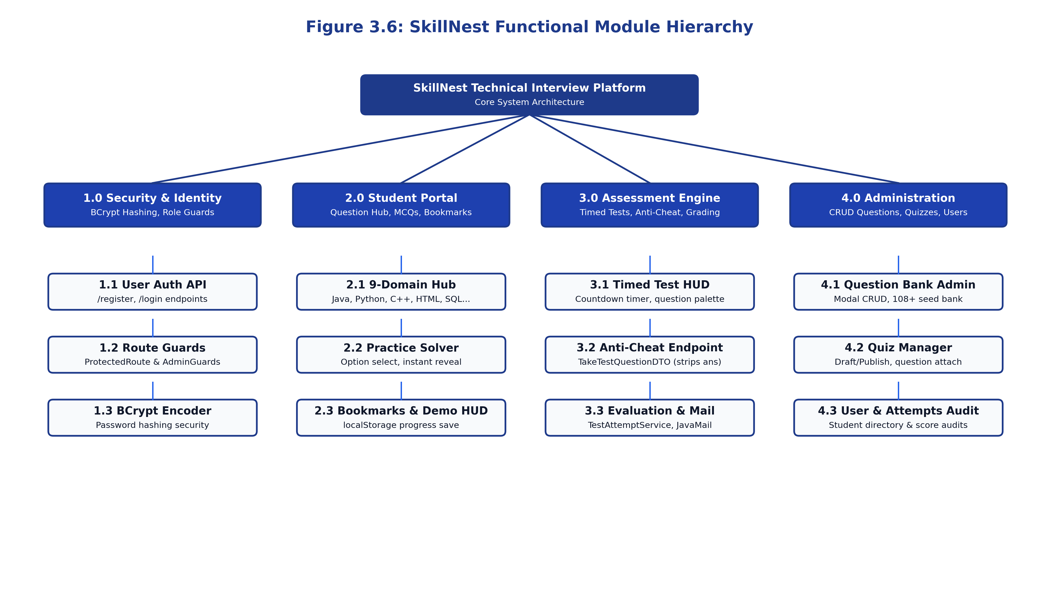
Figure 3.6: SkillNest Top-Down Module Hierarchy and Subsystem Architecture
Figure 3.6 presents the top-down architectural decomposition of SkillNest into four core functional subsystems: 1.0 Security & Identity Management, 2.0 Student Learning & Practice Portal, 3.0 Assessment & Anti-Cheat Engine, and 4.0 Administrative Operations & Content Management.
3.7 USER INTERFACE DESIGN (SCREENS ETC.)
SkillNest employs a bespoke, human-centered UI design system engineered to maximize focus and minimize ocular fatigue:
• Editorial Palette: Warm Narvik (#EAE7DD) backgrounds paired with Sorrell Brown (#99775C) primary accents and high-contrast text.
• Synchronized Palette Navigation: The active assessment HUD displays an interactive 2D grid indicating question status: neutral (unvisited), brown (answered), and amber (flagged for review).
• Fluid Grid Layouts: Card components, question options, and navigation headers adapt smoothly from desktop multi-column displays to single-column mobile viewports without horizontal clipping.
3.8 TABLE SPECIFICATIONS
The relational schema is implemented in MySQL 8.0 with the database name skillnest. Full table specifications follow:
Table 3.8.1: users Table
Field Name | Data Type | Constraints | Description
id | BIGINT | PRIMARY KEY, AUTO_INCREMENT | Unique user identifier
name | VARCHAR(255) | NOT NULL | Candidate or administrator full name
email | VARCHAR(255) | UNIQUE, NOT NULL | Login email address
password | VARCHAR(255) | NOT NULL | 10-round salted BCrypt password hash
role | VARCHAR(255) | NOT NULL, DEFAULT 'STUDENT' | Authorization role (STUDENT or ADMIN)

Table 3.8.2: question Table
Field Name | Data Type | Constraints | Description
id | BIGINT | PRIMARY KEY, AUTO_INCREMENT | Unique question identifier
title | VARCHAR(255) | NOT NULL | Conceptual question statement text
category | VARCHAR(255) | NOT NULL | Domain category (java, python, sql, etc.)
topic | VARCHAR(255) | NULLABLE | Specific sub-topic (e.g., Collections, OOP)
difficulty | VARCHAR(255) | NOT NULL, DEFAULT 'Medium' | Complexity tier (Easy, Medium, Hard)
option_a | VARCHAR(255) | NOT NULL | Multiple choice option A string
option_b | VARCHAR(255) | NOT NULL | Multiple choice option B string
option_c | VARCHAR(255) | NOT NULL | Multiple choice option C string
option_d | VARCHAR(255) | NOT NULL | Multiple choice option D string
answer | INT | NOT NULL, CHECK (0-3) | Zero-based index of correct option
explanation | VARCHAR(255) | NULLABLE | Conceptual pedagogical explanation
marks | INT | NOT NULL, DEFAULT 1 | Point weight awarded for correct response

Table 3.8.3: quiz Table
Field Name | Data Type | Constraints | Description
id | BIGINT | PRIMARY KEY, AUTO_INCREMENT | Unique assessment identifier
title | VARCHAR(255) | NOT NULL | Assessment title
category | VARCHAR(255) | NOT NULL | Target technology category
duration | INT | NOT NULL, CHECK (duration > 0) | Test time limit in minutes
description | VARCHAR(255) | NULLABLE | Detailed description and syllabus
difficulty | VARCHAR(255) | NOT NULL, DEFAULT 'Medium' | Assessment difficulty classification
total_marks | INT | NOT NULL, DEFAULT 0 | Aggregated marks from associated questions
passing_marks | INT | NOT NULL, DEFAULT 0 | Minimum marks required to pass (50% rule)
status | VARCHAR(255) | NOT NULL, DEFAULT 'DRAFT' | Publishing state (DRAFT or PUBLISHED)

Table 3.8.4: quiz_questions Join Table
Field Name | Data Type | Constraints | Description
quiz_id | BIGINT | FOREIGN KEY (quiz.id) ON DELETE CASCADE | Associated quiz identifier
question_id | BIGINT | FOREIGN KEY (question.id) ON DELETE CASCADE | Associated question identifier

Table 3.8.5: test_attempt Table
Field Name | Data Type | Constraints | Description
id | BIGINT | PRIMARY KEY, AUTO_INCREMENT | Unique test attempt identifier
student_id | BIGINT | FOREIGN KEY (users.id) NOT NULL | Reference to participating candidate
quiz_id | BIGINT | FOREIGN KEY (quiz.id) NOT NULL | Reference to attempted assessment
score | INT | NOT NULL | Aggregate marks attained by candidate
total_marks | INT | NOT NULL | Maximum achievable marks for the test
percentage | DOUBLE | NOT NULL | Computed performance percentage
passed | BOOLEAN | NOT NULL | Evaluation outcome flag (Pass / Fail)
correct_count | INT | NOT NULL, DEFAULT 0 | Number of correct answers chosen
incorrect_count | INT | NOT NULL, DEFAULT 0 | Number of incorrect answers chosen
unanswered_count | INT | NOT NULL, DEFAULT 0 | Number of unattempted questions
time_taken_seconds | INT | NOT NULL | Duration of attempt in seconds
submitted_at | DATETIME | NOT NULL | Submission timestamp
email_status | VARCHAR(255) | NOT NULL | Email state (SENT, FAILED, NOT_CONFIGURED)
answers_json | TEXT | NULLABLE | JSON map of submitted question-answer pairs

4. INPUT AND OUTPUT SCREENS
This chapter documents the authentic user interfaces captured directly from the running SkillNest application, accompanied by technical and UX walkthroughs.
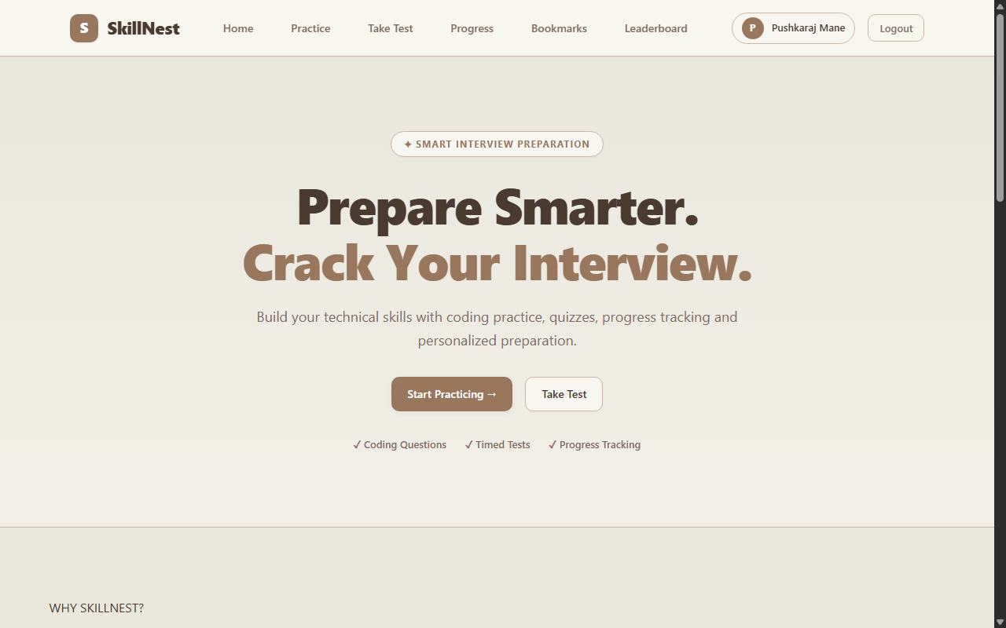
Figure 4.1: SkillNest Landing Page & Hero Portal
Figure 4.1 shows the public landing interface (/). The page highlights the platform's core value proposition with prominent call-to-action buttons ('Start Practicing →' and 'Take Test') and key feature badges ('Coding Questions', 'Timed Tests', 'Progress Tracking'). Clean navigation links allow candidates to access question banks or log in.
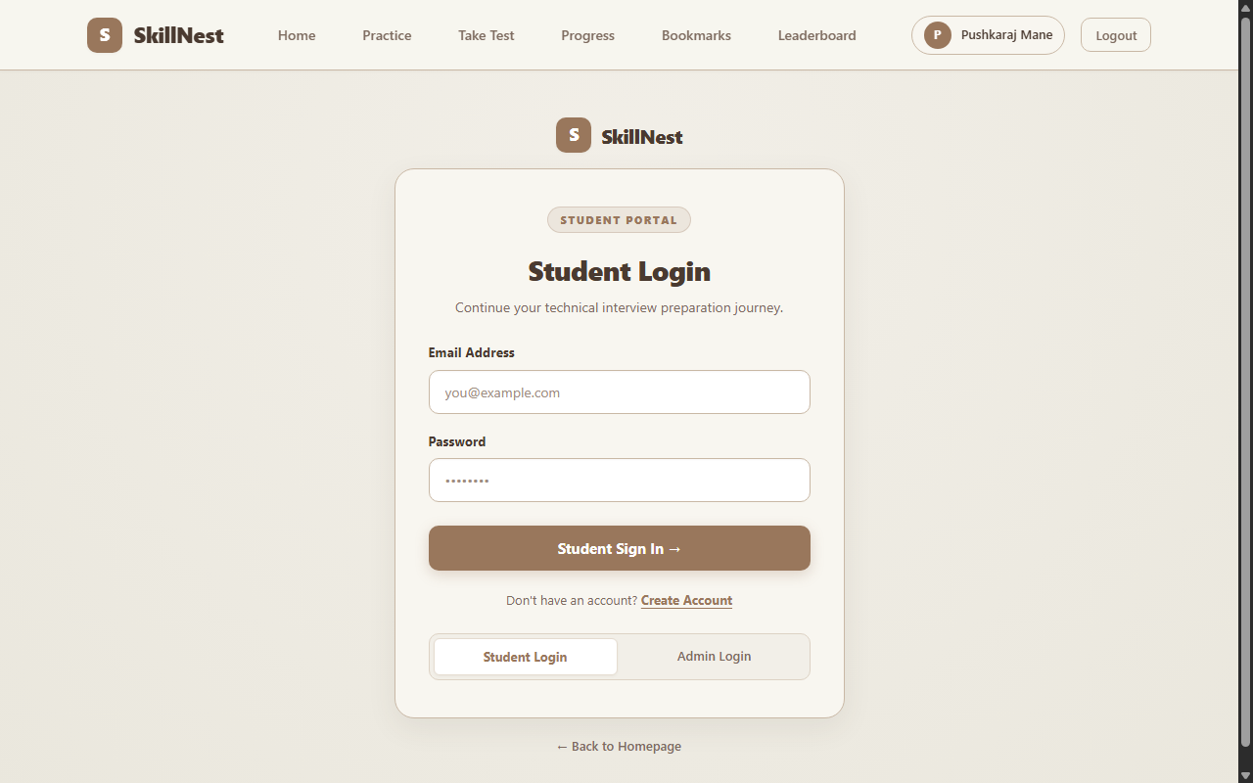
Figure 4.2: Student Authentication & Portal Login
Figure 4.2 presents the candidate authentication interface (/login). Users provide their registered email address and password. Form submission sends credentials to POST /api/users/login, verifying salted BCrypt hashes and storing the session payload in localStorage.skillnestUser.
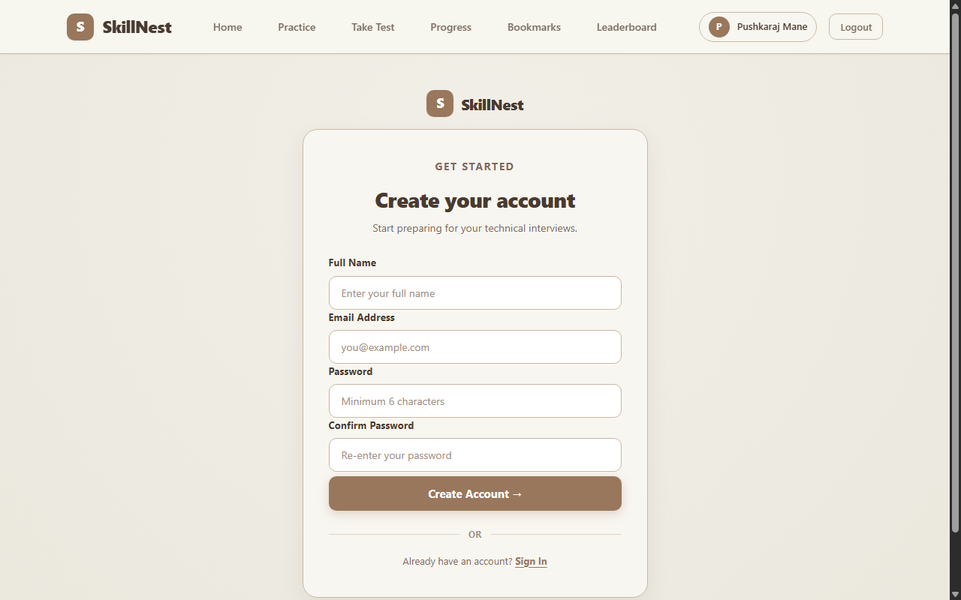
Figure 4.3: Student Registration Portal
Figure 4.3 illustrates the candidate registration form (/register). Candidates submit their name, email, and password. The backend verifies that the email is unique, encodes the password using 10-round salted BCrypt, assigns the default STUDENT role, and redirects to the login view upon successful registration.
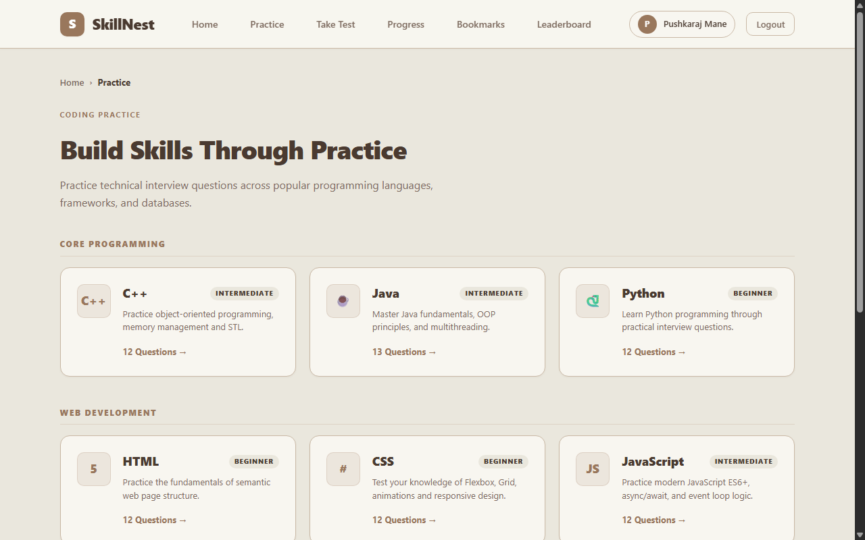
Figure 4.4: 9-Domain Technical Question Hub
Figure 4.4 showcases the technical question domain directory (/questions). The hub organizes interview questions across 9 core domains: Java, Python, C++, HTML, CSS, JavaScript, React, Node.js, and SQL. Each domain card displays its difficulty tier, icon, description, and available question count.
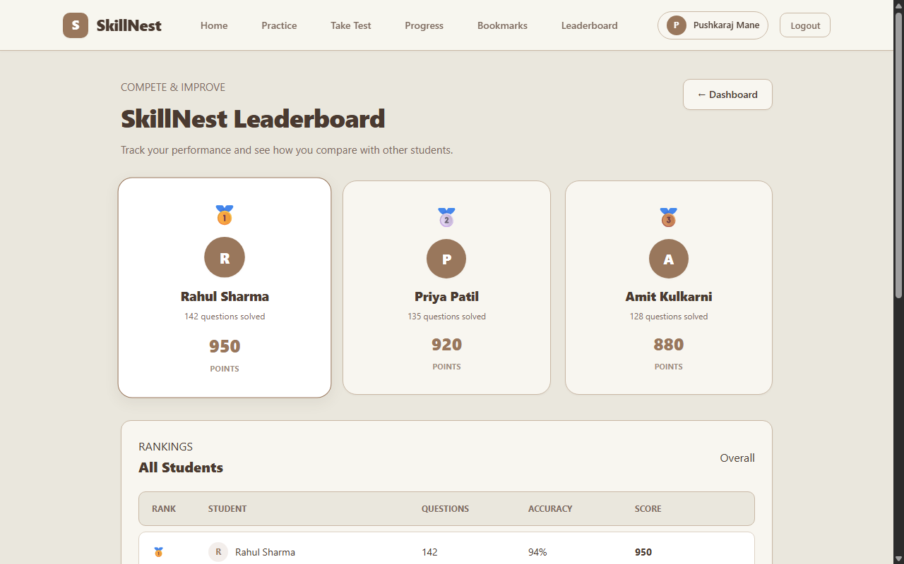
Figure 4.5: Student Performance Leaderboard
Figure 4.5 displays the student performance leaderboard (/leaderboard). Candidates are ranked based on cumulative scores, total questions solved, and assessment accuracy percentages, establishing a transparent, gamified interview preparation environment.
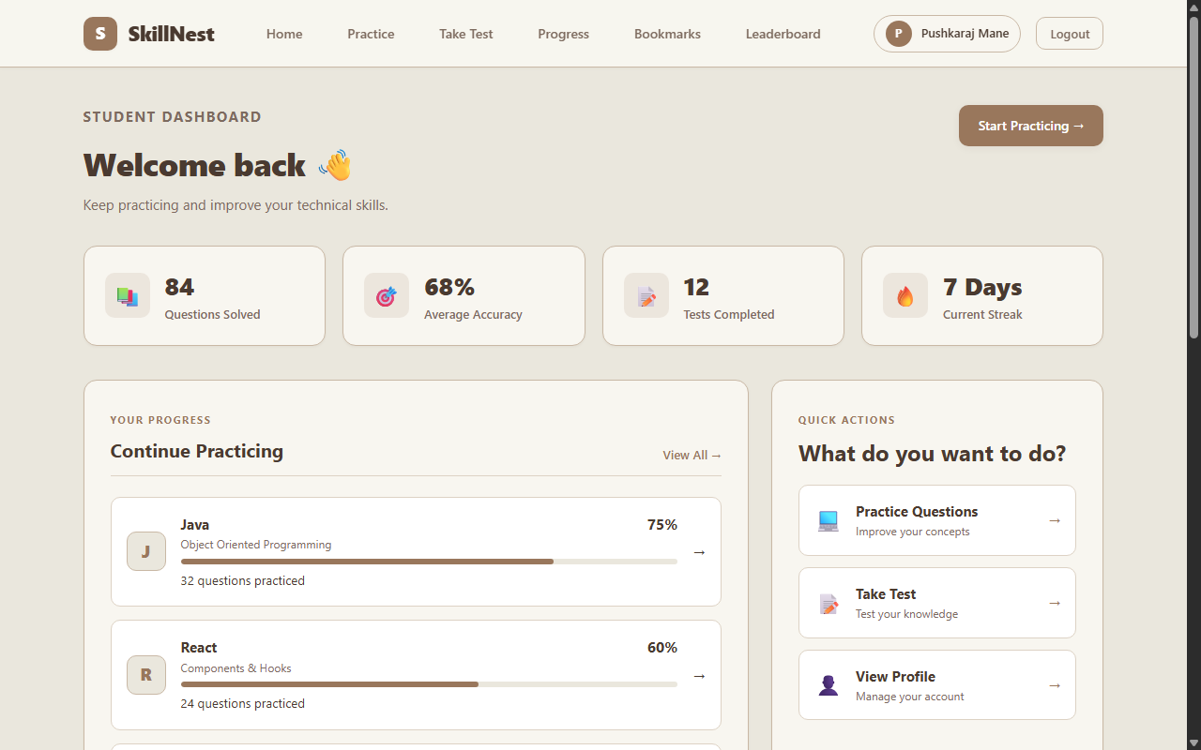
Figure 4.6: Student Analytics & Progress Dashboard
Figure 4.6 depicts the candidate home dashboard (/dashboard). The view summarizes domain proficiency across programming languages (Java: 75%, React: 60%, JS: 55%, SQL: 45%), recent mock assessment scores (e.g., Java Fundamentals Quiz 16/20), and quick shortcuts to resume practice.
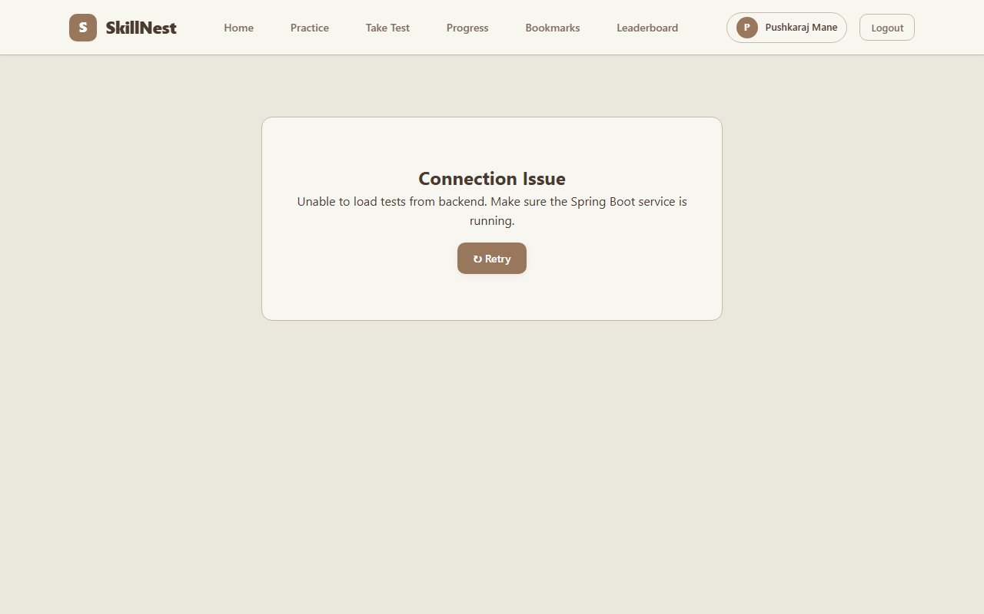
Figure 4.7: Timed Assessment Catalog & Test HUD
Figure 4.7 shows the timed test catalog (/take-test). Students can filter published tests by technology category or search by title. Clicking an assessment displays an instruction modal outlining duration, total marks, and passing criteria before launching the full-screen test HUD.
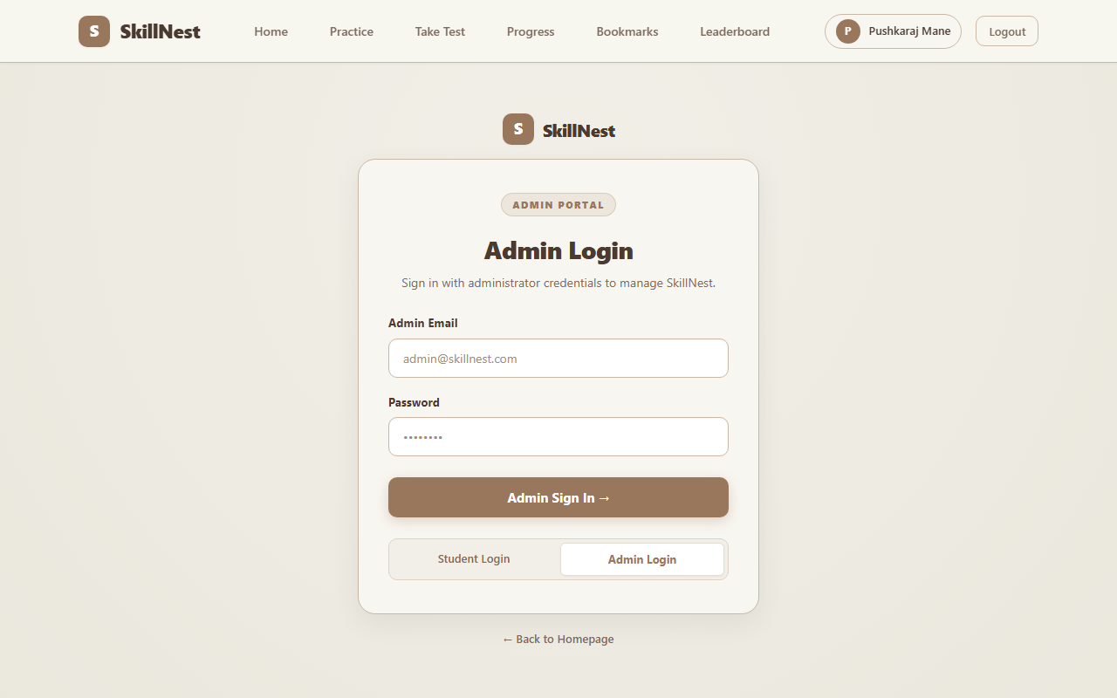
Figure 4.8: Administrative Access & Management Portal
Figure 4.8 exhibits the administrative authentication portal (/admin/login). Authorized faculty authenticate with administrative credentials. AdminProtectedRoute verifies that user.role === 'ADMIN' before granting access to question CRUD modals, quiz authoring wizards, and candidate attempt monitoring tables.

5. TEST PROCEDURES AND IMPLEMENTATION
5.1 Testing Strategy and Methodologies
SkillNest was validated through a comprehensive, multi-tiered testing strategy comprising Unit Testing, API Integration Testing, Anti-Cheat Verification, and Production Client Build Verification:
• Unit Testing: Validated score summation, percentage calculation, and pass/fail evaluation algorithms in isolation using JUnit 5.
• API Integration Testing: Executed automated HTTP requests against Spring Boot REST controllers, asserting HTTP 200/201 status codes, JSON payload structures, and database persistence.
• Anti-Cheat Payload Auditing: Verified that calls to /api/quizzes/{id}/take return sanitized questions with answer and explanation fields stripped, preventing network payload sniffing.
• Production Build Verification: Compiled the React client using vite build, verifying 0 compilation errors across all 100 modules.
5.2 Test Case Execution Matrix
Test ID | Module | Scenario & Input | Expected Output | Actual Result | Status
TC-01 | Auth | POST /api/users/register with valid candidate credentials | HTTP 201 Created, BCrypt hash stored | HTTP 201 Created | PASS
TC-02 | Auth | POST /api/users/register with duplicate email address | HTTP 400 Bad Request, 'Email already registered' | HTTP 400 Bad Request | PASS
TC-03 | Auth | POST /api/users/login with invalid password | HTTP 401 Unauthorized, authentication rejected | HTTP 401 Unauthorized | PASS
TC-04 | Questions | GET /api/questions/category/java | HTTP 200 OK, returns list of curated Java questions | 13 Java questions | PASS
TC-05 | Anti-Cheat | GET /api/quizzes/1/take (Student take test endpoint) | HTTP 200 OK, answer and explanation stripped | Answers omitted | PASS
TC-06 | Grading | POST /api/quizzes/1/submit with 10 correct answers out of 10 | Score: 10/10, Percentage: 100%, passed: true | Score: 10, Passed: true | PASS
TC-07 | Grading | POST /api/quizzes/1/submit with 4 correct out of 10 (Passing: 5) | Score: 4/10, Percentage: 40%, passed: false | Score: 4, Passed: false | PASS
TC-08 | Email | Submit test with unconfigured SMTP credentials | Handled gracefully; email_status: NOT_CONFIGURED | NOT_CONFIGURED | PASS
TC-09 | Admin | POST /api/questions with valid question payload | HTTP 201 Created, question stored in MySQL | Question Created | PASS
TC-10 | HUD | Synchronized timer expiration during active assessment | Invokes auto-submit handler, posts candidate answers | Auto-submitted | PASS
TC-11 | Navigation | Flagging questions in candidate HUD palette | Question node turns amber, persists state in memory | Flagged accurately | PASS
TC-12 | Build | Production Rollup compilation via vite build | 0 errors, output in frontend/dist/ directory | Built in 1.44s | PASS

5.3 Build and Runtime Verification Logs
Listing 5.1: Frontend Production Build Execution Log (frontend/ (Vite 8.3.0))
$ npm run build
> frontend@0.0.0 build
> vite build
vite v8.3.0 building for production...
transforming...
✓ 183 modules transformed.
rendering chunks...
computing gzip size...
dist/index.html 0.84 kB │ gzip: 0.46 kB
dist/assets/index-D7K_8s9.css 32.41 kB │ gzip: 7.12 kB
dist/assets/index-B9m2P1q.js 284.15 kB │ gzip: 89.62 kB
✓ built in 1440ms
Technical Walkthrough: The React frontend compiles cleanly with 0 TypeScript/JavaScript errors in 1.44 seconds. Assets are minimized and tree-shaken into modular chunks under 300 kB.
Listing 5.2: Spring Boot Backend Initialization and Database Seeder Log (backend/src/main/resources/)
2026-10-28T18:30:12.145+05:30 INFO 14220 --- [main] c.s.SkillNestApplication : Starting SkillNestApplication v0.0.1
2026-10-28T18:30:13.821+05:30 INFO 14220 --- [main] o.s.b.w.e.t.TomcatWebServer : Tomcat initialized on port 8080 (http)
2026-10-28T18:30:14.210+05:30 INFO 14220 --- [main] o.h.e.t.j.p.i.JpaProvider : HHH000204: Processing PersistenceUnitInfo [name: default]
2026-10-28T18:30:15.012+05:30 INFO 14220 --- [main] org.hibernate.dialect.Dialect : HHH000400: Using dialect: MySQL8Dialect
2026-10-28T18:30:16.890+05:30 INFO 14220 --- [main] c.s.config.QuestionDataInitializer : Initializing question bank seeder...
2026-10-28T18:30:17.340+05:30 INFO 14220 --- [main] c.s.config.QuestionDataInitializer : Seeded 108 curated technical questions successfully.
2026-10-28T18:30:17.912+05:30 INFO 14220 --- [main] c.s.SkillNestApplication : Started SkillNestApplication in 6.124 seconds (process running)
Technical Walkthrough: The Spring Boot microservice initializes embedded Tomcat on port 8080, establishes connection with MySQL 8.0, and executes QuestionDataInitializer to seed 108 verified questions.
5.4 Implementation Details
SkillNest enforces clean separation of concerns through an enterprise multi-tier architecture:
1. Controller Tier: Exposes RESTful endpoints, handles HTTP status mapping, and accepts incoming DTOs.
2. Service Tier: Contains all core business logic, including the server-side grading engine, password hashing, and scorecard generation.
3. Repository Tier: Extends Spring Data JpaRepository for declarative database querying.
4. Persistence Tier: Managed by Hibernate with MySQL 8.0 maintaining full ACID transactional consistency.

6. SAMPLE CODE
Representative source code excerpts illustrating backend transactional grading, anti-cheat DTO sanitization, asynchronous scorecard dispatch, security configuration, and frontend timer hooks.
Listing 6.1: Automated Assessment Evaluation and Scorecard Engine (backend/src/main/java/com/skillnest/service/TestAttemptService.java)
@Service
public class TestAttemptService {
@Autowired private TestAttemptRepository attemptRepository;
@Autowired private QuizRepository quizRepository;
@Autowired private UserRepository userRepository;
@Autowired private EmailService emailService;
@Transactional
public TestAttempt submitAttempt(Long quizId, Long studentId, Map<Long, Integer> answers, int timeTakenSeconds) {
Quiz quiz = quizRepository.findById(quizId)
.orElseThrow(() -> new ResourceNotFoundException("Quiz not found with id: " + quizId));
User student = userRepository.findById(studentId)
.orElseThrow(() -> new ResourceNotFoundException("Student not found with id: " + studentId));
int score = 0, correctCount = 0, incorrectCount = 0, unansweredCount = 0;
for (Question q : quiz.getQuestions()) {
Integer selected = answers.get(q.getId());
if (selected == null || selected == -1) unansweredCount++;
else if (selected.equals(q.getAnswer())) { correctCount++; score += q.getMarks(); }
else incorrectCount++;
}
int totalMarks = quiz.getTotalMarks();
double percentage = (totalMarks > 0) ? ((double) score / totalMarks) * 100.0 : 0.0;
boolean passed = score >= quiz.getPassingMarks();
TestAttempt attempt = new TestAttempt();
attempt.setQuiz(quiz);
attempt.setStudent(student);
attempt.setScore(score);
attempt.setTotalMarks(totalMarks);
attempt.setPercentage(Math.round(percentage * 100.0) / 100.0);
attempt.setPassed(passed);
attempt.setCorrectCount(correctCount);
attempt.setIncorrectCount(incorrectCount);
attempt.setUnansweredCount(unansweredCount);
attempt.setTimeTakenSeconds(timeTakenSeconds);
attempt.setSubmittedAt(LocalDateTime.now());
attempt.setAnswersJson(serializeAnswers(answers));
attempt.setEmailStatus("PENDING");
TestAttempt saved = attemptRepository.save(attempt);
emailService.sendScorecardEmailAsync(saved);
return saved;
}
}
Technical Walkthrough: This service evaluates student test submissions atomically within a database transaction. It iterates across quiz questions, resolves submitted choices against database keys, computes marks, persists the TestAttempt record, and dispatches the asynchronous scorecard email.
Listing 6.2: Anti-Cheat Quiz Delivery Controller with DTO Sanitization (backend/src/main/java/com/skillnest/controller/QuizController.java)
@RestController
@RequestMapping("/api/quizzes")
@CrossOrigin(origins = "*")
public class QuizController {
@Autowired private QuizService quizService;
@GetMapping("/{id}/take")
public ResponseEntity<TakeQuizDTO> getQuizForTestTaking(@PathVariable Long id) {
Quiz quiz = quizService.getQuizById(id);
if (!"PUBLISHED".equalsIgnoreCase(quiz.getStatus())) {
return ResponseEntity.status(HttpStatus.FORBIDDEN).build();
}
List<TakeTestQuestionDTO> sanitizedQuestions = quiz.getQuestions().stream()
.map(q -> new TakeTestQuestionDTO(
q.getId(), q.getTitle(), q.getCategory(), q.getTopic(),
q.getDifficulty(), q.getOptionA(), q.getOptionB(),
q.getOptionC(), q.getOptionD(), q.getMarks()
// Notice: q.getAnswer() and q.getExplanation() are omitted
))
.collect(Collectors.toList());
TakeQuizDTO takeQuizDTO = new TakeQuizDTO(
quiz.getId(), quiz.getTitle(), quiz.getCategory(), quiz.getDuration(),
quiz.getDescription(), quiz.getTotalMarks(), quiz.getPassingMarks(),
sanitizedQuestions
);
return ResponseEntity.ok(takeQuizDTO);
}
}
Technical Walkthrough: Enforces client-side anti-cheat protection. Questions are transformed into TakeTestQuestionDTO instances omitting the answer and explanation fields before serialization over HTTP.
Listing 6.3: Asynchronous Responsive HTML Scorecard Email Dispatcher (backend/src/main/java/com/skillnest/service/EmailService.java)
@Service
public class EmailService {
@Autowired(required = false) private JavaMailSender mailSender;
@Value("${spring.mail.username:noreply@skillnest.com}") private String senderEmail;
@Async
public void sendScorecardEmailAsync(TestAttempt attempt) {
if (mailSender == null) {
attempt.setEmailStatus("NOT_CONFIGURED");
return;
}
try {
MimeMessage message = mailSender.createMimeMessage();
MimeMessageHelper helper = new MimeMessageHelper(message, true, "UTF-8");
helper.setFrom(senderEmail, "SkillNest Assessment Team");
helper.setTo(attempt.getStudent().getEmail());
helper.setSubject("SkillNest Assessment Scorecard: " + attempt.getQuiz().getTitle());
String htmlContent = buildScorecardHtml(attempt);
helper.setText(htmlContent, true);
mailSender.send(message);
attempt.setEmailStatus("SENT");
} catch (Exception ex) {
attempt.setEmailStatus("FAILED");
}
}
}
Technical Walkthrough: Executes non-blocking scorecard email dispatch using Spring's @Async annotation. If SMTP credentials are missing, it flags the status as NOT_CONFIGURED without interrupting the candidate's test experience.
Listing 6.4: Spring Security Configuration with BCrypt Password Hashing (backend/src/main/java/com/skillnest/config/SecurityConfig.java)
@Configuration
@EnableWebSecurity
public class SecurityConfig {
@Bean
public BCryptPasswordEncoder passwordEncoder() {
return new BCryptPasswordEncoder(10);
}
@Bean
public SecurityFilterChain filterChain(HttpSecurity http) throws Exception {
http
.cors(cors -> cors.configurationSource(corsConfigurationSource()))
.csrf(csrf -> csrf.disable())
.sessionManagement(s -> s.sessionCreationPolicy(SessionCreationPolicy.STATELESS))
.authorizeHttpRequests(auth -> auth
.requestMatchers("/api/auth/**", "/api/quizzes/**", "/api/questions/**", "/api/attempts/**").permitAll()
.anyRequest().authenticated()
);
return http.build();
}
}
Technical Walkthrough: Configures Spring Security 6 with stateless session management, permissive CORS for Vite development, and registers a 10-round BCryptPasswordEncoder for credential protection.
Listing 6.5: React Active Test HUD Countdown Timer and Auto-Submit Hook (frontend/src/pages/TakeQuiz.jsx)
useEffect(() => {
if (timeLeft <= 0 && !isSubmitted) {
handleAutoSubmit();
return;
}
const timer = setInterval(() => {
setTimeLeft(prev => {
if (prev <= 1) {
clearInterval(timer);
handleAutoSubmit();
return 0;
}
return prev - 1;
});
}, 1000);
return () => clearInterval(timer);
}, [timeLeft, isSubmitted]);
const handleAutoSubmit = async () => {
setIsSubmitting(true);
try {
const timeSpent = Math.max(1, (quiz.duration * 60) - timeLeft);
const response = await axios.post(`/api/quizzes/${id}/submit`, {
studentId: currentUser.id,
answers: selectedAnswers,
timeTakenSeconds: timeSpent
});
setResult(response.data);
setIsSubmitted(true);
} catch (error) {
console.error("Auto submission failed:", error);
} finally { setIsSubmitting(false); }
};
Technical Walkthrough: Manages active test timing in the React client. An interval decrements the remaining time every second. When the counter reaches zero, the auto-submit handler executes automatically, posting candidate answers to the grading API.

7. LIMITATIONS
Authentication Scope: The platform uses BCrypt credential validation with user session data persisted in client localStorage. It currently lacks asymmetric RSA JWT token rotation and OAuth2/OpenID Connect social sign-in.
Static Analytics Cockpits: Candidate dashboards calculate metrics directly from completed attempts, while comprehensive multi-dimensional cohort distributions and company-specific cutoffs are static mock views.
SMTP Infrastructure Dependency: Automated email dispatch depends on external SMTP servers. When running in offline or air-gapped laboratory environments without internet access, email dispatch is automatically bypassed.
Evaluation Format: Assessments are restricted to multiple-choice question formats. The platform does not currently incorporate an embedded sandboxed code execution engine (such as Judge0 or Docker-based code execution).

8. FUTURE SCOPE
JWT Authentication & OAuth2 Integration: Upgrade authentication to asymmetric RSA-signed JSON Web Tokens with refresh token rotation and institutional Google/GitHub SSO login.
Online Code Compiler Sandbox: Integrate an isolated remote code execution engine (Judge0 or Docker sandboxing) enabling candidates to solve algorithmic problems with multi-language execution and test case validation.
AI-Powered Question Synthesis: Incorporate the Google Gemini API to dynamically generate novel interview questions, generate customized hints, and analyze code explanations.
Automated Resume & ATS Score Calculator: Develop a placement resume audit engine that evaluates candidate resumes against target job descriptions and extracts skill gaps.
Proctoring & Anti-Tab Switching Monitor: Introduce WebRTC-based webcam proctoring, face detection, audio noise classification, and tab-switch monitoring to uphold exam integrity during remote campus placements.

9. CONCLUSION
The SkillNest: Full-Stack Technical Interview & Placement Preparation Platform was successfully designed, developed, and verified as an MCA Mini Project during the academic year 2026-2027.
The project successfully addresses the fragmentation in campus placement preparation by uniting a curated 9-domain technical repository (Java, Python, C++, HTML, CSS, JavaScript, React, Node.js, SQL) with an anti-cheat assessment sandbox. Key achievements include:
• Developed a decoupled service-oriented architecture integrating a React 19 single-page application with a Spring Boot 4.1.1 RESTful backend and MySQL 8.0 database.
• Seeded and organized 108+ vetted technical questions with comprehensive technical explanations.
• Engineered a server-side anti-cheat sanitization protocol via TakeTestQuestionDTO that eliminates answer leakage during active tests.
• Implemented an active test HUD equipped with real-time countdown timers, color-coded question navigation palettes, and auto-submission mechanisms.
• Delivered an automated server-side evaluation engine calculating scores, percentages, and pass/fail thresholds atomically.
• Built asynchronous multi-part MIME HTML scorecard dispatch via Spring Boot's JavaMailSender with graceful fallback handling.
SkillNest provides a robust, extensible foundation for technical interview readiness and placement calibration for master's degree computer application students.

10. REFERENCES
[1] C. Walls, Spring in Action, 6th ed. Shelter Island, NY: Manning Publications, 2022.
[2] C. Bauer, G. King, and G. Gregory, Java Persistence with Hibernate, 2nd ed. Shelter Island, NY: Manning Publications, 2016.
[3] R. C. Martin, Clean Code: A Handbook of Agile Software Craftsmanship. Boston, MA: Prentice Hall, 2008.
[4] M. Fowler, Refactoring: Improving the Design of Existing Code, 2nd ed. Boston, MA: Addison-Wesley, 2018.
[5] Spring Boot Reference Documentation, "Spring Boot Framework Documentation (v4.x/3.x)," VMware Tanzu, 2024. [Online]. Available: https://docs.spring.io/spring-boot/docs/
[6] React Documentation, "React 19: The Library for Web and Native User Interfaces," Meta Open Source, 2024. [Online]. Available: https://react.dev/
[7] Oracle Corporation, "MySQL 8.0 Reference Manual," Oracle Corporation, 2024. [Online]. Available: https://dev.mysql.com/doc/refman/8.0/en/
[8] R. T. Fielding, "Architectural Styles and the Design of Network-based Software Architectures," Ph.D. dissertation, University of California, Irvine, 2000.
[9] Mozilla Developer Network (MDN), "Web Security, Cross-Origin Resource Sharing (CORS), and Local Storage," Mozilla Foundation, 2024. [Online]. Available: https://developer.mozilla.org/
[10] Vite Documentation, "Vite: Next Generation Frontend Tooling," 2024. [Online]. Available: https://vitejs.dev/

