Step 1: Choose 10 Popular Websites
Include a mix of domain types for variety:
- apple.com (.com - Technology)
- twitter.com (.com - Social Media)
- wikipedia.org (.org - Nonprofit)
- harvard.edu (.edu - Educational Institution)
- bbc.co.uk (.co.uk - Media, UK)
- gov.uk (.gov.uk - Government, UK)
- cnn.com (.com - News Media)
- un.org (.org - United Nations)
- spiegel.de (.de - German News Media)
- google.com (.com - Technology)
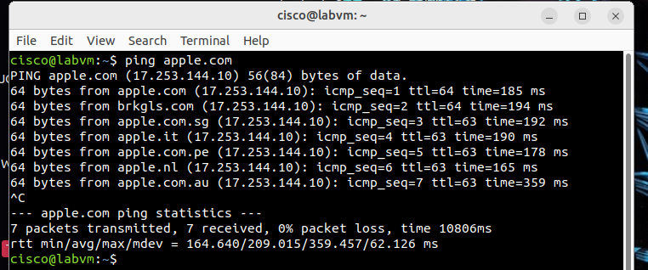
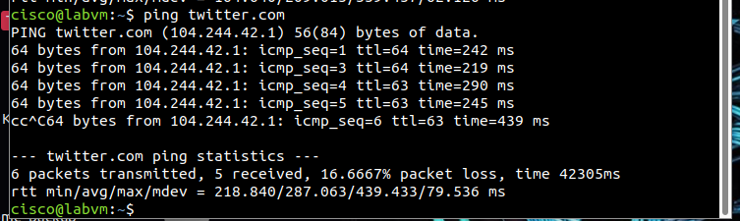
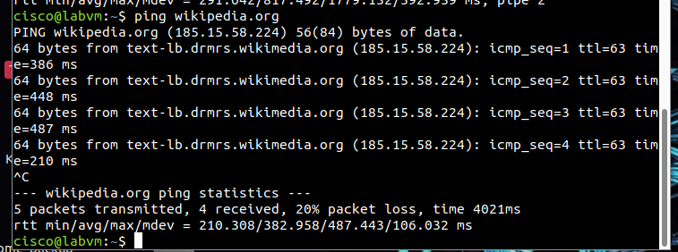
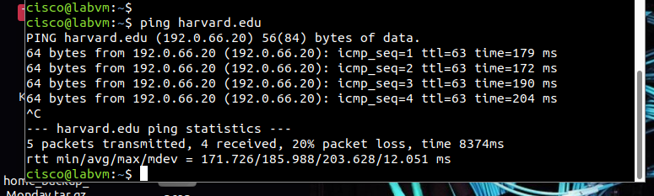
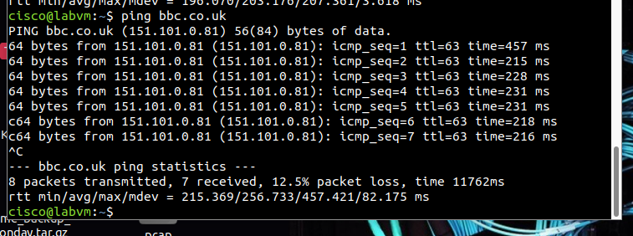
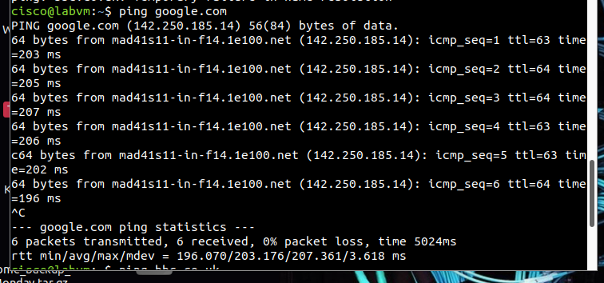
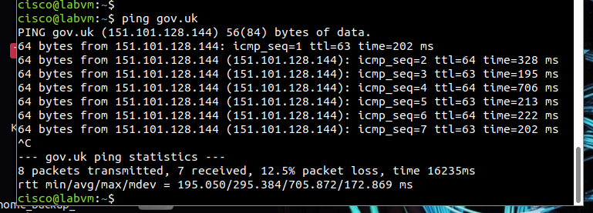
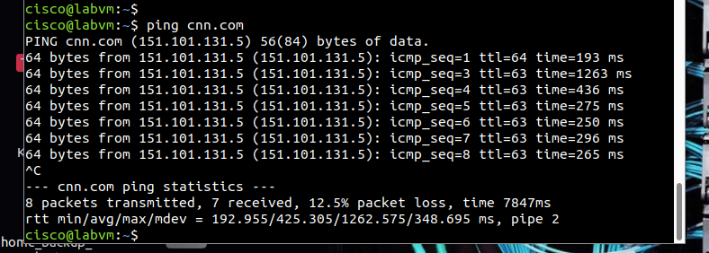
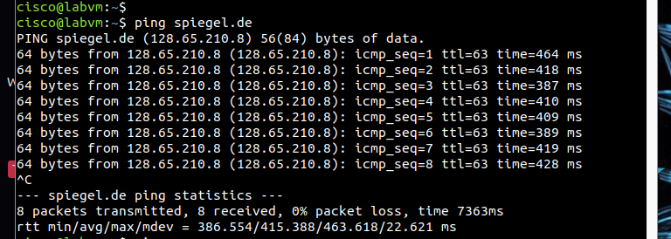
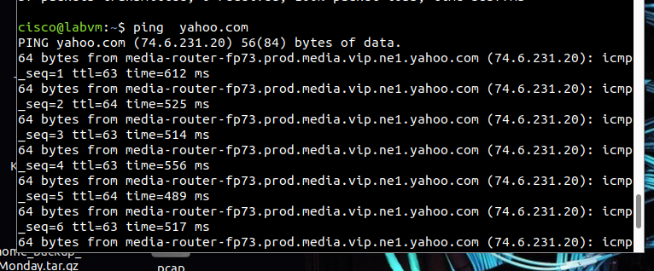
Step 3: Document the IP Addresses
3. Create a table to record the IP addresses for each website you ping.
Serial number | Website | Ip Address
1 | Apple.com | 17.253.144.10
2 | Twitter.com | 104.244.42.1
3 | Wikipedia.org | 185.15.58.224
4 | Harvard.edu | 192.0.66.20
5 | Google.com | 142.250.185.14
6 | Bbc.co.uk | 151.101.0.81
7 | Gov.uk | 151.101.128.144
8 | Cnn.com | 151.101.131.5
9 | Spiegel.de | 128.65.210.8
10 | Sfczonkwa.com.ng | 108.166.183.137

Step 4: Classify the IP Addresses
- Determine the class (A, B, or C) of each IP address based on its first octet
Let's classify each IP address based on its first octet:
- 17.253.144.10
First Octet: 17
Class: A (1-126)
- 104.244.42.1
First Octet: 104
Class: A (1-126)
- 185.15.58.224
First Octet: 185
Class: B (128-191)
- 192.0.66.20
First Octet: 192
Class: C (192-223)
- 142.250.185.14
First Octet: 142
Class: B (128-191)
- 151.101.0.81
First Octet: 151
Class: B (128-191)
- 151.101.128.144
First Octet: 151
Class: B (128-191)
- 151.101.131.5
First Octet: 151
Class: B (128-191)
- 128.65.210.8
First Octet: 128
Class: B (128-191)
- 108.166.183.137
First Octet: 108
Class: A (1-126)
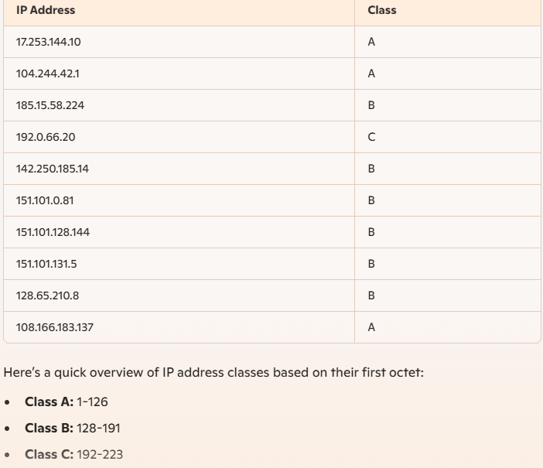

Common Reserved IP Ranges
Reserved IPs are defined by the Internet Assigned Numbers Authority (IANA) in RFC 1918 and other RFCs for private and special-use purposes. These ranges are not routable on the public Internet and are primarily used in internal networks.
Here are the key ranges:

Private IP Ranges (RFC 1918):
- 10.0.0.0/8
Range: 10.0.0.0 – 10.255.255.255
Total IPs: ~16.7 million
Usage: Large private networks (e.g., enterprises or ISPs).
- 172.16.0.0/12
Range: 172.16.0.0 – 172.31.255.255
Total IPs: ~1 million
Usage: Medium-sized private networks.
- 192.168.0.0/16
Range: 192.168.0.0 – 192.168.255.255
Total IPs: ~65,536
Usage: Small/home networks.

Other Special Reserved IP Ranges:
- Loopback (127.0.0.0/8)
Range: 127.0.0.1 – 127.255.255.255
Usage: Testing and internal host communication (e.g., localhost).
- Link-Local (169.254.0.0/16)
Usage: Automatic private IP addressing when no DHCP is available.
- Multicast (224.0.0.0/4)
Range: 224.0.0.0 – 239.255.255.255
Usage: Multicast traffic (e.g., video streams).
- Documentation (192.0.2.0/24, 198.51.100.0/24, 203.0.113.0/24)
Usage: Example addresses for documentation.
- Carrier-Grade NAT (100.64.0.0/10)
Range: 100.64.0.0 – 100.127.255.255
Usage: NAT in ISP-level networks.
- Broadcast Address (255.255.255.255)
Usage: Network-wide broadcasts.

Importance of Reserved IPs in Network Configurations
- Network Segmentation and Scalability
Reserved IPs, especially private ranges, enable organizations to create isolated networks. Without them, IPv4 exhaustion would prevent the scalability of modern networks.
- Security
Private IPs prevent external access by default since they are not routable over the public Internet. This makes them ideal for internal systems.
- Cost-Effectiveness
Organizations can reuse these IP ranges internally without acquiring public IPs for every device.
- IP Conservation
Private IPs help mitigate the exhaustion of IPv4 space. Technologies like NAT allow private networks to share a single public IP for external communication.
- Multicast and Routing Functions
Reserved ranges for multicast and loopback ensure proper routing and application behavior. For example, multicast addresses are used for real-time applications like video conferencing.
- Testing and Documentation
Reserved ranges like 192.0.2.0/24 help avoid conflicts in testing and training environments.

How to Identify Reserved IPs in Your Network
To check if any IPs in your network fall into reserved ranges:
- Identify all subnets in use.
- Compare them against reserved ranges (e.g., using tools like IP calculators or scripting with Python).
- Cross-reference against DHCP and static IP configurations.
Step 5: Calculate the Number of Devices Each IP Can Support

Device Capacity for Each IP Class
- Class A:
Formula: 224−22^{24} - 2
Calculation: 16,777,216−2=16,777,21416,777,216 - 2 = 16,777,214 devices
- Class B:
Formula: 216−22^{16} - 2
Calculation: 65,536−2=65,53465,536 - 2 = 65,534 devices
- Class C:
Formula: 28−22^{8} - 2
Calculation: 256−2=254256 - 2 = 254 devices

Bonus Exercise: Subnetting

Class B Network Subnetting
Let's subdivide a Class B network into smaller subnets.
- Original Class B Network:
Total devices: 65,53465,534
- Subnetting Example 1: /24 Subnet Mask (Subnetting a Class B into Class C sized subnets)
New Subnet Mask: 255.255.255.0 (/24)
Subnets created: 28=2562^{8} = 256 subnets
Devices per subnet: 28−2=2542^{8} - 2 = 254 devices
- Subnetting Example 2: /26 Subnet Mask
New Subnet Mask: 255.255.255.192 (/26)
Subnets created: 210=1,0242^{10} = 1,024 subnets
Devices per subnet: 26−2=622^{6} - 2 = 62 devices

Class C Network Subnetting
Let's consider subnet masks like /26 and /28 for Class C networks.
- Original Class C Network:
Total devices: 254254
- Subnetting Example 1: /26 Subnet Mask
New Subnet Mask: 255.255.255.192 (/26)
Subnets created: 22=42^{2} = 4 subnets
Devices per subnet: 26−2=622^{6} - 2 = 62 devices
- Subnetting Example 2: /28 Subnet Mask
New Subnet Mask: 255.255.255.240 (/28)
Subnets created: 24=162^{4} = 16 subnets
Devices per subnet: 24−2=142^{4} - 2 = 14 devices
By performing subnetting, we can break down larger networks into smaller, more manageable subnets, each with its own device capacity. This enhances network organization and scalability.
Step 6: Determine the Subnet Mask

Default Subnet Masks for Each IP Address Class
- Class A:
Default Subnet Mask: 255.0.0.0
- Class B:
Default Subnet Mask: 255.255.0.0
- Class C:
Default Subnet Mask: 255.255.255.0

Bonus Exercise: Custom Subnetting and Its Impact

Scenario: Custom Subnetting for Network Segmentation
Custom subnetting is often required for network segmentation, which helps in improving network performance, security, and management. By altering the subnet mask, we can create smaller subnets within a larger network, each with its own set of IP addresses.
For example, in an organization, different departments (e.g., HR, Sales, IT) might need separate subnets to isolate their traffic and enhance security.

Impact on Device Capacity and Network Organization
- Subnet Mask /25 (255.255.255.128):
Class C Network:
    - Creates 2 subnets.
    - Each subnet has 128 addresses (2^7) minus 2 for network and broadcast addresses.
    - Usable hosts per subnet: 126
- Subnet Mask /27 (255.255.255.224):
Class C Network:
    - Creates 8 subnets.
    - Each subnet has 32 addresses (2^5) minus 2 for network and broadcast addresses.
    - Usable hosts per subnet: 30

Example Calculation
Original Class C Network (Default Mask /24):
- Total usable addresses: 254
With Subnet Mask /25:
- Number of Subnets: 2
- Usable Hosts per Subnet: 126
With Subnet Mask /27:
- Number of Subnets: 8
- Usable Hosts per Subnet: 30
Step 7: Advanced IP Tools (Bonus Exercises)
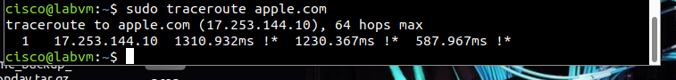
- First (and Only) Hop (17.253.144.10):
The IP address 17.253.144.10 is directly associated with apple.com.
Response Times: The response times for this hop are 1310.932ms, 1230.367ms, and 587.967ms. These times indicate how long it took for the packets to travel to and from this address.
Annotations (!):* The !* symbol indicates an administrative filter preventing the traceroute from progressing. This usually means that further probing is blocked or the destination is configured not to respond to further traceroute queries.

Understanding the Output
- Single Hop: The traceroute shows only one hop, which directly reaches the destination IP address 17.253.144.10.
- Response Times: The relatively high response times (especially the first two) suggest either network latency or load on the destination server.
- Annotations (!):* The !* annotation signifies that this hop is filtered or blocked, commonly by a firewall or other network security mechanism.

Conclusion
This traceroute scan reveals that the packet reaches apple.com (17.253.144.10) in a single hop with notable response times. The !* annotation suggests that further probing is blocked, likely due to security measures at the destination. This indicates the presence of administrative controls, ensuring that network probing tools like traceroute cannot gather more detailed routing information.

