NAME: Adeyemi Akande
REG NO: 2024/INT/EH/3800
COURSE: INT 402

Introduction
This lab exercise is a continuation of the malware dynamic analysis process, focusing on network-level behavior through detailed inspection of a PCAP (Packet Capture) file generated during malware execution. The primary goal is to simulate real-world threat hunting by identifying how malware communicates with the external world and to extract actionable Indicators of Compromise (IOCs).
In this analysis, I investigated network traffic patterns, identify suspicious and malicious activity, and document findings that can assist in understanding the malware’s behavior, targets, and possible intentions.

Resources Used
- PCAP File – Captured traffic generated by detonating the malware sample in a sandboxed environment using FakeNet.
- FakeNet-NG – A dynamic network simulation tool that responds to malware's attempts to connect to external services.
- Wireshark – A powerful packet analysis tool used to filter, visualize, and investigate the PCAP file.
- Operating System Environment – A malware analysis virtual machine (VM) with FakeNet configured.

Methodology
The PCAP file generated by FakeNet during malware detonation was opened in Wireshark. Filters such as http, dns, tcp.port == 80, frame.len > 1000, and ip.dst = 127.0.0.2 were applied to isolate meaningful data. As they can all be seen in my screenshots below. HTTP streams, DNS queries, and anomalies in packet behavior were analyzed. IP addresses, domains, URIs, and data exfiltration attempts was identified but data exchange was incomplete. Findings were documented with screenshots and metadata evidence are shown below.

I first identified the number of ip that was part of this operation using the following command: ip The result shows that we have only two ip addresses as shown in the endpoint statistic below captured in the screenshot. The malware was using 127.0.0.2 to carryout it malicious activities.
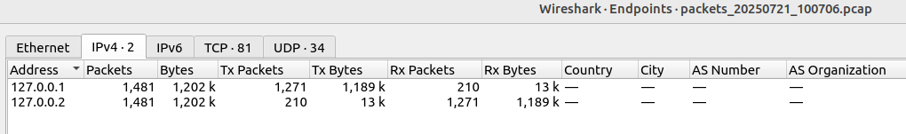
The end point show that the transaction had a number of TCP and UDP activities connected
Searching for Outbound Connections: Domains, IPs, Ports. I used this wireshark filter: tcp.dstport == 80 || tcp.dstport == 443 and the result was captured in the screenshot below:
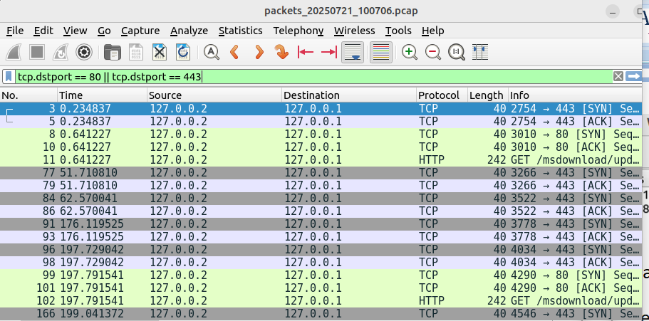
It gave me 177 packets as can be seen below:
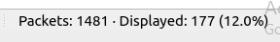
From the packet examination This could be part of malware trying to connect to a remote server over HTTPS: port 443. The ephemeral source port 2754 indicates it’s a client-initiated connection. Even though Len: 0 (no data), it's important connection setup, and might be followed by C2 communication, data exfiltration, or malware updates. It is an indication that the malware was developed to steal vital data without victim suspicion

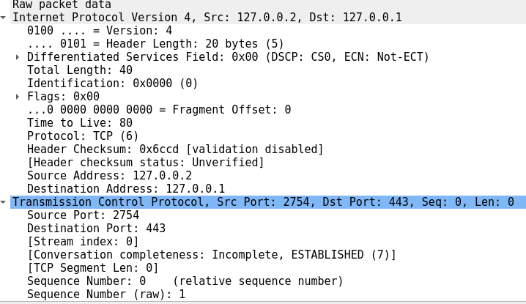
Explanation of vital indicators in tabular form
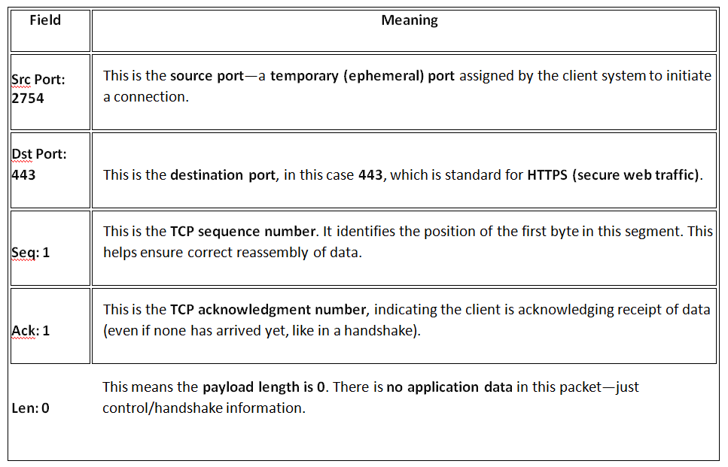
DNS Requests, HTTP Calls, Suspicious Headers
I used udp.port == 53 to search suspicious header
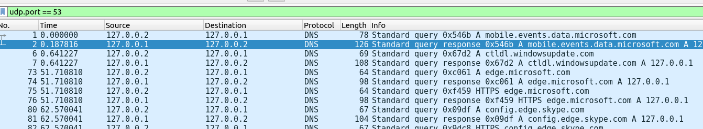
I further evaluate the data found in the filter response as shown below which shows that header checksum: 0x6c60 means that integrity validation was disabled. The malware used this to aid fast data exfilteration without confirming the data integrity
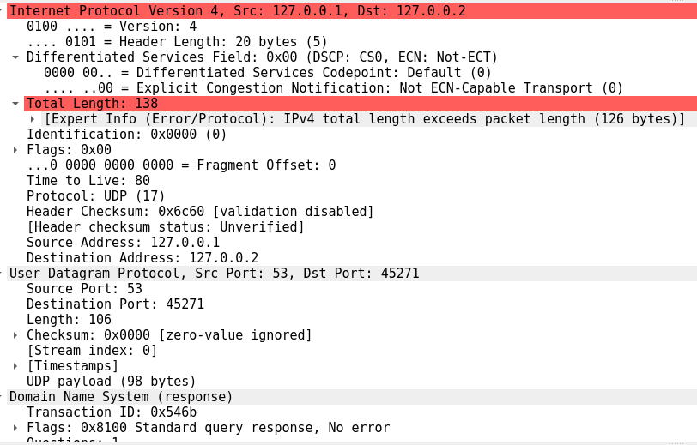
DNS expansion is shown below which indicate attempts but not successful

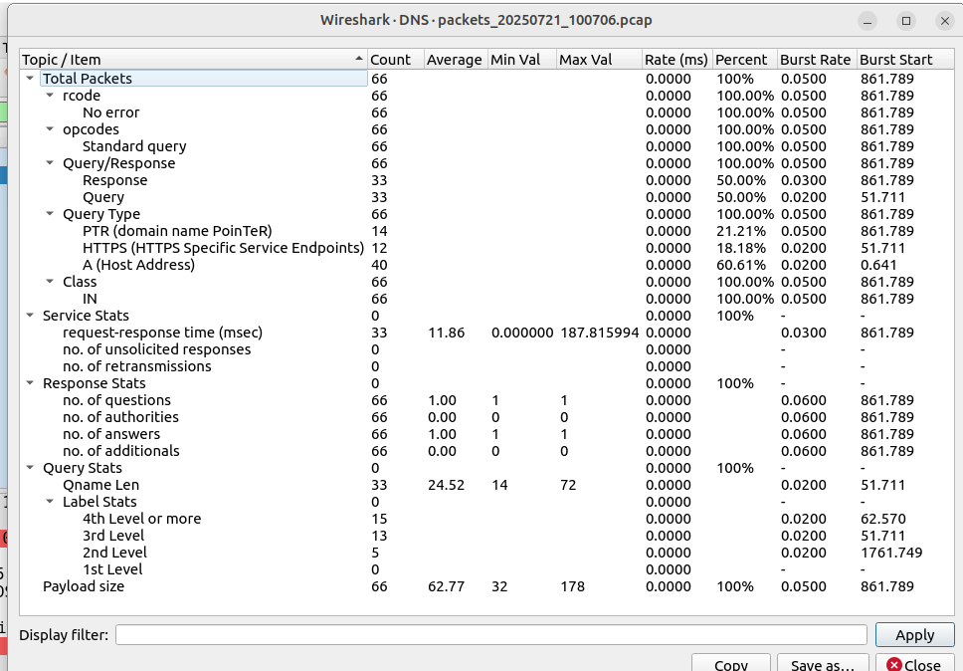

For HTTP request, no form was posted
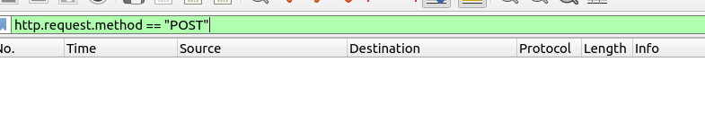
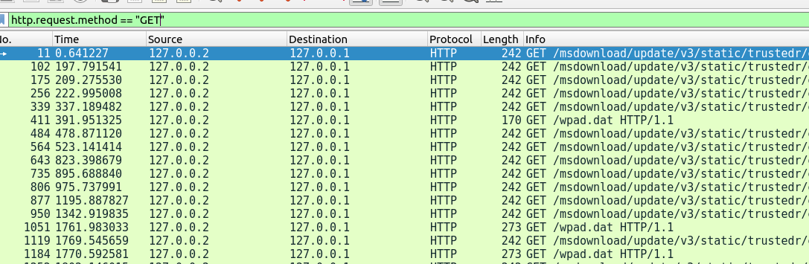
This is an indication that there was attempt to access some data by the malware
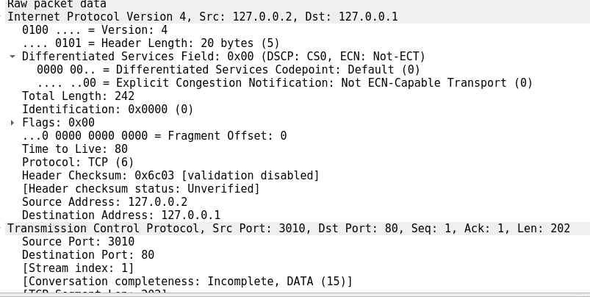
http header checked shown below confirmed some suspected url that are not secure
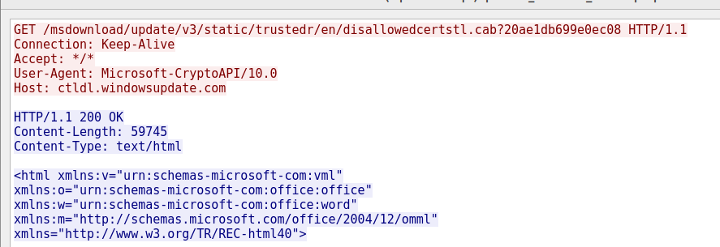

Potential Command-and-Control (C2) Activity: I used the filter as shown below to check for data exfiltration
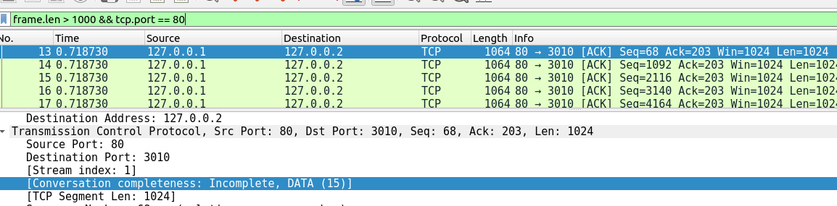
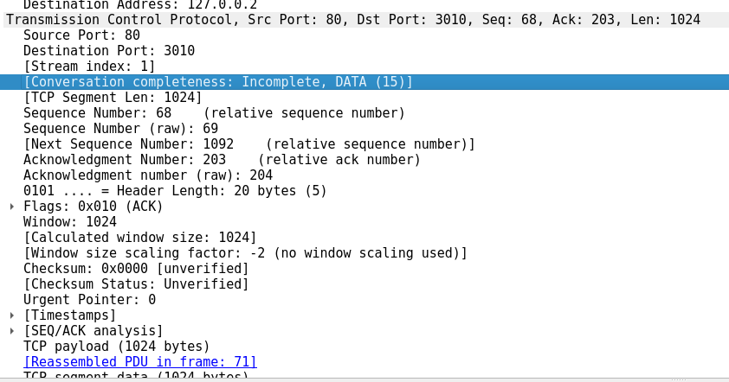
There was an attempt to exfiltrate data but the exfiltration could not be completed as can be seen in the evidence above, the destination ip was 127.0.0.2 which belong to the malware

I searched for Unusual Traffic Behaviour using the following filters
- tcp.analysis.retransmission: Identify retransmitted packets
- ip.len > 1500: Large packets could indicate tunneling
- icmp: Unusual ICMP behavior
- tcp.flags == 0x000: NULL scan (suspicious behavior)
- tcp.window_size == 0: Window size anomalies
but all of them came out as false.

Indicators of Compromise (IOCs)

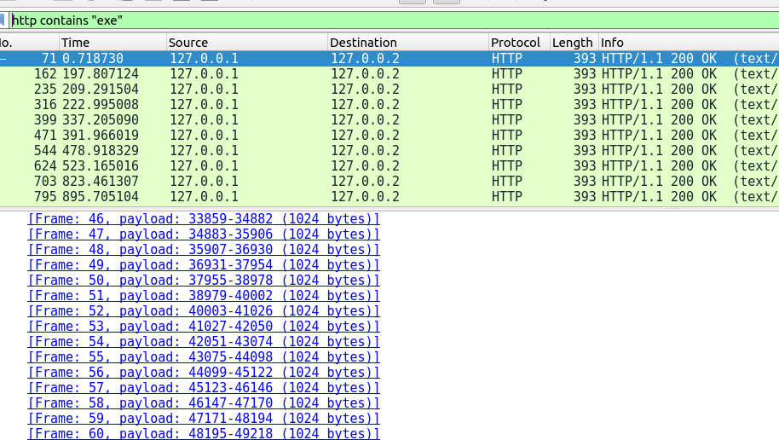

As seen in the screenshot above, the malware attempted it action using payloads but just because we use fakenet, it could not complete it
