NAME: Adeyemi Akande
REG NUMBER: 2024/INT/3800

Introduction
In this lab, I explored key techniques in digital forensics, focusing on disk imaging and data recovery. I began by acquiring disk images from a USB drive using FTK Imager in a Windows environment and the dd command in Linux, creating exact copies of storage devices for forensic analysis. Additionally, I downloaded a disk image file from the web and used Autopsy, a graphical forensic tool, to examine its contents. Through this process, I was able to extract deleted documents and image files from the disk image, demonstrating the practical value of forensic recovery tools. This lab also introduced me to network imaging concepts. I can now understanding the concept of secure acquisition methods in digital investigations.

INT313 - Computer and Digital Forensics – Lab 1
Digital Forensics is the process of identifying, preserving, analyzing, and presenting digital evidence in a way that is legally acceptable. It involves investigating data found on computers, mobile devices, cloud services, networks, and other forms of digital media to uncover information related to criminal activity, security incidents, or internal investigations.
The importance of digital forensics lies in its ability to reconstruct events and prove how cybercrimes or breaches occurred. During investigations, digital forensics specialists collect and preserve evidence carefully to ensure that it remains authentic and reliable in court. This field is critical not only in criminal cases, such as fraud, hacking, or identity theft, but also in corporate environments where data breaches, insider threats, or policy violations need to be examined.
In an era where almost all activities leave a digital footprint, digital forensics plays a crucial role in supporting law enforcement, enhancing cybersecurity practices, and maintaining trust in digital systems. Its methods ensure that investigations are thorough, precise, and legally defensible.

Steps of Digital Investigation
1. Identification
The first step is recognizing potential sources of digital evidence. Investigators determine what data is relevant to the case, where it is stored, and how it can be accessed without altering or damaging the original information.
2. Preservation
This step ensures that digital evidence is protected from alteration, damage, or loss. Techniques such as creating forensic images or using write-blockers are used to maintain data integrity, ensuring it remains admissible in court proceedings.
3. Analysis
Investigators systematically examine the preserved data to uncover facts, patterns, or hidden information. This step may involve recovering deleted files, tracing unauthorized access, or correlating different datasets to reconstruct events or identify perpetrators.
4. Presentation
The final step involves compiling the findings into a clear, concise, and understandable report. Evidence must be presented in a way that non-technical audiences, such as juries or managers, can easily understand its significance and support investigative conclusions.

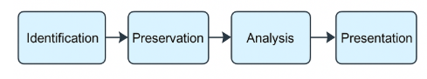

Part 2: Investigating the USB Drive with Autopsy

Screenshot of the details of recovered items
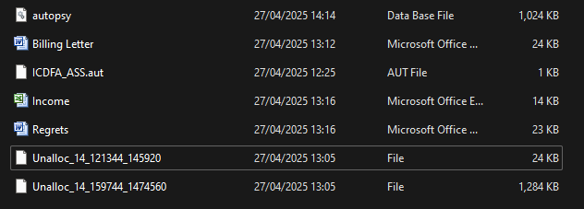
Screenshot of steps to use autopsy to acquire evidence below:

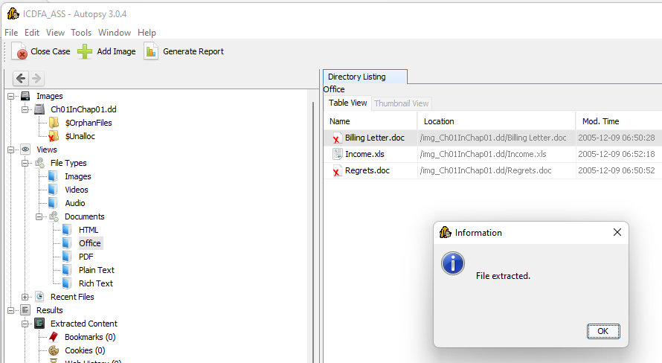

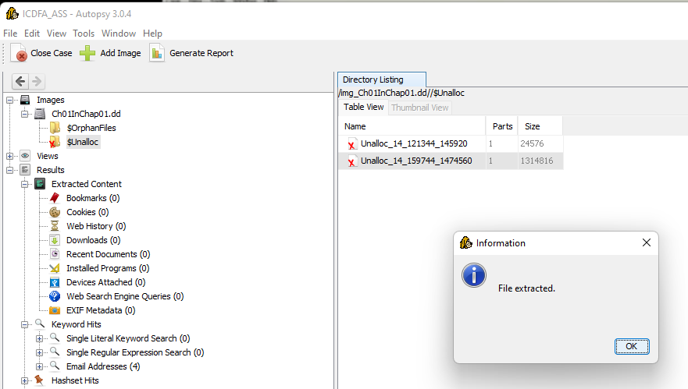

Billing letter retrieved screenshot:
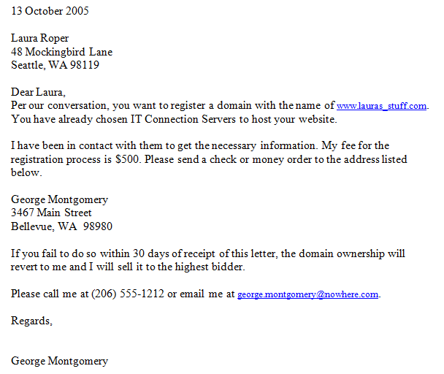
Regrets document retrieved screenshot

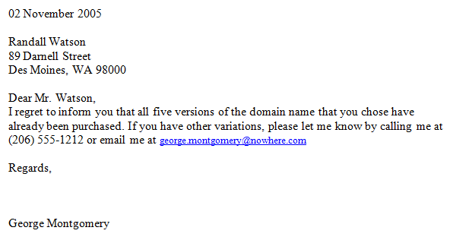

Income document retrieved screenshot:
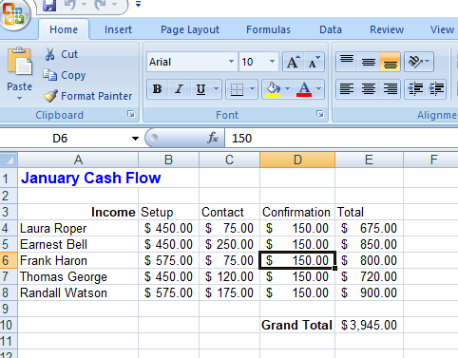

Part 3: Conducting Keyword Searches
Word search

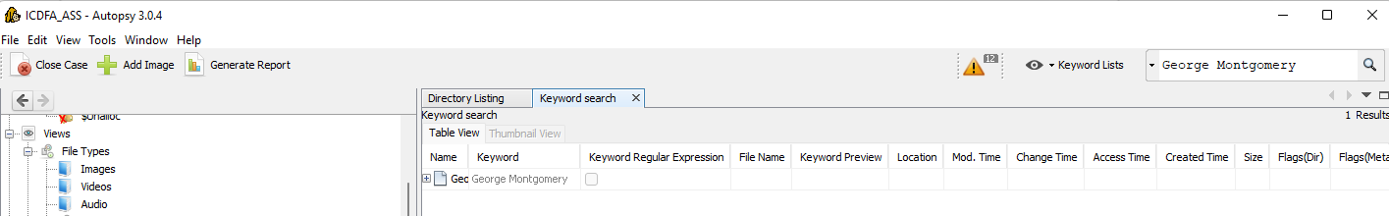

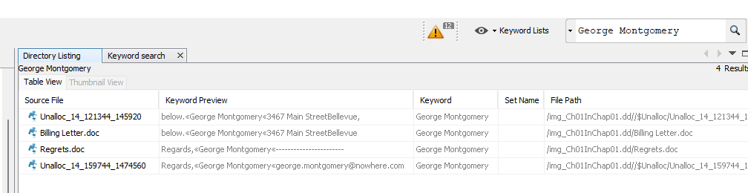

Part 4: Analysis and Documentation
This document set recovered holds significance for both financial management and business communication practices. The first item, a January cash flow table, records income details for six individuals under categories like Income, Setup, Contact, Confirmation, and Total. Although the table presents valuable financial data, it lacks consistent structure, with missing values and unlabeled columns. Income figures range from $450.00 to $575.00, while total cash flows span $675.00 to $850.00 per individual. Cleaning, organizing, and properly labeling this dataset would enhance its usefulness for accurate financial reporting, budgeting, and business performance tracking. A well-maintained cash flow record is crucial for informed decision-making, financial audits, and strategic planning.
The document—a billing letter from George Montgomery to Laura Roper—emphasizes clear, transactional communication in business services. It confirms Laura’s request to register a domain name through IT Connection Servers, states a $500 service fee, and includes a payment deadline with consequences for non-payment. This illustrates the importance of formal, documented agreements in service-based transactions.
The other document, addressed to Randall Watson, reflects effective customer service through prompt and polite notification about unavailable domain names. George invites Randall to submit alternatives and provides contact details for further assistance. This fosters professionalism, maintains client relationships, and highlights the value of courteous, solution-focused correspondence in business operations.

INT313 - Computer and Digital Forensics – Lab 2
Autopsy vs. The Sleuth Kit (TSK): A Comparison
Autopsy and The Sleuth Kit (TSK) are both powerful open-source digital forensics tools, often used together but designed for different user preferences and operational contexts. The Sleuth Kit (TSK) is a command-line-based collection of forensic utilities that allow investigators to analyze disk images, file systems, and recover deleted data. It provides precise, low-level access to forensic artifacts like file metadata, timestamps, and unallocated space, making it highly flexible for advanced users comfortable with terminal commands.
In contrast, Autopsy serves as a graphical front-end for TSK and other forensic tools. It offers an intuitive, easy-to-navigate user interface, making forensic analysis accessible to both beginners and professionals. Autopsy simplifies complex tasks such as keyword searching, timeline analysis, hash filtering, and email examination through point-and-click options and visual dashboards.
While TSK is ideal for scripting and automation in forensic workflows, Autopsy is better suited for visual case management and collaborative investigations. Together, they form a complementary forensic suite, combining TSK’s detailed command-line precision with Autopsy’s user-friendly interface and case organization features.

TSK Architecture Layers and Tools
- Media Management Layer
Function: Accesses and reads raw disk images or devices.
Tools:
    - mmstat — Displays information about the media management structures.
    - mmls — Lists partitions within a disk image.
- Volume System Layer
Function: Identifies and interprets volume systems such as partition tables.
Tools:
    - mmls — Lists partitions and layouts within a volume system.
    - mmcat — Extracts raw data from a volume.
- File System Layer
Function: Interprets the file systems within partitions (e.g., NTFS, FAT, EXT).
Tools:
    - fsstat — Displays file system details.
    - fls — Lists files and directories within a file system.
    - icat — Extracts file content by inode.
    - istat — Displays metadata details for a file.
    - blkls — Extracts data from unallocated space.
- Data Unit Layer
Function: Accesses raw data blocks and clusters within file systems.
Tools:
    - dls — Lists deleted data units.
    - blkcat — Outputs the contents of specified blocks.

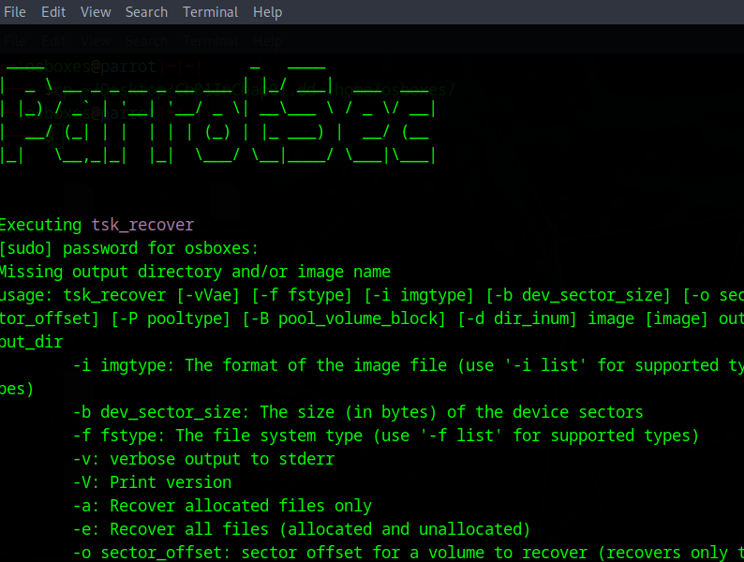

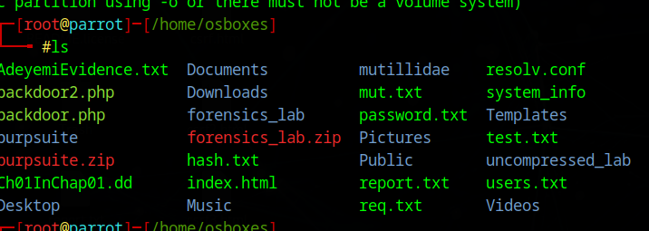

There are ten documents in the image as seen in the screenshot below

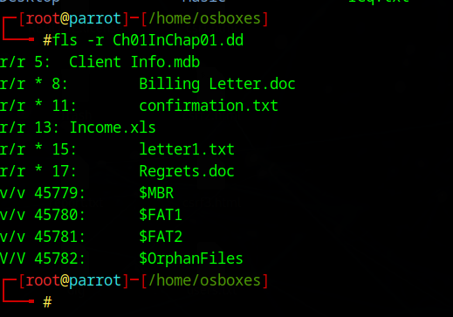

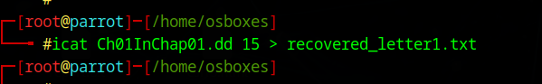

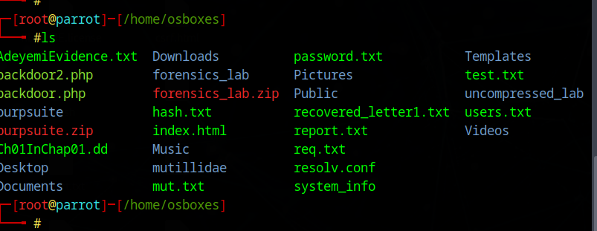

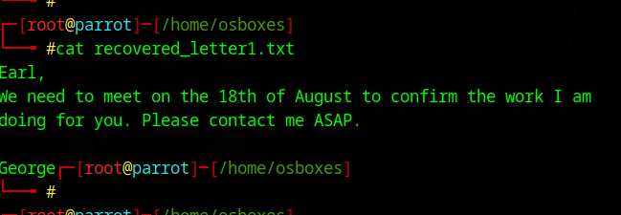

Step 1: Use Modulus to Select Questions
My Student ID = 3800.
needed to calculate:
3800 mod 28
the math:
- 3800 ÷ 28 ≈ 135.714
- 28 × 135 = 3780
- 3800 - 3780 = 20
3800 mod 28 = 20

INT313 - Computer and Digital Forensics – Lab 3
A disk image is an exact, bit-by-bit copy of a digital storage device, such as a hard drive, USB flash drive, or memory card. It captures every piece of data on the device, including active files, deleted files, file system structures, and unallocated space. In digital forensics, disk images are crucial because they preserve the original evidence in its entirety, allowing investigators to analyze data without altering the source device.
The primary benefit of creating disk images in forensic investigations is to maintain data integrity. By working on copies rather than original devices, investigators protect evidence from accidental changes or damage. Disk images also enable repeatable examinations, allow collaboration among investigators, and provide a verifiable record for use in legal proceedings. Additionally, forensic tools can thoroughly analyze disk images to recover hidden, deleted, or fragmented data, supporting comprehensive incident investigations and evidence discovery.

Windows image creation from my flash drive with FTK
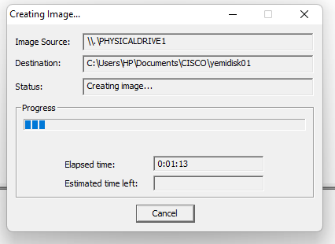

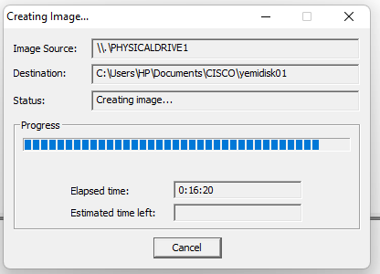

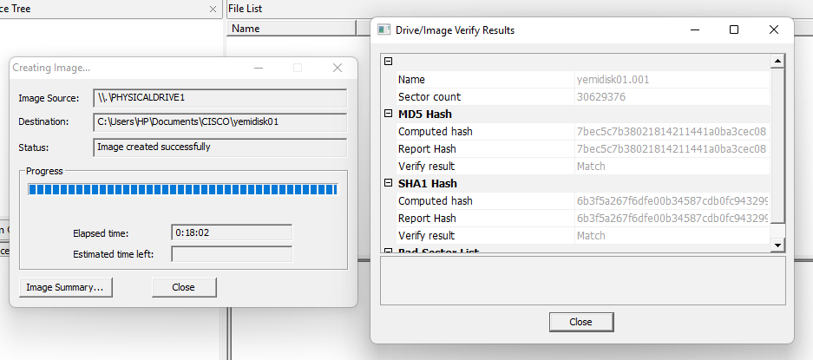

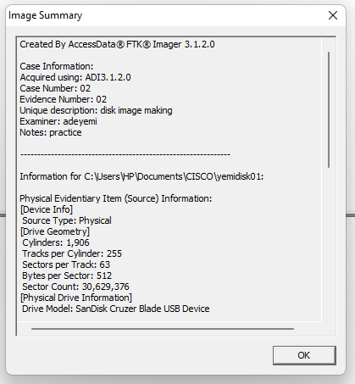

Image created from my flash drive saved in the documents
Screenshot
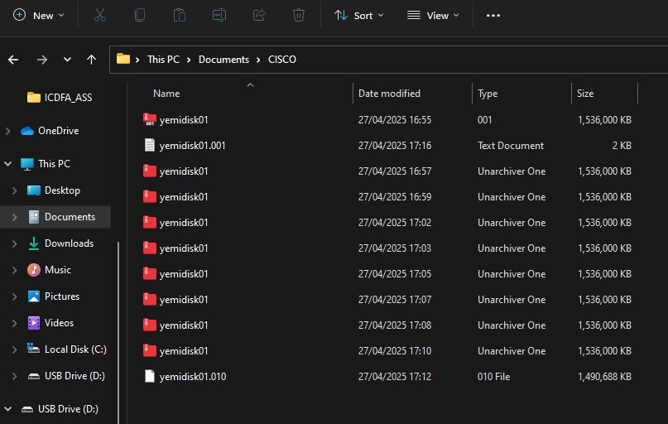
The image I extracted from my flash drive was opened with autopsy, and I was able to see all the files, folders and images I already deleted long ago. See the screenshot below:
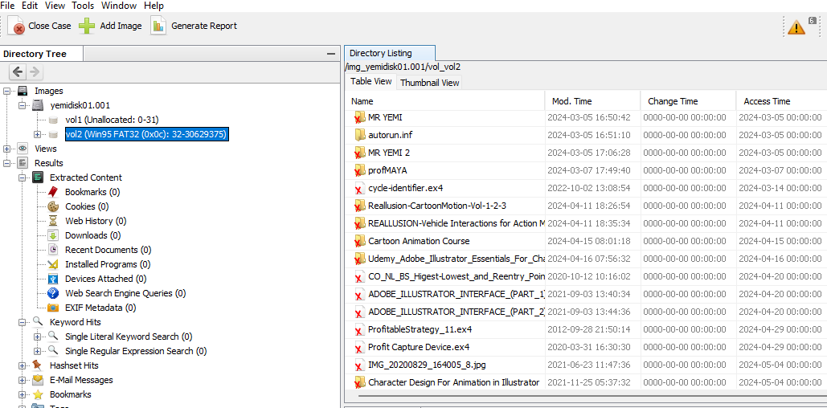
Identify the USB Drive on the terminal as shown in the screenshot below:
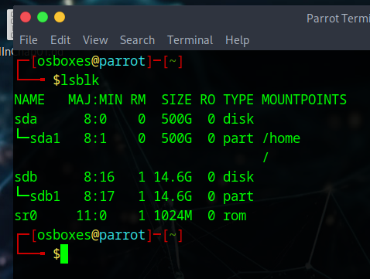
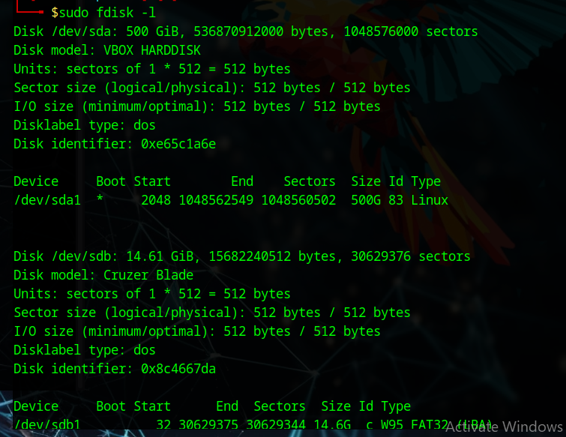

I created a Disk Image with the command: sudo dd if=/dev/sdb1 of=~/usb_image.img bs=4M status=progress as shown in the screenshot below:

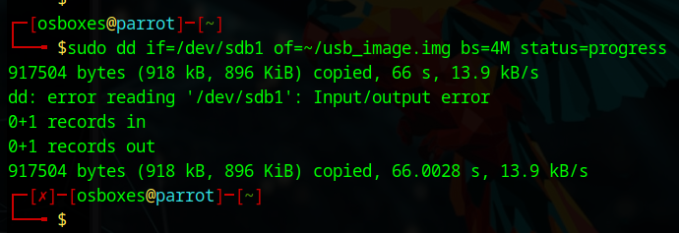

Task 3: Acquisition via Network
Network imaging involves acquiring disk images from a remote system over a network connection, rather than directly from the physical device. This method is valuable in situations where physical access is limited, such as in enterprise environments or incident response cases. Tools like FTK Imager and dd can be paired with network protocols like FTP, SCP, or Netcat to transfer disk images securely. The main advantage is the ability to collect forensic evidence from remote or offsite devices quickly. However, challenges include ensuring data integrity during transfer, network reliability, and potential risks of alerting malicious actors on compromised systems.

Part 3: Forensic Research Preparation
I plan to dedicate a small USB flash drive exclusively for forensic research and lab exercises as requested by the lab. It will be used to simulate real-world scenarios such as file creation, deletion, and data manipulation for recovery experiments. I will create disk images using tools like FTK imager, dd and analyze them with Autopsy and The Sleuth Kit (TSK). The drive will also store sample malicious files, encrypted data, and hidden partitions for forensic investigation practice. Additionally, I’ll test network imaging techniques by transferring its image over protocols like SCP or FTP, ensuring consistent, hands-on experience with various acquisition and analysis methods.

Conclusion
In this lab, I successfully applied various digital forensics techniques to acquire and analyze disk images from USB drives. I used FTK Imager on a Windows system and the dd command in a Linux environment to create exact copies of storage devices, ensuring the integrity of forensic evidence. I also downloaded a disk image from the web and examined it using Autopsy, where I was able to recover deleted documents and image files. This experience deepened my understanding of disk imaging, file recovery, and the importance of preserving data during investigations. Overall, this lab strengthened my practical skills and confidence in handling forensic evidence acquisition and analysis tasks.

