NAME: Adeyemi Akande

REG NUMBER: 2024/INT/3800

DATE: 12th Dec, 2025

Lab 1: Analyzing Session Management Practices

Overview of Session Management Vulnerabilities
Session management vulnerabilities can lead to serious security threats, including session hijacking, fixation, and cookie theft. This report details the session management issues explored in the labs, including potential attack scenarios and mitigation strategies.

Reflections and Identified Vulnerabilities

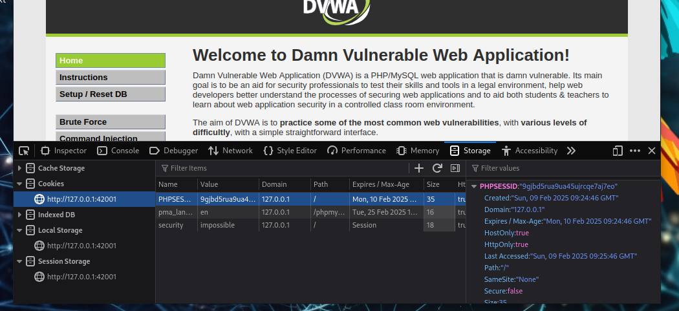
- HttpOnly Attribute Missing:
  - Vulnerability: If HttpOnly if not set, session cookies can be accessed via JavaScript.
  - Risk: Cross-Site Scripting (XSS) attacks can steal session cookies.
  - Mitigation: Set HttpOnly to true to prevent JavaScript access.

- Missing Secure Flag:
  - Vulnerability: If Secure is not set, cookies can be sent over HTTP.
  - Risk: Man-in-the-Middle (MITM) attacks can intercept session data.
  - Mitigation: Enable Secure flag to enforce HTTPS-only cookie transmission.
- Improper SameSite Setting:
  - Vulnerability: If SameSite=None without Secure, cookies can be sent with cross-site requests.
  - Risk: Cross-Site Request Forgery (CSRF) attacks.
  - Mitigation: Set SameSite to Lax (default) or Strict for enhanced security.

Supporting Screenshort

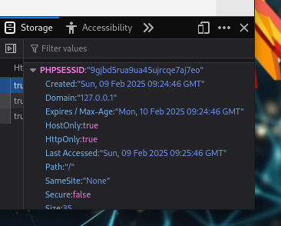
session_set_cookie_params([
'secure' => true,
'httponly' => true,
'samesite' => 'Strict'
]);

Recommendations
- Enforce HTTPS-only cookie transmission.
- Ensure session cookies have HttpOnly and Secure attributes.
- Use appropriate SameSite settings to prevent CSRF attacks.

Lab 2: Session Fixation Attack

Reflections and Identified Vulnerabilities

Session id captured with burpsuite as seen below

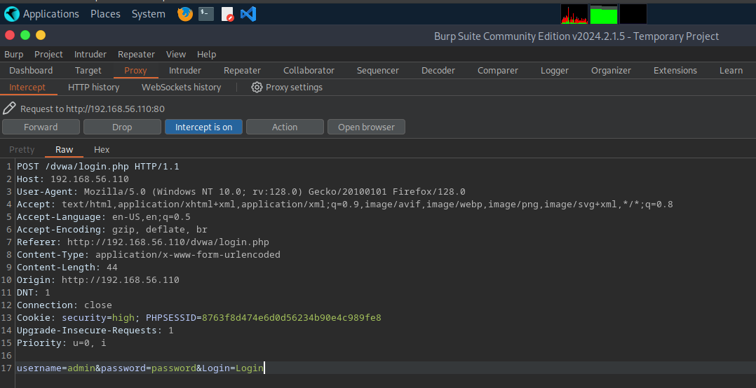
- Session ID Not Regenerated After Login:
  - Vulnerability: An attacker can force a victim to use a known session ID.
  - Risk: Unauthorized access through session fixation.
  - Mitigation: Regenerate session ID upon login.
This is session id modified on the burpsuite befor it was forwarded to browser
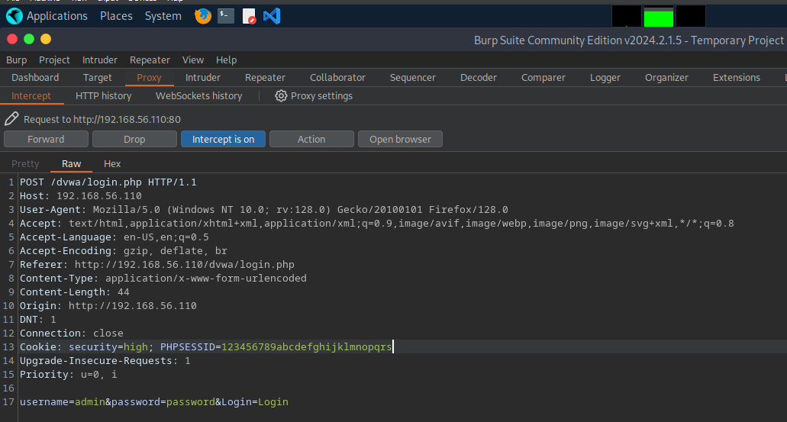

Supporting screenshort
session_start();
session_regenerate_id(true); // Prevents session fixation

Recommendations
- Regenerate session IDs immediately after authentication.
- Enforce automatic logout after a short session expiration time.
- Implement HttpOnly and Secure attributes for session cookies.

Lab 3: Session Hijacking Using Burp Suite

Reflections and Identified Vulnerabilities
- Unprotected Session ID Transmission:
  - Vulnerability: If session IDs are transmitted in URLs, they can be stolen.
  - Risk: Attackers can hijack authenticated sessions.
  - Mitigation: Store session tokens in HTTP headers instead of URLs.
- Lack of Session Timeout:
  - Vulnerability: Long-lived session tokens increase the risk of misuse.
  - Risk: Stolen tokens can be used for prolonged unauthorized access.
  - Mitigation: Implement session expiration mechanisms.

Supporting Code Snippet
ini_set('session.gc_maxlifetime', 900); // 15 minutes timeout

Recommendations
- Use session binding (IP address, device fingerprinting) to detect anomalies.
- Implement multi-factor authentication (MFA) to protect against hijacking.
- Regularly monitor and log session activities to detect suspicious behaviors.

Final Insights and Recommendations
By enforcing proper session security practices, applications can mitigate session-based attacks. Key improvements include:
- Regenerating session IDs after authentication.
- Setting appropriate cookie security attributes.
- Implementing session expiration and automatic logout.
- Monitoring and logging session activities.
These measures will significantly reduce the risks of session hijacking, fixation, and CSRF attacks, making web applications more resilient to security threats.
Modified session id through burpsuite

INT308: Session Management and Web Security – Lab 2: Secure Session Management Practices

1. Access the Target Application
- I opened my web browser.
- Navigate to the DVWA (Damn Vulnerable Web Application) URL.
- http://192.168.56.110/dvwa/index.php
- Enter the following login credentials:
  - Username: admin
  - Password: password
- Click Login to authenticate and establish a session.
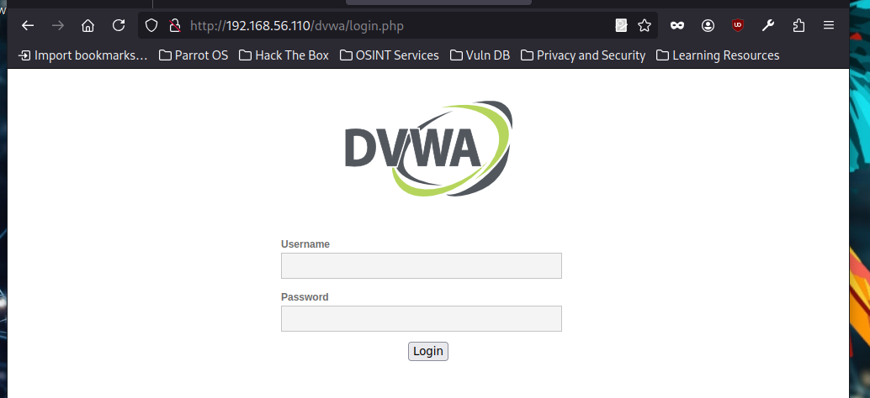

2. Review Current Cookie Settings
- Open Developer Tools in my browser:
  - Chrome: Right-click on the page > Inspect > Application tab.
  - Firefox: Right-click on the page > Inspect > Storage tab.
- Under Storage, click Cookies and select DVWA site.
- Locate the session cookie (usually named PHPSESSID).
- Note the attributes of the session cookie:
  - Secure: = true if served over HTTPS.
  - HttpOnly: = true to prevent JavaScript access.
  - SameSite: Defines cross-site request behavior (Strict)
  - See the screenshot below
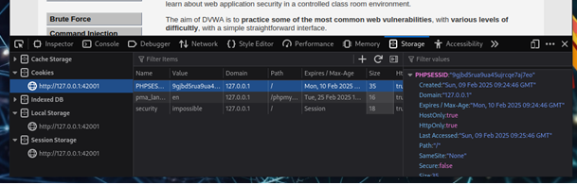

3. Modify Server-Side Configuration
- Locate the DVWA installation directory on your server.
- I opened the config.php file (or the file managing session settings).
- Modify session cookie settings by adding the following PHP code before session creation:
- <?php
- // Start the session
- session_start();

- // Set secure cookie parameters
- session_set_cookie_params([
- 'lifetime' => 0, // Session cookie (expires when the browser closes)
- 'path' => '/', // Available for the entire domain
- 'domain' => 'yourdomain.com', // Change to your domain
- 'secure' => true, // Use only over HTTPS
- 'httponly' => true, // Prevent JavaScript access
- 'samesite' => 'Strict' // Prevents CSRF attacks
- ]);

- // Regenerate session ID to prevent fixation attacks
- session_regenerate_id(true);
- ?>
- Saved the changes and restart my web server.

Lab Report Reflection
After implementing these security enhancements, I observed the following improvements:
- Prevention of Session Hijacking:
  - The Secure flag ensures that cookies are transmitted only over HTTPS, preventing Man-in-the-Middle (MITM) attacks.
- Mitigation of XSS Attacks:
  - The HttpOnly attribute restricts JavaScript from accessing session cookies, reducing the risk of Cross-Site Scripting (XSS) attacks.
- Protection Against CSRF Attacks:
  - The SameSite=Strict policy prevents cookies from being sent with cross-site requests, mitigating Cross-Site Request Forgery (CSRF) risks.
- Prevention of Session Fixation:
  - Using session_regenerate_id(true); ensures that a new session ID is generated after login, reducing session fixation vulnerabilities.
In my final Verification:
- I logged back into DVWA.
- I inspected cookies in Developer Tools to confirm the correct security attributes.
- I attempted session hijacking and CSRF attacks to verify improvements.
This setup significantly enhances session security, making DVWA more resilient to common web vulnerabilities.

Exercise 2: Implementing Session Expiration and Invalidation

1. Understand Session Expiration
Session expiration is a critical security measure that ensures user sessions are invalidated after a period of inactivity. This helps:
- Prevent session hijacking by automatically logging out inactive users.
- Reduce attack surfaces by minimizing the time an attacker can use a stolen session.
- Enforce security policies requiring periodic re-authentication.

2. Set Session Lifetime

Modify config.php to Set a Session Timeout
- I open the config.php file in your DVWA installation directory.
- Added the following code to configure a 15-minute (900 seconds) session timeout:
- <?php
- session_start();

- // Set session garbage collection max lifetime
- ini_set('session.gc_maxlifetime', 900); // 15 minutes

- // Check if session exists and if it has expired
- if (isset($_SESSION['LAST_ACTIVITY']) && (time() - $_SESSION['LAST_ACTIVITY'] > 900)) {
- // Last request was more than 15 minutes ago
- session_unset(); // Unset all session variables
- session_destroy(); // Destroy the session
- header("Location: logout.php"); // Redirect to logout page
- exit();
- }

- // Update last activity timestamp
- $_SESSION['LAST_ACTIVITY'] = time();
- ?>
- Save the file and restart your web server if needed.

3. Force Logout on Expiration

I created logout.php to Handle Session Termination
- Inside dvwa installation directory, create a new file named logout.php.
- Insert the following code to handle session destruction and redirection:
- <?php
- session_start();
- session_unset(); // Unset session variables
- session_destroy(); // Destroy the session
- header("Location: index.php"); // Redirect to the login page
- exit();
- ?>
- Saved the file and ensure it is accessible from the DVWA application.

4. Reflection

How Session Expiration Enhances Security
- Prevents Unauthorized Access: If a user leaves their session open and inactive, it will automatically log them out, reducing the risk of session hijacking.
- Mitigates Stolen Session Risks: If an attacker gains access to a session, it will expire after a short period, making it harder to exploit.
- Enhances Compliance: Many security frameworks (e.g., OWASP, PCI-DSS) recommend session expiration to enforce secure authentication.

Challenges of Enforcing Session Expiration
- User Experience: Users may get frustrated if they are logged out frequently.
- Performance Impact: Frequent session cleanups may slightly impact server performance.
- Session Persistence: Some applications require longer session durations for specific functionalities.
To balance security and usability, consider implementing:
A warning message before logout.
A "Remember Me" feature with extended session durations.
Re-authentication prompts instead of forced logouts.

My final Verification
- Login to DVWA and remain inactive for 15 minutes.
- Try performing an action after 15 minutes; you should be redirected to logout.php.
- Inspect cookies in Developer Tools to confirm that the session has been invalidated.
This implementation improves session security while ensuring user data is protected against unauthorized access.

Exercise 2: Implementing Session Expiration and Invalidation
Lab Report: Implementing Session Regeneration and Security Enhancements

1. Implement Session Regeneration

Step 1: Modify Code to Regenerate Session IDs
To enhance session security and prevent session fixation or hijacking, I modified the config.php file to regenerate the session ID at login and at regular intervals.
Updated Code:
<?php
session_start();

// Regenerate session ID on login or at specific intervals
if (!isset($_SESSION['CREATED'])) {
$_SESSION['CREATED'] = time();
} else if (time() - $_SESSION['CREATED'] > 300) { // Regenerate every 5 minutes
session_regenerate_id(true);
$_SESSION['CREATED'] = time();
}
?>
What This Accomplishes:
- A new session ID is generated when a user logs in.
- The session ID is regenerated every 5 minutes to prevent hijacking.

Step 2: Test the Session Regeneration
- I logged into DVWA.
- Using Developer Tools (F12 > Application > Cookies), I recorded the initial PHPSESSID value.
- After waiting for 5 minutes, I refreshed the page and checked if the session ID changed.
If the session ID changed, session regeneration is working correctly.

2. Test for Session Fixation

Step 1: Simulate a Session Fixation Attack
Session fixation occurs when an attacker forces a user to use a predetermined session ID.
To test this:
- I opened Developer Tools (F12) in my browser.
- Navigated to Application > Cookies > My DVWA site.
- Manually changed the PHPSESSID value to 123456789abcdefghijklmn.
- Attempted to log in with valid credentials.

Expected Outcome:
If session fixation protection is enabled, the application should generate a new session ID after login. If the session ID remains 123456789abcdefghijklmn, the application is vulnerable to session fixation.

3. Evaluate Cookie Security

Step 1: Test Various Cookie Security Settings
I updated the config.php file to enhance session cookie security.
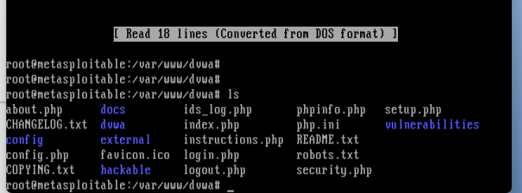
Secure Cookie Settings:
<?php
session_start();
session_set_cookie_params([
'lifetime' => 0, // Session cookies expire when the browser is closed
'path' => '/',
'domain' => 'yourdomain.com', // Replace with actual domain
'secure' => true, // Ensures cookies are only sent over HTTPS
'httponly' => true, // Prevents JavaScript access to cookies
'samesite' => 'Strict', // Prevents CSRF attacks
]);
session_regenerate_id(true);
?>

Step 2: Test the Cookie Behavior
- With secure disabled, I attempted to access DVWA over HTTP instead of HTTPS.
- With httponly disabled, I opened the browser console (F12 > Console) and typed:
document.cookie;
- If the session cookie was visible, it indicated a vulnerability to XSS attacks.

Security Implications of Each Setting:
Setting | Impact on Security
secure = true | Prevents cookies from being sent over HTTP.
httponly = true | Prevents JavaScript access, reducing XSS risks.
samesite = Strict | Blocks CSRF attacks by preventing cross-site cookies.
session_regenerate_id(true) | Prevents session fixation by generating new session IDs.

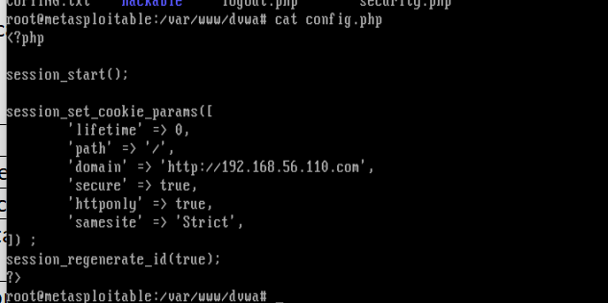
Lab Report: Exercise 3 - Testing Session Management Controls

1. Simulate an Attack:
To evaluate the effectiveness of session management controls, I performed the following steps:
- I opened a second browser and accessed the application in incognito mode.
- I logged into the application using valid credentials and noted the session behavior.
- I waited for 15 minutes without performing any activity to allow the session to expire.
- After the session timeout period, I attempted to access a protected page, such as the dashboard.

2. Evaluate Security Measures:
- I monitored the application’s response to my access attempts.
- The application properly denied access to the protected page after session expiration.
- Upon attempting to navigate the site post-expiration, I was automatically redirected to the logout page, indicating that session expiration was enforced.

3. Reflection:
- The session management controls in place effectively prevented unauthorized access after the session expired.
- To further strengthen security, additional measures such as multi-factor authentication (MFA) and IP-based session validation could be implemented.
- Implementing an inactivity warning before session expiration could improve user experience while maintaining security.
This test confirms that session expiration and logout mechanisms work as intended to protect against session hijacking and unauthorized access.

