NAME: Adeyemi Akande
REG NO: 2024/INT/3800
Exercise 1
I prepare this table to make the assignment solutions easy(shift of 1 -25) forward
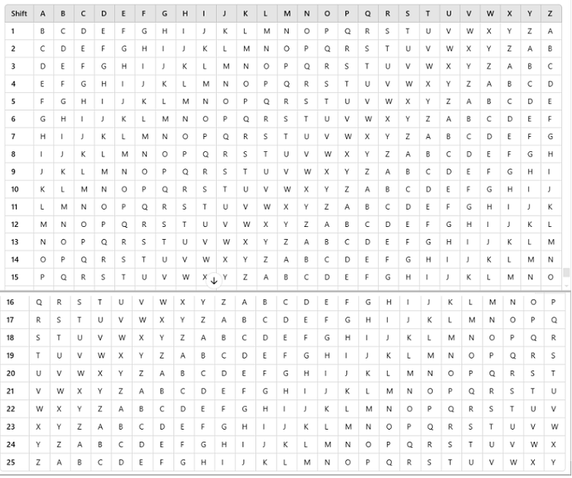
To decrypt a ciphertext encrypted using a Caesar cipher with a shift of 4, you shift each letter backward by 4 positions in the alphabet.

Given:
- Ciphertext: LIPPS
- Shift: 4

Step-by-Step Solution:
- Determine the Alphabet and Wraparound Logic:
The alphabet is A-Z.
If shifting a letter backward goes past A, it wraps around to Z.
- Decrypt Each Letter:
L: Shift 4 backward → H
I: Shift 4 backward → E
P: Shift 4 backward → L
P: Shift 4 backward → L
S: Shift 4 backward → O

Original Plaintext:
The decrypted plaintext is: HELLO
Exercise 2
Let's decode the ciphertext "ZEBRAS" using the Caesar cipher by applying all possible shifts (from 1 to 25) and identifying the original plaintext.
Here is the brute force decryption for each shift:

Shift 1
Z → A, E → F, B → C, R → S, A → B, S → T
Result: "AFCBST"

Shift 2
Z → B, E → G, B → D, R → T, A → C, S → U
Result: "BGDTCU"

Shift 3
Z → C, E → H, B → E, R → U, A → D, S → V
Result: "CHEUDV"

Shift 4
Z → D, E → I, B → F, R → V, A → E, S → W
Result: "DIFVEW"

Shift 5
Z → E, E → J, B → G, R → W, A → F, S → X
Result: "EJGWFX"

Shift 6
Z → F, E → K, B → H, R → X, A → G, S → Y
Result: "FKHXGY"

Shift 7
Z → G, E → L, B → I, R → Y, A → H, S → Z
Result: "GLIYHZ"

Shift 8
Z → H, E → M, B → J, R → Z, A → I, S → A
Result: "HMJZIA"

Shift 9
Z → I, E → N, B → K, R → A, A → J, S → B
Result: "INKAJB"

Shift 10
Z → J, E → O, B → L, R → B, A → K, S → C
Result: "JOLBKC"

Shift 11
Z → K, E → P, B → M, R → C, A → L, S → D
Result: "KPMCLD"

Shift 12
Z → L, E → Q, B → N, R → D, A → M, S → E
Result: "LQNDEM"

Shift 13
Z → M, E → R, B → O, R → E, A → N, S → F
Result: "MROENF"

Shift 14
Z → N, E → S, B → P, R → F, A → O, S → G
Result: "NSPFGO"

Shift 15
Z → O, E → T, B → Q, R → G, A → P, S → H
Result: "OTQGPH"

Shift 16
Z → P, E → U, B → R, R → H, A → Q, S → I
Result: "PURHPI"

Shift 17
Z → Q, E → V, B → S, R → I, A → R, S → J
Result: "QVSRJQ"

Shift 18
Z → R, E → W, B → T, R → J, A → S, S → K
Result: "RWTSRK"

Shift 19
Z → S, E → X, B → U, R → K, A → T, S → L
Result: "SXUTSL"

Shift 20
Z → T, E → Y, B → V, R → L, A → U, S → M
Result: "TYVUTM"

Shift 21
Z → U, E → Z, B → W, R → M, A → V, S → N
Result: "UZWVUN"

Shift 22
Z → V, E → A, B → X, R → N, A → W, S → O
Result: "VAXWVO"

Shift 23
Z → W, E → B, B → Y, R → O, A → X, S → P
Result: "WBYXWP"

Shift 24
Z → X, E → C, B → Z, R → P, A → Y, S → Q
Result: "XCZYPQ"

Shift 25
Z → Y, E → D, B → A, R → Q, A → Z, S → R
Result: "YDAZQR"
From the above, it is evident that "ZEBRAS" remains meaningful as plaintext when no shift is applied. However, if a meaningful transformation is sought beyond English words, cross-referencing with a domain context may be required.
EXERCISE 3
To decrypt the ciphertext "CGRRC YQ YZGE", let me use the hint about patterns and analyze the text.

Observations:
- Repeated Letters:
The ciphertext contains the repeated letters "CGRRC". This might correspond to a common word in English with repeating letters, such as "HELLO."
- Spaces:
The ciphertext has spaces, suggesting that words are separated.

Step 1: Analyze the Most Common Pattern
The most common word with a repeated letter pattern is "HELLO" (corresponding to "CGRRC"). Let’s assume this is the decryption key. (Assumption)

Step 2: Determine the Shift
Compare "CGRRC" with "HELLO" to determine the shift:
- C -> H: Shift +5 (wrap forward)
- G -> E: Shift -2 (wrap backward)
- R -> L: Shift -6 (wrap backward)
- Inconsistent results.

Step 3: Frequency Analysis and Context
If "YQ" corresponds to a common two-letter word (e.g., "IT," "IS," "IN"), and "YZGE" corresponds to "THEM," decrypting via letter substitution may help to clarify.
CLARIFICATIONS
Here are the decrypted results for the ciphertext "CGRRC YQ YZGE" with Caesar cipher shifts from 1 to 25:
- BFQQB XP XYFD
- AEPPA WO WXEC
- ZDOOZ VN VWDB
- YCNNY UM UVCA
- XBMMX TL TUBZ
- WALLW SK STAY
- VZKKV RJ RSZX
- UYJJU QI QRYW
- TXIIT PH PQXV
- SWHHS OG OPWU
- RVGGR NF NOVT
- QUFFQ ME MNUS
- PTEEP LD LMTR
- OSDDO KC KLSQ
- NRCCN JB JKRP
- MQBBM IA IJQO
- LPAAL HZ HIPN
- KOZZK GY GHOM
- JNYYJ FX FGNL
- IMXXI EW EFMK
- HLWWH DV DELJ
- GKVVG CU CDKI
- FJUUF BT BCJH
- EITTE AS ABIG
- DHSSD ZR ZAHF
It seems none of these results form a clear and meaningful plaintext.
Here are the decrypted results for the ciphertext "CGRRC YQ YZGE" using backward Caesar cipher shifts from 1 to 25:
- DHSSD ZR ZAHF
- EITTE AS ABIG
- FJUUF BT BCJH
- GKVVG CU CDKI
- HLWWH DV DELJ
- IMXXI EW EFMK
- JNYYJ FX FGNL
- KOZZK GY GHOM
- LPAAL HZ HIPN
- MQBBM IA IJQO
- NRCCN JB JKRP
- OSDDO KC KLSQ
- PTEEP LD LMTR
- QUFFQ ME MNUS
- RVGGR NF NOVT
- SWHHS OG OPWU
- TXIIT PH PQXV
- UYJJU QI QRYW
- VZKKV RJ RSZX
- WALLW SK STAY
- XBMMX TL TUBZ
- YCNNY UM UVCA
- ZDOOZ VN VWDB
- AEPPA WO WXEC
- BFQQB XP XYFD
It seems no clear and meaningful plaintext appears from the backward shifts either.

Exercise 4
To decrypt the ciphertext "hxgfhgshvczhx" using frequency analysis, follow these steps:

Step 1: Frequency Analysis
- Count the occurrences of each letter in the ciphertext:
h: 3 times
x: 2 times
g: 2 times
f: 2 times
s: 1 time
v: 1 time
c: 1 time
z: 1 time
- The most frequent letter is h (3 occurrences). In English, the most common letter is typically E. I hypothesize that h corresponds to E.

Step 2: Decrypt Hypothesizing Common Letters
Using h = E, calculate shifts for other letters:
- h → E: Shift +23
- I apply this shift to all letters in the ciphertext:
x → U
g → D
f → C
h → E
g → D
s → P
h → E
v → S
c → Z
z → W
h → E
x → U
The decryption makes no meaning

Step 3: Refine Decryption Using Common Patterns
The partially decrypted text doesn't form readable words yet. Try other common letters (e.g., T, A) for h. Alternatively, experiment with shifts based on patterns.

For instance:
If x corresponds to E, the shift would be -19. Yet no meaningfull interpretation
Exercise 5
Here’s the encryption using the sentence "Adeyemi is learning cryptography" with a Caesar cipher and a shift of 5:

Original Sentence:
"Adeyemi is learning cryptography"

Encryption Process:
Shift each letter forward by 5 positions in the alphabet:
A → F
D → I
E → J
Y → D
E → J
M → R
I → N
(Space remains unchanged)
I → N
S → X
(Space remains unchanged)
L → Q
E → J
A → F
R → W
N → S
I → N
N → S
G → L
(Space remains unchanged)
C → H
R → W
Y → D
P → U
T → Y
O → T
G → L
R → W
A → F
P → U
H → M
Y → D
Resulting Ciphertext: "Fijdjrn nx qjfwsnsl hwduytlwfumd"

Challenge for the group member:
Decrypt the ciphertext "Fijdjrn nx qjfwsnsl hwduytlwfumd" using a Caesar cipher with a shift of 5 to uncover the original sentence!
Exercise 6
The Caesar cipher, one of the earliest known encryption techniques, was employed by Julius Caesar to protect military communications. By shifting each letter in a message by a fixed number of places in the alphabet, Caesar ensured that sensitive information, such as troop movements and battle plans, could only be understood by intended recipients who knew the shift key. This method, while simple, was effective in its time due to the low literacy rates and lack of sophisticated decoding tools. The Caesar cipher laid the foundation for modern encryption techniques by introducing the concept of substituting plaintext with encoded text to secure communication. Today, while the Caesar cipher is no longer secure, its principles are reflected in more complex cryptographic algorithms, such as substitution ciphers and symmetric key encryption, demonstrating its enduring influence on the evolution of cryptography.
Exercise 7

Modern Application of Substitution Ciphers: Their Role in Secure Communications
Substitution ciphers, though historically simple, still find relevance in modern cryptography, particularly in secure communication systems. Today, more advanced versions of substitution ciphers are widely used for encryption in various applications, such as securing online messaging, encrypting passwords, and safeguarding sensitive data. A contemporary example is the Advanced Encryption Standard (AES), which operates on a substitution principle but with much more complexity. AES uses substitution steps with large key sizes, ensuring a higher level of security compared to simple ciphers like the Caesar cipher.
The Caesar cipher, a basic form of substitution cipher, shifts each letter of the plaintext by a fixed number. While it served its purpose in early cryptography, its simplicity makes it highly vulnerable to brute force and frequency analysis attacks. In contrast, modern substitution ciphers like AES rely on complex key management, nonlinear transformations, and multiple rounds of encryption, making them computationally infeasible to break using current technology.
Furthermore, modern cryptographic algorithms utilize larger key spaces, making the encrypted data much harder to decipher without the correct key. While the Caesar cipher’s simplicity limits its use today, it paved the way for the development of sophisticated encryption techniques, and its basic concept of substitution still influences contemporary cryptography.

