NAME: Adeyemi Akande
REG NUMBER: 2024/INT/3800
INT305: Network Security and Protocols – Lab 1: User Management: Exercise 1.
User Account Creation and Modification:
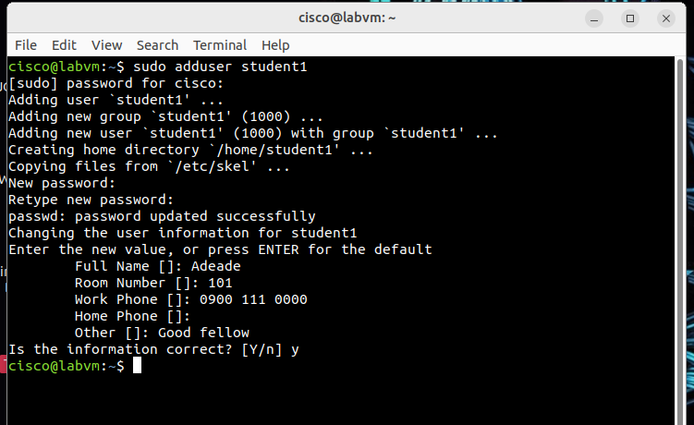
o Create a user named student1. 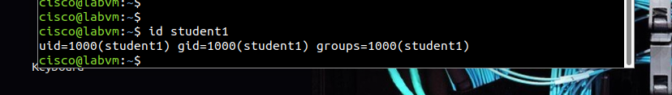
o Add student1 to the group students. 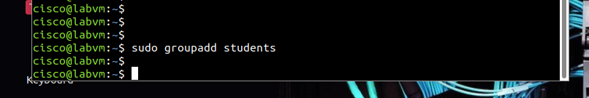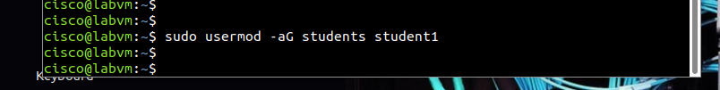
o Change the password for student1 to a secure value. 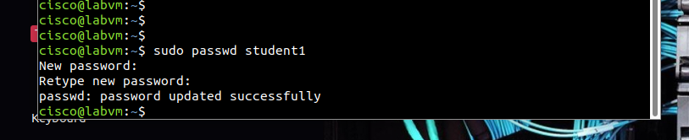
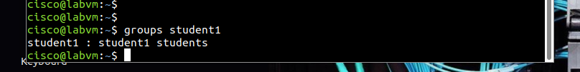
2. Account Locking and Unlocking:
o Check for any active processes under student1 and terminate them if necessary. 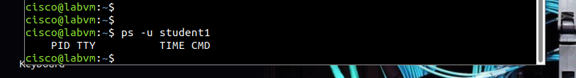
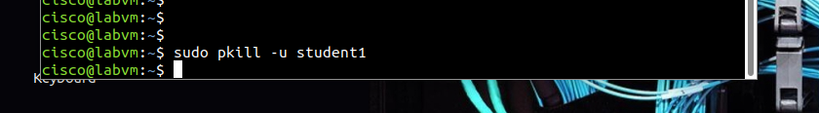
o Lock the student1 account and verify that the account is locked. 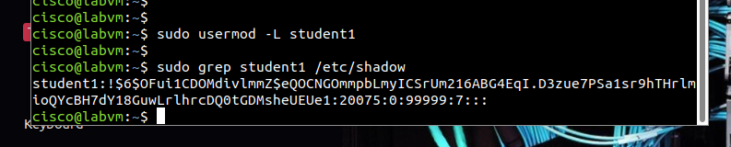
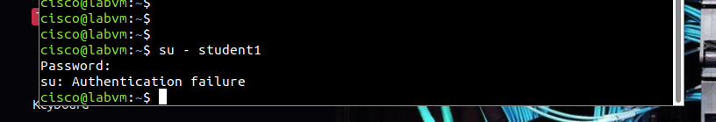
o Unlock the account and confirm it is accessible again. 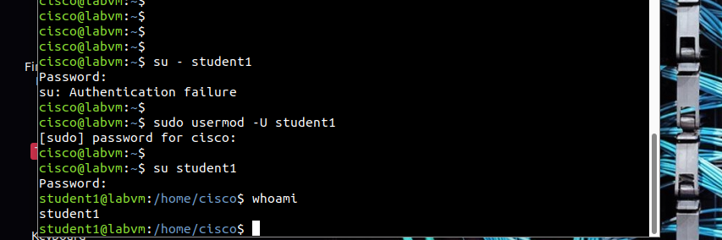
3. User Account Deletion:
o Delete the student1 user account while keeping the home directory. 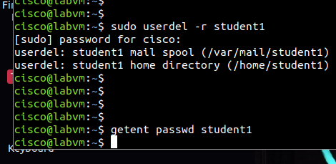
o Finally, remove student1 completely, including their home directory 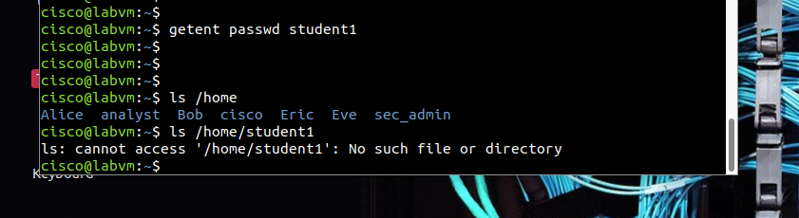

Challenges I Encountered and How I Addressed Them
- Challenge: I initially encountered an error when trying to add the user to a non-existent group.
Solution: I resolved this by creating the students group beforehand using groupadd students.
- Challenge: Active processes under student1 prevented me from locking the account.
Solution: I used the ps -u command to identify the processes and terminated them using kill.
- Challenge: Verifying the account’s lock status was unclear initially.
Solution: I used the passwd -S command to confirm whether the account was locked.
3. Insights I Gained
- I learned that secure user account management is essential for protecting system integrity. Practices such as enforcing secure passwords, regularly reviewing account statuses, and cleaning up unused accounts are vital.
- I realized that locking accounts ensures that inactive or compromised accounts do not pose security risks.
- I appreciated the flexibility of command-line tools for managing users, but I also recognized the importance of careful planning and accurate execution to avoid errors.
Conclusion
This activity emphasized the significance of secure and precise user management procedures. The challenges I faced during the hands-on exercises taught me the importance of system knowledge and proper tools to address issues effectively.

INT305: Lab 2: File and Directory Permissions Objectives

Report on File and Directory Permissions in Cybersecurity

Commands for Checking and Modifying Permissions
- Checking Current Permissions
  - Use ls -l file1.txt to display the current permissions of a file.
Display of the ls -l file1.txt command output showing file permissions. 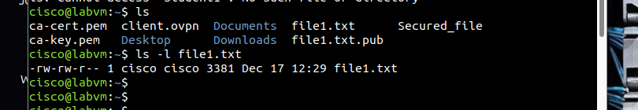
- Changing File Permissions
  - Numeric Mode: Use chmod 755 file1.txt to set permissions numerically (7 for owner, 5 for group, 5 for others).
Output of chmod 755 file1.txt. After execution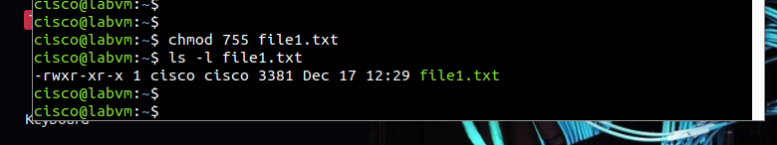
  - Symbolic Mode: Use chmod u+x file1.txt to add execute permission for the owner.
Output /input of chmod u+x file1.txt. 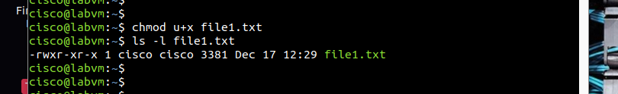
- Managing Directory Permissions 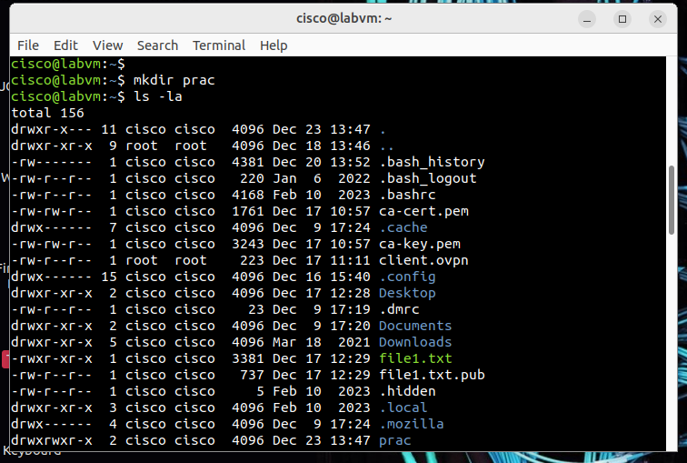
  - Use chmod 755 directoryname(prac) to grant full access to the owner and restrict others.
- Examples
  - Create a directory: mkdir project.
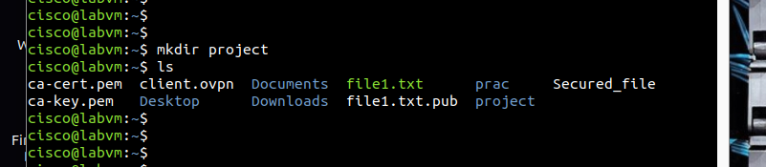
  - Set permissions: chmod 755 project.
Permissions of the project directory using chmod 755. 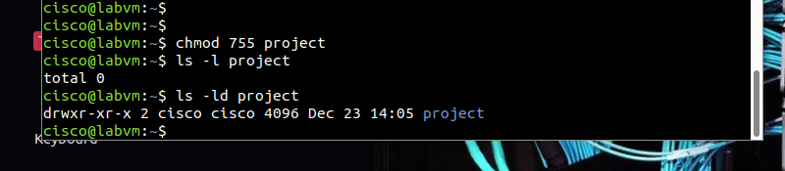
  - Change ownership: chown student1:students project.
Ownership details of the project directory before and after applying chown. 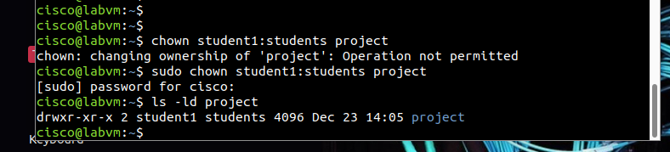

Significance of File and Directory Permissions in Cybersecurity
File and directory permissions are crucial in cybersecurity. The following areas are benefits.
- Access Control:
  - Restricting access to sensitive files and directories.
- Minimizing Risks:
  - Demonstrating how incorrect permissions can lead to vulnerabilities.
- Protecting Sensitive Data:
  - Ensuring critical files are not accessible by unauthorized users.
- Maintaining System Integrity:
  - Correct permissions can prevent modifications to system files.

