Cybersecurity Capstone Project

Title:

Vulnerability Assessment Report And Secure Network Design Proposal

Report And Proposal Written by:
ADEYEMI AKANDE
FE/23/57878485

COHORT 2 FELLOW

WEBSITE SECURITY ASSESSMENT REPORT
PART 1
Target Website: https://juice-shop.herokuapp.com
Date: November 8, 2024
Tool Used: OWASP ZAP (Version 2.15.0)

Executive Summary
This report provides an overview of security vulnerabilities identified on the website. Addressing these issues will improve the website’s resilience against common security threats, including cross-site scripting (XSS), data leaks, and unauthorized data access.

KEY VULNERABILITIES AND RECOMMENDATIONS

1. Content Security Policy (CSP) Header Not Set
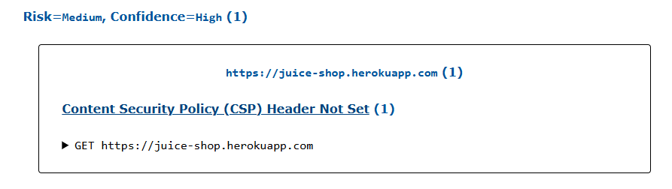
- Risk Level: Medium
- Description: A missing Content Security Policy (CSP) header makes the website vulnerable to cross-site scripting (XSS) and data injection attacks, where unauthorized scripts could be loaded and run. This could lead to data theft, unauthorized access, or other malicious actions.
- Recommendation: Configure the website to include a Content Security Policy (CSP) header that specifies trusted sources for scripts, styles, images, etc. This will restrict the loading of resources from unapproved sources and minimize risks of injection attacks. Use CSP to Control Cross-Origin Resource Access like this Content-Security-Policy: default-src 'self'

2. Cross-Domain Misconfiguration (CORS)
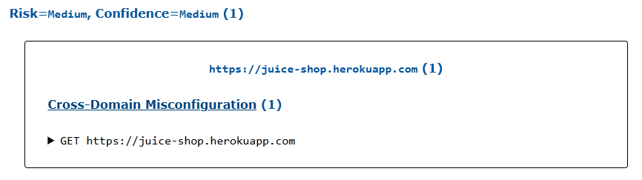
- Risk Level: Medium
- Description: The Cross-Origin Resource Sharing (CORS) settings currently allow access from any external domain, which could expose sensitive information to unauthorized parties. Allowing all origins (Access-Control-Allow-Origin: *) can expose your application to cross-site request forgery (CSRF) attacks, data exposure issues, and unauthorized API access. This is particularly risky when: The response contains sensitive data. The application allows any web page to interact with potentially sensitive resources.
- Recommendation: Update the CORS policy to allow access only from trusted domains. This will ensure that sensitive data is only accessible by pre-approved origins, reducing exposure to unauthorized domains. Restrict Allowed Origins: Instead of using *, specify trusted origins explicitly: Access-Control-Allow-Origin: https://trusted-domain.com Avoid allowing all origins, especially if the application handles sensitive data. Limit Allowed Methods: Use Access-Control-Allow-Methods to permit only necessary HTTP methods (like GET, POST): Access-Control-Allow-Methods: GET, POST

3. Strict-Transport-Security Header Not Set
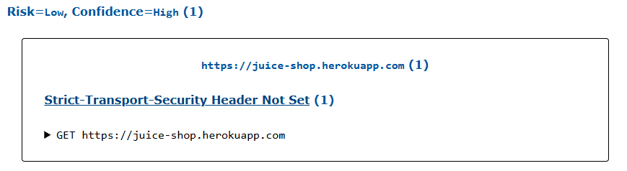
- Risk Level: Low
- Description: Missing HTTP Strict Transport Security (HSTS) headers mean that browsers could access the site over an insecure HTTP connection, exposing it to potential man-in-the-middle attacks.
- Recommendation: Enable HSTS headers, which instruct browsers to only connect to the website over HTTPS. This change will help protect data in transit and prevent downgrade attacks.

4. Cross-Domain JavaScript Source File Inclusion
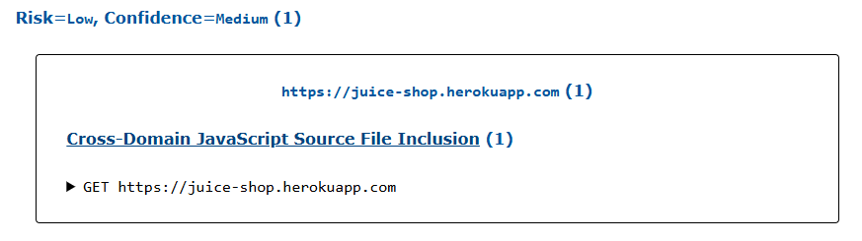
- Risk Level: Low
- Description: The website includes JavaScript from a third-party CDN, which could be risky if the CDN is compromised.
- Recommendation: Limit third-party JavaScript to only trusted sources. Self-hosting essential JavaScript files can further reduce risk by avoiding dependency on external sources.

5. Timestamp Disclosure
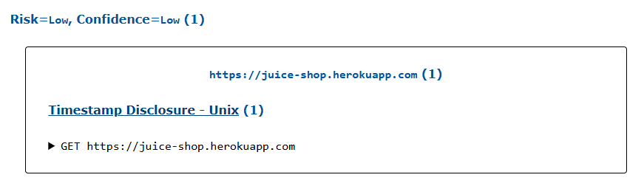
- Risk Level: Low
- Description: The server discloses timestamps that could reveal information about server configurations and potentially assist in social engineering.
- Recommendation: Prevent unnecessary information disclosure by hiding timestamps and other sensitive metadata in HTTP responses.

Additional Recommendations for Informational Issues
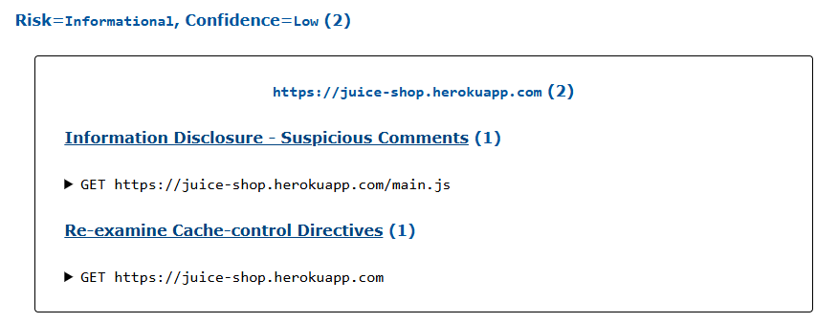
Informational issues, while lower risk, also present opportunities for enhancing security:
- Comment and Metadata Review: Review and sanitize comments in code and metadata to prevent potential exposure of sensitive information.
- Cache-Control Policy: Ensure sensitive data is not cached by using strict cache-control settings.

PLEASE NOTE THE TABLE
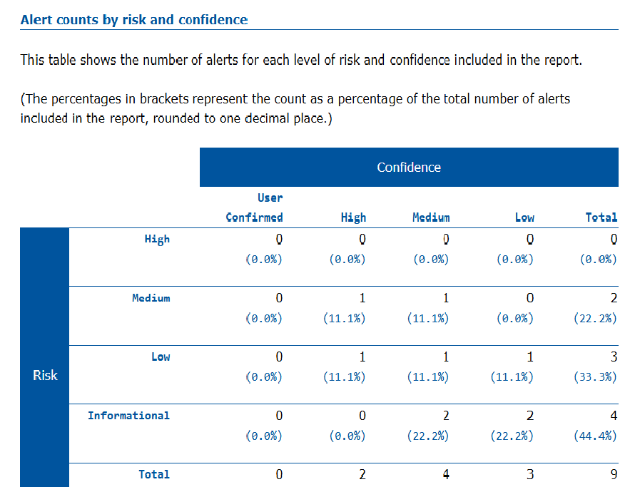

Conclusion
Implementing these recommendations will strengthen the security of https://juice-shop.herokuapp.com, protect user data, and reduce exposure to common security threats. Regular security assessments and proactive updates to your security posture are essential in maintaining a secure web environment. I recommend scheduling a follow-up review to verify the effectiveness of the implemented changes. Please contact me for any assistance during the remediation process.

PART 2
SECURE NETWORK ARCHITECTURE DESIGN PROPOSAL FOR VULNERABILITY MITIGATION
Overview
This proposal outlines a secure network architecture designed to mitigate risks identified in the security assessment of https://juice-shop.herokuapp.com. The architecture applies best practices such as network segmentation, firewalls, and intrusion prevention systems to strengthen security and protect sensitive data.

1. Network Design Components
Each component in this architecture has been selected based on its role in addressing the identified vulnerabilities and ensuring a comprehensive security posture.
2. Detailed Component Descriptions
A. Network Segmentation
Divides the network into separate zones (e.g., DMZ, internal, and secure segments) based on function and security requirements.
Purpose: Restricts traffic flow between sensitive areas, reducing the impact of potential attacks. For instance, web servers are isolated in a DMZ, while sensitive application servers are placed in a more protected internal zone.
Mitigated Risks: Minimizes exposure to attacks on assets such as databases or application servers by isolating network segments.

B. Firewalls
Deploys firewalls at the network perimeter and between segmented zones, with rules that control inbound and outbound traffic based on IP, protocol, and port.
Purpose: Enforces strict access control to the DMZ and internal networks, preventing unauthorized access to sensitive resources. This mitigates cross-domain misconfigurations and prevents unintended access.
Mitigated Risks: Reduces exposure to data breaches and cross-domain attacks by enforcing access restrictions on sensitive areas.
C. Web Application Firewall (WAF)
Protects web applications by filtering and monitoring HTTP traffic and defending against threats like XSS, SQL injection, and CSRF.
Purpose: Detects and blocks malicious web traffic targeting vulnerabilities, such as missing CSP headers or CORS misconfigurations.
Mitigated Risks: Shields web applications from injection and XSS attacks, supporting CSP and preventing unauthorized data exposure.

D. Intrusion Detection and Prevention System (IDPS)
Monitors network traffic for malicious activities, alerts on potential threats, and prevents unauthorized access.
Purpose: Detects suspicious activity across the network and blocks identified threats, mitigating the risk of man-in-the-middle attacks and attempts to exploit CORS or HSTS misconfigurations.
Mitigated Risks: Reduces the likelihood of successful intrusion attempts, including data interception, unauthorized data access, and XSS attacks.
E. Secure Web Gateway (SWG)
Manages access to web content and enforces content security policies to restrict risky web content.
Purpose: Ensures content security by blocking or filtering potentially dangerous websites and enforcing security policies on web content.
Mitigated Risks: Supports content security policies (CSP) and mitigates risks associated with third-party JavaScript file inclusions.
F. Virtual Private Network (VPN)
Provides encrypted connections for remote access to sensitive internal resources, accessible only to authenticated users.
Purpose: Secures connections to internal network segments, preventing unauthorized access and ensuring encrypted data transit for authorized users.
Mitigated Risks: Protects against unauthorized access and ensures data is securely transmitted to internal systems.
G. Logging and Monitoring System
Centralized logging system captures and monitors logs from all network devices, including firewalls, IDPS, and application servers.
Purpose: Provides continuous monitoring, allowing quick detection and response to suspicious activities, and aids in compliance and forensic analysis.
Mitigated Risks: Detects and alerts on potential breaches and intrusions, ensuring rapid response to minimize damage.
H. Database Security Controls
Implements database security measures, such as encryption, regular access audits, and role-based access control.
Purpose: Protects sensitive data at rest within databases, ensuring access is limited to only authorized personnel.
Mitigated Risks: Reduces the risk of unauthorized access or data leaks by enforcing strict access control and ensuring secure storage of data.
3. Summary of Security Controls
Component | Security Function | Primary Risk Mitigated
Network segmentation | Isolate sensitive systems from public facing service | Reduce exposure of internal resources
Firewall | Controls and restricts network traffic | Blocks unauthorized access to network zones
WAF | Protect against web application vulnerabilities | Mitigates XSS, SQL injection, and CSRF threats
IDP | Monitor and prevent intrusion attempts | Detect and blocks network attacks
SWG | Manages secure access to web content | Enforce CSP blocks malicious content
VPN | Secure remote connections | Prevent unauthorized access
Logging monitoring (SIEM) | Tracks and alert on suspicious activities | Enables rapid detection and response
Database security | Secure data storage and access | Prevent unauthorized data access and exposure

Implementing this architecture will help mitigate the identified vulnerabilities by establishing strong access control, monitoring, and intrusion prevention mechanisms. Regular updates and assessments will ensure continued alignment with best practices and evolving threats.

