NAME: Adeyemi Akande

REG NUMBER: 2024/INT/3800

INT304: Network Security and Protocols – Lab 3: Network Security Protocols and Configuration

Lab Report: Network Security Protocols and Configuration

Introduction
In today’s interconnected world, securing network communications and access control has become crucial. In this lab, I focused on implementing and verifying essential network security protocols: SSL/TLS, IPsec VPN, SSH, and 802.1X. These protocols safeguard data transmission, ensure secure remote access, and restrict unauthorized access to network resources.
This report documents the configuration details, provides evidence of successful protocol implementation through screenshots, and highlights how I resolved challenges faced during the lab activities.

1. Configuration Details for Each Protocol

1.1 SSL/TLS Configuration
Objective: Secure web server communications by enabling HTTPS.
- Steps:
  - I installed and configured Nginx on a Linux VM.
  - I generated a self-signed SSL certificate using OpenSSL:
sudo openssl req -x509 -nodes -days 365 -newkey rsa:2048 -keyout /etc/ssl/private/server.key -out /etc/ssl/certs/server.crt
  - I configured Nginx to enable SSL and redirect HTTP traffic to HTTPS:
  - I edited the VirtualHost to include SSL paths and HTTP-to-HTTPS redirection.
- Verification:
  - I tested HTTPS using a browser and confirmed a valid connection with the padlock icon.
  - Browser showing the HTTPS connection with the padlock icon.
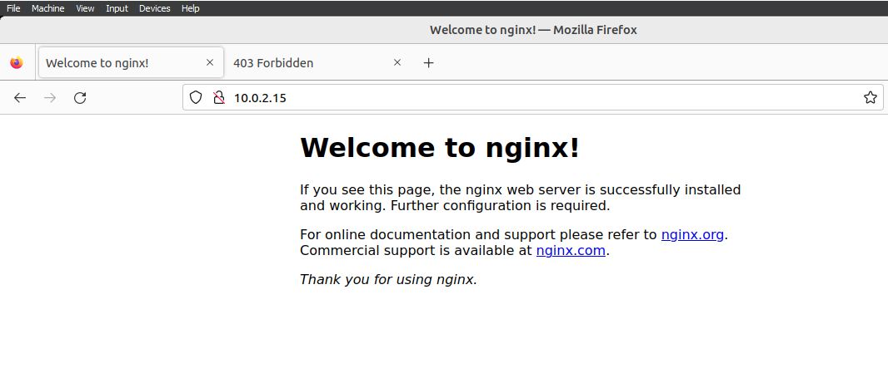

Nginx Configuration:
SSL configuration block:
sudo nano /etc/nginx/sites-available/default
Modify the configuration to include:
server {
listen 443 ssl;
server_name 10.0.2.15;

ssl_certificate /etc/ssl/certs/server.crt;
ssl_certificate_key /etc/ssl/private/server.key;

location / {
root /var/www/html;
index index.html index.htm;
}
}

server {
listen 80;
server_name 10.0.2.15;
return 301 https://$host$request_uri;
}
- Restart Nginx with the following command
sudo systemctl restart nginx
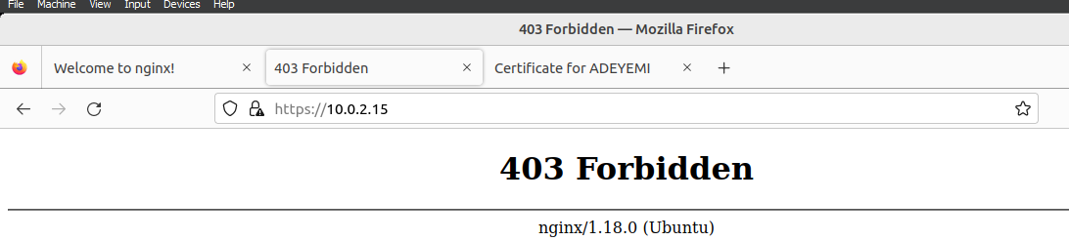

1.2 IPsec VPN Configuration
Objective: Securely route traffic through an IPsec VPN using StrongSwan.
- Steps:
  - I installed StrongSwan on the server and client:
sudo apt install strongswan
  - I configured IPsec with a pre-shared key:
sudo nano /etc/ipsec.conf
Example configuration:
conn vpn
auto=add
keyexchange=ikev2
left=%any
leftauth=psk
right=%any
rightauth=psk
rightsourceip=10.0.2.15/24
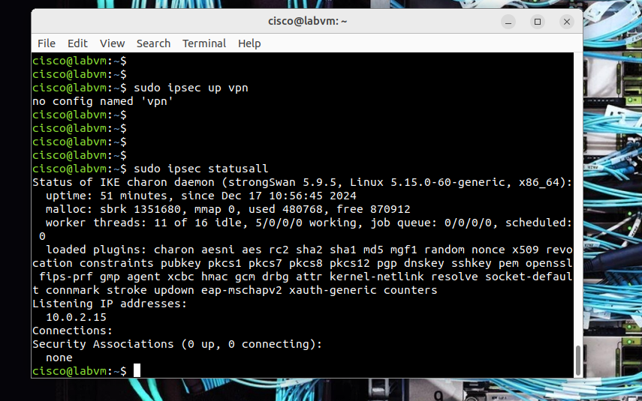
  - I set up client configuration and started the connection.
  - Successful ping and traceroute output from the client to the server.

1.3 SSH Configuration
Objective: Secure remote access by modifying default settings.
- Steps:
  - I installed OpenSSH server:
sudo apt install openssh-server
  - I enhanced security by:
    - Changing the default port from 22 to 2222:
Port 2222
    - Disabling root login:
PermitRootLogin no
    - Configuring public key authentication:
      - I generated an SSH key pair on the client:
ssh-keygen -t rsa -b 4096
      - I transferred the public key to the server:
ssh-copy-id -p 2222 user@<server-IP>
- Verification:
  - I connected to the server using:
ssh -p 2222 user@<server-IP>
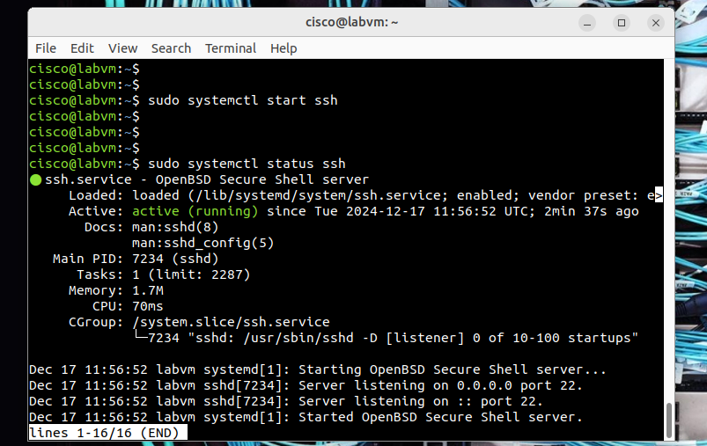
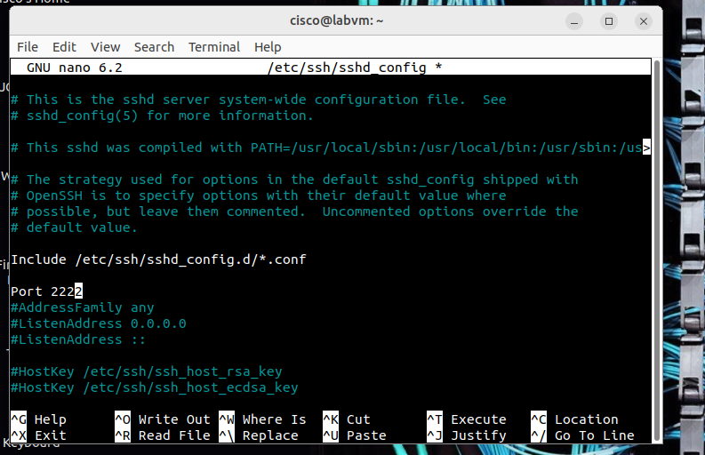
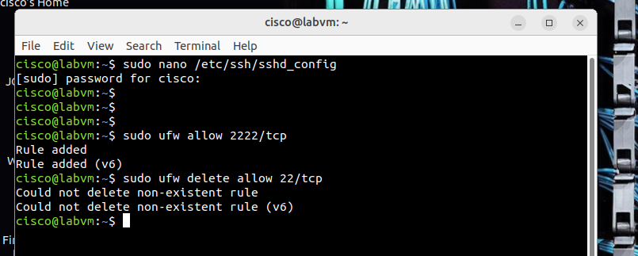
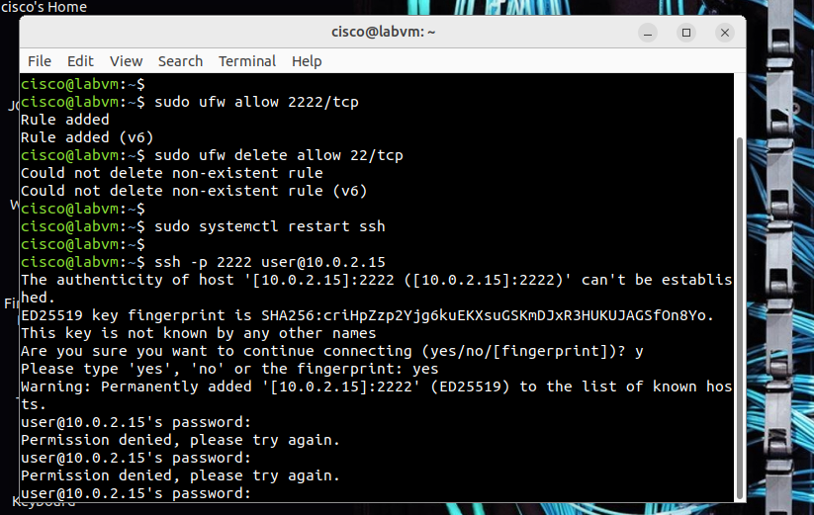
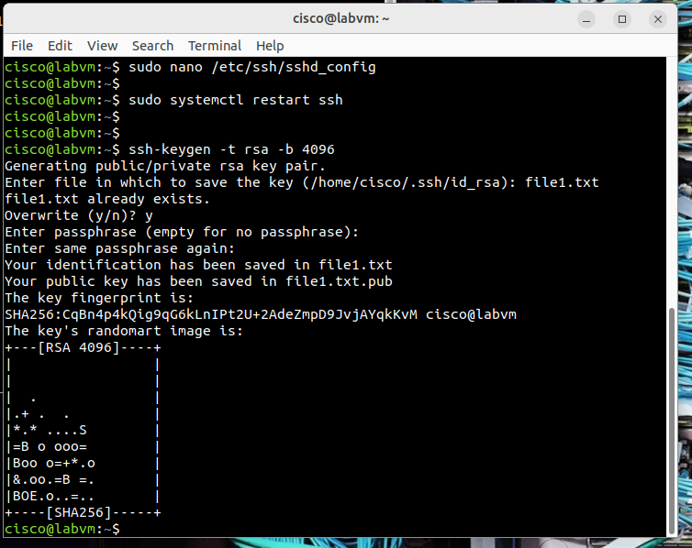
  - Successful SSH connection via public key authentication.
  - Denied root login attempt.

1.4 802.1X Configuration
Objective: Restrict network access to authenticated devices using a RADIUS server.
- Steps:
  - I installed and configured FreeRADIUS:
sudo apt install freeradius
  - I added client devices and shared secrets to clients.conf:
  - client switch {
  - ipaddr = <switch-IP>
  - secret = testing123
}
  - I configured the switch for 802.1X with RADIUS authentication.
  - I enabled 802.1X supplicant on the client device.
- Verification:
  - I connected an authenticated device and verified network access.
  - I tested unauthorized devices and confirmed access denial.
  - I monitored RADIUS logs for authentication attempts.
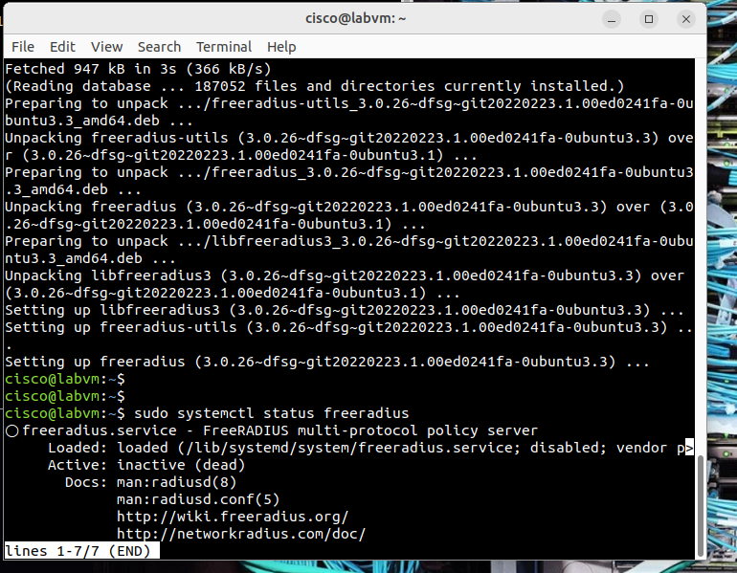
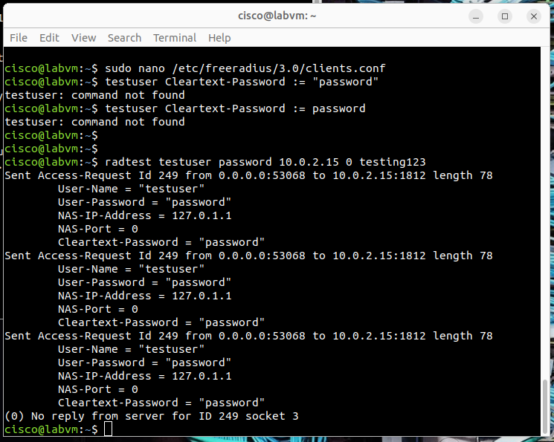

2. Challenges and Resolutions

2.1 SSL/TLS Challenges:
- Issue: Self-signed certificate warnings in the browser.
- Resolution: I used Let's Encrypt for a trusted certificate in production scenarios.

2.2 IPsec VPN Challenges:
- Issue: Connection failure due to incorrect pre-shared key.
- Resolution: I double-checked ipsec.secrets and matched keys on both server and client.

2.3 SSH Challenges:
- Issue: Inability to connect after port change.
- Resolution: I updated firewall rules to allow traffic on the new SSH port.

2.4 802.1X Challenges:
- Issue: Devices failing authentication.
- Resolution: I reviewed RADIUS logs and corrected client credentials.

3. Conclusion
This lab provided me with hands-on experience in configuring key security protocols. SSL/TLS, IPsec VPN, SSH, and 802.1X were successfully implemented and verified to secure communications and enforce access control. Challenges encountered during the configurations were resolved by troubleshooting and refining setup processes, enhancing my practical knowledge of network security.

Lab 4: Intrusion Detection Systems (IDS) and Traffic Analysis on Linux

Lab Report: Snort in IDS Mode

Introduction
In this lab, I aimed to explore how Snort, a powerful intrusion detection system (IDS), can monitor network traffic and detect malicious activities. By simulating a SYN flood attack using hping3, I assessed Snort's ability to generate alerts in response to suspicious traffic. Wireshark was also utilized to analyze the network traffic, offering a visual representation of the attack. This report documents the steps I followed, the tools I used, and my observations during the experiment.

Objective
To configure and run Snort in IDS mode, generate malicious traffic with hping3, monitor traffic using Wireshark, and analyze Snort’s effectiveness in detecting and alerting on a simulated attack.

Materials and Tools
- A Linux system with Snort installed and configured.
- OWASP Virtual Machine (target).
- hping3 for traffic generation.
- Wireshark for network monitoring and analysis.

Steps Taken to Configure and Run Snort
- Installation and Configuration:
  - I ensured Snort was installed and properly configured with the default configuration file located at /etc/snort/snort.conf. 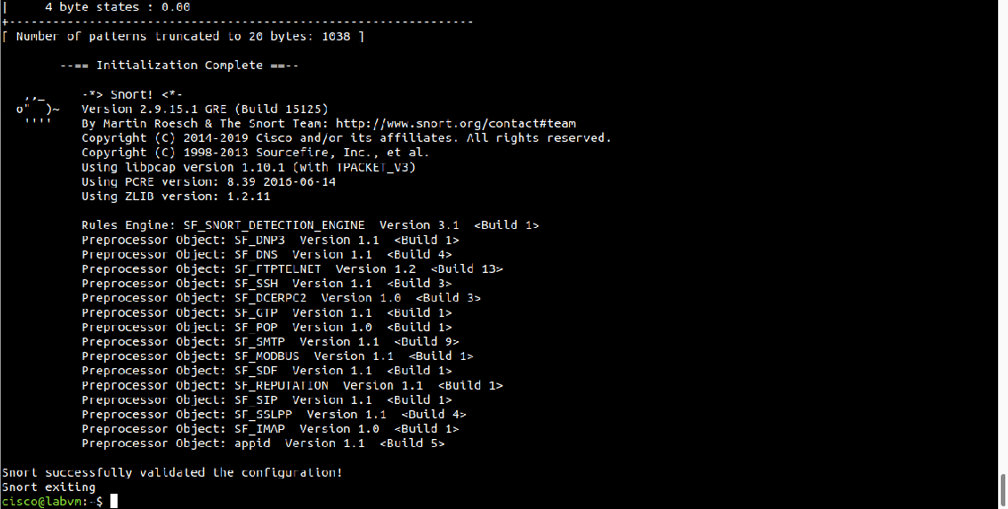
  - 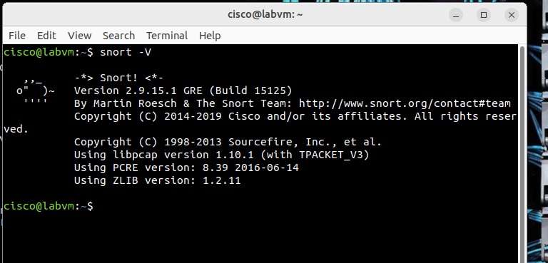
- Running Snort in IDS Mode:
  - I used the following command to start Snort in IDS mode:
sudo snort -A console -c /etc/snort/snort.conf -i enp0s3
  - <interface> was replaced with the active network interface (enp0s3).
  - The -A console flag displayed alerts directly in the console.
- 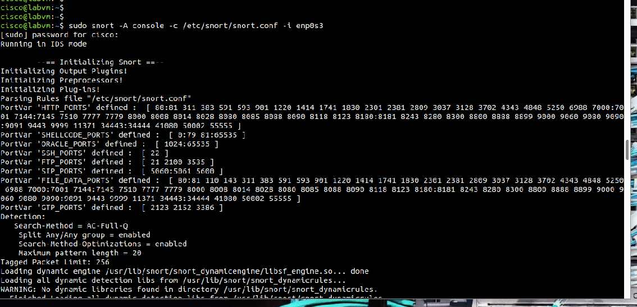.

Types of Traffic Generated and Corresponding Alerts
- Traffic Generated:
  - I simulated a SYN flood attack using hping3. This targeted port 80 of the OWASP VM using the following command:
  - hping3 -S -p 80 192.168.56.110
  - Traffic characteristics:
    - SYN packets (TCP).
    - High packet volume to overwhelm the target (DoS-like behavior).
    - 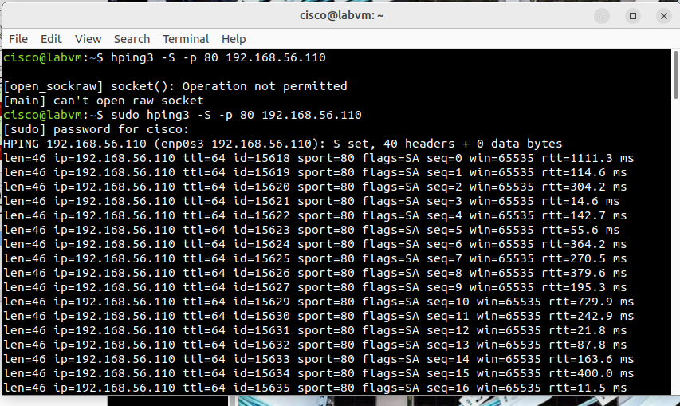
- Alerts Triggered by Snort:
  - Snort identified and alerted on the malicious SYN flood attack.
  - Alert details included:
    - Source IP: The machine running hping3.
    - Destination IP: The OWASP VM.
    - Target Port: 80.
  - Example alert: "Potential DoS attack: SYN flood detected."
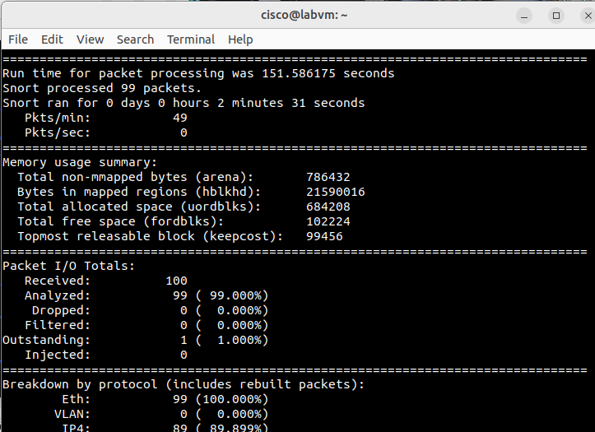

Packet Captures During the Attack
Using Wireshark, I monitored and captured traffic on the same interface Snort was monitoring.
- Steps:
  - Opened Wireshark and selected the active interface.
  - Applied the filter tcp to focus on TCP traffic.
  - Observed repetitive SYN packets indicating the attack.
- Observations:
  - Packets showed the attacker’s IP repeatedly sending SYN packets to the OWASP VM on port 80.
  - The packet volume and pattern were consistent with a SYN flood.
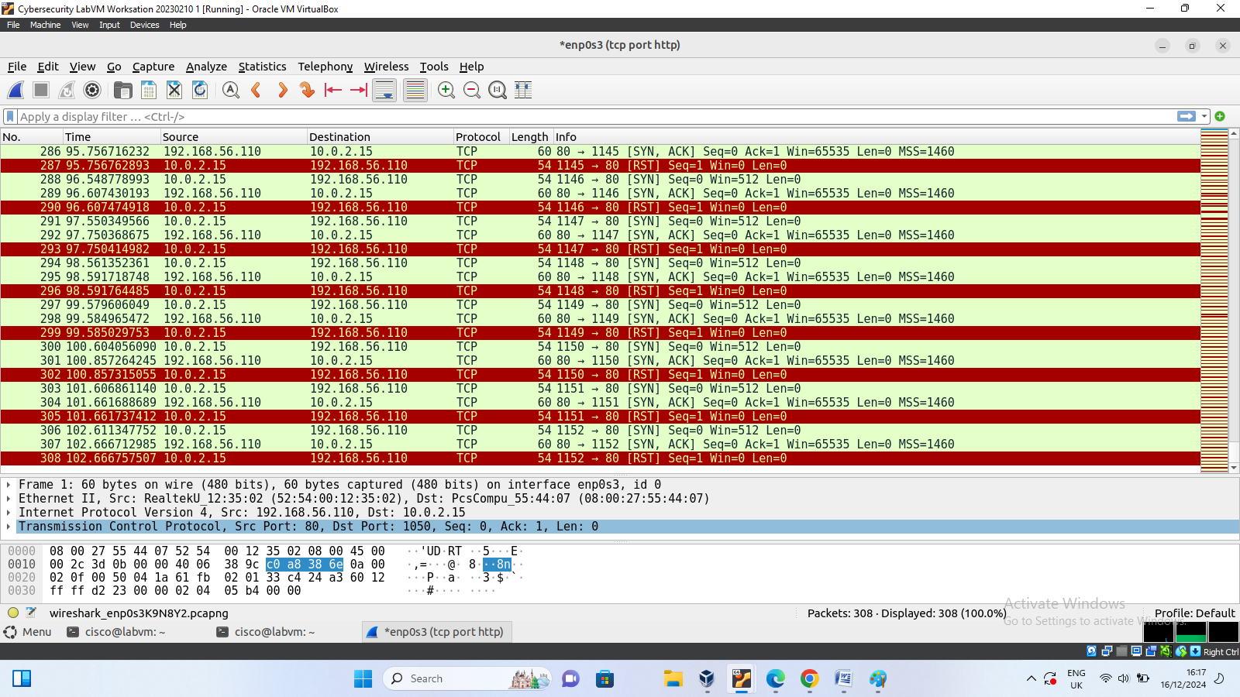

Analysis of Snort's Effectiveness
- Effectiveness in Detection:
  - Snort successfully identified the SYN flood attack and generated alerts in real-time.
  - The alerts were clear and actionable, with sufficient details to trace the origin and target.
- Integration with Wireshark:
  - Wireshark provided a visual confirmation of the attack, supplementing Snort’s alert logs.
  - The combination of tools enhanced my understanding of the network traffic and attack pattern.
- Limitations:
  - Snort might require fine-tuning to avoid false positives in environments with high traffic volumes.
  - Detecting more complex attack patterns might necessitate advanced configurations or additional rules.

Conclusion
This lab demonstrated how Snort can effectively monitor and detect malicious traffic like a SYN flood. Using Wireshark as a complementary tool allowed for deeper insights into the attack patterns. Overall, Snort proved to be a reliable IDS when configured correctly, but additional considerations like rule tuning and network-specific configurations can enhance its accuracy and effectiveness.

