NAME: Adeyemi Akande
REG NO: 2024/INT/3800
DATE: 5th February, 2025
INT307 Web Application Security Lab 4: File Upload Vulnerabilities in DVWA
Exercise 1 Summary
Observations: 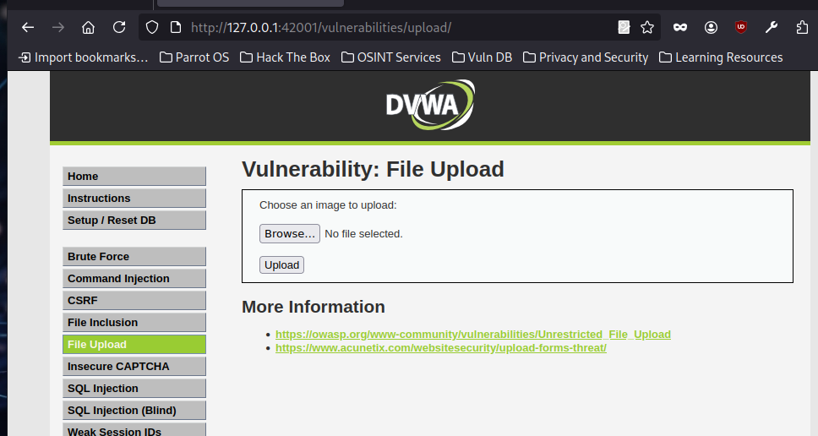

- The file upload form included an input field (<input type="file">), a submit button, and used the HTTP POST method for sending files to the server.
- The uploaded files were stored in a predefined directory such as /uploads/ or dvwa/uploads/.
- A harmless file (test.txt) was uploaded successfully, and no immediate restrictions were encountered.
Characteristics:
- The file upload feature allows users to submit and store files on the server.
- Uploaded files were accessible via a direct URL.
- The DVWA security level influences the presence of file type and size restrictions.
- At higher security levels, additional controls are likely implemented to prevent unauthorized file uploads.
Exercise 2 Summary
Shell Generation Outcome:
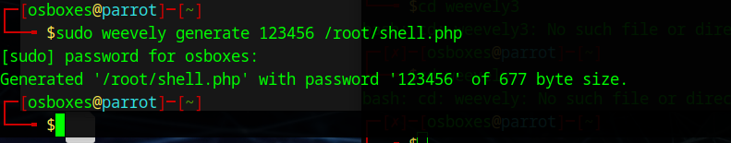
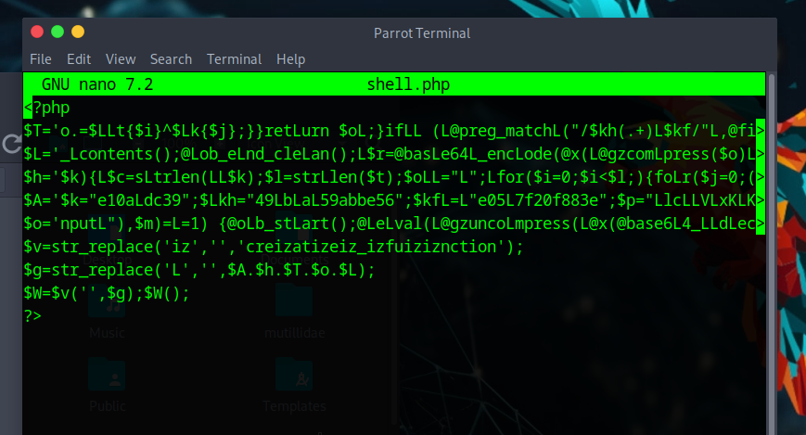
- The malicious shell (shell.php) was successfully created using Weevely.
- The shell was generated with a password to allow remote access.
Observations:
- Examining the shell.php file revealed an obfuscated PHP script, designed to establish a backdoor connection.
- The shell enables remote command execution once deployed on a vulnerable server.
Exercise 3 Summary
Low Security Level:
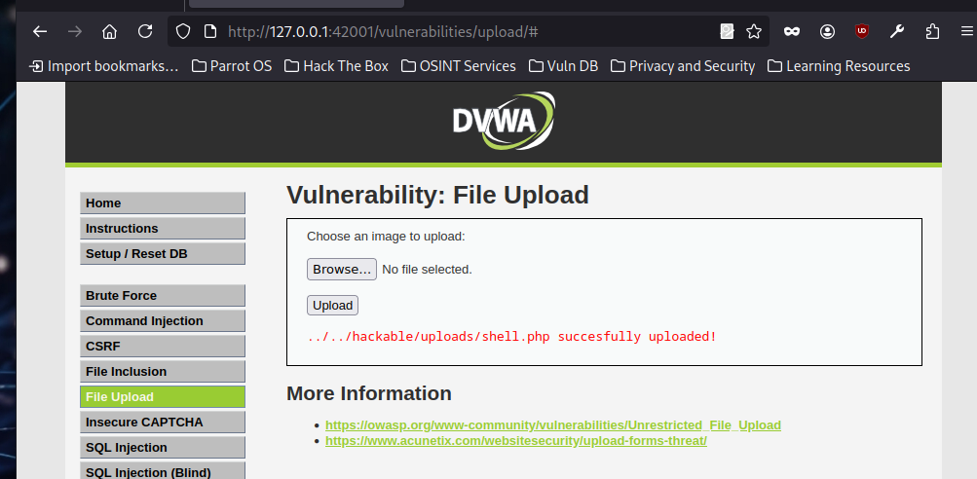
- Upload Outcome: The shell.php file was successfully uploaded without restrictions.
- Implications:
  - Allowed remote execution of commands, leading to unauthorized server access.
  - Potential for privilege escalation and data breaches.
  - Attackers could maintain persistent access by uploading additional backdoors.
Medium Security Level:
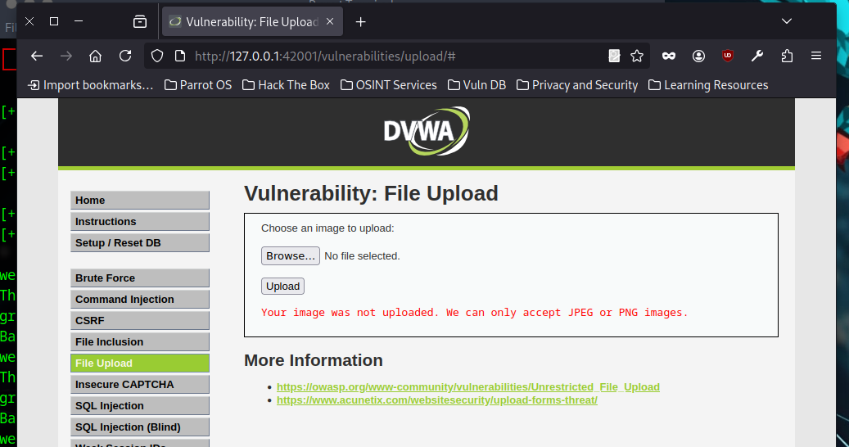
- Upload Outcome: The shell.php upload was blocked due to file extension validation.
- Discussion:
Improved security through file type restrictions.
Bypass attempts using Burp Suite (e.g., modifying file extensions and MIME types) were partially effective.
Further security measures like MIME type checking and content scanning are necessary to prevent circumvention.
High Security Level:
- Upload Outcome: The upload was strictly blocked, even after request modifications using Burp Suite.
- Discussion:
The high-security level enforces stricter controls, including MIME type verification and content filtering.
Prevents execution of PHP files by blocking unauthorized file uploads entirely.
Additional mitigations include logging suspicious upload attempts and using Web Application Firewalls (WAFs).
Exercise 4 Summary
Shell Access Outcome:
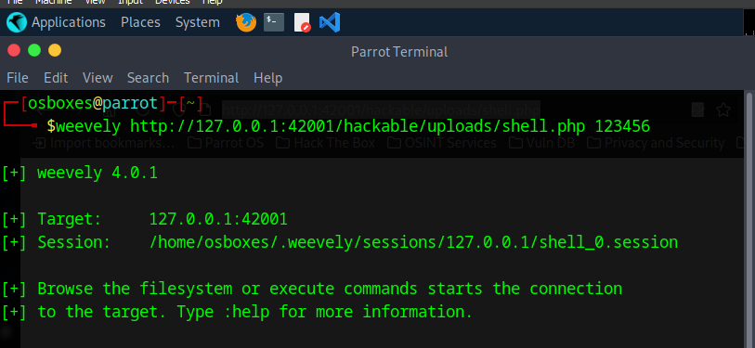
- Successfully accessed the uploaded shell.php through a web browser.
- Entered the password set during shell generation and gained access to the Weevely shell.
Discussion:
- The shell allows remote command execution on the server.
- Can be used to navigate directories, retrieve files, and escalate privileges.
- An attacker could compromise the web server entirely, extract sensitive data, and deploy additional exploits.
Exercise 5 Summary
Security Measures Outcome:
- At low security, the application allowed unrestricted file uploads.
- At medium security, file type validation was present but bypassable using Burp Suite.
- At high security, the file upload was strictly blocked, preventing execution of malicious scripts.
Discussion:
- File Type Validation: Prevents certain file types from being uploaded but can be bypassed if weakly enforced.
- Size Restrictions: Helps limit large-scale attacks by restricting file sizes.
- MIME Type Checking: Ensures files match expected content types, reducing the risk of disguised malicious uploads.
- Content Scanning: Detects and blocks potentially harmful scripts embedded in uploaded files.
- Access Controls: Prevents unauthorized file execution, even if uploaded successfully.
- Logging & Monitoring: Helps detect and respond to suspicious upload attempts.
Key Takeaways:
- Low-security settings leave applications highly vulnerable.
- Medium security provides moderate protection but remains bypassable.
- High security significantly reduces risks by enforcing strict validation and filtering measures.
- Combining multiple security strategies (whitelisting, scanning, and access control) offers the best defense against file upload vulnerabilities.
INT307 Web Application Security Lab 5: Security Misconfiguration in DVWA/Mutillidae
INT307 Web Application Security Lab 5: Security Misconfiguration in DVWA/Mutillidae
Overview In this lab, I explored various security misconfigurations that can occur in web applications, specifically in DVWA and Mutillidae. Security misconfigurations arise when security settings are not properly defined, implemented, or maintained, making applications vulnerable to exploitation.
Lab Objectives
- Identify common security misconfigurations in DVWA/Mutillidae.
- Exploit vulnerabilities arising from these misconfigurations.
- Discuss best practices for securing web applications against misconfiguration risks.
Exercise 1: Default Credentials and Permissions
1. Accessing the Application:
I opened DVWA and Mutillidae in my web browser.
2. Testing Default Credentials:
- I attempted to log in using admin/password for DVWA.
- I checked for default credentials in Mutillidae.
3. Reflection:
- Using default credentials allowed me to gain unauthorized access.
- This is a significant security risk because attackers can exploit weak or unchanged credentials to take control of an application.
- Best practice: Enforce strong, unique passwords and disable default credentials immediately.
Exercise 2: Directory Listing
1. Checking for Directory Listing:
- I navigated to /uploads/ and /images/ directories in DVWA and Mutillidae.
- The server displayed a list of files in some cases.
2. Reflection:
- I could see uploaded files, including scripts and images.
- Directory listing exposes sensitive information, allowing attackers to discover files that can be exploited.
- Best practice: Disable directory listing and restrict file access through proper permissions.
Exercise 3: Error Handling Misconfiguration
1. Inducing an Error:
- I attempted to access /vulnerabilities/invalid_page to trigger an error.
- The application returned detailed error messages containing file paths and database queries.
2. Reflection:
- The error messages exposed internal details, which could help attackers understand the application’s structure.
- Detailed error messages aid attackers in identifying vulnerabilities.
- Best practice: Configure generic error messages and log detailed errors on the server-side.
Exercise 4: Security Headers
1. Analyzing Security Headers:
- I used BurpSuite and browser developer tools to inspect HTTP response headers.
- I checked for the presence of security headers like:
X-Content-Type-Options
X-Frame-Options
Content-Security-Policy
Strict-Transport-Security
2. Reflection:
- Some security headers were missing, making the application susceptible to clickjacking and MIME-based attacks.
- Security headers help mitigate attacks such as cross-site scripting (XSS) and man-in-the-middle (MITM) attacks.
- Best practice: Implement and enforce security headers to protect the application.
Exercise 5: Insecure File Upload Configuration
1. Accessing File Upload Feature:
- I navigated to the file upload functionality in DVWA and Mutillidae.
2. Attempting to Upload a Malicious File:
- I created a simple PHP web shell and attempted to upload it.
- The application allowed the upload in lower security levels, but blocked it at higher security settings.
3. Reflection:
- I was able to upload the malicious file in some cases, allowing me to execute remote commands.
- Allowing arbitrary file uploads can lead to remote code execution and server compromise.
- Best practice: Restrict file types, scan uploads for malicious content, and store uploaded files outside web-accessible directories.
INT307 Web Application Security Lab 6: Insecure Direct Object References (IDOR) in DVWA
Researching IDOR
Definition of IDOR:
Insecure Direct Object References (IDOR) is a vulnerability that occurs when an application provides direct access to objects (such as database records, files, or URLs) based on user-supplied input without proper authorization checks. This allows attackers to manipulate object references and gain unauthorized access to sensitive information or perform actions on behalf of other users.
How IDOR Vulnerabilities Arise:
- Developers fail to implement proper access control mechanisms.
- Object identifiers (such as user IDs or file names) are exposed in URLs, request parameters, or API endpoints.
- The application assumes that a user can only access objects they are assigned to without verification.
- Insufficient logging and monitoring make it difficult to detect exploitation.
Real-World Examples of IDOR Attacks:
- Facebook (2013): A vulnerability allowed attackers to delete any photo album by modifying the album ID in the request.
- PayPal (2016): Attackers exploited IDOR to access and manipulate invoices of other users.
- Tesla (2020): A researcher identified an IDOR flaw that allowed unauthorized access to Tesla service records.
2. Reflection: Summary of Findings on IDOR
IDOR is a critical security vulnerability that arises when applications fail to properly validate user permissions before granting access to resources. Attackers can manipulate object references in URLs or API requests to access, modify, or delete data belonging to other users. Implementing robust access controls, enforcing least privilege principles, and regularly testing applications for IDOR vulnerabilities can help mitigate this risk. Developers should ensure that user authorization checks are in place at every level where objects are referenced to prevent unauthorized access.

Exercise 2: Identify IDOR Vulnerabilities in DVWA

Observed Results
- Upon changing the user ID, I observed that the page displayed information for different users without any access control checks.
- Sensitive details, such as usernames and emails of other users, were revealed, confirming the presence of an IDOR vulnerability.
Reflection
- This exercise clearly demonstrated that the application does not enforce proper access controls for user data.
- The ability to access unauthorized user information by simply altering the URL parameter highlights a serious security flaw.
- IDOR vulnerabilities can lead to privacy breaches and unauthorized data manipulation, posing significant risks in real-world scenarios.
- To mitigate this risk, it is crucial to implement robust access control mechanisms, use indirect object references, and conduct regular security audits.
- By following the above steps, I confirmed that DVWA is vulnerable to IDOR attacks. This lab reinforces the importance of strict access controls and secure coding practices to protect sensitive user data from unauthorized access.
Exercise 3: Exploit IDOR to Access Unauthorized Data
Attempt to Access Different User Profiles
- I logged into the DVWA application and navigated to the user information page using the URL:
http://192.168.56.110/dvwa/vulnerabilities/idor/?user=1
- From this page, I observed the details of the currently logged-in user.
- I then changed the user parameter in the URL to other values: user=2, to try to access profiles that should not be available to me.
Analyze the Response
- When I altered the user ID in the URL, I was able to view information associated with different user accounts.
- The unauthorized profiles displayed sensitive information including:
  - Usernames
  - Email addresses
- The response from the server did not enforce any access control checks, which confirmed the presence of the IDOR vulnerability.
Reflection
- Sensitive Data Accessed:
  - I could access personally identifiable information (PII) such as usernames and email addresses. In some cases, additional details like account creation dates or user roles might also be exposed.
- Potential Risks Involved:
  - Privacy Breach: Unauthorized access to user data can lead to privacy violations.
  - Identity Theft: Attackers can leverage exposed PII to impersonate users or steal identities.
  - Data Manipulation: Without proper access controls, attackers might modify or delete user data.
  - Further Exploitation: Exposed data can serve as a stepping stone for more advanced attacks, including phishing, social engineering, or escalation of privileges within the system.
  - This lab clearly demonstrates the risks associated with IDOR vulnerabilities. The ability to access unauthorized user profiles by simply modifying a URL parameter indicates a severe lack of proper access controls. It is imperative for developers to implement robust authorization checks and indirect object references to protect sensitive user data and prevent such vulnerabilities.
Exercise 4: Preventing IDOR Vulnerabilities
Identify Mitigation Strategies
- Access Control Measures:
Implement strict access controls to ensure that users can only access data and resources for which they have explicit permissions. This involves defining roles and privileges clearly and enforcing them across the application.
- Using Indirect Object References:
Instead of exposing direct references (like numeric IDs) in URLs, I learned that developers can use indirect references. This method involves mapping user-supplied values to internal objects in a secure way, making it difficult for attackers to guess or manipulate object identifiers.
- Implementing Authorization Checks:
Every time a request is made to access a resource, the application should verify whether the authenticated user is authorized to perform the action. This means validating that the user has the correct permissions for the requested object before displaying or modifying it.
- Logging and Monitoring Access Attempts:
Establishing detailed logging and monitoring helps detect unusual or unauthorized access attempts. This strategy not only aids in identifying potential exploitation of IDOR vulnerabilities but also provides valuable forensic data in the event of a breach.
Reflection
Implementing these strategies in DVWA can significantly reduce the risk of IDOR attacks:
- In DVWA, I could enforce strict access controls by modifying the code to verify that the logged-in user's session matches the requested object's owner before displaying any information.
- Using indirect object references in place of predictable numeric IDs (e.g., using tokens or hashed identifiers) makes it much harder for attackers to manipulate URLs to access other users’ data.
- Consistently applying authorization checks at every point where sensitive data is accessed would ensure that even if an attacker changes the URL parameters, the system prevents unauthorized access.
- Finally, integrating robust logging and monitoring can alert administrators to suspicious activities, such as repeated attempts to access different user IDs, thereby allowing timely responses to potential breaches.
By combining strong access control measures, indirect object references, thorough authorization checks, and proactive logging and monitoring, web applications can better defend against IDOR vulnerabilities. These strategies create multiple layers of defense that collectively mitigate the risk of unauthorized access, making it significantly harder for attackers to exploit these weaknesses.
Reference:
• Facebook (2013):
Reference: The Hacker News. “Facebook’s Photo Album Deletion Vulnerability: How IDOR Can Be Exploited.” Published June 2013.
URL: https://thehackernews.com/2013/06/facebook-album-deletion-vulnerability.html
• PayPal (2016):
Reference: Infosecurity Magazine. “Exploiting IDOR: How PayPal’s Invoice Vulnerability Was Uncovered.” Published 2016.
URL: https://www.infosecurity-magazine.com/news/paypal-invoice-idor/
• Tesla (2020):
Reference: BleepingComputer. “Tesla Service Records Exposed via IDOR Vulnerability.” Published 2020.
URL: https://www.bleepingcomputer.com/news/security/tesla-service-records-vulnerable-to-idor/

