PyScanner3
Adelina Duca, (Mihai Daniel Beuca)

Table of Contents
Overview of the project 2
What it is? 2
Why using it? 2
Requirements 3
How to get started 3
Installation steps 3
How to use the application 3
User Interface 3
The purpose 3
How it is implemented 4
Other functions 4
The clearing function 4
The verifying process 4
Saving the scan to a file function 4
The scanning process 5

Overview of the project

What it is?
PyScanner3 is a port scanner with graphical interface made in python3. The graphical interface is implemented via PyQt5 module of python which was very intuitive and has its own program for design which made the work a lot easier. The rest of the functions were implemented using other modules of python.

Why using it?
PyScanner3 has a very intuitive graphical interface which makes it easier for beginners to scan a host.
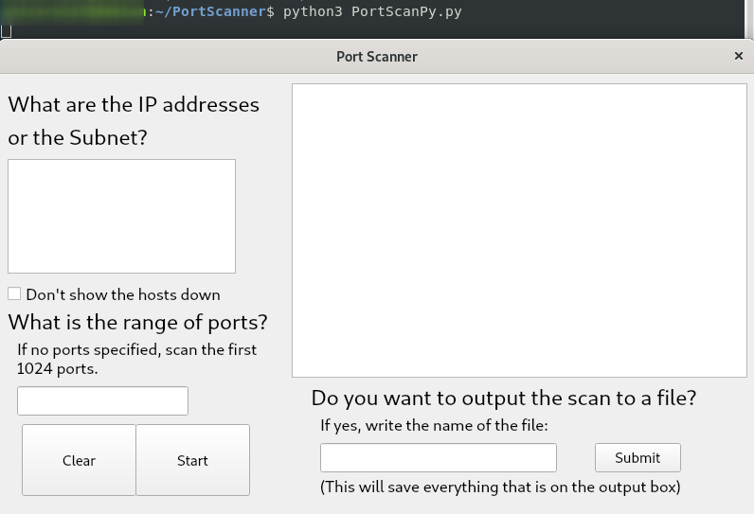
As you can see you have multiple messages that help you understand what is happening in the back.

Requirements
- Python3 installed
- Internet access
- A Host/Subnet to be scanned

How to get started

Installation steps
If your using Linux, you can simply use “sudo apt install python3” in terminal if you don’t already have it. Also you can download it from the site (https://www.python.org/downloads/).
Besides python you also need the PyScanner3.py that you can get from github ( git clone https://github.com/ade7000/Port-Scanner.git )

How to use the application
The application is very easy to use, if you are alright with the default settings (that are described in the GUI), you only have to write the host or the subnet to be scanned. If you don’t want the unavailable hosts to be shown, you can check a button. You can also set a range of ports, or just a higher port to which to scan. After the scan is done you can save the output to a file of your choice (This will save everything that is on the screen). If there’s too much information on the screen that you don’t want it (say you performed a subnet scan and your screen is full of unavailable host) you can clean the screen with the button located near “Start”.

User Interface

The purpose
The purpose of the graphical interface is just to facilitate the scanning process and use of access.

How it is implemented
To make things easier, the Qt5 Designer app was used first to create all the elements needed and put them in place. Almost all of the elements are created in the same way: First assigning the type of object (example: self.ip_label = QtWidgets.Qlabel(self.centralwidget) defines the self.ip_label as a label), then setting the position and size with setGeometry function (self.ip_label.setGeometry(QtCore.QRect(10, 10, 300, 41)), setting a font size (self.ip_label.setFont(font) and writing the text (self.ip_label.setText(_translate("MainWindow", "What are the IP addresses")). All of the functions are implemented inside a class to make it easier to access the variables needed. The buttons are connected to the specific function ( the CLEAR button with the clearing function and the START button with the verifying function, these functions are explained in the next secton)

Other functions

The clearing function
This cleans all the output on the screen. It uses the function clean of QtextBrowser.

The verifying process
This function verifies if any port range was given and all the host given (if it’s an IP address or a whole subnet) in the interface.
For the port range, first it verifies if any input is given ( if (self.input_ports.text()=='') ). If there is any input, it verifies if there is a hyphen( that means that the lower limit will be the number before the hyphen and the upper limit the number after it). If there’s no hyphen, assigns the number as the upper limit and starts the scan from one.
For the IPs, it first split them on lines as the user can input more than one IP or subnet. It then verifies if it’s an IP or subnet, pings each IP and, if it respond to the ping, sends the IP to the scanning function.

Saving the scan to a file function
This function saves all the text that is on the box with the output. If no file name is given, it just skips. Otherwise it creates that file with the txt extension and save there all the output of the scan. Remember that if the file already exist it will write in it at the end as many times the button Submit is pressed.

The scanning process
The scanning involves using sockets to connect to a port and threading to make it faster. The socket contains the IPv4 (AF_INET) and is using the TCP protocol (SOCK_SREAM). It tries to connect to a port and if it success it print the port and the service name ( socket.getservbyport(port,”tcp”) ).

