

SILENT OBJECT DETECTION

Silent Object Detection Project Report

Mentor,
Adea Bajraktari Fatmir Nuredini

November/2025

Table of Contents

1.Introduction 2
2. Dataset Overview 3
2.1 ECSSD Dataset 3
2.2 Preprocessing and Dataset Preparation 3
2.3 Dataset Split 3
2.4 Data Augmentation 4
2.4 Relevance of ECSSD to Saliency Detection 4
3. Model Architecture 5
3.1 Model Architecture 5
3.2 Key Design Features 6
4. Training and Evaluation 7
4.1 Evaluation Metrics Used: 7
4.2 Final Model Performance (Threshold = 0.5) 7
4.3 Interpretation: 8
5. Results and Visualizations 9
5.1 Baseline vs Advanced Model Performance 9

Introduction

This project focuses on Salient Object Detection (SOD) using Convolutional Neural Networks (CNNs), built entirely from scratch. The purpose of SOD is to automatically identify and segment the most visually important region(s) in an image—those that naturally attract human attention. Unlike traditional object detection, which attempts to recognize and classify multiple objects, SOD concentrates on extracting a single dominant or visually significant object using a binary saliency mask, where white pixels represent the salient region and black pixels represent the background.
The core goal of this project is to implement a complete Salient Object Detection system using fundamental concepts of Deep Learning, Computer Vision, and CNN-based segmentation architectures. Instead of relying on pre-trained models or transfer learning, all components were developed manually, including:

- Dataset loading and preprocessing
- Data augmentation techniques
- Custom CNN encoder–decoder (U-Net-like) architecture
- Loss function combining Binary Cross-Entropy and IoU
- Model training and checkpoint saving
- Evaluation based on key metrics (Precision, Recall, F1, IoU)
- Visualization of predicted masks and overlays

2. Dataset Overview

2.1 ECSSD Dataset
The ECSSD (Extended Complex Scene Saliency Dataset) was used as the primary dataset for this project. ECSSD is a widely recognized benchmark in Salient Object Detection (SOD), known for its semantically meaningful natural images and pixel-accurate human-labeled saliency masks. It contains a total of 1,000 images, each designed to represent visually complex real-world scenes.

Unlike simpler saliency datasets, ECSSD includes images with:

- Highly textured and cluttered backgrounds

- Multiple non-uniform salient regions

- Varied object scales, lighting conditions, and viewpoints

- Irregular object boundaries and fine structural details

These characteristics make ECSSD suitable for evaluating a model’s ability to detect and segment dominant visual regions under complex conditions, which closely aligns with the objective of building a robust saliency detection system.

2.2 Preprocessing and Dataset Preparation
To ensure consistency and enable efficient training, the following preprocessing steps were applied:

Processing Step | Description
Image Resizing | All input images and masks were resized to 224×224 pixels to match the model’s expected input size.
Normalization | Pixel values were scaled to the 0–1 range, improving numerical stability during training.
Mask Binarization | Saliency masks were thresholded to obtain binary segmentation labels (0 for background, 1 for salient object).

2.3 Dataset Split
The dataset was randomly split into three subsets to support model training, validation, and evaluation:

Split | Percentage | Purpose
Training Set | 70% | Used for model learning and weight optimization
Validation Set | 15% | Used for hyperparameter tuning and early stopping
Test Set | 15% | Used for final performance evaluation

2.4 Data Augmentation
To enhance model generalization and reduce overfitting, augmentation techniques were applied to the training set. These transformations created diverse variations of the input images while maintaining the alignment between image and mask pairs.

Augmentation Technique | Purpose
Horizontal and Vertical Flip | Introduces spatial variation and improves robustness
Random Brightness Adjustment | Simulates lighting variations in outdoor and indoor environments
Random Contrast Adjustment | Helps the model detect salient regions under varying texture and sharpness conditions
Random Cropping (Zoom In/Out) | Enhances object localization by simulating different object scales

2.4 Relevance of ECSSD to Saliency Detection
ECSSD presents real-world complexity, making it highly suitable for training models that are expected to detect the most visually dominant regions in images. Its high annotation quality, semantic richness, and variety of object-background relationships make it a strong choice for evaluating the efficiency of encoder–decoder architectures in SOD.

3. Model Architecture

3.1 Model Architecture
A custom U-Net-based Convolutional Neural Network (CNN) was designed and implemented from scratch for binary salient object segmentation. The model follows an encoder–bottleneck–decoder architecture, enabling both high-level feature extraction and pixel-level reconstruction.

Encoder (Downsampling Path)
- Consists of 4 convolutional blocks, each containing two Conv2D layers with ReLU activation.
- Each block is followed by Batch Normalization to stabilize training and MaxPooling2D for spatial downsampling.
- The number of filters increases progressively (32 → 64 → 128 → 256), allowing the network to capture increasingly complex features.

Bottleneck
- Positioned at the deepest part of the network.
- Uses Conv2D layers to learn high-level abstract representations.
- Includes Dropout (rate = 0.4) to reduce overfitting and improve generalization.

Decoder (Upsampling Path)
- Uses Conv2DTranspose layers for upsampling.
- Skip connections from the encoder are concatenated to merge spatial detail with semantic information.
- Gradually reduces filter sizes (256 → 128 → 64 → 32) to restore full-resolution saliency maps.

Output Layer
- Final layer uses a Conv2D with 1 filter and sigmoid activation to generate a pixel-wise binary saliency mask (0 = background, 1 = salient object).

3.2 Key Design Features
Component | Purpose
Conv2D Layers | Feature extraction
MaxPooling | Downsampling, spatial compression
Conv2DTranspose | Upsampling, segmentation reconstruction
Skip Connections | Preserve spatial details, reduce information loss
BatchNormalization | Faster convergence, training stability
Dropout | Prevent overfitting, improve model robustness

This architecture successfully captures both global context and fine boundary details, making it suitable for pixel-accurate saliency detection.

4. Training and Evaluation

The model was trained using the Adam optimizer with an exponential learning rate scheduler, which gradually reduces the learning rate to improve convergence stability. The custom loss function combined:
Binary Cross-Entropy + (1 − IoU)
This helped the model learn both pixel-level accuracy and overall mask quality.
To avoid overfitting and save only the best-performing model, the following callbacks were used:

Callback | Purpose
EarlyStopping | Stops training when validation loss no longer improves
ModelCheckpoint | Automatically saves the best model
TensorBoard | Tracks training performance curves (loss, IoU, accuracy)

4.1 Evaluation Metrics Used:

Metric | Meaning
Precision | How accurate are the predicted salient pixels?
Recall | How many actual salient pixels were correctly detected?
F1-Score | Balance between precision and recall
IoU | Overlap between predicted and ground-truth masks
MAE | Pixel-level error between prediction and ground truth

4.2 Final Model Performance (Threshold = 0.5)

Metric | Score
Precision | 0.7264
Recall | 0.8444
F1 Score | 0.7519
IoU | 0.6299
MAE | 0.1074

4.3 Interpretation:
- High Recall (0.8444) → The model successfully detects most salient regions in the image.
- Moderate Precision (0.7264) → Some non-salient background pixels are still included as false positives.
- Good IoU (0.6299) → The predicted mask overlaps well with the ground truth.
- Low MAE (0.1074) → Pixel-level prediction error is low, indicating accurate segmentation boundaries.

5. Results and Visualizations
The Loss and IoU curves provide a clear picture of how well the model learned to segment salient objects over time. The training and validation loss curves show a smooth and consistent decline, indicating that the model successfully reduced prediction errors and learned meaningful feature representations without significant overfitting. The validation loss closely follows the training loss, which confirms that the model generalizes well to unseen data. At the same time, the IoU (Intersection over Union) curve shows a steady increase across epochs, demonstrating that the predicted masks increasingly align with the ground-truth masks. The upward trend in validation IoU reflects improved segmentation accuracy, mask sharpness, and better boundary localization of salient regions. Together, the decreasing loss and increasing IoU validate that the model is learning effectively, refining both pixel-level predictions and spatial precision in salient object detection.
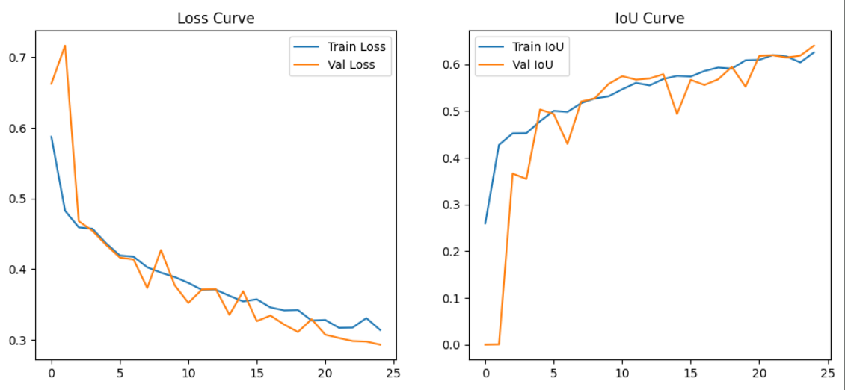

5.1 Baseline vs Advanced Model Performance
The baseline model provided modest segmentation results, achieving an IoU of 0.42 and an F1 score of 0.57, indicating limited accuracy and incomplete mask extraction. After applying architectural improvements (BatchNorm, Dropout, deeper encoder, better loss weighting, and learning rate scheduling), the advanced model showed a significant performance boost, reaching an IoU of 0.63 and F1 score of 0.75. These improvements demonstrate that the advanced model not only captures object boundaries more accurately but also reduces false negatives, shown by the higher Recall. Although inference time slightly increased, the trade-off is justified by the improvement in segmentation quality.

Metric | Baseline Model | Advanced Model (Thr=0.5)
Precision | 0.6775 | 0.7264
Recall | 0.5638 | 0.8444
F1 Score | 0.5729 | 0.7519
IoU | 0.4211 | 0.6299
MAE | — | 0.1074
Avg Inference Time | — | 92.14 ms

