**Solutions**

**Problem statement :** Ainun has 20 cakes and 25 apples. She wants to bundle those cakes and apples into boxes and give them to her friends. **How many boxes that Ainun can make? And how many cakes and apples does every box have?**

* 1. Solve this problem using language you know and confident
  2. Create function to count boxes Ainun can make
  3. Create function to count how many cake and apple in a box
  4. Create unit test for the function
  5. Apples and cakes divided evenly every box

The algorithm of the function can follow below solution.

Solution :

**Step 1** : We are given that the number of cakes and apple sare evenly divided in every box. That means the number of cake in one box is equal to the number of cake in each other box i.e. all the boxes contain same number of cake. Similarly apples are also evenly divided, hence number of apple in each box should be equal. We have 20 ginger bread and 25 fruit cakes .

**Step 2 :** Find Common factors of 20, 24

Step (i) The factors of 20 are: 1, 2, 4, 5, 10, 20

Step (ii) The factors of 25 are: 1, 5, 25

From step (i) and step (ii) we get , The common factors are: 1, 5

def compute_boxes(self, cakes, apples):

if cakes > apples:

small = apples

else:

small = cakes

for i in range(1, small+1):

if(cakes % i == 0) and (apples % i == 0):

gcd = i

return gcd

**Step 3 :** Find greatest common factor i.e. GCF ( 20, 25) Among all the factors the greatest common factor is 5. Therefore Number of boxes needed to bundle these 20 cake and 25 apple evenly in all the boxes is 5 boxes. We are considering the greatest common factor as it evenly distributes or divides the units.

**Step 4 :**

Find number of cakes in each box = 4. Since ainun can make 5 boxes , the number of cake in each box equals Total number of cake ÷ GCF = 20 ÷ 5 = 4

**Step 5 :** Answer : Number of fruit cake in each box = 5. Similarly, the number of apple in each box equals Total number of apples ÷ GCF = 50 ÷ 10 = 5

**Technical Guideline**

Technical Requirement

* Python 3.8.4 above

Run program :

1. To run the program you can use below command

python compute_boxes.py

1. Enter the number of cakes and apple



1. The result should be shown as below

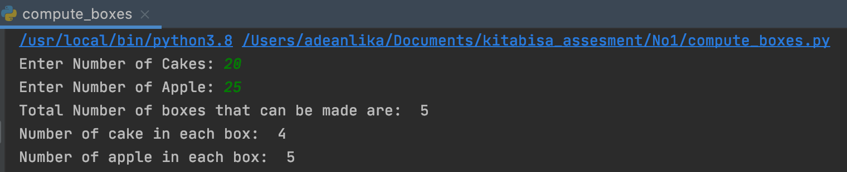

1. To run the unit test you can use below command

python compute_boxes_unittest.py