**Application of Supply Chain Management Information System of Inventory at Computer Shop in Jambi City**

# Ade Indra Saputra1∗ and Mulyadi2

1Master of Information Systems, Universitas Komputer Indonesia, Indonesia

2Department of Information System, Universitas Dinamika Bangsa Jambi, Indonesia

E-mail: [ade.75118017@mahasiswa.unikom.ac.id](mailto:ade.75118017@mahasiswa.unikom.ac.id)

**Abstract.** The XYZ Store is a one of computer shop in Jambi City which selling computer equipment. This computer shop requires good inventory management in order to manage the procurement for customers precisely, estimated number of minimum ordered and predicted capital that must spent every year. So, a computerized system which is supported by supporting methods which chose in the prepartory proccess in computer shop to ensure that supplies can be existing. One of method that can be used in the management of the inventory is a method of Supply Chain Management (SCM). The system developed is a computer equipment inventory information system using the concept of Supply Chain Management use some software like MySQL for DBMS (Database Mangament System) and Web Application for selling in computer shop.

*Keywords*: SCM, Information System, Inventory

# Introduction

Competition between companies lately does not only occur in domestic companies, but also occurs globally as a result of the era of globalization and ASEAN free trade on Indonesia. The competition requires companies to provide the best service to consumers by ensuring the product distribution process up to the hands of consumers goes well. Various activities in production include activities to obtain raw materials, process them with various transformation processes become final products and distributed to consumers. Companies compete to meet the desires of consumers with ”customer oriented” services, covering 3 main points namely price, quality, service (speed, comfort, etc.) [1].

XYZ Store is a computer store that sells computer hardware and accesorries in Jambi. This company has to improve the quality of services to customers, by implementing appropriate strategies to win the competitions. Interview and observation data show this company often occurs out of stock in every month. High demand for

goods, causing frequently out of stock and became unfulfilled orders. The Current web-based Transaction Processing system has been operated but did not have a stock management feature, and they cannot estimate the amount of goods should be purchased in the next month.

Estimates for inventory are usually predicted based on product items and the number of units sold. This technique is less effective, it is proven that there is a buildup of goods because it is not in accordance with the needs of the customer, plus the delay in the supply of goods causes a vacuum of goods which results in customer disappointment, and turns to the competitor’s company. Product circulation is not running well and has an impact on customer service quality.

To overcome this problem, the authors designed the application to support XYZ Store business growth with features that can ensure that orders can be fulfilled, using the Supply Chain Management (SCM) method. The supply chain consists of all stages involved, directly or indirectly, in meeting customer demand. The supply chain includes not only producers and suppliers, but also transporters, warehouses, retailers, and customers themselves [2].

SCM is needed for organizations to compete in dynamic international markets. The purpose of SCM is to combine internal activities and cross-organizational activities to provide customers value [3].

# Methods

* 1. *Data Collection Methodology and Data Analysis*

Data collection techniques began with observing business processes, interviews with owners and literature studies. Literature study is done by digging more information from similar research.

Data analysis was performed with qualitative and quantitative descriptive analysis. Qualitative descriptive analysis describes the relationship between supply chain management from the purchase and sale of products to customers. Quantitative descriptive analysis is performed to calculate the stock in the database from the initial inventory and ending inventory.

* 1. *Supply Chain Management Concept*

Ref [4] Supply Chain Management Professionals (Vitasek, 2010) is Supply chain management encompasses the planning and management of all activities involved in sourcing, procurement, conversion, and all logistics management activities. Encompasses the planning on business proccess management be a important to stores for the capitals management, it also includes the coordination and collaboration with channel partners, which can be suppliers, intermediaries, third-party service providers, and customers.

Guided by an integrated production plan, supported by various technologies, especially based on Internet/Intranet, and is implemented around supply, production operations, logistics (mainly manufacturing processes), and meeting demand which is Supply Chain Management [5]. Pujawan (2010) stated that supply chain is the network of companies that work hand-in-hand to create and deliver product to the hands of end users [6]. W. Edwards Deming, author and consultant on quality, says that ”The consumer is the most important part of the production line. Quality should be aimed at the needs of the consumer, present and future.” [7]

* 1. *Evolution of Supply Chain Management*

The supply chain literature review was conducted to study the past researches. The emergence and evolution of SCM may be depicted as a timeline shown in **Figure** **1** [3].

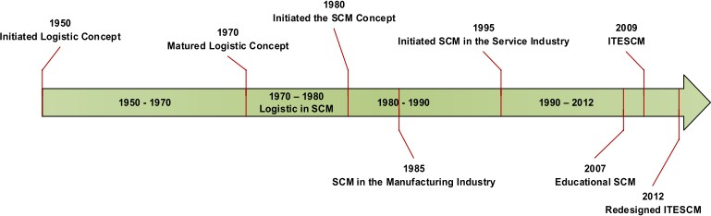

**Figure 1.**Evolutionary Timeline of Supply Chain Management.

* 1. *Lot Sizing Method*

In inventory control proccess there are several methods lotting that use. Lotting proccess is a proccess to determine the size of individual order that optimal based on calcuate result clean needs [8]. The use of the Lot Sizing technique is appropriate for use in determining the quantity of inventory orders in which in addition to minimizing the number of orders, it can also minimize the cost of direct inventory and inverse cost of inventory orders [9]. An inventory system controls the level of inventory by determining how much to order (the level of replenishment) and when to order. There are two basic types of inventory systems: a continuous (or fixed-order-quantity) system and a periodic (or fixed-time-period) [7].

* 1. *Economic Order Quantity (EOQ)*

A formula for determining the optimal order size that minimizes the sum of carrying costs and ordering costs is the basic EOQ model [7]. The XYZ Store has unsold inventory, so the store has a carrying cost for the product.