Sort Planets

A micro:bit makecode project (workshop challenges)

CHALLENGE 1
THINGS TO MAKE YOUR PROGRAM DO AS SOON AS IT STARTS RUNNING (BEFORE YOU PRESS ANY BUTTONS OR ANYTHING ELSE)

Declaring Variables
- Make 8 variables named planet_1 to planet_8.
- Assign a planet name (text string) to each of these 8 variables in the correct order, with planet_1 being the closest and planet_8 the furthest away from Sol (the name of our sun).
- Add these blocks to an on start block.

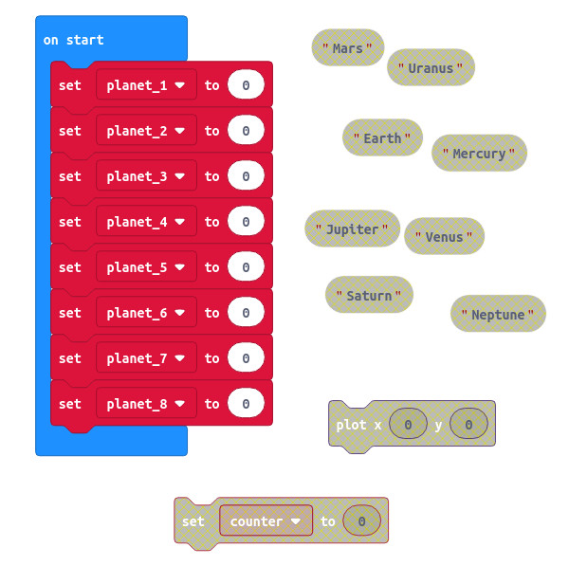

CHALLENGE 1A
Make a function to create a solar system (called create_solar_system) that gets called when the program starts running.
Make an Array variable called solar_system and add the 8 planet variables (text strings remember!) to it. Make sure they’re in the correct order.

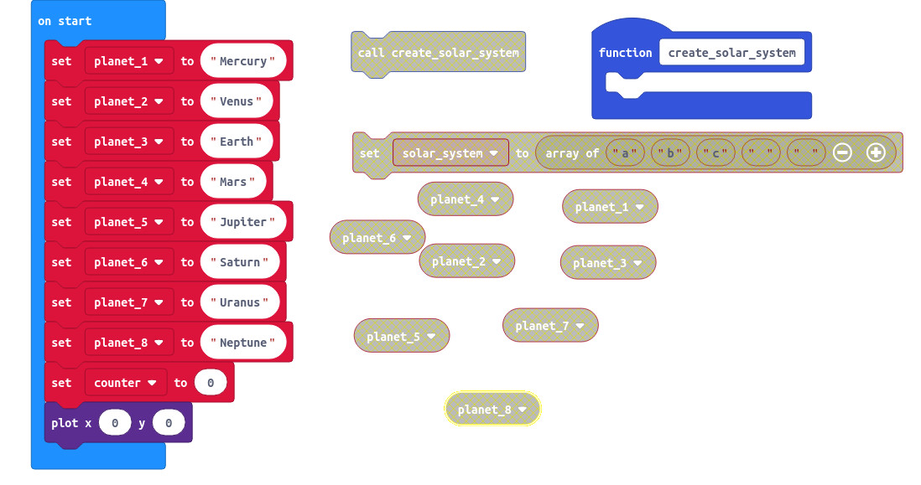

Nothing to see so far, unless you made an LED come on as a ‘power on indicator’.

Explain to someone how the program works so far.
What’s the point of the plot 0,0 block?
Question: I have a set of books labelled from 0 to 7. How many books are there?
Which variable type is used for planet variables?

CHALLENGE 2
THINGS TO MAKE YOUR PROGRAM DO WHEN YOU PRESS A BUTTON
- Create a function (called display_planets) to loop through the array, displaying the value of a planet at each loop.
- Make a for loop that will do something the same number of times as there are planets in the solar_system... BUT it has to start from zero!
- The value of a variable called planet_position must change for each loop, going FROM (zero) TO (the length of the solar_system array minus 1). How many loops is that?
- The something to do bit : Make a block to show a string at every loop. Make this string by getting the value at planet_position in the solar_system array.

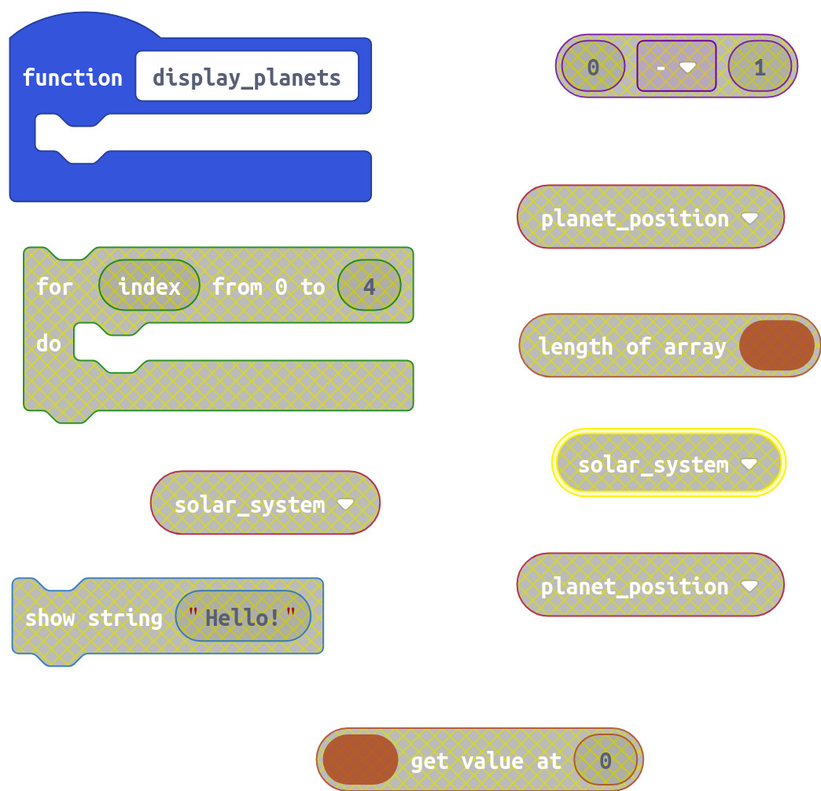

- Create the code to call the display_planets function whenever button A is pressed

See if you can name the next planet before it scrolls onto the display!

CHALLENGE 3
Update your display_planets function to use a while loop to keep the display going forever in an ‘infinite loop’.

CHALLENGE 4
Update your display_planets function to show the text string “Home” whenever the text string used for planet3 (“Earth”) is displayed.

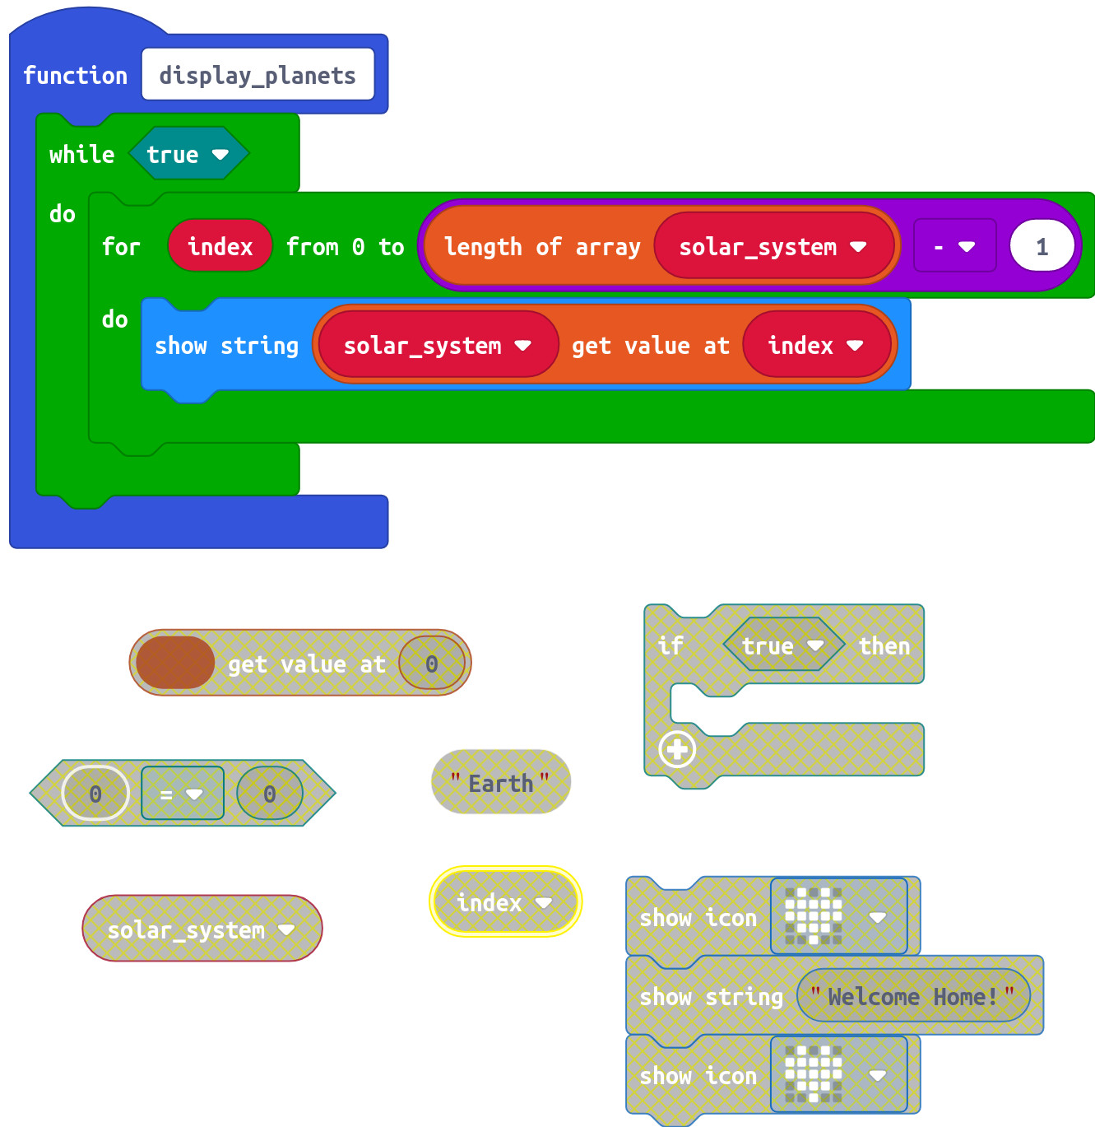

CHALLENGE 5
Update your makecode to display one planet at a time (still in order of distance from the sun), each time button A is pressed.
To do this you’ll need to make a counter that goes up by one every time you press the button, but NEVER goes above the number of planets.
You’ll also need to make a new function called display_next_planet.

Inside the button A block add blocks to do the following:
- Switch off the micro:bit ‘power on’ indicator at 0,0 if you used one.
- Call the display_next_planet function, passing it the number of the planet you want it to display.
- Increment the value of the counter by 1.
- Use an if block to decide whether the counter needs to be reset to zero.

Inside the display_next_planet function, tell it to do the following each time it’s called:
- Show the name of the planet that has the position of the number (num) it received.

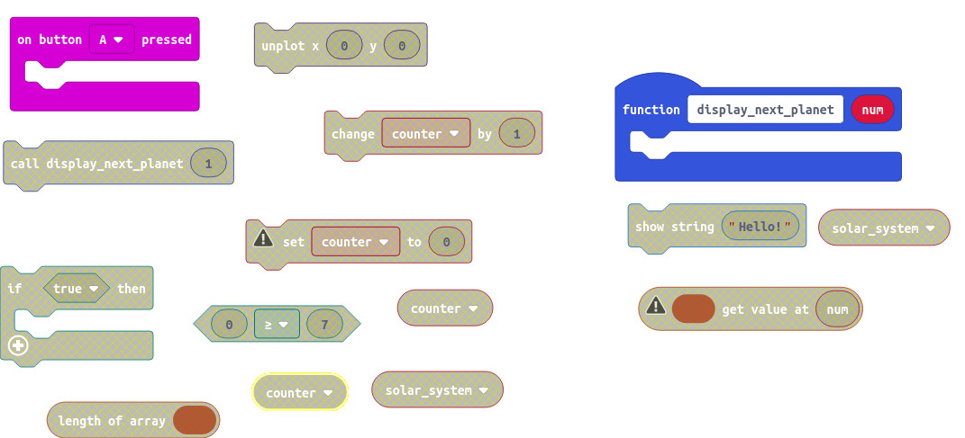

What’s wrong with not just saying ‘if counter >= 8...’ ?

CHALLENGE 6
To display a randomly chosen planet each time button A is pressed.
We need to be able to generate a randomly chosen number between 0 and 7.

CHALLENGE 7

Now completely separate from the random planet displaying you’ve just done, you need to program button B to increment a counter with values between 1 and 8 ( or 0 to 7) . Just as before, when the counter tries to go above 8 ( or 7), it gets reset to the beginning. This time though, you need to display the counter value. A new function called display_counter to

In this order, put these blocks into an on button B pressed block:
- A block to call the display_counter function and pass it the counter variable at the same time.
- create a block to increment the value of counter by 1.
- create an if block that does something if the value of counter becomes equal or greater than the number of planets in the solar_system.
- Create a single block to do that ‘something’.

